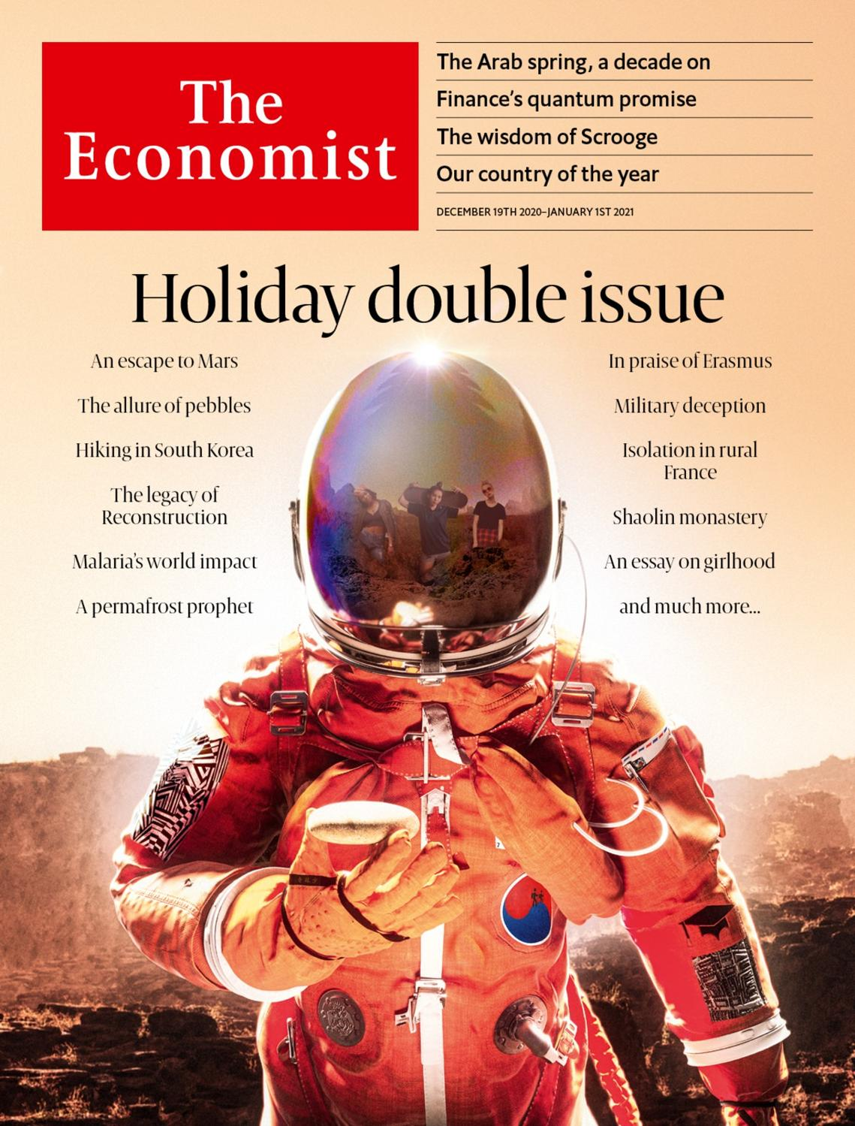

# Table of Contents

The world this week

The world this year

KAL’s cartoon

Leaders

Covid-19 in 2020: The plague year

Targeting big tech: Credibility gap

Children: Getting girlhood right

The Arab world: Ten years after the spring

Country of the year: Admiration nation

Letters

Letters to the editor: On farming, books, aerial combat, Latin, Machiavelli, diversity, Ireland, the turkey

United States

The final Senate races: The decider

Covid-19 in New York: The Holly and the UV

Cyber-security: Bear hunt

Schools and covid-19: Lesson learned

Lexington: Good neighbours

The Americas

Brazil: Awaiting their fate

Cuba: From distortion to disruption

Asia

Expatriates in Asia: Shipping out

Preserving Yangon: In with the old

Banyan: A lonely furrow

China

Sexual harassment: Refusing to be silent

Human rights: Proxy war

Middle East & Africa

The Arab spring at ten: No cause for celebration

Iran: Go hang

Western Sahara: Heat in the desert

Kidnapping in Nigeria: The lost boys of Kankara

Congo’s gold rush: Beer, brothels and broken dreams

Europe

The Vatican’s finances: Falling on hard times

The European Union budget: Locked and loaded

Health care: Flight of the white coats

Azerbaijan’s ghost towns: Bitterness prevails

Charlemagne: Sprechen Sie Tory?

Britain

Negotiations with the EU: An extra mile, a narrow path

Brexit-related disruption: Lorrypolitik

Heathrow expansion: Cleared for take-off

Animal welfare: The pet offensive

Bagehot: The wisdom of Scrooge

International

Waste-pickers: Down in the dumps

Christmas Specials

Newsletters: Season’s greetings!

Rural France: Fragments from a forgotten valley

Bloodsuckers: History, written by the vectors

Sidney Street: The one that got away

Digital humanities: The book of numbers

Sadie Tanner Mossell Alexander: The Alexander technique

Shingle art: A universe of stones

Essay: Awesome, weird and everything else

Erasmus: Citizen of the world

South Korean mountains: Race to the top

Crossword, etc: Cryptic and coniferous

Quiz: Try our Christmas quiz

Gay rights: A queer old tale

Travels in Zululand: Trust deficit

Extraterrestrial hiking: A short walk in Gale crater

Economies past: Factories and families

Shaolin monastery: The profession of renunciation

Reconstruction: Revolutionary embers

Military deception: Bodyguard of lies

Pleistocene Park: The prophet of permafrost

Business

Big oil: Brown v broad

Cinema and streaming: Big bets on the small screen

Bartleby: Straight talking

Schumpeter: The parable of Ryanair

Finance & economics

High-tech finance: Quantum for quants

Market mania: Froth or fundamentals?

Counterfactual economics: Panned

Free exchange: Location, location, location

Science & technology

The highest fidelity: An auricular spectacular

Evolution and agriculture: Good catch

Data storage: Re-record, not fade away

Books & arts

Poetry on the Tube: Tunnels of love

Winter weather: The white stuff

Economic & financial indicators

Economic data, commodities and markets

Graphic detail

The media and covid-19: The biggest story ever?

We’re hiring full-time and trainee data journalists

Obituary

John le Carré: The watchful scribbler



### Thursday, December 17, 2020

|  |  |
| --- | --- |
| The world this week | 2 |
| Leaders | 5 |
| Letters | 1 |
| United States | 5 |
| The Americas | 2 |
| Asia | 3 |
| China | 2 |
| Middle East & Africa | 5 |
| Europe | 5 |
| Britain | 5 |
| International | 1 |
| Christmas Specials | 20 |
| Business | 4 |
| Finance & economics | 4 |
| Science & technology | 3 |
| Books & arts | 2 |
| Economic & financial indicators | 1 |
| Graphic detail | 2 |
| Obituary | 1 |

|  |  |  |
| --- | --- | --- |
|  | 章节 | Leaders |

The world this week

The world this year

.

KAL’s cartoon

.

|  |  |  |
| --- | --- | --- |
|  | 章节 | Leaders |

|  |  |  |  |
| --- | --- | --- | --- |
|  | 文章 | 章节 | 下一项 |

# The world this year

Dec 16th 2020 |

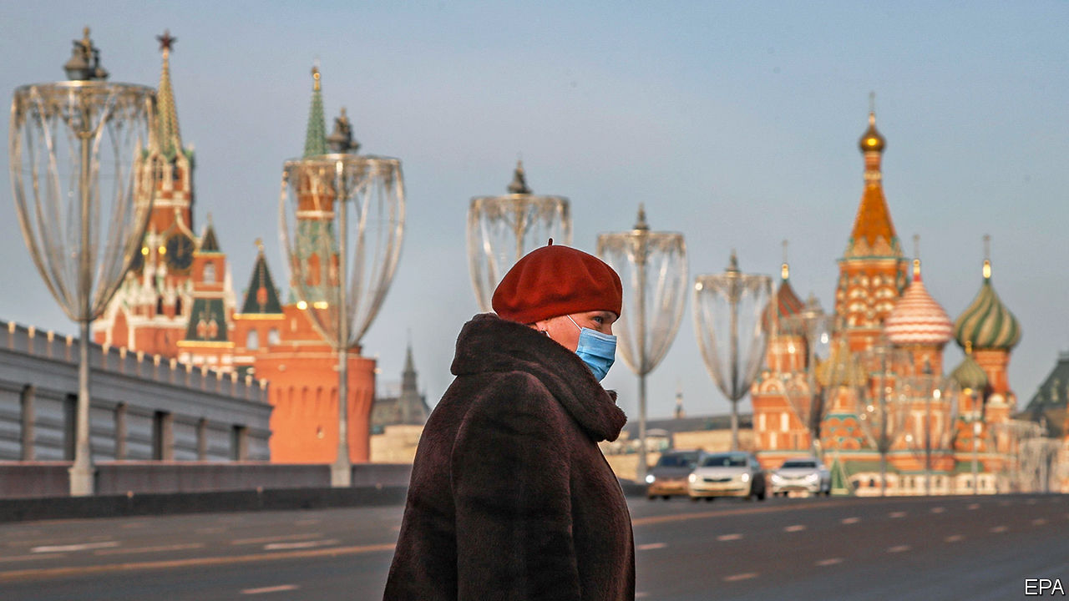

A novel coronavirus, possibly transmitted by animals sold at a market in the Chinese city of Wuhan, spread to create one of the worst global crises since the second world war. Covid-19 has so far caused over 73m recorded infections and more than 1.6m recorded deaths. On January 23rd the Chinese authorities imposed a quarantine in Wuhan, soon extending it to the rest of Hubei province and beyond. Variants of this “lockdown” policy were adopted by other countries as they struggled to contain the outbreak. See article.

## Every breath you take

By late January cases were widely reported in Germany, Japan, Taiwan and Vietnam. Markets were rattled, fearing disruption to global supply chains that run through China. By late February the World Health Organisation said that most infections were occurring outside China. Italy was the first country to be hit hard. After hospitals were overwhelmed, the country went into lockdown in early March.

The sudden imposition of lockdowns led to panic buying in some places, notably in America and Britain, where supermarket shelves were stripped bare. Shopping moved online. Internet searches rocketed for goods such as toilet paper, fitness equipment and breadmakers. In poorer countries, such as India, the human cost was higher. Left suddenly without work, many migrant labourers tried to return to their family homes; it was the country’s greatest movement of people since partition in 1947. India’s economy shrank by around 25% in April-June.

By late March China was recording fewer domestic cases. The lockdown in Wuhan ended in early April. China closed its border to foreigners as the disease spread rapidly in Europe, most menacingly in Britain, France, Italy and Spain.

## Don’t stand so close to me

America was hit almost as hard by the coronavirus. Donald Trump didn’t take it seriously at first; he tried to lift federal restrictions in April, promising a return to normality by Easter. Wearing a face mask became a badge of political allegiance. Mr Trump rowed with the WHO, accusing it of being in China’s pocket, and said that America would leave it in 2021. Brazil was also led by a sceptic. Jair Bolsonaro said the disease was just a case of the “sniffles”.

The extent of the market crash in mid-March (the S&P 500 lost a quarter of its value over three weeks) sparked fears of a depression. The Federal Reserve and other central banks made emergency cuts to interest rates. The Fed also propped up the corporate-bond market, action it had shied away from during the financial crisis a decade earlier.

Oil markets took a hammering. As if the pandemic were not enough of a problem, in March Saudi Arabia instigated a price war with Russia, as their deal over production levels broke down. Prices plunged in the steepest one-day decline since 1991. They eventually recovered somewhat. By the end of the year OPEC and Russia had struck a tentative agreement to increase supply.

Politicians in many countries pulled out their fiscal bazookas to defend their economies. America’s Congress passed a $2.2trn stimulus bill (the CARES act), which directed cash payments to households and topped up unemployment benefits. Some 21m people lost their jobs in April alone; unemployment soared to 14.7%, but it never hit the 20% that some had forecast. Britain guaranteed 80% of wages to workers who had been furloughed, and even subsidised restaurant meals in August.

## Spirits in the material world

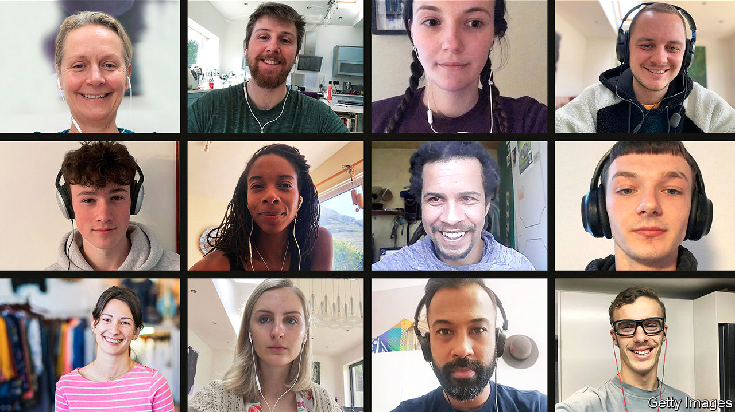

The pandemic was a boon for some. Once the shock of lockdowns faded, stockmarkets climbed towards new records, in part because of the soaring share prices of tech firms. Zoom meetings became a feature for office employees sent home to work remotely (Zoom fatigue was soon a common gripe). As online shopping flourished, Amazon recruited hundreds of thousands of extra staff. Jeff Bezos, Amazon’s boss, saw his wealth increase from $111bn in March to $185bn in December. The combined wealth of the world’s ten richest people grew by 57%, to $1.14trn.

Among industries, aviation and tourism were the biggest losers from the pandemic. Even with huge government bail-outs, airlines are reckoned to have lost $510bn in revenue, according to their international association. The UN reported that international tourism declined by 70% in January-August, causing a loss of $730bn in export revenues.

Scientists had what many thought to be a Herculean task developing a vaccine for covid-19, but drug firms made great strides and by the end of the year several jabs were ready. Britain started the first inoculation programme using a fully tested vaccine, followed soon after by America. Even with the vaccine, officials warn, the world will be battling the virus for another year.

The outbreak of civil war in Ethiopia was one of 2020’s great disappointments. Abiy Ahmed, the prime minister and winner of a Nobel peace prize, launched an attack on the Tigray region when separatist forces attacked the army.

Chinese and Indian troops clashed along their Himalayan border, the first deadly encounter between the two sides in decades. Fighting also erupted between Armenia and Azerbaijan over the long-disputed enclave of Nagorno-Karabakh. Their truce is shaky.

Abe Shinzo, Japan’s longest-serving prime minister, stood down from office because of ill health. He was replaced by Suga Yoshihide, who is determined that the Tokyo Olympics will go ahead in July 2021.

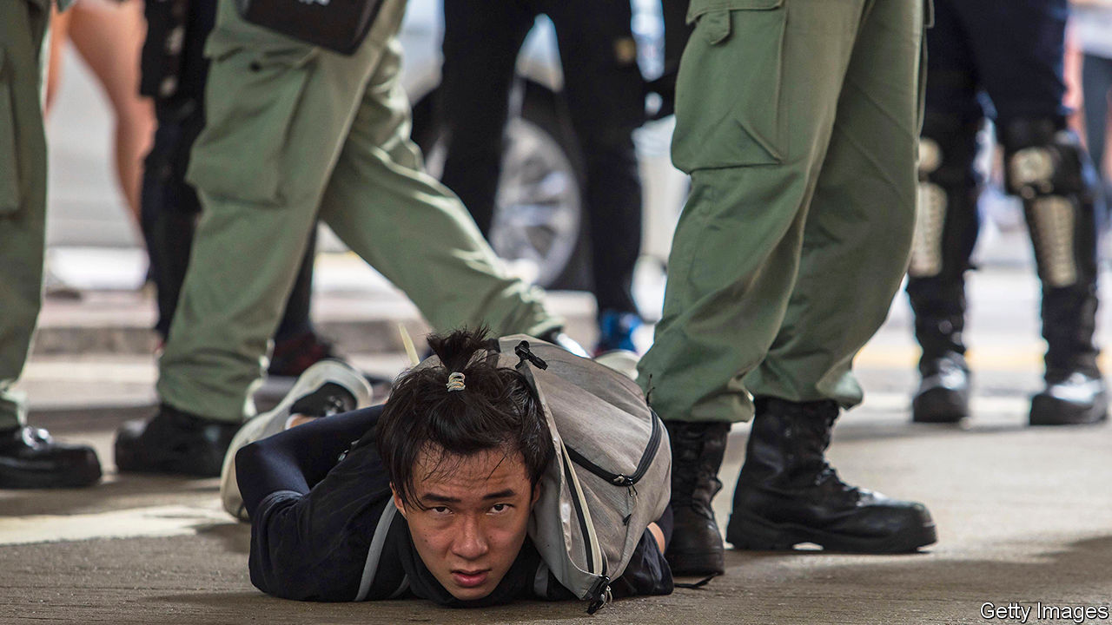

China imposed a draconian national-security law on Hong Kong to crush anti-government unrest. It came into force just before the 23rd anniversary of the city’s handover to China from British rule. Elections to the Legislative Council were postponed; pro-democracy candidates had been expected to do well. Opposition legislators resigned en masse in protest against the disbarring of colleagues. De do do do, de da da da

## De do do do, de da da da

America’s presidential election was a rowdy affair. The Democratic primaries produced a surprise when Pete Buttigieg was declared the winner in Iowa; a delay in the count because of a technical glitch raised more questions about America’s election machinery. Joe Biden cleaned up on Super Tuesday, and went on to win the presidency. Donald Trump, who was acquitted at his impeachment trial in February, resorted to more shenanigans, falsely claiming the result was fraudulent. He will be gone from the White House on January 20th 2021.

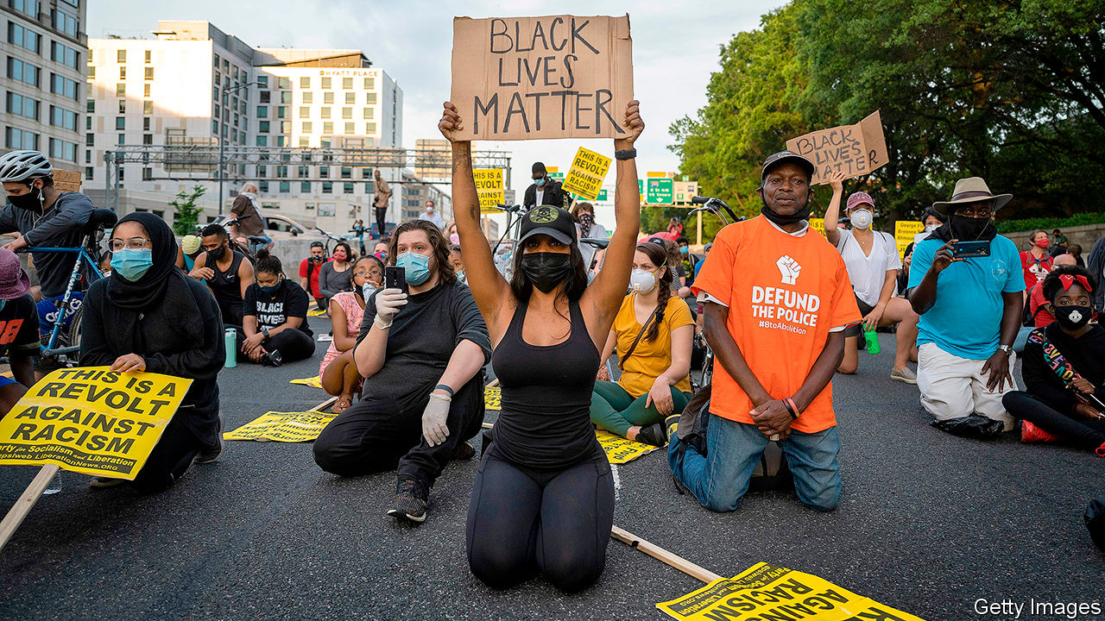

The death of George Floyd, a black man, at the hands of police in Minneapolis sparked the worst unrest across America for decades. Floyd’s cry that he couldn’t breathe to the officer kneeling on his neck reverberated around the world. The incident led to a surge in global support for Black Lives Matter and a reckoning with the legacy of slavery and colonialism. Toppling statues of white men was de rigueur for woke activists in many cities. America endured a summer of protest; notable flashpoints included Kenosha and Portland.

## So lonely

Britain officially left the European Union on January 31st, entering a transition period that ends on December 31st. Talks about a trade deal dragged on. Whatever the outcome, Britons were told to expect delays when visiting the continent from now on. See [article](https://www.economist.com/node/21796292).

Venezuelan troops intercepted two small boatloads of men who wanted to overthrow the country’s dictator, Nicolás Maduro. “Operation Gideon” was led by two former members of America’s special forces. Six of the invaders, a group of deserters and Maduro opponents, were executed.

Western intelligence fingered the Kremlin for trying to assassinate Alexei Navalny, Russia’s main opposition leader. Poisoned by novichok, a nerve agent, Mr Navalny fell ill on a plane and was airlifted to Germany for treatment. He eventually recovered and later called on the EU to impose sanctions on high-ranking Russian oligarchs.

## King of pain

Belarus was thrown into crisis when Alexander Lukashenko won a sixth term as president in another rigged election. Widespread protests were brutally suppressed by state goons, forcing opposition leaders to flee the country.

Israel’s third election in less than a year led to a power-sharing agreement, with Binyamin Netanyahu remaining as prime minister until November 2021. Israel also signed peace deals, brokered by the Trump administration, with the United Arab Emirates, Bahrain, Morocco and Sudan. Other Arab countries may follow.

In other noteworthy elections, Sinn Fein got the most votes at the polls in Ireland but came second in terms of seats. The country got its first-ever coalition government between Fianna Fail and Fine Gael. In Bolivia’s twice-postponed election Luis Arce won the presidency. He is from the left but is viewed as a technocrat.

There was talk of war in the Gulf region after America assassinated Qassem Suleimani, Iran’s foremost general, in a drone strike at Baghdad’s airport in January. Five days later a Ukrainian airliner crashed after taking off from Tehran airport, killing all 176 people on board. Iran’s armed forces later admitted that they had mistaken the plane for a missile and shot it down.

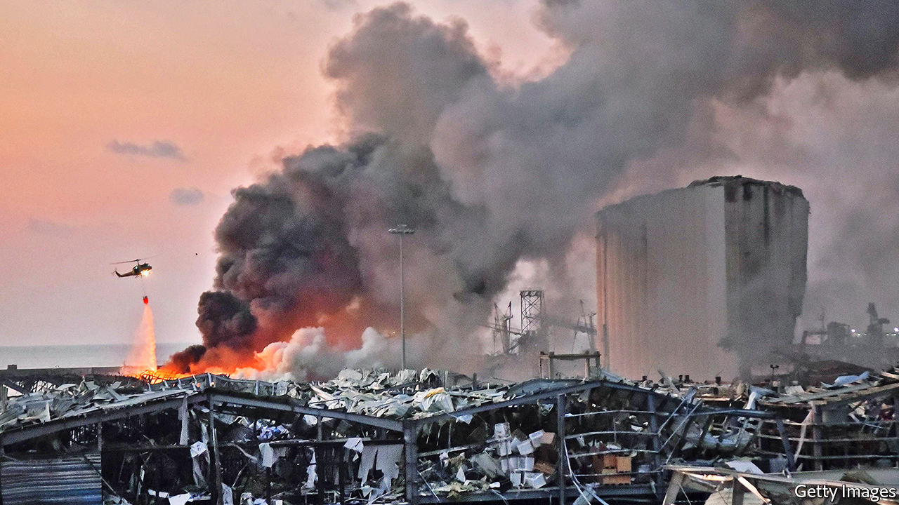

Parts of central Beirut were destroyed by a huge explosion, killing 200 people and injuring 6,500. A fire at the port ignited 2,750 tonnes of ammonium nitrate that had been stored and neglected for seven years. The blast, felt 240km away in Cyprus, led to the resignation of the Lebanese government.

NASA launched astronauts into space from American soil for the first time since the end of the shuttle programme in 2011. It used a SpaceX capsule, a first for a private company putting humans into orbit. China sent a spacecraft to the Moon to collect rocks, which hasn’t been done since the 1970s.

“Parasite”, a South Korean comedy thriller, was the surprise winner at the Oscars. It beat the bookies’ favourite, “1917”, to scoop best picture, the first foreign-language film to do so.

## Synchronicity

The film industry was hit hard by lockdowns, as cinema closures postponed the release of many blockbusters until 2021. Some went straight to streaming. Disney+, the studio’s streaming service, ended the year with 87m subscribers. It wasn’t expecting to reach that number until 2024; it now thinks it may have 260m users in four years’ time. Disney reorganised its content delivery around streaming. See [article](https://www.economist.com/node/21796269).

Africa was declared free from wild polio. The disease is now found only in Afghanistan and Pakistan. There is no cure, but there is a vaccine.

This article was downloaded by calibre from <https://www.economist.com/the-world-this-week/2020/12/16/the-world-this-year>

|  |  |  |  |
| --- | --- | --- | --- |
|  | 文章 | 章节 | 下一项 |

|  |  |  |  |
| --- | --- | --- | --- |
| 上一项 | 文章 | 章节 | 下一项 |

# KAL’s cartoon

Dec 16th 2020 |

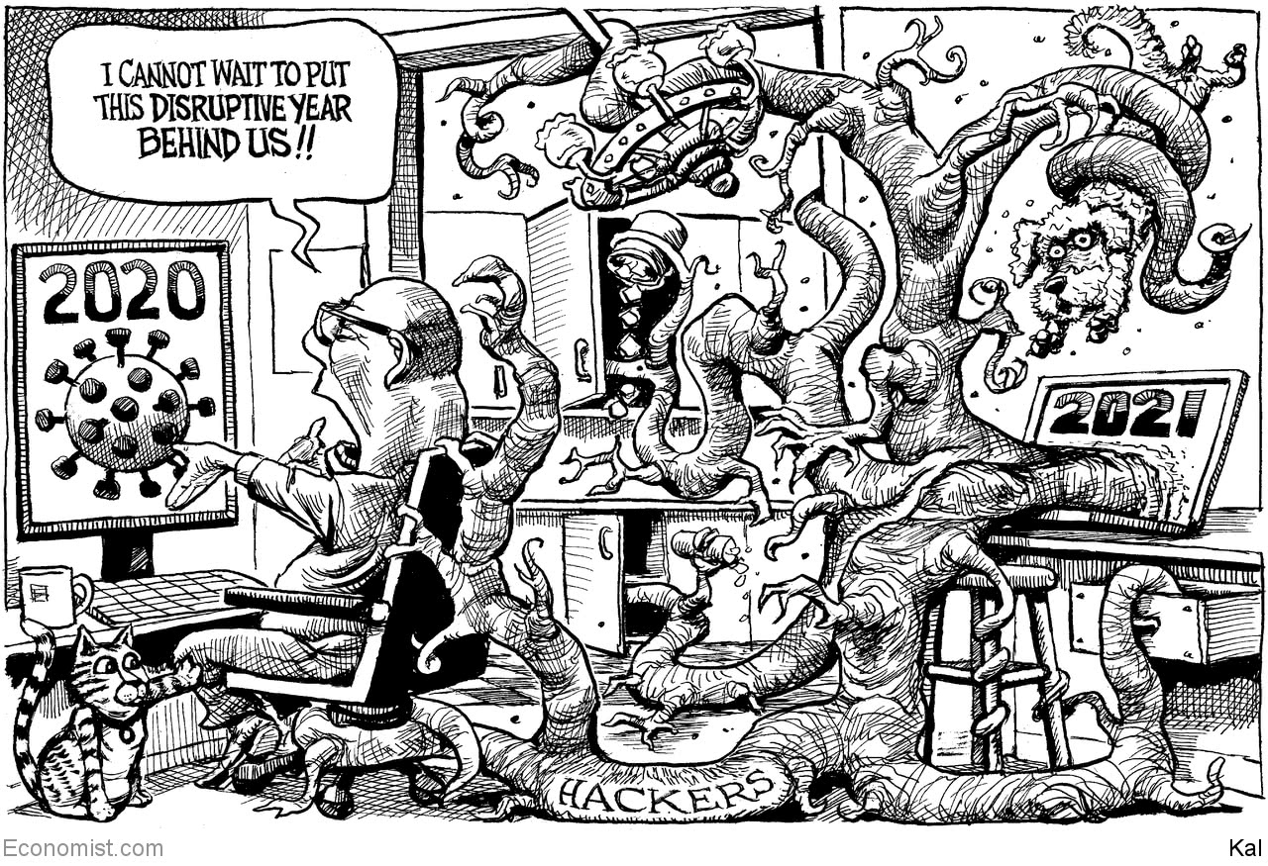

This article was downloaded by calibre from <https://www.economist.com/the-world-this-week/2020/12/16/kals-cartoon>

|  |  |  |  |
| --- | --- | --- | --- |
| 上一项 | 文章 | 章节 | 下一项 |

|  |  |  |
| --- | --- | --- |
| The world this week | 章节 | Letters |

Leaders

Covid-19 in 2020: The plague year

.

Targeting big tech: Credibility gap

.

Children: Getting girlhood right

.

The Arab world: Ten years after the spring

.

Country of the year: Admiration nation

.

|  |  |  |
| --- | --- | --- |
| The world this week | 章节 | Letters |

|  |  |  |  |
| --- | --- | --- | --- |
|  | 文章 | 章节 | 下一项 |

#### Covid-19 in 2020

# The year when everything changed

Why the pandemic will be remembered as a turning-point

Dec 19th 2020 |

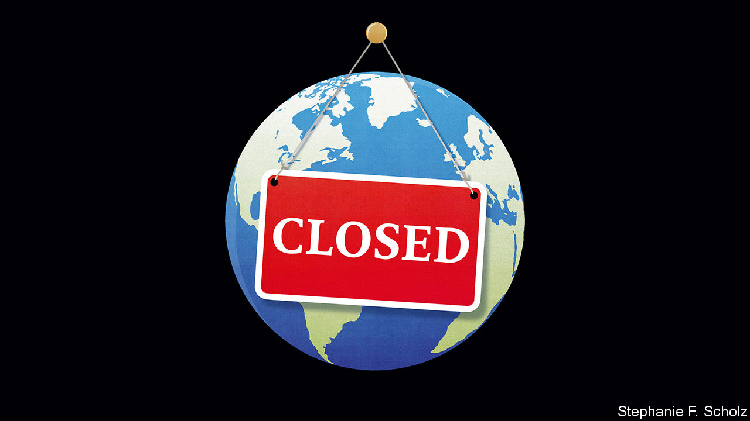

WARREN HARDING built a campaign for the presidential election in 1920 around his new word “normalcy”. It was an appeal to Americans’ supposed urge to forget the horrors of the first world war and the Spanish flu and turn back to the certainties of the Golden Age. And yet, instead of embracing Harding’s normalcy, the Roaring Twenties became a ferment of forward-looking, risk-taking social, industrial and artistic novelty.

War had something to do with the Jazz Age’s lack of inhibition. So did the flu pandemic, which killed six times as many Americans and left survivors with an appetite to live the 1920s at speed. That spirit will also animate the 2020s. The sheer scale of the suffering from covid-19, the injustices and dangers the pandemic has revealed, and the promise of innovation mean that it will be remembered as the year when everything changed.

The pandemic has been a once-in-a-century event (see Graphic detail). SARS-CoV-2 has been found in over 70m people and possibly infected another 500m or more who were never diagnosed. It has caused 1.6m recorded deaths; many hundreds of thousands have gone unrecorded. Millions of survivors are living with the exhaustion and infirmities of “long covid”. World economic output is at least 7% lower than it would otherwise have been, the biggest slump since the second world war. Out of the ashes of all that suffering will emerge the sense that life is not to be hoarded, but lived.

Another reason to expect change—or, at least, to wish for it—is that covid-19 has served as a warning. The 80bn animals slaughtered for food and fur each year are Petri dishes for the viruses and bacteria that evolve into a lethal human pathogen every decade or so. This year the bill came due and it was astronomical. The clear blue skies that appeared as the economy went into lockdown were a powerful symbol of how covid-19 is a fast-moving crisis within a slow-moving one that it in some ways resembles. Like the pandemic, climate change is impervious to populist denials, global in the disruption it causes and will be far more costly to deal with in the future if it is neglected now.

And a third reason to expect change is that the pandemic has highlighted injustice. Children have fallen behind in their lessons—and too often gone hungry. School leavers and graduates have once again seen their prospects recede. People of all ages have endured loneliness or violence at home. Migrant workers have been cast adrift, or sent back to their villages, taking the disease with them. The suffering has been skewed by race. A 40-year-old Hispanic-American is 12 times more likely to die from covid-19 than a white American of the same age. In São Paulo black Brazilians under 20 are twice as likely to die as whites.

As the world has adapted some of these iniquities have got worse. Studies suggest that about 60% of jobs in America paying over $100,000 can be done from home, compared with 10% of jobs paying under $40,000. As unemployment has soared this year, the MSCI index of world stockmarkets has risen by 11%. In the worst case, the UN reckons, the pandemic could force over 200m people into extreme poverty. Their plight will be exacerbated by authoritarians and would-be tyrants who have exploited the virus to tighten their stranglehold on power.

Perhaps that is why pandemics have led to social upheaval in the past. The IMF looked at 133 countries in 2001-18 and found that unrest surged about 14 months after the onset of disease, peaking after 24 months. The more unequal a society, the more upheaval. Indeed, the fund warns of a vicious circle in which protest further increases hardship which, in turn, feeds protest.

Fortunately, covid-19 has not just brought about the need for change, it also points a way forward. That is partly because it has served as an engine of innovation. Under lockdown, e-commerce as a share of American retail sales increased as much in eight weeks as it had in the previous five years. As people worked from home, travel on the New York subway fell by over 90%. Almost overnight, businesses like this newspaper began to be run from spare rooms and kitchen tables—an experiment that would otherwise have taken years to unfold, if ever.

This disruption is in its infancy. The pandemic is proof that change is possible even in conservative industries like health care. Fuelled by cheap capital and new technology, including artificial intelligence and, possibly, quantum computing (see article), innovation will burn through industry after industry. For example, costs at American colleges and universities have increased almost five times faster than consumer prices in the past 40 years, even as teaching has barely changed, making it tempting to disrupters. Further technological progress in renewable sources of energy, smart grids and battery storage are all vital steps on the path to replacing fossil fuels.

The coronavirus has also revealed something profound about the way societies should treat knowledge. Consider how Chinese scientists sequenced the genome of SARS-CoV-2 within weeks and shared it with the world. The new vaccines that resulted are just one stop in the light-speed progress that has elucidated where the virus came from, whom it affects, how it kills, and what might treat it.

It is a remarkable demonstration of what science can achieve. At a time when conspiracies run wild, this research stands as a rebuke to the know-nothings and zealots in dictatorships and democracies who behave as if the evidence for a claim is as nothing next to the identity of the person asserting it.

And the pandemic has led to a burst of innovative government. Those which can afford it—and some, like Brazil’s, that cannot (see article)—have suppressed inequality by spending over $10trn on covid-19, three times more in real terms than in the financial crisis. That will dramatically reset citizens’ expectations about what governments can do for them.

Many people under lockdown have asked themselves what matters most in life. Governments should take that as their inspiration, focusing on policies that promote individual dignity, self-reliance and civic pride. They should recast welfare and education and take on concentrations of entrenched power so as to open up new thresholds for their citizens. Something good can come from the misery of the plague year. It should include a new social contract fit for the 21st century. ■

Editor’s note: Some of our covid-19 coverage is free for readers of The Economist Today, our daily [newsletter](https://my.economist.com/user#newsletter). For more stories and our pandemic tracker, see our [hub](https://www.economist.com/news/2020/03/11/the-economists-coverage-of-the-coronavirus)

This article was downloaded by calibre from <https://www.economist.com/leaders/2020/12/19/the-year-when-everything-changed>

|  |  |  |  |
| --- | --- | --- | --- |
|  | 文章 | 章节 | 下一项 |

|  |  |  |  |
| --- | --- | --- | --- |
| 上一项 | 文章 | 章节 | 下一项 |

#### Taming big tech

# America and Europe clamp down on big tech

Trustbusters say they are going after the tech giants. Markets don’t take them seriously

Dec 19th 2020 |



FIVE YEARS ago antitrust was a backwater. In America complacent trustbusters had failed to spot the rise of big tech firms. In the European Union they noticed it, but didn’t do much. But the competition cops have at last sprung. On December 15th the EU unveiled two draft digital-services laws that would create a sweeping supervisory apparatus to control Silicon Valley. In America the federal government has just launched antitrust cases against Google and Facebook. These moves mark the biggest shift in competition policy in a generation, so you might expect investors to be worried that big tech firms are under serious threat. Instead, their reaction has been Olympian indifference. The market value of the five biggest Silicon Valley firms has risen by 46% in 2020, to reach $7.2trn. Antitrust’s credibility deficit reflects a lack of transatlantic unity and the flaws of two very different strategies.

In America the chances of new laws being passed are low because of a gridlocked Congress and because some politicians think that having dominant American tech firms is a strategic advantage in the contest with China. Instead, trustbusters have to demonstrate in court that the tech firms have broken existing laws. The case against Google is more likely to succeed—it focuses on a web of $10bn or more in annual payments made by Google to Apple and manufacturing firms to ensure that its services got prominence on device screens. The case against Facebook argues that it illegally acquired WhatsApp and Instagram to kill off competition; this is more of a stretch, because both were small firms at the time. Do not expect any decisions soon. Microsoft’s antitrust case began in 1998 and took six years to resolve. Recently the courts have been sceptical of big antitrust suits, including those against American Express and AT&T Time Warner.

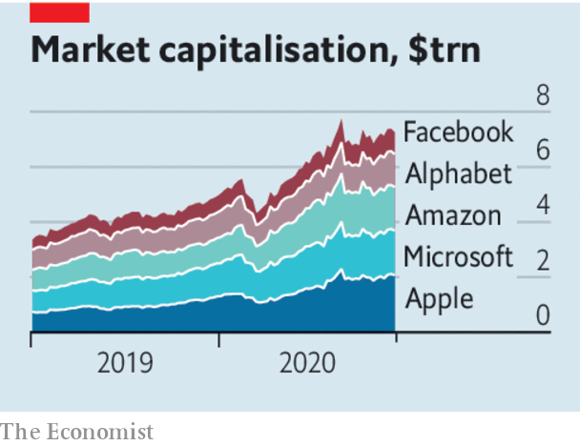

If America’s strategy is narrow and backward-looking, the EU’s is broad and forward-looking. It tends to put more faith in regulation—and does not have any home-grown tech giants to worry about. Big tech firms will be designated as systemically important, and in some cases as “gatekeepers” too, and face obligations over data, content and the treatment of other firms which use their platforms. The danger is that an ill-defined and sprawling regime muffles dynamism and entrenches incumbents. Yet even if the EU eventually passes new laws, it may have problems enforcing them. The five biggest tech firms make 25% of their sales in Europe, versus 51% in America, and may prefer to run their European arms under local rules, rather than adopt EU policy globally. The maximum fine the EU is contemplating is just 1% of big tech’s market value. It is hard to imagine how the EU could break up an American company on its own.

On paper it is possible to pick the best of both approaches. The goal should be to catalyse competition, rather than accept monopolies and mitigate their cost through regulation. Prising open closed markets should be the priority: America’s trustbusters are right to focus on the ways in which Google and others have locked out competitors. Taking a sceptical line on future acquisitions by big tech firms is essential, too. America should copy the EU’s effort to give individuals power over their data, which could also help unlock competition. Last, both sides should agree that policing content—for example, fake news—is a matter for media policy, not trustbusters.

Yet transatlantic agreement is far off. And, complicating things further, parts of the industry are getting more competitive even amid the howls to tame “big tech”. Trustbusters should worry about products where market shares are high, profits are suspiciously plump and new entrants are thin on the ground. Search and online advertising fit this description, but large areas of tech look increasingly contested, including streaming, e-commerce and the cloud—and often the competition is coming from other big tech firms. They, not the transatlantic trustbusters, are more likely to change the weather. ■

This article was downloaded by calibre from <https://www.economist.com/leaders/2020/12/19/america-and-europe-clamp-down-on-big-tech>

|  |  |  |  |
| --- | --- | --- | --- |
| 上一项 | 文章 | 章节 | 下一项 |

|  |  |  |  |
| --- | --- | --- | --- |
| 上一项 | 文章 | 章节 | 下一项 |

#### Getting girlhood right

# Covid-19 threatens girls’ gigantic global gains

Countries must work harder to safeguard progress

Dec 19th 2020 |



FOR MUCH of human history and in many places, girls were considered property. Or, at best, subordinate people, required to obey their fathers until the day they had to start obeying their husbands. Few people thought it worthwhile to educate them. Even fewer imagined that a girl could grow up to govern Germany, run the IMF or invent a vaccine.

In most of the world that vision of girlhood now seems not merely old-fashioned but unimaginably remote. In much of the rich world parents now treat their daughters as well as they do their sons, and invest as much in their future (see Essay). In field after field girls have caught up with boys. Globally, young women now outnumber young men at university. The speed of change has been blistering. Fifty years ago only 49% of primary-school-age girls in lower-middle-income countries were in school, compared with 71% of boys; today the share of both is about 90%. In 1998 only half the world’s secondary-school-age girls were enrolled; today two-thirds are. Over the same period rates of illiteracy fell from one in five young women aged 15-24 to one in ten, bringing them roughly on a par with young men.

Girl babies are more wanted than ever before. Parents in some countries prefer them. Even in places, such as China, where the sex-selective abortion of girl fetuses has been rife, it is often becoming less so. Girls are also less likely to be married off in childhood. In 1995 almost six in ten girls in South Asia were hitched before reaching 18; that ratio has fallen by half. Around the world, it has fallen from one in four to one in five.

Girls are healthier, too. Compared with the mid-1990s, they become sexually active later and are more likely to use contraception. Rates of teenage pregnancy have fallen by a quarter globally and by two-thirds in South Asia and North America. Girls are less likely to suffer female genital mutilation—and object to this horrific tradition more vocally. Whereas in 2000 just 27% of women and girls in the most-affected regions said it should be banned, today 54% do.

When societies handle girlhood well, the knock-on effects are astounding. A girl who finishes secondary school is less likely to become a child bride or a teenage mother. Education boosts earning power and widens choices, so she is less likely to be poor or to suffer domestic abuse. She will earn almost twice as much as a girl without schooling.

And she will pass on a smorgasbord of advantages to her offspring. She will have fewer children, and invest more in them. They will be less likely to die in infancy, or to grow up stunted physically or mentally. She will read to them more, and help them with their homework. All this means they will learn more, and earn more as adults. A recent study by Citigroup and Plan International estimated that, if a group of emerging economies ensured that 100% of their girls completed secondary school, it could lead to a lasting boost to their GDP of 10% by 2030.

Because the benefits of nurturing girls are so large, it is a scandal that some countries have still failed to grasp them. Less than half the girls in South Asia, the Middle East or Africa have access to the contraception that they may want. Only one girl in three south of the Sahara finishes her secondary education. And although rates of child marriage have fallen by half in South Asia, they have fallen by less than that in Africa (which now has the highest rate in the world) and have remained stagnant in Latin America and the Caribbean.

The covid-19 pandemic could hobble progress for girls in poor countries, or even reverse it. During previous disasters, they have often suffered most. When Ebola forced west African schools to close in 2014, many girls dropped out, never went back and ended up pregnant or as child labourers. UNICEF warns that something similar could happen with covid-19—but on a larger scale. Studies suggest that in the next decade 13m child marriages that would have been averted may go ahead, and an extra 2m girls may have their genitals cut.

The risk of regression is real. So it is crucial that, even if governments of poor countries have to tighten their belts, they prioritise spending on education and girls. Donors should help, too. And policies should be joined up. Persuading girls to stay in school longer is not only a way to teach them maths; it is also a chance to vaccinate them and teach them about birth control, consent and self-assertion. It can even be an opportunity to advise parents about the downsides of child marriage.

Adolescence is a crucial juncture for girls. It is when many health problems emerge or are averted; and many social ones, too, from truancy to self-harm. Only recently has this phase been recognised as the most important for brain development after infancy. Get it right and billions of girls will have a better shot at fulfilling their potential. Get it wrong and they will live poorer, shorter lives, less able to stand up for themselves, more vulnerable to coercion, and more likely to pass these disadvantages on to the next generation. So, get girlhood right. ■

This article was downloaded by calibre from <https://www.economist.com/leaders/2020/12/19/covid-19-threatens-girls-gigantic-global-gains>

|  |  |  |  |
| --- | --- | --- | --- |
| 上一项 | 文章 | 章节 | 下一项 |

|  |  |  |  |
| --- | --- | --- | --- |
| 上一项 | 文章 | 章节 | 下一项 |

#### Ten years after the Arab spring

# Why democracy failed in the Middle East

And how it might, one day, succeed

Dec 19th 2020 |

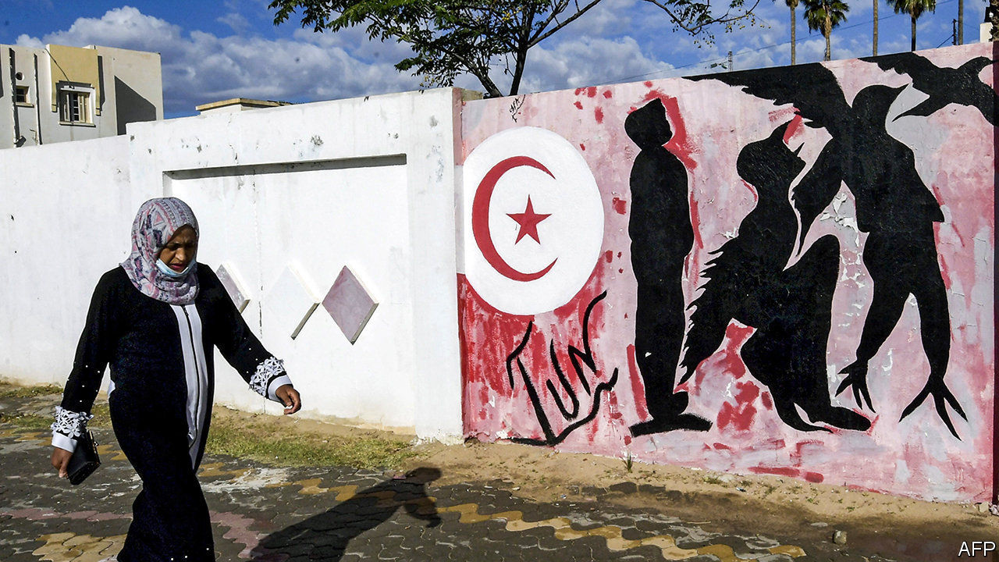

“WHAT KIND of repression do you imagine it takes for a young man to do this?” So asked Leila Bouazizi after her brother, Muhammad, set himself on fire ten years ago. Local officials in Tunisia had confiscated his fruit cart, ostensibly because he did not have a permit but really because they wanted to extort money from him. It was the final indignity for the young man. “How do you expect me to make a living?” he shouted before dousing himself with petrol in front of the governor’s office.

His actions would resonate across the region, where millions of others had reached breaking-point, too. Their rage against oppressive leaders and corrupt states came bursting forth as the Arab spring. Uprisings toppled the dictators of four countries—Egypt, Libya, Tunisia and Yemen. For a moment it seemed as if democracy had arrived in the Arab world at last.

A decade later, though, no celebrations are planned (see article). Only one of those democratic experiments yielded a durable result—fittingly, in Bouazizi’s Tunisia. Egypt’s failed miserably, ending in a military coup. Libya, Yemen and, worst of all, Syria descended into bloody civil wars that drew in foreign powers. The Arab spring turned to bitter winter so quickly that many people now despair of the region.

Much has changed there since, but not for the better. The Arab world’s despots are far from secure. With oil prices low, even petro-potentates can no longer afford to buy their subjects off with fat subsidies and cushy government jobs. Many leaders have grown more paranoid and oppressive. Muhammad bin Salman of Saudi Arabia locks up his own relatives. Egypt’s Abdel-Fattah al-Sisi has stifled the press and crushed civil society. One lesson autocrats learned from the Arab spring is that any flicker of dissent must be snuffed out fast, lest it spread.

The region is less free than it was in 2010—and perhaps more angry. It has been shaken by wars, jihad, refugees and covid-19. Activists contend that Arabs are no longer willing to put up with the same old misery, and say they are more confident that they can bring about change. The Arab spring’s flame never completely went out, says one. No fancy name was given to the swathe of protests that engulfed Arab countries in 2019, yet they pushed out as many leaders as those of the Arab spring.

Unfortunately, the states that were jolted in 2019—Algeria, Iraq, Lebanon and Sudan—are faring only a little better than those convulsed by the Arab spring. Could it be true, as some argue, that Arabs simply cannot abide democracy? Some lament that the region’s generals are too politically entrenched to allow a real opening. Others say that austere local strains of Islam are incompatible with pluralism. Is Tunisia, blessed with pragmatic Islamists and generals who have apparently learned to obey elected politicians, the exception that proves the rule?

It is too early to say. The seeds of modern democracy have yet to be properly sown in the Arab world. The thirst among Arab citizens to choose their own rulers is as strong as it is elsewhere. What they need most is for independent institutions—universities, the media, civic groups, above all the courts and the mosques—to evolve without being in thrall to government. Only then can space be found for an engaged and informed citizenry. Only then are people likely to accept that political disputes can be resolved peacefully.

It would help if Arabs had more freedom to debate. Schools in the region tend to emphasise rote learning over critical thinking. The media and the mosques tend to parrot the government line. Autocrats seek to co-opt social media, too. All this breeds distrust in information itself. Conspiracy theories abound. Arabs tend to mistrust not only their governments but also each other, thanks in part to a system that requires bribes and wasta, or connections, to accomplish even the most mundane tasks. Corruption undermines confidence in the state. Few expect it to provide for the common good. Despots encourage people to think of politics in zero-sum terms: if another group wins power, they will grab all the money and public jobs. Opponents are portrayed as extremists who wish their fellow countrymen dead.

In such parched soil, it is unsurprising that democracy failed to take root. But there are ways, in the long run, to fertilise it. Promoting education is vital. Democracies should welcome more Arab students. They should also speak up for Arab journalists, human-rights campaigners and NGOs. A culture of pluralism takes time to grow. But the status quo is unstable and unsustainable, as a frustrated fruit-seller tragically demonstrated. ■

This article was downloaded by calibre from <https://www.economist.com/leaders/2020/12/19/why-democracy-failed-in-the-middle-east>

|  |  |  |  |
| --- | --- | --- | --- |
| 上一项 | 文章 | 章节 | 下一项 |

|  |  |  |  |
| --- | --- | --- | --- |
| 上一项 | 文章 | 章节 | 下一项 |

#### Admiration nation

# Which is The Economist’s country of the year?

The most-improved country is one where people stood up for democracy

Dec 19th 2020 |



IN MOST YEARS most countries improve in various ways. In 2020, however, premature death and economic contraction became the new normal, and most countries aspired only to dodge the worst of it. Inevitably, our shortlist of most-improved countries includes some that merely avoided regressing much.

Few people would argue that life in New Zealand was better in 2020 than in 2019. But the virus has been contained. When only 100 cases had been detected, the prime minister, Jacinda Ardern, closed the borders, locked down the country and urged its “team of 5m” (ie, the whole population) to be kind to each other. Only 25 Kiwis have died and life has more or less returned to normal. Rugby stadiums finished the season packed with fans. The amiable Ms Ardern was re-elected with a majority in a country where such things are almost unheard of.

Taiwan has done even better, with only seven deaths and a far stronger economic performance. Leave aside whether Taiwan is a country or merely a contender for “de facto self-governing territory of the year”. It kept the virus at bay without closing schools, shops or restaurants, much less imposing lockdowns. Its economy is one of the few expected to have grown in 2020. It also showed courage, refusing to back down despite relentless threats from Beijing. China’s government often says that Taiwan must be reunited with the mainland. It has been sending warships and fighter jets ever closer to the island, ever more often. Yet in January Taiwanese voters spurned a presidential candidate who favoured warmer ties with China and re-elected Tsai Ing-wen, whose government has been sheltering democracy activists from Hong Kong. Taiwan is a constant reminder that Chinese culture is perfectly compatible with liberal democracy.

These achievements are impressive. However, the pandemic is not yet over and to judge a country on its covid-fighting record is to focus on specific forms of good governance when circumstances of geography and genes make comparisons hard. Being an island helps. Some populations may have immunity to coronaviruses. So it is worth considering other candidates.

The United States did almost as badly as Britain, Italy and Spain in its response to covid-19, but its Operation Warp Speed was central to bringing about a vaccine in record time. And by rejecting President Donald Trump in November, American voters did their bit to curb the spread of populism—another global scourge. Mr Trump’s efforts to overturn the will of those voters were unprecedented for a sitting president, but the judges he appointed were loyal to the law, not the man who picked them.

Voters in Bolivia, too, restored a measure of normality. After a fraud-tainted election, the overthrow of a socialist president, violent protests and the vengeful, incompetent rule of an interim president, the Andean nation held a peaceful re-run ballot in October and picked a technocrat, Luis Arce.

But this year’s prize goes to a country in southern Africa. Democracy and respect for human rights regressed in 80 countries between the start of the pandemic and September, reckons Freedom House, a think-tank. The only place where they improved was Malawi.

To appreciate its progress, consider what came before. In 2012 a president died, his death was covered up and his corpse flown to South Africa for “medical treatment”, to buy time so that his brother could take over. That brother, Peter Mutharika, failed to grab power then but was elected two years later and ran for re-election. The vote-count was rigged with correction fluid on the tally sheets. Foreign observers cynically approved it anyway. Malawians launched mass protests against the “Tipp-Ex election”. Malawian judges turned down suitcases of bribes and annulled it. A fair re-run in June booted out Mr Mutharika and installed the people’s choice, Lazarus Chakwera. Malawi is still poor, but its people are citizens, not subjects. For reviving democracy in an authoritarian region, it is our country of the year. ■

This article was downloaded by calibre from <https://www.economist.com/leaders/2020/12/19/which-is-the-economists-country-of-the-year>

|  |  |  |  |
| --- | --- | --- | --- |
| 上一项 | 文章 | 章节 | 下一项 |

|  |  |  |
| --- | --- | --- |
| Leaders | 章节 | United States |

Letters

Letters to the editor: On farming, books, aerial combat, Latin, Machiavelli, diversity, Ireland, the turkey

.

|  |  |  |
| --- | --- | --- |
| Leaders | 章节 | United States |

|  |  |  |  |
| --- | --- | --- | --- |
|  | 文章 | 章节 | 下一项 |

#### On farming, books, aerial combat, Latin, Machiavelli, diversity, Ireland, the turkey

# Letters to the editor

A selection of correspondence

Dec 19th 2020 |

Letters are welcome via e-mail to letters@economist.com

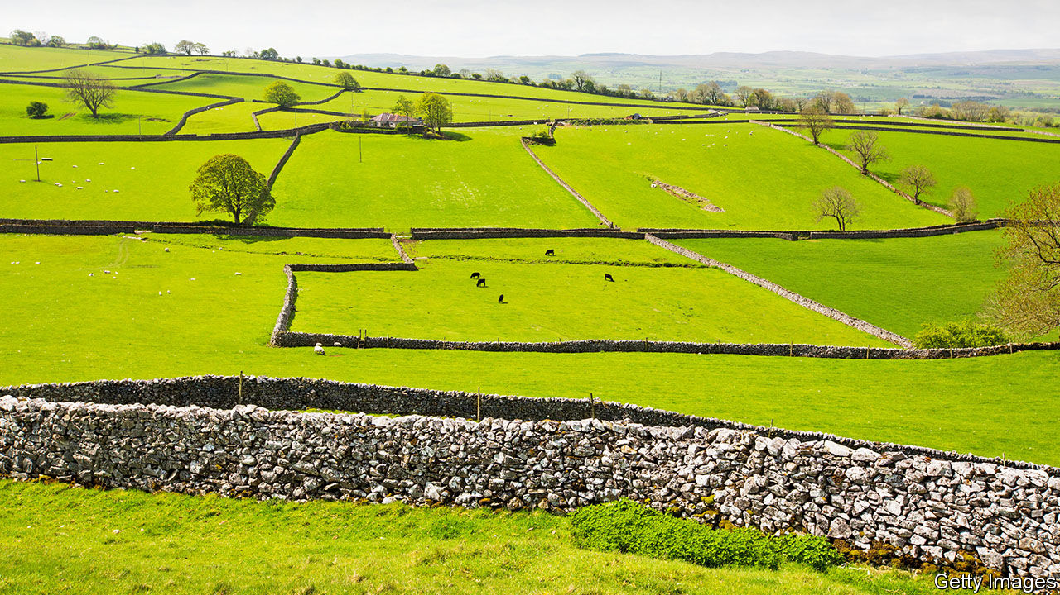

## Brexit lays an egg

Your leader on British farming and food standards after Brexit underplayed the role of international agritrade policy (“Ploughing its own furrow”, [November 28th](https://www.economist.com/leaders/2020/11/28/british-farming-after-the-common-agricultural-policy)). Take your example of free-range eggs. British consumers can buy them in confidence now because of high EU and British standards. A tariff on eggs and egg products protects the market from imports that are marked as free range but are of a lower standard. In America, for example, an egg can be marketed as free-range as long as the hen house has one pophole; there is no definition as to what counts for a “range” or outside area for the hens, drastically reducing the cost. A British hen house will have, say, 20 popholes depending on the size of a flock. Without a tariff, lower-priced American imports would bankrupt British free-range egg farmers.

Your supposition that British consumers would prefer to buy the more expensive British free-range eggs over cheap imported ones has already been disproved in the example of pig meat. In the 1990s Britain banned sow stalls ahead of the rest of the EU, adding considerable cost to the production of domestic pig meat products. The government thought consumers would favour more expensive, higher welfare British pork, but instead they turned to cheaper pork from Denmark and the Netherlands. Half the British pig industry was exported overnight, a loss to the economy, and pig welfare.

ROBERT GOOCH  
Chief executive  
British Free Range Egg Producers Association  
Saxmundham, Suffolk

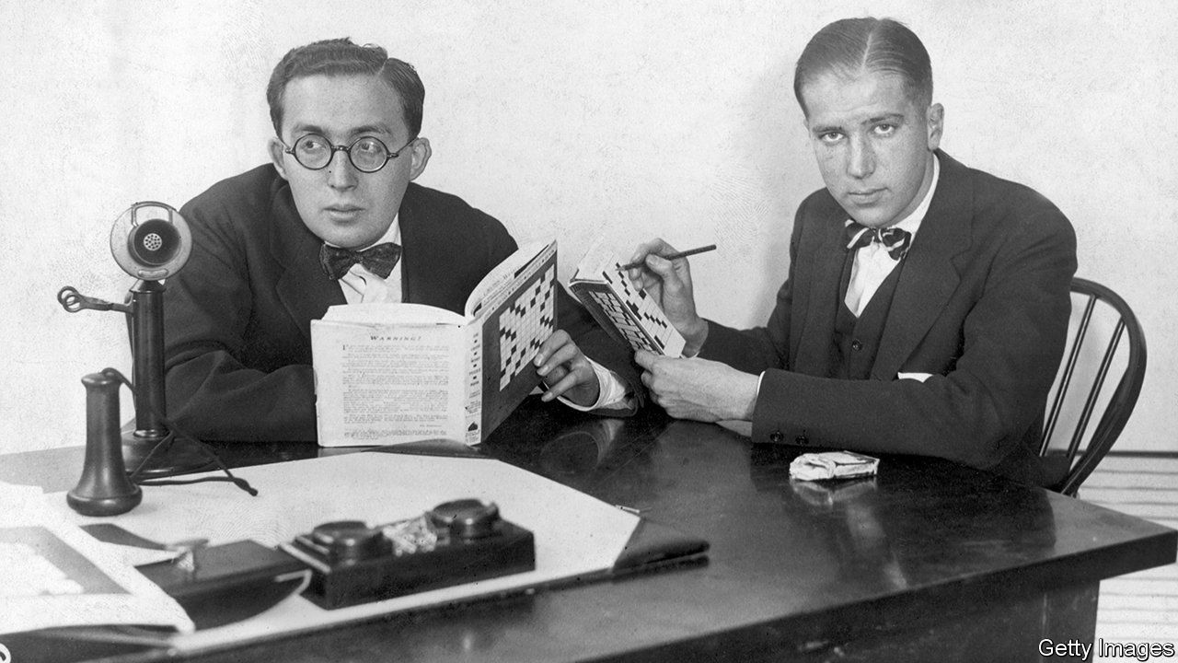

## The plot thickens

With all due respect, Simon & Schuster (“Book-binding”, [November 28th](https://www.economist.com/business/2020/11/26/bertelsmann-snaps-up-simon-and-schuster)) was not even close to representing Scott F. Fitzgerald, Ernest Hemingway, and Thomas (not Tom) Wolfe. That honour belonged to Scribner’s. Simon & Schuster merely acquired Scribner’s when it bought Macmillan in 1994 (Macmillan had merged with Scribner’s). Fitzgerald, Hemingway and Wolfe died decades before.

BOB POWELL  
Birmingham, Michigan



## Life in the old dogfight yet

A dogfight in aerial combat is known as “basic fighter manoeuvring”, or BFM, within the profession (“Virtual mavericks”, [November 21st](https://www.economist.com/science-and-technology/2020/11/19/fighter-aircraft-will-soon-get-ai-pilots)). Guns are no longer used, but a missile shot within visual range after the point at which two fighters pass each other and the manoeuvring that follows is in fact a dogfight.

Throughout the history of combat aviation many have said that the dogfight is dead, and have been proved wrong. In Vietnam it was because the missiles were unreliable. In the future it may be stealth, electronic warfare, or strict rules of engagement that prevent a shot beyond visual range against a target. America’s shooting down of a Syrian SU-22 in 2017 may not be a true dogfight to some, but it was conducted within visual range with extensive manoeuvring. The pilot, a graduate of the US navy’s TOPGUN, employed his BFM skills that day.

You also noted that an autonomous aircraft cannot explain what it did and why. The role of briefing and debriefing in combat aviation cannot be understated, and until this gap is addressed it limits what we can expect from robot wingmen.

BRIAN ROLLER  
Honolulu

## Latin lesson

Very clever to take Christopher Wren’s epitaph and repurpose it for the Arecibo radio telescope (“Si monumentum requiris respicite”, [November 28th](https://www.economist.com/science-and-technology/2020/11/25/with-the-death-of-arecibo-an-era-ends-for-radio-astronomy)), inviting us to look back, respicere, rather than around, circumspicere. And very astute to modify the imperative to address a presumed plurality of readers (respicite) instead of the original’s solitary visitor to St Paul’s (circumspice).

But perplexing that you failed to address the other verb (requiris) to all your readers as well (requiritis). The Economist’s wordplay department risks being seen as too clever by exactly half.

BOB LADD  
Edinburgh

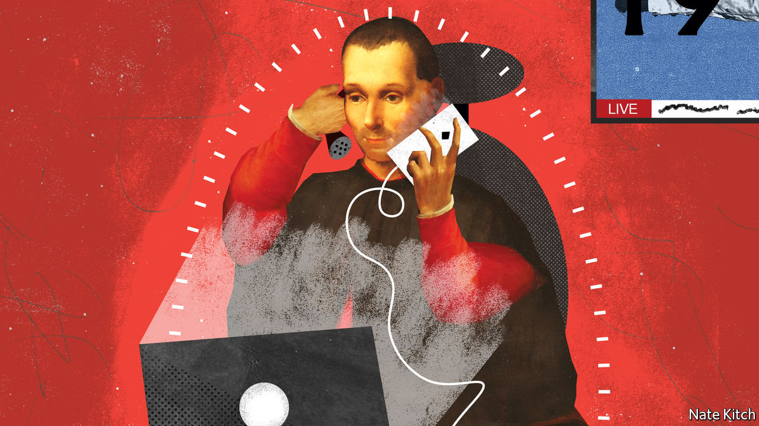

## If you want my advice

Bagehot’s search of a modern Machiavelli for Boris Johnson is timely ([November 21st](https://www.economist.com/britain/2020/11/21/in-search-of-a-modern-machiavelli)). Machiavelli’s “The Prince” advises a leader how to act. Machiavelli, who suffered two turns on the rack for his guidance, compares Fortune to a violent river that causes havoc when enraged. When the river is quiet, a leader needs to protect himself by building embankments, dykes and canals. A leader who does not take these precautions is at the mercy of Fortune, but if he prepares and adapts, he prospers. Mr Johnson did not prepare for the pandemic, has not built defences against the potential havoc of Brexit, and the protections against climate change are as yet just words.

DUNCAN STEPHENSON  
Leeds

Bagehot’s list of Boris Johnson’s traits inadvertently places him alongside such familiar British characters as Mr Micawber, Derek Trotter and Arthur Daley.

ANDY CHEW  
Little Gaddesden, Hertfordshire

Sitting in South Asia I feel obliged to point out that Kautilya, the Indian Machiavelli, wrote “Arthashastra”, his science of politics, around 1,800 years before “The Prince”. As Roger Boesche noted in the preface to “The First Great Political Realist”, Kautilya makes Machiavelli seem mild. For example, whereas Machiavelli only cursorily examines the topic of assassination and gives no advice about spies, arrest on suspicion, and torture, Kautilya discusses all these issues at length.

JOHN CROCKER  
Colombo, Sri Lanka

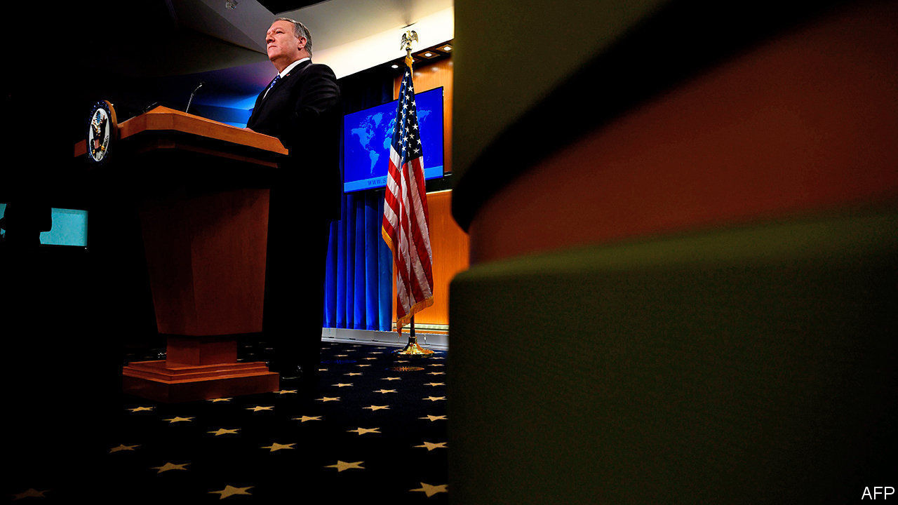

## Employ more conservatives

America’s State Department has an obvious diversity problem by employing too many white males (“Altered state”, [November 21st](https://www.economist.com/united-states/2020/11/21/two-new-reports-provide-a-road-map-for-reforming-american-diplomacy)). But the not so obvious problem is a lack of diverse political opinion. One would be hard-pressed to find any significant percentage of Republicans in its ranks, let alone a number like 48%, which more accurately represents the politics of America. This blind spot has left the department vulnerable to changing administrations and ineffective in implementing policy that is often at odds with its staff’s core beliefs.

RICHARD WALKER  
Dubuque, Iowa

## Spuds they like

Ireland’s cuisine is heavy on potatoes, explains Charlemagne ([November 21st](https://www.economist.com/europe/2020/11/21/life-beyond-europes-rainbow-curtain)). That is understating it. Where else in Europe, nay, the world, can you find a theme park based on the potato chip?

ALAN FINLAYSON  
Düsseldorf

## Talking turkey

There is a very intriguing bit of etymological happenstance for the word “turkey” (World in a dish, 1843, [November 18th](https://www.economist.com/1843/2020/11/18/the-thanksgiving-turkey-is-actually-an-immigrant-where-does-it-come-from)). In Arabic, a turkey, deek rumi, is the literal translation of “roman chicken”. The turkey made its way into the Arab lexicon and kitchens long after the Roman Empire had met its end. What the literal translation misses is that “Roman” throughout various Arab and Muslim empires had generally become a lexical stand in for Christian, the implication being that a turkey is a chicken from some Christian parts of the world.

TIMOTHY PATTEN  
Chicago

This article was downloaded by calibre from <https://www.economist.com/letters/2020/12/19/letters-to-the-editor>

|  |  |  |  |
| --- | --- | --- | --- |
|  | 文章 | 章节 | 下一项 |

|  |  |  |
| --- | --- | --- |
| Letters | 章节 | The Americas |

United States

The final Senate races: The decider

.

Covid-19 in New York: The Holly and the UV

.

Cyber-security: Bear hunt

.

Schools and covid-19: Lesson learned

.

Lexington: Good neighbours

.

|  |  |  |
| --- | --- | --- |
| Letters | 章节 | The Americas |

|  |  |  |  |
| --- | --- | --- | --- |
|  | 文章 | 章节 | 下一项 |

#### The decider

# Georgia’s run-offs could decide Donald Trump’s future—and the Senate

The elections will test how people vote when Mr Trump is not on the ballot

Dec 19th 2020 | CONYERS AND HARTWELL

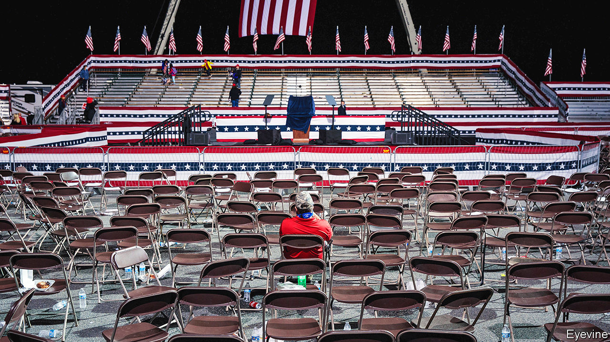

COVID-19 HAS led to many innovations. In America one has been the drive-in political rally. On December 5th the two Democratic Senate candidates in Georgia, Jon Ossoff and Raphael Warnock, held one such event in Rockdale County, a fast-growing suburb of Atlanta where Joe Biden won almost 70% of the vote. Most of those attending listened to the speeches from their cars, honking enthusiastically rather than clapping. Despite the protection of their windscreens, almost everyone in the multiracial crowd wore masks. The candidates discussed health care, jobs, justice and, of course, what to do about the virus.

Republicans have not embraced this innovation. Four days later David Perdue, Mr Ossoff’s Republican opponent, held his event in Hartwell, the seat of a small rural county on the South Carolina border where Donald Trump won almost 75% of the vote. Mr Perdue’s rally was indoors, and although most of the crowd was elderly and covid-19 has ravaged the county, few wore masks. The crowd, which was entirely white, sat quietly as Mr Perdue warned that he was the bulwark against Democrats controlling government and implementing a “socialist agenda” that included “open borders” and “defund[ing] the police”.

In November, Mr Biden became the first Democratic presidential candidate to win Georgia since 1992. On December 14th, after a month of ever more ludicrous lawsuits by Mr Trump’s allies, the electoral college confirmed Mr Biden’s victory nationwide. But his ability to govern effectively hinges on the state’s two Senate seats. Both are up for grabs on January 5th in two run-off elections, which Georgia holds when no candidate reaches 50% in the first round. If the Democrats can win both, they will have 50 Senate seats—enough, with the vice-president as the tie-breaker, to hold a majority.

In November Mr Perdue, first elected to the Senate six years ago, fell 0.3% short, but still finished nearly two points ahead of Mr Ossoff. In the other race—a special election to fill two years remaining in the term of Johnny Isakson, who retired for health reasons—Mr Warnock finished top of a crowded pack, but with just 32.9%. He faces Kelly Loeffler, appointed by Georgia’s governor, Brian Kemp, in December 2019, who came top out of six Republicans. Early voting began on December 14th.

In both races, one candidate is clearly stronger. In the main election Mr Perdue has the advantages of incumbency, staunch loyalty to Mr Trump, a folksy manner and a famous name—his cousin Sonny was Georgia’s first Republican governor since Reconstruction. He is the only one of the four candidates who has ever won a general election. Mr Ossoff is a rousing speaker, but he often sounds like a Barack Obama impersonator. He runs a media firm and, at the age of just 30, ran unsuccessfully for Congress three years ago.

In the special election, by contrast, it is Mr Warnock who has the more compelling story. Brought up in public housing in Savannah, he earned a doctorate in theology, and in 2005 became the youngest-ever senior pastor at Ebenezer Baptist Church, where Martin Luther King junior and senior preached. Decades in the pulpit have made him practised on the stump, whereas his opponent, Ms Loeffler, is awkward, robotic even. She has spent the campaign attacking Mr Warnock as a “radical liberal” (a phrase she repeated at least a dozen times during a debate on December 6th).

Polls show that both races are tight. But Democrats like their chances. Atlanta and its surrounding area have been growing—thanks in part to migration, particularly of African-American professionals, from other parts of America—as Georgia’s more conservative rural population has declined. Activists led by Stacey Abrams, the former state House minority leader, have spent the past decade registering young and non-white voters.

And the Republicans are at each other’s throats. Mr Trump reckons Mr Kemp is a “fool” who let the election be stolen. Ms Loeffler and Mr Perdue have called on the Republican secretary of state to resign, apparently for not throwing out the vote. Two hard-right lawyers, Lin Wood and Sidney Powell, have been urging Trump supporters not to “vote in another rigged election” on “another machine made by China”. If some of Mr Trump’s most enthusiastic supporters stay away, it will hurt Mr Perdue’s and Ms Loeffler’s chances.

The two also face scandals of their own. Both have been investigated by the Justice Department over allegations that they profited from insider information gleaned from congressional briefings (neither was charged and both deny wrongdoing).

Yet it may not be enough for the Democrats. Republicans rarely lose run-off races, because Democrats are less likely to turn out in non-presidential elections than Republicans. Though he failed to break 50%, Mr Perdue got a slightly higher share of the vote than Mr Trump in November. The combined share of the Republicans in Ms Loeffler’s race was only slightly lower. Messrs Ossoff and Warnock have been pitching their victories as essential to Mr Biden’s success. But that will succeed only if a critical mass of the suburban voters who propelled Mr Biden to victory are now reliable Democrats who want to see his agenda enacted, rather than Republicans who voted against Mr Trump but would prefer divided government.

As well as control of the Senate, the outcome may determine Mr Trump’s status in the Republican Party. Both Republicans have stuck fast to the president despite his loss, and in defiance of the state’s other elected Republican officials. If they win, it will show the enduring appeal of Trumpism to Republican voters. A win for two unabashedly progressive Democrats, however—particularly if Republicans cannot win back some suburban voters—will show Trumpism’s limits and usher its progenitor out of office, having lost and endorsed a pair of losers. Motivation, then, for both parties. ■

Dig deeper:  
Read our [latest coverage of the presidential transition](https://www.economist.com/us-election-2020), and then sign up for Checks and Balance, our [weekly newsletter](https://www.economist.com/checksandbalance/) and [podcast](https://www.economist.com/checks-and-balance-our-weekly-podcast-on-american-politics) on American politics.

This article was downloaded by calibre from <https://www.economist.com/united-states/2020/12/19/georgias-run-offs-could-decide-donald-trumps-future-and-the-senate>

|  |  |  |  |
| --- | --- | --- | --- |
|  | 文章 | 章节 | 下一项 |

|  |  |  |  |
| --- | --- | --- | --- |
| 上一项 | 文章 | 章节 | 下一项 |

#### The Holly and the UV

# A covid-19-themed shop in New York is thriving

A different sort of Christmas shopping bonanza

Dec 19th 2020 | NEW YORK

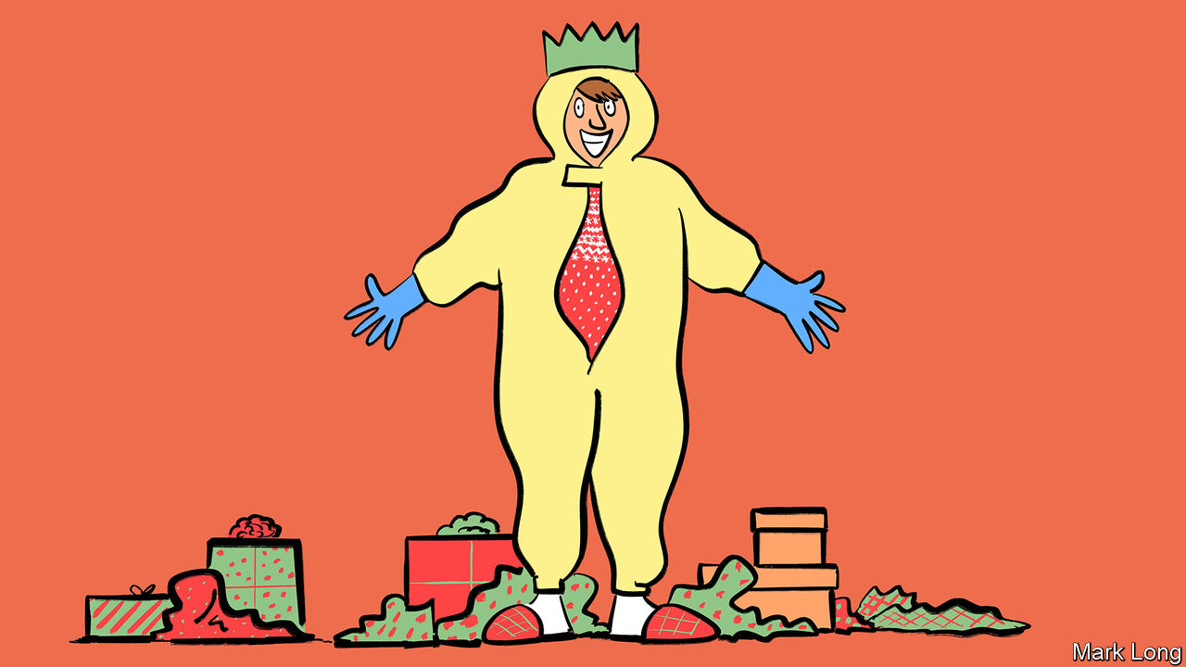

LAST YEAR New Yorkers might have found a pair of headphones or perhaps some woolly socks in their Christmas stockings. Some lucky ducks might have found tickets to a Broadway show. This year’s most popular stocking-stuffer may be the portable ultraviolet-light sanitiser wand, which comes with a handy bag. It is one of the big sellers, says Valerie Zirema, who works in CV19 Essential, New York City’s first dedicated coronavirus-prevention shop.

The urban-survivalist shop, near Macy’s department store, looks like a cross between an Apple Store and a pharmacy. It has everything a tech-minded, fashion-conscious New Yorker could want to navigate a pandemic. Disposable masks in fun patterns and colours are especially popular. “People want fashion and function,” says Benjamin Hu, the shop’s manager. And they love the gadgets, many of them touchless technology. As well as cheaper goodies like the masks and UV wands, the shop also sells a $10,000 system which scans people’s temperature as they enter a shop. Another device can detect if someone is not wearing a mask and sound an alarm.

Midtown Manhattan is quiet now. Most office workers are working from home and tourists have disappeared. The city has seen an alarming jump in covid-19 cases, which have more than tripled since the start of November. Hospitalisations and intubations are increasing, too. Restaurants have closed their dining rooms again. On December 14th Bill de Blasio, the city’s mayor, warned New Yorkers “to be ready now for a full shutdown, a pause like we had back at the end of the spring”. But the covid-19 shop, which also provides rapid testing and PCR testing for the virus, is seeing an increase in footfall.

CV19 Essential was founded by Tony Park, the owner of Samwon Garden, a Korean BBQ restaurant. After he fitted it out with UV light systems, anti-microbial film and a facial thermal scanner, other firms came looking for advice. Seeing a business opportunity, in September Mr Park opened his first covid-19 shop in a space where he originally intended to have another restaurant. He has since opened a second branch.

Opening safety boutiques and testing centres geared towards anxious New Yorkers is clever. “I like to think people are taking [prepping] more seriously,” says Jason Charles, head of the New York City Prepper’s Network, a survivalist group, who has seen more interest in his talks. Yet with luck business may not be brisk for long. On December 14th, even as New York prepared to shut down again, health-care workers began administering the first doses of the Pfizer-BioNTech vaccine in the borough of Queens. If the roll-out goes to plan, those sanitising wands might soon end up in a drawer, along with other forgotten gifts.

Editor’s note: Some of our covid-19 coverage is free for readers of The Economist Today, our daily [newsletter](https://my.economist.com/user#newsletter). For more stories and our pandemic tracker, see our [hub](https://www.economist.com/news/2020/03/11/the-economists-coverage-of-the-coronavirus)

This article was downloaded by calibre from <https://www.economist.com/united-states/2020/12/19/a-covid-19-themed-shop-in-new-york-is-thriving>

|  |  |  |  |
| --- | --- | --- | --- |
| 上一项 | 文章 | 章节 | 下一项 |

|  |  |  |  |
| --- | --- | --- | --- |
| 上一项 | 文章 | 章节 | 下一项 |

#### Bear hunt

# Hackers have vaulted into the heart of America’s government

The intrusion is one of the largest cyber-espionage campaigns ever seen

Dec 14th 2020 |



ON SEPTEMBER 25TH Russia’s president, Vladimir Putin, warned that a “large-scale confrontation in the digital sphere” was looming. He offered a solution. Russia and America would “exchange guarantees of non-interference in each other’s internal affairs, including electoral processes, including using ICT”—in short, a cyber-truce. Even as he spoke, his hackers were apparently deep inside some of America’s most sensitive networks.

American officials claim that a group of hackers known as APT29, or more evocatively as Cozy Bear, thought to be part of the SVR, Russia’s foreign intelligence service, penetrated several American government bodies—the list so far includes the Treasury, Commerce, State and Homeland Security Departments, along with the National Institutes of Health—where they could read emails at will. It appears to be one of the largest-ever acts of digital espionage against America.

The intrusion took a circuitous route. Between March and June, SolarWinds, a Texan company, pushed out updates to its Orion software, which is widely used to help organisations monitor their networks. The malware hitched a ride on those updates. Once downloaded, it allowed hackers to impersonate an organisation’s system administrators, who typically have the run of the entire network. It cleverly funnelled out data by disguising it as legitimate traffic while parrying anti-virus tools. Once inside, intruders can remain present even if Orion is disconnected.

The campaign showed “top-tier operational tradecraft”, says FireEye, a cyber-security firm that was itself a victim. Orion’s ubiquity explains why so many organisations were affected. SolarWinds says that “fewer than 18,000” customers may have been struck, though most would have been collateral damage.

America’s ability to muster a response is unlikely to be helped by President Donald Trump’s dismissal, on November 17th, of Chris Krebs, the head of the Cyber-security and Infrastructure Security Agency (CISA), for publicly affirming the integrity of the presidential election. CISA has struggled to cope with the onslaught.

Over the past decade, America has tended to categorise and respond to cyber-attacks according to their aims. It regarded intrusions intended to steal secrets—in other words, old-fashioned espionage—as fair game, not least because its own National Security Agency (NSA) is a prolific thief. After China stole 22m security-clearance records from America’s Office of Personnel Management (OPM) in 2015, Michael Hayden, a former NSA chief, conceded that it was “honourable espionage work”. In contrast, attacks intended to cause harm, like North Korea’s assault on Sony Pictures in 2014, or those with commercial aims, like China’s theft of industrial secrets, were thought to cross a line. America has accordingly indicted and imposed sanctions on scores of Russian, Chinese, North Korean and Iranian hackers.

Yet this effort to stamp norms onto a covert and chaotic arena of competition has been unsuccessful. For one thing, it is not always simple to define what is “honourable”, in Mr Hayden’s parlance, and what is not. If stealing a policy document is kosher, why not a vaccine? The line between espionage and subversion is also blurred: is Russia stealing emails to understand American policy, or to publish them later? It is not always clear until after the fact.

Most so-called cyber-attacks are simply espionage. But espionage conducted over computer networks has enabled intelligence gathering on a scale that was previously impossible. Though America has been as much a beneficiary of this intelligence revolution as it has been a victim, it has grown less tolerant in recent years. American views of “what’s allowed in cyberspace” have changed since the OPM breach five years ago, says Max Smeets of the Centre for Security Studies in Zurich. Such large-scale espionage “would be now at the top of the list of operations that they would deem as unacceptable,” he suggests.

Yet forbidding something is different from stopping it. “Deterrence is mostly irrelevant in an intelligence contest,” writes Joshua Rovner of the American University in Washington, a scholar-in-residence at the NSA in 2018-19. “No combination of threats and promises will stop a rival intelligence service from collecting information.” Sturdier defences are needed. ■

This article was downloaded by calibre from <https://www.economist.com/united-states/2020/12/14/hackers-have-vaulted-into-the-heart-of-americas-government>

|  |  |  |  |
| --- | --- | --- | --- |
| 上一项 | 文章 | 章节 | 下一项 |

|  |  |  |  |
| --- | --- | --- | --- |
| 上一项 | 文章 | 章节 | 下一项 |

#### Lessons learned

# Shutting schools has hit poor American children’s learning

Evidence is trickling in that this year’s cohort have fallen behind

Dec 19th 2020 | WASHINGTON, DC

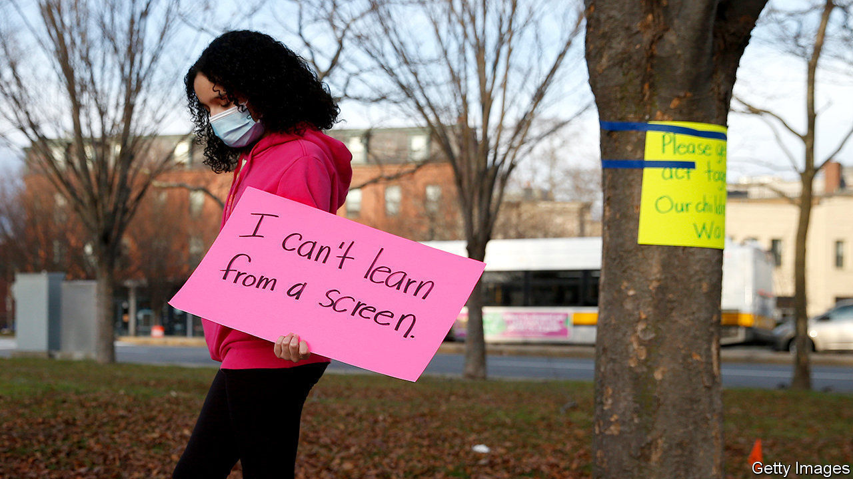

CLOSED SCHOOLS are bad for all children, but especially bad for poor and disadvantaged pupils. This basic pattern recurs wherever and whenever researchers look for it—in the wake of an epidemic of polio in America in 1916, after teachers’ strikes in Argentina since the 1980s, and after a devastating earthquake in Pakistani-controlled Kashmir in 2005.

Most natural experiments in school disruption come after isolated natural disasters. The covid-19 pandemic is leading to a simultaneous global experiment, however. In America, where schools have been significantly disrupted for the better part of a year, the first batches of reliable data are being gathered to assess how bad the damage has actually been. Sorting through them shows that sadly, America has not defied the gloomy predictions.

A recent analysis of standardised tests carried out by McKinsey, a consulting firm, found that pupils examined in the autumn had learned 33% less maths and 13% less reading than expected. For schools that are majority non-white, the learning losses were much steeper: pupils there had learned 41% less maths and 23% less reading. NWEA, a producer and administrator of standardised exams used in primary and secondary schools, published its own review of autumn scores that was less worrying. Pupils slid back substantially in maths, but not reading, with few detectable differences along racial or socioeconomic lines. But a substantial share of students, disproportionately poor and non-white, simply did not take the tests this year—which may have flattered the results.

In Washington, DC, 73% of white children in kindergarten and 45% of black children typically show adequate reading progress. When examined this year, white children showed a modest drop in adequate literacy, to 67%, while black children experienced a much larger one—to 31%. The gaps are also showing up in coursework, not just exams. Teachers in Los Angeles are reporting a stark increase in the number of failing grades—with the greatest increase in poor neighbourhoods. Researchers from Brown and Harvard universities examining data from Zearn, an online maths-teaching platform, found that pupils in high-income schools are actually performing 12% better in their coursework than in January 2020. But for low-income schools, scores fell by 17%.

The results suggest that the fears of worsening achievement gaps at the start of the pandemic were justified. There are enormous racial gaps in the kinds of instruction being received: 70% of black and Hispanic children are receiving fully remote education, compared with 50% of white pupils. Parents with the means to do so appear to be pulling their children out of public education altogether. There are 31,000 fewer pupils in the New York City public school system than in 2019; the roster in Austin, Texas, is 6% smaller. Instead, parents are hiring private tutors to teach their children in person. That is almost certain to widen the achievement gap.

Standardised exams are far from perfect. They do not measure the learning of impatient children well. More meaningful measures of lost learning, such as wages in adulthood, will not be known for years. Yet tests are not all bad. Given third-grade maths scores, researchers can quite accurately pick out which children will go on to become patent-holding inventors. They need not be a counsel of despair. Learning loss is remediable. But it requires the sort of serious investment that only Congress could provide and, so far, the gridlocked House and Senate have not seemed especially interested in providing it. ■

Editor’s note: Some of our covid-19 coverage is free for readers of The Economist Today, our daily [newsletter](https://my.economist.com/user#newsletter). For more stories and our pandemic tracker, see our [hub](https://www.economist.com/news/2020/03/11/the-economists-coverage-of-the-coronavirus)

This article was downloaded by calibre from <https://www.economist.com/united-states/2020/12/19/shutting-schools-has-hit-poor-american-childrens-learning>

|  |  |  |  |
| --- | --- | --- | --- |
| 上一项 | 文章 | 章节 | 下一项 |

|  |  |  |  |
| --- | --- | --- | --- |
| 上一项 | 文章 | 章节 | 下一项 |

#### Lexington

# Mutual-aid groups spread in covid-stricken America

Their expansion has been a positive development in a ghastly year

Dec 19th 2020 |

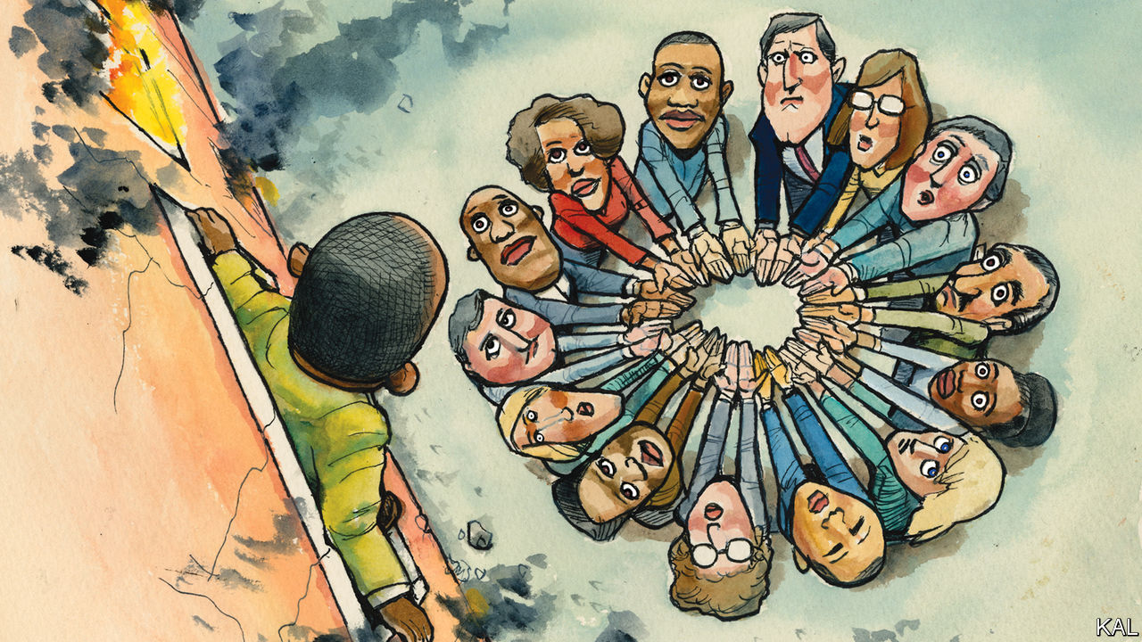

FOR MAURICE COOK, a community organiser in Washington, DC, the covid-19 pandemic has brought mostly the worst of times—but in some ways the best.

The poor black neighbourhoods where the burly Washingtonian has spent 20 years trying to improve educational opportunity are among the most ravaged in the country. Plagued by generations of poverty and ill-health, black residents of the capital city have succumbed to the virus at six times the rate of whites. And with government-support programmes running dry, even as many of Washington’s restaurants and other businesses remain shut, years of steady poverty alleviation in the city are unravelling.

“The effects of covid-19 look like this,” said Mr Cook, gesturing grimly, while handing out masks in an encampment of homeless people one wet and icy day this week. Huddled beneath an underpass, a short walk from Capitol Hill, its rows of dowdy tents had doubled since he began distributing basic supplies there early this year. Yet he has at least had unprecedented backup in that effort. “The incomers, the gentrifiers, they really stepped up,” he said.

Having refocused his education efforts on disaster relief as soon as the pandemic hit, Mr Cook emerged as a local leader of a distinctive form of civic engagement, known as mutual aid. Harking back to hardscrabble times, before the passage of the New Deal, its advocates preach the virtues of neighbourly “solidarity” over “charity”, which left-wingers such as Mr Cook consider paternalistic and obnoxious. The origins of the phrase “mutual aid” make that seem even more Utopian.

It was the title of a book published in 1902 by an aristocratic Russian anarchist, Peter Kropotkin, in which he promulgated a vision of communal harmony drawn from his observations of birds and beavers co-existing on the harsh Siberian tundra. The term was then dusted off by the Black Panthers to describe a multi-city programme of free breakfasts for children launched by the radical group in 1969. With at least nodding bipartisan support, nonetheless, the mutual-aid networks that have mushroomed in most American cities this year are a rare bright spot in the crisis.

Mr Cook was inundated by offers of help, mostly from local white professionals. A tweeted call-to-arms from one of his early supporters, Allison McGill, a social worker at a largely white evangelical church, elicited 3,600 offers. There were perhaps few true Kropotkinites among these volunteers (though that is another verboten word for mutual-aiders such as Mr Cook; they prefer “members”). “Mutual aid is not reducible to one political valance,” says Benjamin Soskis, a historian of philanthropy at the Urban Institute—who, coincidentally, also does a food run every other week for Mr Cook’s Ward 6 Mutual Aid. Yet at least some of the original leftist vision is still evident in their efforts.

The Facebook page of Ward 6 Mutual Aid presents a heart-warming exchange of offers and requests for English language tuition, flat-pack-furniture assembly and Christmas presents for children. The group’s fundraising and distribution of basic goods—including face-masks, food and clothing for several hundred poor Washingtonians—is more recognisably Tocquevillian. Though there are no reliable national data on the phenomenon, a multitude of similarly engaged new mutual-aid groups have sprung up across the country.

Julia Ho, a leader of St Louis Mutual Aid, describes its 1,700 “members”—and also the network’s origins in the racial justice protests that roiled nearby Ferguson, Missouri, in 2014-15. Kristen Gonzalez of Mutual Aid NYC points to that huge network’s slick database, which she helped compile. It lists 131 groups across the city, ranging from “LI Face Masks for the People” on Long Island, to “The End is Queer”, a citywide endeavour. The evidence of Lexington’s own neighbourhood, which has launched quieter schemes to shop for elderly residents or feed the families of poor classmates, suggests the phenomenon may be more common still. It speaks to America’s volunteering tradition. And to the paradoxical sense of reciprocity inherent in an infectious-disease crisis in which suddenly everyone has a stake in everyone else’s health.

Set against the enormity of the crisis—and the more than $3trn that Congress threw at it in April and May—the social impact of this do-gooding will be marginal. Contrary to a recurring fantasy on the right, notably pushed by George W. Bush and Paul Ryan among others, charity is never a substitute for the government action required to alleviate poverty or a crisis of this magnitude. As the effects of the stimulus have worn off, the poverty rate has duly soared. Figures released this month suggest that it has grown by almost a quarter in the past five months, easily the fastest pace in half a century. There are meanwhile indications from Ward 6 and elsewhere that, as expectations of a successful vaccine roll-out climb and the temperature drops, the zeal for volunteering (or membering) is tailing off. Yet it could leave a lasting mark, in politics as well as philanthropy.

## Leftier than thou

That could in theory be on the right. One of the Panthers’ unwitting contributions, notes Joanna Wuest of Princeton, was to spur Ronald Reagan, as governor of California, to boost the state’s food-assistance programme as a retaliatory measure. Yet, given the do-nothing mentality of today’s Republican Party, it is much easier to imagine the mutual-aid groups augmenting the rise of left-wing activism. Decentralised and tech-savvy, they are part-modelled on leftist campaign groups such as Indivisible. They have in turn championed those groups’ politics. A striking feature of this year’s Black Lives Matter protests in Washington was the mutual-aid stalls handing out free face masks, food and water. Thus have protest, campaigning and volunteering become dynamically reinforcing on the American left. For good or ill, this may turn out to be one of the major legacies of the Trump era.■

Editor’s note: Some of our covid-19 coverage is free for readers of The Economist Today, our daily [newsletter](https://my.economist.com/user#newsletter). For more stories and our pandemic tracker, see our [hub](https://www.economist.com/news/2020/03/11/the-economists-coverage-of-the-coronavirus)

This article was downloaded by calibre from <https://www.economist.com/united-states/2020/12/19/mutual-aid-groups-spread-in-covid-stricken-america>

|  |  |  |  |
| --- | --- | --- | --- |
| 上一项 | 文章 | 章节 | 下一项 |

|  |  |  |
| --- | --- | --- |
| United States | 章节 | Asia |

The Americas

Brazil: Awaiting their fate

.

Cuba: From distortion to disruption

.

|  |  |  |
| --- | --- | --- |
| United States | 章节 | Asia |

|  |  |  |  |
| --- | --- | --- | --- |
|  | 文章 | 章节 | 下一项 |

#### Awaiting their fate

# Brazil faces hard spending choices in 2021

The poor received huge welfare payments during the pandemic. These may soon dry up

Dec 19th 2020 | SÃO GONÇALO

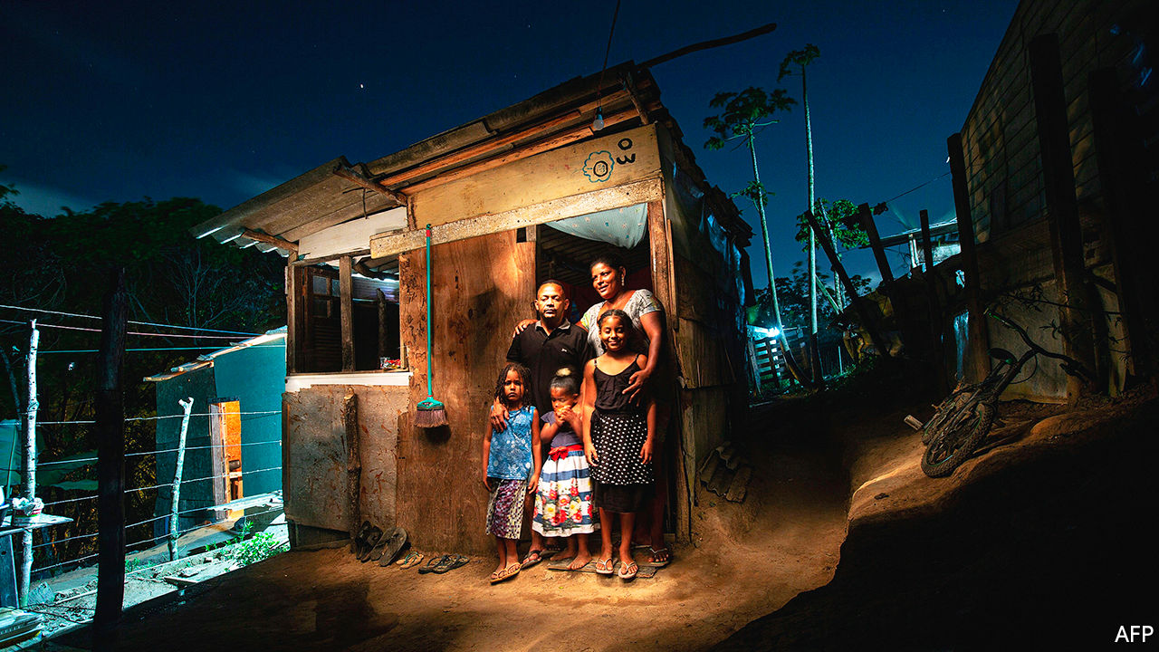

IN THE FINAL days of a tight mayoral race in November in São Gonçalo, an unglamorous city across the bay from Rio de Janeiro, one of the candidates, a retired police officer known as Capitão Nelson, made his way down a street lined with supporters. The mood was euphoric. A maskless man with a bottle of sanitiser on a string around his neck stomped his feet to funk music and squirted the gel into the air “to kill the germs” of the rival party. Humberto Perez, a handyman, likes the captain “because he cares about poor people, just like the president”, Jair Bolsonaro. After work dried up in March a monthly payment from the federal government kept him from going hungry. “And the campaign gave me a free lunch,” he said, with a toothy grin.

The fact that some Brazilians are celebrating during a pandemic that has killed 180,000 of their fellow citizens is among covid-19’s many paradoxes. So is the reason for their cheer: that a right-wing, pro-market government has rolled out the biggest welfare programme in Brazil’s history. Before the pandemic, extreme poverty was on the rise. Nearly 1m families were on the waiting list for Bolsa Família, a conditional cash-transfer programme that the government had cut back after a recession in 2014-16. In March 2020 widespread hunger seemed imminent. Paulo Guedes, the economy minister, proposed to spend no more than 5bn reais ($1bn), 0.2% of the budget, to fight the pandemic.

But momentum began to build in Brazil’s Congress to provide a basic income to poor people. Realising that it risked looking miserly, the government announced that it would give monthly payments of 600 reais to 68m Brazilians, a third of the population. Single mothers got twice that. In September the government halved the benefit, called auxílio emergencial (emergency aid), but extended it until the end of 2020. Brazil’s fiscal response to the pandemic, which also includes job-retention schemes, adds up to more than 8% of GDP, among the highest for G20 countries and twice the average for emerging markets. Congress declared a “state of calamity” to allow the government to bypass a constitutional ceiling on spending.

But with public debt approaching 100% of GDP, the government now faces a moment of truth. The state of calamity ends on December 31st, and with it the auxílio. Brazil can do one of three things: chop welfare spending to pre-pandemic levels, breach the ceiling or enact fiscal reforms that would allow it to maintain both. The third choice is the best, but it is also the most difficult. Since a landmark pension reform in 2019, the government has done little to cut spending or improve its effectiveness.

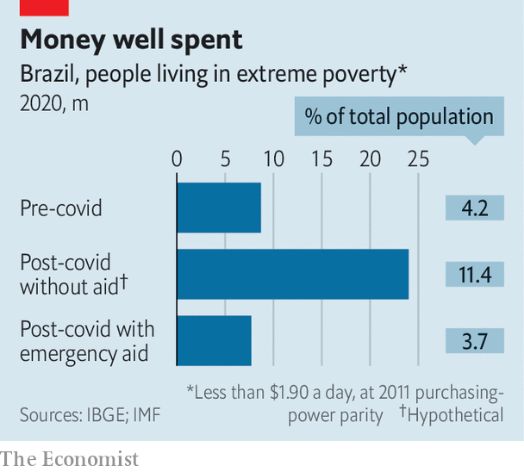

The auxílio has been a remarkable success. For more than 7m informal workers who lost their jobs, it was a crucial safety-net. It tripled payments to 14m families who had received an average of 190 reais a month from Bolsa Família. The auxílio lifted 1m people out of extreme poverty (see chart) and kept another 15m from becoming poor. Fundação Getulio Vargas (FGV), a university, found that Brazil’s Gini coefficient, a measure of inequality, swiftly dropped from 0.55 to 0.49, which is a lot. Poverty and inequality are the lowest since FGV began tracking them in 1970.

Brazilians whose pockets were empty after years of low growth bought televisions and ovens. Millions opened their first bank accounts. The poor north-east experienced a construction boom. After a 9.7% contraction in the second quarter, the economy grew 7.7% in the third. It will shrink in 2020 by half as much as many economists had predicted.

Mr Bolsonaro’s approval ratings climbed, smoothing the way for an alliance with the centrão (big centre), a bloc of opportunistic centre-right parties in Congress. “The expectation of victory and power brings us together,” says Ricardo Barros, now the government’s whip. Centrão candidates were the biggest winners in the local elections. They included Capitão Nelson, who won an upset victory against his left-wing rival. He promised money for new clinics and more police.

That will be a hard promise to keep. The stimulus was a “huge dose of anaesthesia that numbed the pain of the pandemic”, says Marcelo Neri of FGV. On January 1st “it will wear off”. The unemployment rate of 14.6% is the highest it has ever been. People in the poorest half of households have lost 28% of their earnings. “Unwinding all the extraordinary support in the coming months could risk derailing the incipient recovery,” warns the IMF. Millions could fall into poverty.

If Brazil tapers spending gradually, as other countries plan to do, it will breach the ceiling, which was enacted in 2016 to control rising debt. It limits growth in most federal expenditure to the previous year’s rate of inflation. Because 94% of the budget is eaten up by mandatory spending (chiefly pensions and salaries), little is left for investment and social programmes. In 2019 the government spent 30bn reais, or 0.4% of GDP, on Bolsa Família. The auxílio cost ten times that.

Some Brazilians think the ceiling is essential to prevent an eventual default. But Brazil’s debt is largely denominated in its own currency, which reduces that risk. If interest rates were to rise uncontrollably, the Central Bank could buy government debt. The cap matters more as a sign of commitment to reforms, says Arthur Carvalho of Truxt Investimentos, a hedge fund. “If you can’t cut anything in a mammoth state to fund an important social programme, you can’t make choices,” he says. The IMF urges Brazil to keep the ceiling and make space for a more targeted benefit in 2021 by “swiftly” passing money-saving reforms. Brazil risks hyperinflation if it scraps the spending ceiling, warned Mr Guedes in an interview with The Economist.

Neither big reforms nor a change in the spending cap is in prospect, which means welfare spending is set to fall. The damage to the poor will be modest, Mr Guedes thinks. The beneficiaries of the auxílio “were alive before the pandemic”, he said. “They had informal jobs” cleaning houses or selling sweets on the beach. “If the economy recovers they’ll be back.” Mr Guedes is bullish about that. “We will end this year with zero net jobs lost in the formal labour market,” he predicts. “I challenge any country to beat our record.”

His boss is less relaxed. Mr Bolsonaro wants to launch a new programme, Renda Cidadã (Citizens’ Income), which would help more families than Bolsa Família, although fewer than the auxílio. But he has rejected proposals for how to pay for it. “I can’t take away from the poor to give to the poorer,” he said when Mr Guedes suggested trimming other programmes.

There are other ideas. Congress is considering an “emergency” constitutional reform that would curb public-sector pay and tax exemptions. This would free a bit of cash for welfare. More would be available if that reform were coupled with an amendment to make the spending limit more flexible during crises, suggests Monica de Bolle of the Peterson Institute for International Economics, a think-tank in Washington. “You could do this without spooking markets,” she says. But Congress signalled last week that it will discuss the emergency measures only in February at the earliest. Mr Guedes promptly said he would take a holiday.

The government and Congress could put off a reckoning by extending the state of calamity, using a second wave of covid-19 as its justification. Mr Guedes has hinted he might endorse that. It would merely postpone the choice between fiscal reform and welfare cuts. The auxílio “can’t last for ever”, says Carlos Jordy, a congressional ally of Mr Bolsonaro who attended Capitão Nelson’s rally. Mr Perez, the handyman, may learn painfully that there is no such thing as a free lunch.■

Editor’s note: Some of our covid-19 coverage is free for readers of The Economist Today, our daily [newsletter](https://my.economist.com/user#newsletter). For more stories and our pandemic tracker, see our [hub](https://www.economist.com/news/2020/03/11/the-economists-coverage-of-the-coronavirus)

This article was downloaded by calibre from <https://www.economist.com/the-americas/2020/12/19/brazil-faces-hard-spending-choices-in-2021>

|  |  |  |  |
| --- | --- | --- | --- |
|  | 文章 | 章节 | 下一项 |

|  |  |  |  |
| --- | --- | --- | --- |
| 上一项 | 文章 | 章节 | 下一项 |

#### From distortion to disruption

# Cuba ends its dual-currency system

A long-awaited reform will cause pain in the short run

Dec 16th 2020 |

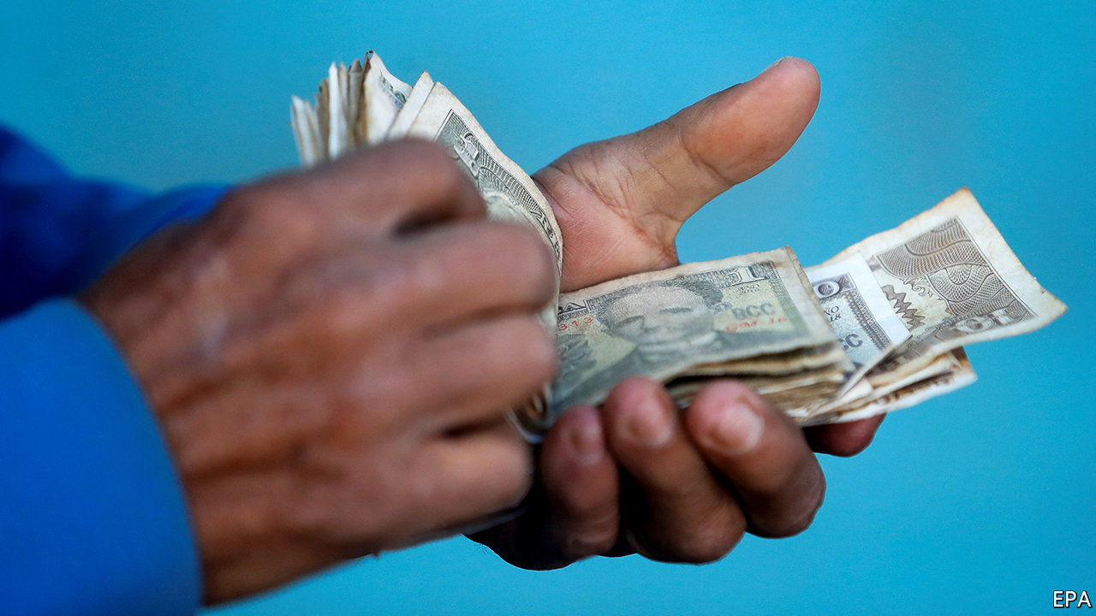

AFTER YEARS of dithering, Cuba is finally about to take the plunge. On December 10th the country’s president, Miguel Díaz-Canel, announced that on the first day of the new year it would abolish one of its two currencies. That is a big step towards ridding the socialist economy of distortions that thwart production, drain the treasury and keep people poor. But it leaves in place many enterprise-crushing rules and creates new problems that the government will struggle to overcome.

It set up the dual-currency system in 1994, when the country was reeling from the loss of subsidies from the Soviet Union, on which it had relied during the cold war. Alongside the Cuban peso it created the CUC, a convertible currency pegged to the dollar at one to one. It hoped this would prevent Cubans from dumping pesos in favour of dollars. Importers, which are state-owned, use CUC to obtain dollars on favourable terms, which makes imports cheap. Most Cubans, who work for the state, are paid in pesos. It takes 24 pesos to buy a CUC at the official exchange rate. Workers in the country’s growing private sector, most of whom are paid in CUC, earn seven times what state employees make.

The abolition of the CUC is meant to make the public sector behave more like the private one, and give private firms a better chance to compete. Firms and consumers will now use just pesos, initially at the official rate (though the dollar will remain important). State pensions and salaries are to rise five-fold. But inflation, already high, will increase. Subsidies for water, transport and electricity are being diminished.

To cope with these stresses, the government has introduced new distortions. Besides keeping controls on prices for some goods (many of which are scarce) at new higher levels, it has imposed them on such services as hair cuts and shoe repairs. Firms that profited from access to cheap dollars will get government help for a year to delay mass lay-offs. Cuba will enter the single-currency era with an overvalued exchange rate. On the black market the dollar sells for 35-40 pesos.

Mr Díaz-Canel’s big-bang reform does not let farmers decide what to grow or at what price to sell. Nor does it allow entrepreneurs, who create most new jobs, to incorporate. These needed changes and others may be coming. The government has said that some small firms, like restaurants, will be privatised. Cuba’s communist regime has sped up its reluctant conversion to market economics.

This article was downloaded by calibre from <https://www.economist.com/the-americas/2020/12/16/cuba-ends-its-dual-currency-system>

|  |  |  |  |
| --- | --- | --- | --- |
| 上一项 | 文章 | 章节 | 下一项 |

|  |  |  |
| --- | --- | --- |
| The Americas | 章节 | China |

Asia

Expatriates in Asia: Shipping out

.

Preserving Yangon: In with the old

.

Banyan: A lonely furrow

.

|  |  |  |
| --- | --- | --- |
| The Americas | 章节 | China |

|  |  |  |  |
| --- | --- | --- | --- |
|  | 文章 | 章节 | 下一项 |

#### Shipping out

# Western expatriates are leaving Asia

Covid-19 is not the only reason for the exodus

Dec 19th 2020 |

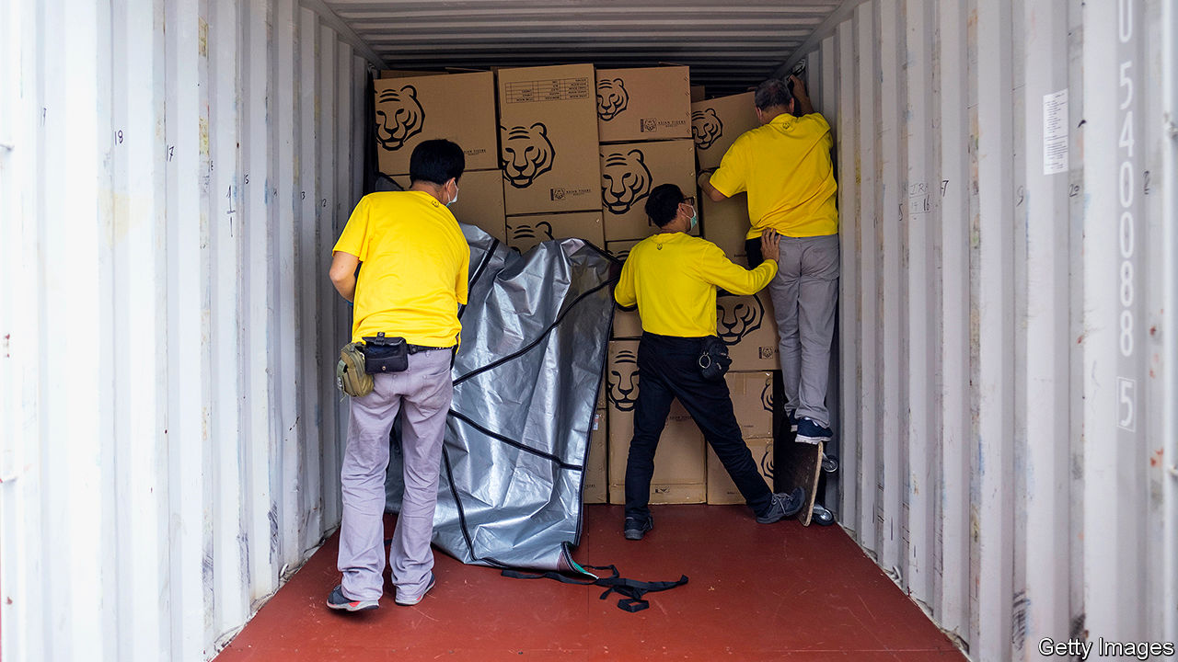

WHEN JAKARTA went into lockdown in April Asian Tigers Group, a moving company, received a flurry of business from wealthy expatriates who had fled overnight. Removal teams were led into deserted homes by maids or colleagues. Without the owners on hand to sort belongings, they found themselves stripping beds and packing dirty sheets into boxes alongside broken toys and other junk.

All the expats who want to move away have now done so and there are few new arrivals. Asian Tigers is laying off staff for the first time in its 35-year history. “Unless the tap turns back on we’re in a tough spot,” says Bill Lloyd, head of the group’s Indonesian operations.

Asian metropolises have long attracted migrants from the rich world. Fast-growing businesses, vast natural resources and unfamiliar commercial environments make for interesting work. Meanwhile, living costs are low, so expats can afford maids and big houses that would be out of reach back home. Around 3m migrants from the OECD were living in Asia last year, according to data from the club, which is composed mostly of rich countries, up from 2.3m in 1990. But the pandemic has underlined the drawbacks of living abroad, including distance from family and (in some places) a lack of good medical facilities. Unlike most immigrants, these are a well-off lot for whom relocation is a choice. Many have raced home rather than weather the pandemic in a foreign country.

That is a loss for both their home and host countries. People moving from the developed world to emerging markets make up a tiny portion of the world’s 270m international migrants. But they play an outsized role in the global economy, bringing new ideas and cosmopolitan connections wherever they go. A study in Canada found that a 10% increase in migrants from a given country is associated with a 1% increase in exports to that country and a 3% increase in imports from it. There is no reason why migration to developing economies should not produce similar benefits, says Amanda Klekowski von Koppenfels of the University of Kent. “We rarely think of the global North as a region that gains from emigration but it absolutely does,” she says. “This is a small but powerful movement.”

However, covid-19 has diminished the appeal of living abroad for many in the rich world. Iñigo Lumbreras de Mazarredo spent much of his 20s working his way up the ranks at a food-delivery firm in Asia. The best thing about expat life, he says, was the opportunity to travel widely and meet new people. After a stressful couple of weeks trying to pack up and go home, including four cancelled flights, the 29-year-old returned from Cambodia to Spain in April. “The main point of going abroad is to have an experience,” he explains. “Now that isn’t an option.”

Data are patchy on migration in Asia, but all the evidence points to a mass exodus. By June America had repatriated more than 15,000 of its citizens from the continent, including both tourists and migrants. Knight Frank, a multinational estate agent, has seen a big rise in expats looking to buy a base in their home country, particularly among those with elderly parents or children at boarding school back home. In a survey in June roughly 30% of the group’s agents said these clients were planning to move permanently and 60% said they wanted to split their time between their original and adoptive homes.

For employers, the pandemic has accentuated the disadvantages of hiring pricey Westerners in Asia. Most countries have introduced quarantine rules and stalled visa applications, making it difficult to get people where they are supposed to be going. Eliminating expensive foreign postings is an easy way to save money in a recession. Meanwhile, the need to work from home has shown that colleagues can collaborate reasonably well at a great distance using video-calling. More than 50% of businesses have repatriated employees on long-term assignments abroad and only half of them expect to move them back within a year, according to a survey by ECA International, which helps firms relocate staff. Almost all the companies surveyed also said they were allowing expats to work from other places if they wanted to.

Covid-19 is accelerating a trend that was already under way, says Toby Fowlston of Robert Walters, a recruiting firm. Education and language skills across the region have improved markedly in recent years. There is much less need to fly in expats to get a job done. In Hong Kong, Mr Fowlston says, the growing influence of mainland China means that employers are looking for Mandarin-speakers. He estimates that expats occupy just a fifth of client-facing roles at investment banks in the city, down from a third five years ago.

Host governments are also obstructing the hiring of expats, imagining that this might reduce unemployment. In Malaysia firms can employ foreigners only if they cannot find a local applicant who fits the bill. Employers have to advertise jobs through a central portal, interview candidates within 30 days and report back to the authorities afterwards. In August the Singaporean government raised the minimum wage businesses have to pay foreigners to secure a visa. It also launched an investigation into 47 firms that, it suspects, have not given local applicants a fair shot. In a similar vein, several Asian countries say they will cancel the residence permits of foreigners who leave the country without obtaining special permission first.

Whether businesses and governments want them or not, there will always be Westerners eager to live in Asia. Most people move either for love or for work. The first group is not that flighty. For the second, the appeal of expatriate life is likely to return when borders reopen and social-distancing rules fall away.

Hector Drake and his wife recently moved to London to have their first child after a decade in Hong Kong, Beijing and Shanghai. If anything, Mr Drake says, the pandemic has revealed what a desirable place to live Asia is. The governments of Hong Kong, Singapore, Taiwan and Vietnam have done a far better job than most in the West of keeping the virus under control. The couple caught covid-19 shortly after returning to Britain. Mr Drake may put more thought into his health insurance next time, but he hopes to work abroad again. “People will chase opportunities if they are there,” he says. ■

Editor’s note: Some of our covid-19 coverage is free for readers of The Economist Today, our daily [newsletter](https://my.economist.com/user#newsletter). For more stories and our pandemic tracker, see our [hub](https://www.economist.com/news/2020/03/11/the-economists-coverage-of-the-coronavirus)

This article was downloaded by calibre from <https://www.economist.com/asia/2020/12/19/western-expatriates-are-leaving-asia>

|  |  |  |  |
| --- | --- | --- | --- |
|  | 文章 | 章节 | 下一项 |

|  |  |  |  |
| --- | --- | --- | --- |
| 上一项 | 文章 | 章节 | 下一项 |

#### In with the old

# Conservationists are rushing to save Myanmar’s colonial buildings

Yangon has more of them than any other city in South-East Asia

Dec 16th 2020 | YANGON

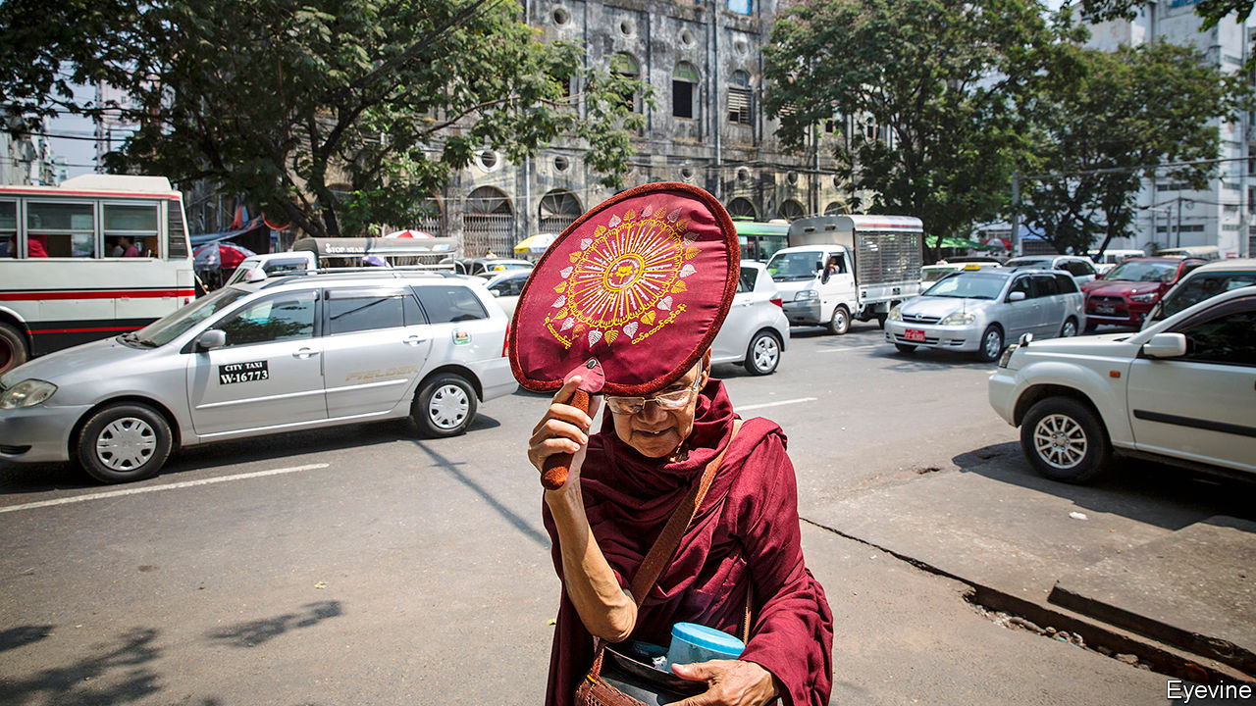

SINCE MYANMAR began to reverse decades of isolationism in 2011, it has embraced modernity with a zeal befitting a country deprived of it for so long. Students tap smartphones, food-delivery jockeys zip down the streets and cash machines are everywhere. But while the people of Yangon, the country’s biggest city and commercial capital, are rushing into the present, much of the urban fabric remains firmly in the past. Most buildings in the city centre were built in the colonial era, when Rangoon, as the city was then known, was the biggest commercial hub of the British empire between Singapore and Calcutta (as it was). Indian merchants, Armenian hoteliers, Filipino barbers and Saudi tobacco-dealers set up shop or took up residence in stately Victorian, Edwardian and Art Deco buildings.

Myanmar’s subsequent economic stagnation left Yangon with more colonial buildings than any other city in South-East Asia. But the grand edifices were neglected during the long years of military rule, and most are now streaked with mould. Red signs affixed to rotting doors mark many out as unfit for habitation. They are not beyond repair: a stone’s throw from the shimmering Sule Pagoda in the centre of the city stands the Tourist Burma building, a former office and department store spattered with pediments and pilasters. Once derelict, it was renovated by Burmese and British NGOs and reopened as a community centre in 2019.

One of the NGOs involved was the Yangon Heritage Trust (YHT), founded by Thant Myint-U in 2012. As the military regime began to reform the economy a decade ago, Mr Thant, a historian, worried that the government would raze Yangon’s architectural inheritance in the name of progress, as has happened in so many other booming Asian cities. So he began to advocate for the preservation of colonial Yangon, arguing that the spruced-up buildings would not only draw tourists but also make Yangon more appealing for its residents.

The municipal government quickly saw the light, perhaps because Mr Thant was friendly with the president. In 2012 it imposed a 50-year moratorium on the demolition of buildings more than 50 years old. Although Mr Thant worries that the city has yet to develop “a coherent vision and plan for what Yangon should be”, it does see the value in conservation, he says. Moreover, it is “in pretty much daily contact” with YHT, which has helped with some 350 conservation projects. Several other organisations also provide expertise or funding for renovations, among them Turquoise Mountain, a British charity which worked on the Tourist Burma building.

But finding wealthy foreigners to help renovate urban landmarks is one thing; fixing up crumbling private residences is quite another. Many of the 15,000 buildings in Yangon that YHT wants preserved are residential, and in serious disrepair. Moe Thida, a shopkeeper and lifelong resident of downtown Yangon, has no qualms about demolition. By all means preserve Bagan, the site of an ancient Burman kingdom and Myanmar’s most famous tourist destination, she says, but in a residential neighbourhood houses should not be “dangerous to live in”. She is far more comfortable living in her newish apartment building than she was in her parents’ 1940s wreck.

But even if new buildings are nice at first, Mr Thant argues, they do not remain so for long. In Myanmar most are poorly constructed and weather badly. Colonial stock tends to be better designed and sturdier, says Nathalie Paarlberg of Turquoise Mountain. The lime-mortar walls of the Tourism Burma building withstand tropical heat and moisture better than concrete, which is more commonly used today.

Renovations are costly, but financing is available for home-owners. Doh Eain, a charitable enterprise, renovates homes in return for a cut of the revenue generated by renting out the refurbished property, typically for five to ten years. “Owners say to us, ‘We didn’t realise that we owned something that is valuable,’” says Emilie Röell, Doh Eain’s founder. “We help them see that.” Not everyone needs to be told. For every Moe Thida, there is a Sithu Maung. A young MP, he lives in a late 19th-century building that the government has deemed dangerous. But he hopes his house will be preserved. “Old buildings have their unique beauty”, he says, “and that makes the city also unique.” ■

This article was downloaded by calibre from <https://www.economist.com/asia/2020/12/16/conservationists-are-rushing-to-save-myanmars-colonial-buildings>

|  |  |  |  |
| --- | --- | --- | --- |
| 上一项 | 文章 | 章节 | 下一项 |

|  |  |  |  |
| --- | --- | --- | --- |
| 上一项 | 文章 | 章节 | 下一项 |

#### Banyan

# India’s government is undermining its own agricultural reforms

Its high-handed methods needlessly alienated farmers

Dec 16th 2020 |



WHEN IT COMES to voicing demands, India’s 150m farmers are not shy. Recent protests have seen throngs of them descend on the national capital to express desperation by, among other things, stripping naked, being buried alive, displaying skulls (allegedly of fellow farmers who have killed themselves in despair), and even by eating rats and human faeces.

This year’s biggest agitation has relied on numbers and grit, not telegenic antics. Since late November tens of thousands of farmers have camped at Delhi’s northern gates, bringing tractors, animals, bedding and industrial-scale soup kitchens. Having failed to disperse this horde with tear-gas and water cannon, police, too, have settled in behind a defence of trenches, iron railings and rows of shipping containers. The protesters have a simple demand: repeal three farm laws that Narendra Modi, the prime minister, rushed through parliament in September.

Agronomists and economists generally welcome those reforms. Many farmers, too, agree that laws dating from the 1950s and 1960s, an era of scarcity and state socialism, need updating if Indian agriculture is to compete in an age of global markets. Mr Modi’s measures end the monopoly enjoyed by state-controlled wholesale markets, axe “anti-hoarding” rules that scare off investment in, for example, cold storage, and ease, among other things, long-term contracts between farmers and customers.

But the musty laws and institutions so disliked by experts have, in fact, served one constituency rather well. Growers across much of India have tended to vary crops and rely little on government, but farmers in its grain belt, which happens to stretch across the plains north and west of Delhi, have grown ever more dependent. Pumping unlimited groundwater using free government-supplied electricity, planting subsidised seeds and spreading subsidised fertiliser, farmers in the states of Punjab and Haryana produce the bulk of the rice and wheat that the government spends around $25bn every year buying at a guaranteed price for the sake of “food security”. They grow so much that, although India exports more rice than any other country, and the government sells it on the cheap to some 810m of its own citizens, by June it had accumulated a massive 97m-tonne mountain of the stuff.

Such policies are plainly not sustainable, yet the risk-free farming cycle has proved addictive to the growers who profit most. In the 1970s rice and wheat took up less than half of Punjab’s farmland. They now swallow four-fifths. As with any addiction, this one comes with unhealthy disadvantages, including depleted groundwater, poisoned soil and toxic air from the burning of rice stubble.

After huge gains in living standards from the 1960s to the 1990s, when the “green revolution” tripled or quadrupled grain yields, growth has stagnated. Farmers worry about job prospects for their children, who are better educated than they are. They fear a loss in status as earnings from their land—Punjabi farms are bigger than elsewhere in India, but still average less than four hectares—fail to keep pace with urban wages.

Yet much as Punjabi farmers dream of change, they also fear any shift in the policies that sustain them. They know the government will some day lose its penchant for dishing out subsidies, and it is not illogical to suspect that day may be now, amid a raging pandemic and economic crash. Mr Modi, who has pledged to double farmers’ incomes in five years, failed to take this doubt into account. Rather than consult powerful farming unions, or build support for the bills in parliament, his government used its majority to ram them into law without discussion. When the protests erupted, his ministers made things worse, sneering that the angry farmers were stupid, swayed by “anti-national” leftists or, since many are Sikhs, were dangerous separatists, perhaps terrorists.

Mr Modi’s government has offered minor concessions, to no avail. It can still save face by temporarily suspending the laws. As with countless other protests in India, this one may also simply dissolve. Divine intervention ended last year’s nationwide protests against a discriminatory citizenship law, which petered out with the arrival of covid-19. However the siege of Delhi ends, India’s rulers would be wise to learn its lessons: in such a diverse and noisy country, you cannot make one rule for all, and you cannot make rules at all without first winning people to your cause.

This article was downloaded by calibre from <https://www.economist.com/asia/2020/12/16/indias-government-is-undermining-its-own-agricultural-reforms>

|  |  |  |  |
| --- | --- | --- | --- |
| 上一项 | 文章 | 章节 | 下一项 |

|  |  |  |
| --- | --- | --- |
| Asia | 章节 | Middle East & Africa |

China

Sexual harassment: Refusing to be silent

.

Human rights: Proxy war

.

|  |  |  |
| --- | --- | --- |
| Asia | 章节 | Middle East & Africa |

|  |  |  |  |
| --- | --- | --- | --- |
|  | 文章 | 章节 | 下一项 |

#### Refusing to be silent

# Though muffled, China’s #MeToo movement still has support

Campaigners see signs that sexual harassment is being viewed more seriously

Dec 16th 2020 |

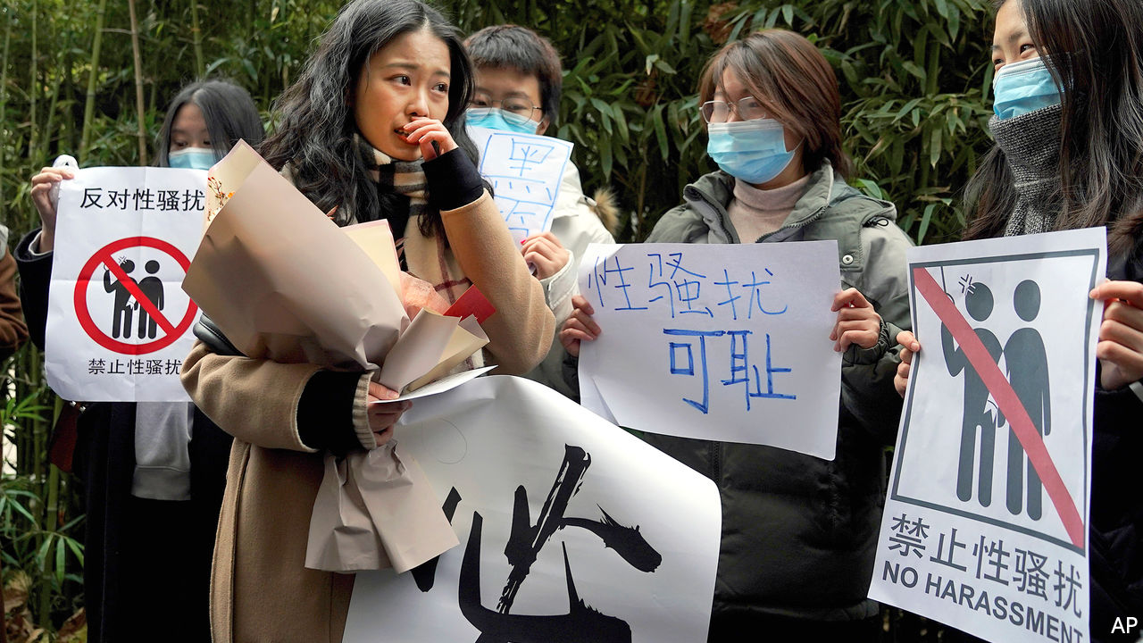

XIANZI WAS an intern at China’s national television network when she visited the dressing room of Zhu Jun, a presenter, in 2014. She wanted to interview him to gather information for a project at her university. Once they were alone, she says, he groped and kissed her. When she later complained to the police, they told her not to sue him because it would reflect badly on the Communist Party. Mr Zhu is a household name. His jobs have included hosting China’s annual new-year gala, the world’s most-watched television show.

Four years later the #MeToo campaign, which had been spreading elsewhere in the world, began to inspire women in China to publicise their experiences of sexual harassment. Xianzi (a pseudonym by which she is always known in China) wrote about her alleged mistreatment and became the movement’s best-known face in the country. Mr Zhu denied the accusation and sued Xianzi for defamation. She counter-sued, demanding an apology and payment of 50,000 yuan ($7,600) in damages.

The government is wary of #MeToo activism, fearful that it might morph into political dissent. It suppressed media coverage of the dispute. On December 2nd, however, the first court hearing into Xianzi’s suit thrust her back into the limelight. It produced no new insights—Mr Zhu failed to appear and the case was adjourned, probably until 2021. But on Weibo, a social-media platform, posts with a hashtag related to the launch of the court proceedings attracted more than 17m views and thousands of comments.

That the #MeToo cause is still alive in China was also evident outside the court in Beijing. Despite the presence of numerous police, and a political climate that discourages all but the brave or foolhardy from demonstrating in public, more than 100 people gathered in support of Xianzi (a few are pictured, with the plaintiff in the foreground). Some waved pictures of rice and rabbits, the Mandarin for which sounds like the English words “me too”. A slogan displayed by one group said: “Together we demand an answer from history.”

Since Xianzi went public with her allegation, she says she has received tens of thousands of messages from women across the country sharing their own experiences of being sexually harassed and assaulted. Many women in China have also made public allegations of sexual assault against powerful men. The accused include academics, media personalities, charity bosses and religious figures (few have dared to point fingers at officials).

In 2018 China’s highest court made it clear for the first time that sexual harassment could be grounds for suing. But it is remarkable that Xianzi’s case has got this far. Women who are victims of sexual assault in China face tremendous obstacles to fighting in court. Financial costs are high. Most lawyers and NGOs in China lack expertise in this rarely explored area of law. Victims who go public are often subjected to online abuse by men who oppose feminism and #MeToo. As Xianzi puts it, they face an “extremely hostile system”.

Many aspects of the system in China are heavily skewed in favour of men, not least in employment and family matters. The World Economic Forum places China above South Korea and Japan in its ranking of countries by gender equality. But since Xi Jinping became China’s leader in 2012 his country has fallen from 69th to 106th on that list, below Malaysia and Sri Lanka. Despite this, more women than ever in China are gaining degrees. In 2009, for the first time, the number of female undergraduates surpassed those who were male. Since then women have retained this majority. Young highly educated women have been at the forefront of China’s #MeToo movement. Their demands for rights as women are “very difficult to suppress”, says Wang Zheng of the University of Michigan.

The Communist Party accuses “hostile foreign forces” of stoking such advocacy. In 2015 police arrested a group of women merely for planning to hand out stickers about sexual harassment on public transport. The “feminist five”, as they became known, were released only after weeks in prison, and after news of their plight had sparked outrage in China and abroad. When visiting the state-backed All-China Women’s Federation in 2018, President Xi said the organisation “absolutely must not become one of those organisations like they have in other countries for feminists or posh women”.

Though stifled by the government, campaigning has made some impact. “Prior to #MeToo, discussions about women and gender in mainstream media and on social media were quite limited,” says Zhang Zhiqi, the host of a podcast popular among feminists in China. “There’s now a lot more awareness about gender equality and I think that’s due to #MeToo.”

A new civil code, which will take effect on January 1st, requires employers to prevent sexual harassment at work. Many feminists call this a success for their efforts to publicise the problem. “We’ve seen some real progress made in recent years in China’s legal sphere to better protect women’s rights, although it is becoming extremely difficult for feminist NGOs to operate,” says Feng Yuan of Equality, a Beijing-based group promoting women’s rights.

Xianzi is not optimistic that she will win her case (and Mr Zhu’s against her is still pending). But she says even defeat would be “victory” because her suit has helped to raise awareness of sexual assault. As night fell outside the court and the temperature dropped below freezing, people following her case online began sending anonymous donations of bubble tea, hamburgers, fried chicken, noodles, hand sanitiser, gloves and taxi money to supporters still gathered there. When couriers arrived with the deliveries, they read out the intended recipient, asking “Who is ‘Xianzi’s friend’?” The crowd replied: “We all are.” ■

This article was downloaded by calibre from <https://www.economist.com/china/2020/12/16/though-muffled-chinas-metoo-movement-still-has-support>

|  |  |  |  |
| --- | --- | --- | --- |
|  | 文章 | 章节 | 下一项 |

|  |  |  |  |
| --- | --- | --- | --- |
| 上一项 | 文章 | 章节 | 下一项 |

#### Proxy war

# Sensing change in Washington, China is mustering allies at the UN

Joe Biden may show more interest than Donald Trump in the body’s human-rights debates

Dec 16th 2020 | NEW YORK

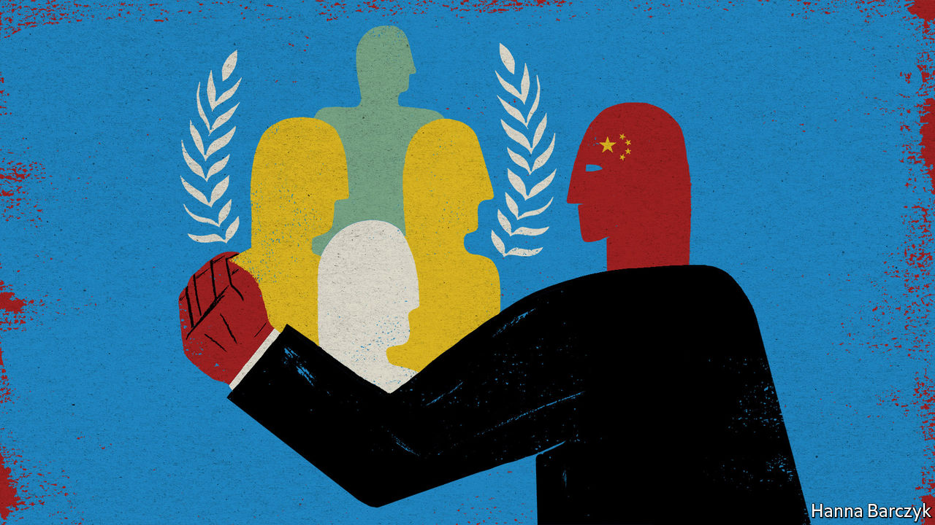

WHEN AMERICA withdrew from the UN Human Rights Council in 2018, China expressed regret. No one bought it. The forum deals with a topic that is a huge potential embarrassment for China. The absence of the world’s most powerful democracy from its deliberations made it likelier that China’s abuses would escape censure. But with Joe Biden preparing to take over as America’s president, China fears trouble ahead. It is girding its loins in the council.

Evidence of this can be detected in a shadowy feud over who should lead the Geneva-based body. It involves an attempt by China—backed by Russia and Saudi Arabia—to nobble the presumed front-runner for control of the presidency, the tiny Pacific island nation of Fiji, and manoeuvre a country more to its liking into that position. (China and Russia were not on the council in 2020, but will be from January 1st.) Democratic members of the council, hoping that Mr Biden will soon send America to rejoin them, see this as an important battle. They are supporting Fiji.

The question of who leads the council may seem trifling. After all, it is the body’s 47 members, not its president, who set the agenda. And members have been loth to challenge China. The council has yet even to introduce a resolution, much less pass one, on China’s mass internment of Uyghurs in Xinjiang or its stripping of Hong Kong’s freedoms. The Trump administration pulled America out after failing to persuade the UN to impose standards for membership of the council.

But the president does have leeway in the appointment of special rapporteurs, who have much autonomy and can be thorns in the side of authoritarian regimes. In June more than 50 special rapporteurs and experts appointed by the council signed a statement chiding China for violating rights in Xinjiang, Tibet and Hong Kong. China was furious. It accused the signatories of breaching the UN charter.

The council’s next leader will also play a big role in a five-year review of its work by the UN General Assembly. This could result in reforms wanted by America, such as setting criteria for membership.

Crucially, the appointment of a president from a country with an appalling human-rights reputation could cause even greater damage to the council’s already underwhelming image in the West. In 2003 the council’s predecessor body, the UN Commission on Human Rights, elected Libya to its chairmanship. This contributed to its dissolution three years later. Were something similar to happen again, it may become difficult for Mr Biden to endorse America’s return to the council.

That would be a victory for China, which sees the organisation as a beachhead in its campaign to redefine global norms. It has used it to secure resolutions that weaken the language of human rights, emphasising state-led development over the rights of individuals, and respectful “dialogue” between states rather than holding countries to account when they commit abuses. It has also vigorously opposed resolutions against specific states, arguing that countries should not interfere in others’ affairs. China’s voice in the council, whether as an observer or a member, helps it to counter its growing band of critics. In October, 39 UN members signed a statement condemning the horrors in Xinjiang, up from 23 who did so a year earlier. The number who signed a statement defending China fell from more than 50 to 45.

In 2021 the presidency is supposed to be held by a member of the UN’s Asia-Pacific group, to which Fiji and China belong (the regions take turns). Fiji’s representative is widely respected for her stance on human rights. She had been running unopposed. But in November Bahrain formally made a bid for the job. Syria then objected to Fiji’s candidacy. Diplomats say these moves were encouraged by China and its friends. Later a third contender, also acceptable to China, emerged: Uzbekistan. Fiji and its Pacific-island neighbours felt bullied.

But Asia-Pacific countries have failed to agree on a choice. So the council’s full membership may pick a president in January. That could work in Fiji’s favour, and, Western envoys hope, to the betterment of the UN’s human-rights efforts. ■

This article was downloaded by calibre from <https://www.economist.com/china/2020/12/16/sensing-change-in-washington-china-is-mustering-allies-at-the-un>

|  |  |  |  |
| --- | --- | --- | --- |
| 上一项 | 文章 | 章节 | 下一项 |

|  |  |  |
| --- | --- | --- |
| China | 章节 | Europe |

Middle East & Africa

The Arab spring at ten: No cause for celebration

.

Iran: Go hang

.

Western Sahara: Heat in the desert

.

Kidnapping in Nigeria: The lost boys of Kankara

.

Congo’s gold rush: Beer, brothels and broken dreams

.

|  |  |  |
| --- | --- | --- |
| China | 章节 | Europe |

|  |  |  |  |
| --- | --- | --- | --- |
|  | 文章 | 章节 | 下一项 |

#### No cause for celebration

# The Arab spring at ten

A decade ago Arabs rose up. Why haven’t things improved?

Dec 16th 2020 | DUBAI

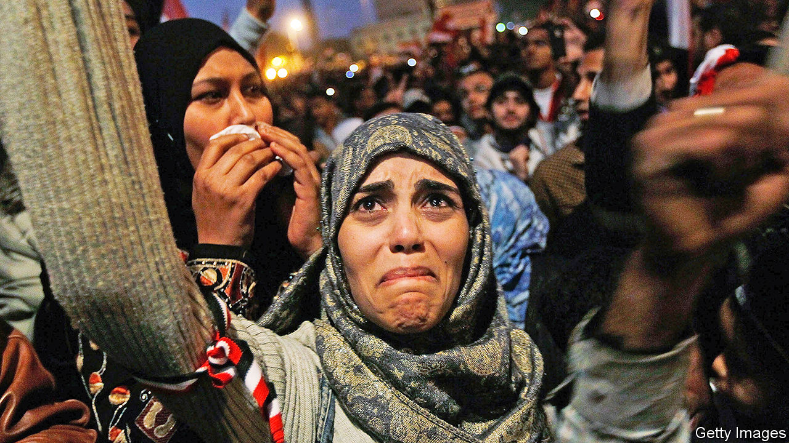

IT IS AN anniversary no one is eager to mark. The numbers boggle the mind: half a million people dead; another 16m displaced from states no longer recognisable. There are the individual stories too, of dreams dashed and hopes shattered. One former activist, who long since gave up on the politics of his native Egypt, scrolls through the contacts on his phone, stopping now and then to list his friends’ fates: exiled, disappeared, dead.

Ten years have passed since Muhammad Bouazizi, a Tunisian street peddler, set himself ablaze to protest against the corrupt police who confiscated his wares. His self-immolation, on December 17th, is widely seen as the spark that ignited the Arab spring, a wave of revolutionary protest that swept across the region. Those early days were a time of unbridled optimism. Dictators who had looked invulnerable fell, one after the other—in Tunisia, Egypt and, later, Libya and Yemen.

But revolution soon gave way to a sort of Thermidorian reaction. Egypt’s brief experiment with democracy failed. Libya, Syria and Yemen plunged into civil war and became playgrounds for foreign powers. Wealthy Gulf states spent heavily to placate their own people and bolster anti-democratic forces elsewhere. The region is less free than it was in 2010—and worse off by most other measures, too.

Much has been said and written about what went wrong. In the West, pundits and policymakers tend to talk about themselves, what they could have done to help the revolutions succeed. There is a solipsism to these debates, which relegate Arabs to a secondary role in their own story. And counterfactuals are hard. It is plausible to argue that Syria would be less of a charnel house had America destroyed Bashar al-Assad’s air force in 2012; far less to claim it would have become stable or prosperous or democratic. The no-fly zone over Libya in 2011 helped overthrow Muammar Qaddafi but did not prevent his country’s ruin.

Cynics suggest that the Middle East is simply not suited for democracy. Yet Tunisia emerged from its revolt with a fragile but genuine republic, of which its citizens are justly proud.

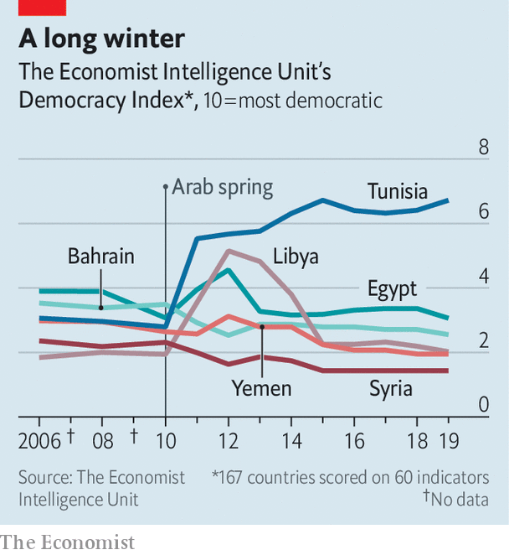

There is no one answer to why things went wrong for the other countries that took part in the Arab spring. Blame foreign powers, from Iran and Russia to the impotent, incoherent West. Blame Islamists, who often stoked division in cynical bids for power. Most of all, though, blame the men who ruled Arab states after they gained independence in the 20th century. Though few were democrats, they understood something about democracy. It requires more than elections to succeed. It also needs engaged and informed citizens, a common set of rules and a shared belief that political disagreements do not pose an existential threat. Dictatorships, by design, lack these qualities—and prevent them from emerging.

Anyone who has spent time in the Middle East knows the region crackles with conspiracy theories. A non-trivial number of Egyptians believe that America put the Muslim Brotherhood in power (in fact, Egyptian voters did) or that Hillary Clinton created Islamic State. The popularity of such ideas is perhaps understandable. Schools in Egypt teach by rote; the government prefers placid subjects to engaged citizens. The media read from a script; a wayward word in a café or a Facebook post can land anyone in jail. It is hard to have a say in how you are governed in a system that tries to prevent it.

It can also seem futile in a system where governance is so poor. Arabs loathe the bribes and wasta, or connections, required to navigate daily life in much of the region. Yet to survive in such a system requires the tacit acceptance of its terms. Every act of graft, no matter how petty, undermines confidence in the state, in the very idea of a common good. Corruption makes everyone complicit. Mr Bouazizi struck a nerve because so many of his countrymen had been in his place.

Beyond futile, it can seem dangerous: people who think their countrymen wish them dead will not wish those countrymen to gain power. Mr Assad convinced many of his supporters that the Syrian uprising was the work of extremists. This was not prescience but self-fulfilling prophecy. Release enough jihadists from prison, murder enough moderates, starve the populace for long enough, and sooner or later a peaceful movement will become radical.

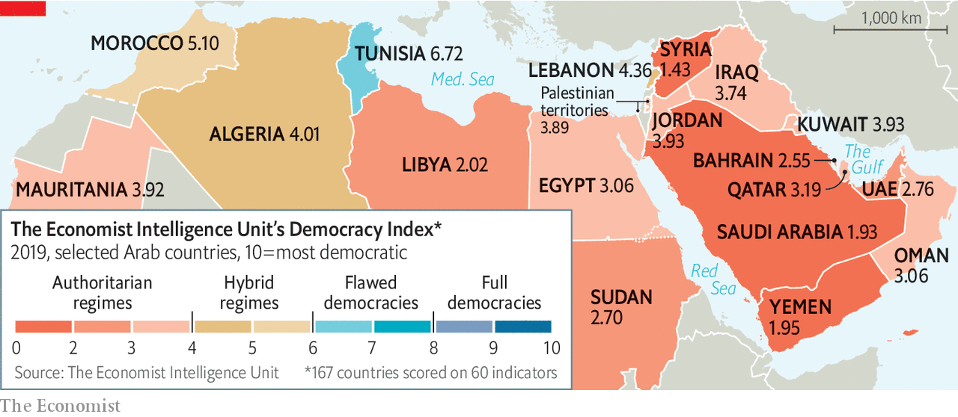

None of this is unique to the Middle East. America has an alarming level of polarisation and an outgoing president who lies reflexively. But robust institutions and centuries of democratic tradition make it virtually impossible for any American president to become a dictator. The Middle East has no such safeguards. For decades it has been ruled by visionless autocrats who promised only stability for stability’s sake.

Today’s crop of dictators, those who survived 2011 and those who emerged from it, speak a subtly different language, one that posits development, not democracy, as the region’s most dire deficit. In their telling the focus on political change is misguided. What Arabs truly need is better governance and more job opportunities. Yet even on their own terms many rulers are failing. Abdel-Fattah al-Sisi talks of developing Egypt; most Egyptians have seen their standards of living deteriorate on his watch.

And like his counterparts, Mr Sisi is eagerly salting the earth lest any other revolutionary shoots take root. The tight political space of Hosni Mubarak’s Egypt looks positively freewheeling compared with today’s. In Algeria, a new army-backed regime is less interested in stamping out corruption than in wielding corruption charges as a cudgel against its foes. Bahrain’s monarchy portrays criticism of its rule as an Iranian plot to colonise the island.

This is no era of authoritarian stability, though. With few exceptions the region is miserable, a mix of failed states and stagnant ones that offer meagre prospects for their young populations. Even in the Gulf states, which mostly dodged serious unrest in 2011, rulers are nervous about their future in the twilight of the oil age. Their old social contract offered material comfort in exchange for political quiescence. If they can no longer provide the former, they cannot long expect the latter.

History is not linear. Revolutions fail; bad guys sometimes win. There is no reason to expect that the next round of Arab uprisings will produce happier results than the previous one. Equally, though, there is no reason to believe the autocrats when they say they can prevent it. ■

This article was downloaded by calibre from <https://www.economist.com/middle-east-and-africa/2020/12/16/the-arab-spring-at-ten>

|  |  |  |  |
| --- | --- | --- | --- |
|  | 文章 | 章节 | 下一项 |

|  |  |  |  |
| --- | --- | --- | --- |
| 上一项 | 文章 | 章节 | 下一项 |

#### Death of a firebrand

# Why Iran abducted and hanged Ruhollah Zam

The execution may complicate Joe Biden’s plan to re-engage

Dec 16th 2020 |

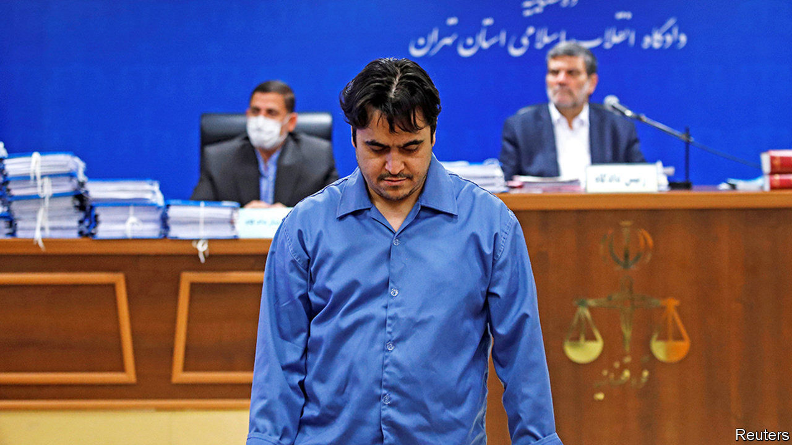

EVEN BY IRAN’S standards the justice was rough. Four days after sentence was passed, Ruhollah Zam was hanged. The judge said he had spied, incited violence and “sown corruption on earth”. Most Iranians took that to mean that he had simply disagreed with the right of the ayatollahs to rule.

Mr Zam had been a remarkable dissident. In 2011 he went to Paris to escape the regime and, four years later, launched Amad, a news channel on Telegram, a messaging app. At its peak Amad had more subscribers than the BBC’s Persian service, which many Iranians rely on. He exposed the sexual and financial peccadilloes of the regime’s top turbans. The son of an influential cleric and an alumnus of a school in Tehran, the capital, favoured by the elite, he had a wide web of contacts.

When nationwide protests erupted three years ago, he posted the place and time of rallies and was often first to get videos from the scene. He issued a manual for making petrol bombs. He called for regime change: “Ruhollah began the revolution, Ruhollah will end it,” he said, referring first to Ruhollah Khomeini, father of the Islamic revolution, then to himself. The regime blocked Telegram but failed to silence him. Then last year its agents lured him to Iraq, apparently with a honey trap, kidnapped him and took him home.

Mr Zam’s treatment shows yet again that the regime will stop at nothing to crush civil society. Snipers shoot demonstrators. In September a prominent wrestler was hanged for joining a protest. The hardliners control parliament and the courts, so they can rig next year’s presidential election.

Human-rights outfits in Europe warn Iranian dissidents abroad against travelling home. “Zam is just the beginning,” read a social-media message to an anchor at the BBC’s Persian service in London. “I always look over my shoulder when leaving the office,” she says.

“Horrifying,” tweeted Jake Sullivan, Joe Biden’s choice for national security adviser. Yet the new administration’s eagerness to curb Iran’s enrichment of uranium may outweigh human rights. On December 16th the parties to the nuclear deal with Iran met on schedule. President Donald Trump pulled America out of the agreement. Mr Biden says he will rejoin it.

This article was downloaded by calibre from <https://www.economist.com/middle-east-and-africa/2020/12/16/why-iran-abducted-and-hanged-ruhollah-zam>

|  |  |  |  |
| --- | --- | --- | --- |
| 上一项 | 文章 | 章节 | 下一项 |

|  |  |  |  |
| --- | --- | --- | --- |
| 上一项 | 文章 | 章节 | 下一项 |

#### Heat in the desert

# The Israel-Morocco peace deal is roiling Western Sahara

Tensions had already been rising in the disputed territory

Dec 16th 2020 |

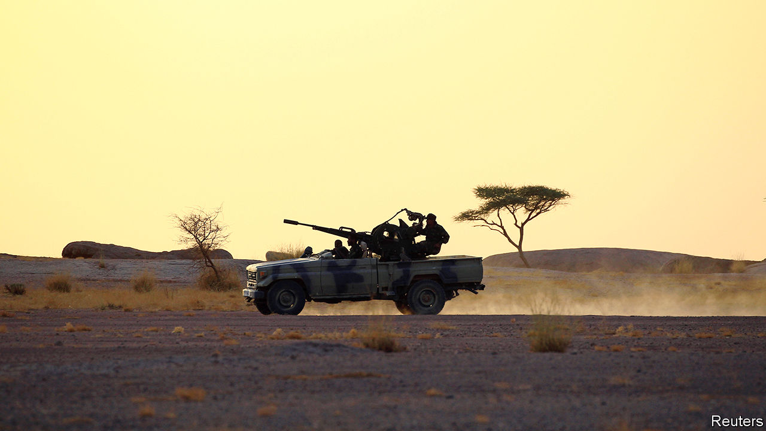

ISRAEL’S FORMAL ties with the Arab world now extend from the United Arab Emirates (UAE) in the east to Morocco in the west. On December 10th President Donald Trump announced the latest breakthrough in his diplomatic push on behalf of the Jewish state. Morocco, the Arab world’s oldest monarchy, will become the fourth Arab state in as many months to establish diplomatic relations with Israel (following the UAE, Bahrain and Sudan).

The agreement is a win for Israel, and also for Morocco. As part of the deal, Mr Trump recognised Morocco’s annexation of Western Sahara. The territory, slightly larger than Britain, is also claimed by the Polisario Front, a nationalist movement backed by Algeria. Mr Trump’s intervention comes amid provocations by both sides that risk restarting a war that ended three decades ago.

That old conflict kicked off in 1975, when Morocco annexed Western Sahara after Spain, the colonial power, pulled out. Polisario, which the UN considers the legitimate representative of the Sahrawi people, resisted—but was outgunned. With Morocco in control of about two-thirds of the territory, and Polisario controlling the other third, the UN brokered a ceasefire deal in 1991 that promised the Sahrawis a referendum on independence. Morocco, though, stands in the way.

Morocco’s treatment of the Sahrawis is in some ways like Israel’s treatment of the Palestinians. Over the years Morocco has used subsidies and tax breaks to convince thousands of its people to move to Western Sahara in an effort to cement its control. Sahrawi protests are suppressed; activists talk of torture by the security services. But the kingdom has also spent billions of dollars fixing up the territory.

Once of primarily symbolic value, Western Sahara’s strategic value has been growing. The side held by Polisario has little in the way of resources. But the portion controlled by Morocco is rich in phosphates and fish. Large reserves of oil may lie offshore. The kingdom also sees Western Sahara as its gateway to west Africa, which buys up Moroccan exports.

So the kingdom is working hard to transform its de facto control of Western Sahara into something more legitimate. Over the past year it has convinced around 20 African and Arab states to recognise its claim. The UN seems to have all but given up on overseeing the referendum. A UN Security Council resolution in October extending the mandate of the UN’s peacekeeping mission did not mention the vote, though it is called the UN Mission for the Referendum in Western Sahara.

“Morocco’s serious, credible and realistic autonomy proposal is the ONLY basis for a just and lasting solution for enduring peace and prosperity!” tweeted Mr Trump, referring to a proposal Polisario does not feel is serious or credible. “Morocco recognized the United States in 1777. It is thus fitting we recognize their sovereignty over the Western Sahara.” Indeed, both acts neglected the opinion of the indigenous population. President-elect Joe Biden could adopt a more even-handed approach.

Inside Morocco, the king’s decision to normalise relations with Israel is controversial. Many Islamists and leftists oppose the move. But most Moroccans seem to consider America’s recognition of the kingdom’s claim over Western Sahara more important than the kingdom’s recognition of Israel. They have long called for putting their needs before those of the Palestinians. A popular slogan, “Taza before Gaza”, refers to cities in Morocco and Palestine.

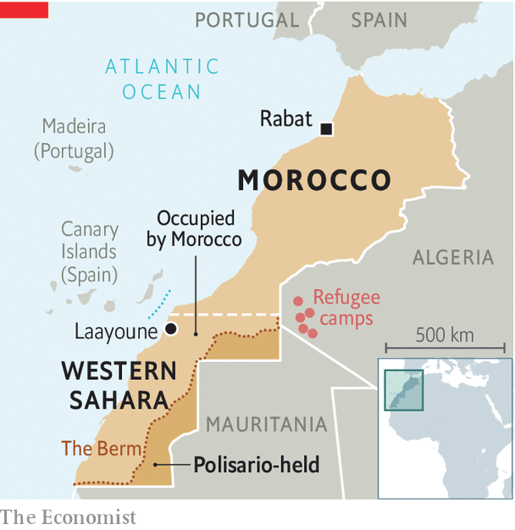

The Sahrawis pose a bigger risk. In October Sahrawi protesters closed the UN-patrolled border crossing at Guerguerat (see map). The area is meant to act as a buffer zone, but Morocco sent in troops to quell the unrest. That enraged Brahim Ghali, leader of Polisario. In November he abandoned the ceasefire and claimed a series of attacks around the 2,700km (1,700-mile) sand berm, built by the Moroccan army, that separates the two sides.

Whether things escalate further depends, in part, on Algeria. It competes with Morocco for access to markets and may see a benefit in the trouble around Guerguerat. But Mr Trump’s deal has it worried. American and Israeli support, warn Algerian generals, might embolden Morocco at a time when Algeria is economically weak and politically unstable. Algeria’s prime minister, Abdelaziz Djerad, warns of a “real threat on our borders, reached by the Zionist entity”.

Some of this may be an effort by Algerian leaders to divert attention from problems at home. But they have the backing of Russia, which criticised America for acting unilaterally on Western Sahara. The manoeuvring of local players and foreign powers is pushing the situation into dangerous territory. Whether or not Mr Trump’s deal lowers tensions in the Holy Land, it is raising them in the Sahara. ■

This article was downloaded by calibre from <https://www.economist.com/middle-east-and-africa/2020/12/16/the-israel-morocco-peace-deal-is-roiling-western-sahara>

|  |  |  |  |
| --- | --- | --- | --- |
| 上一项 | 文章 | 章节 | 下一项 |

|  |  |  |  |
| --- | --- | --- | --- |
| 上一项 | 文章 | 章节 | 下一项 |

#### The lost boys of Kankara

# More than 300 schoolchildren are abducted in Nigeria

President Buhari has failed to contain bandits or jihadists

Dec 19th 2020 | ABUJA

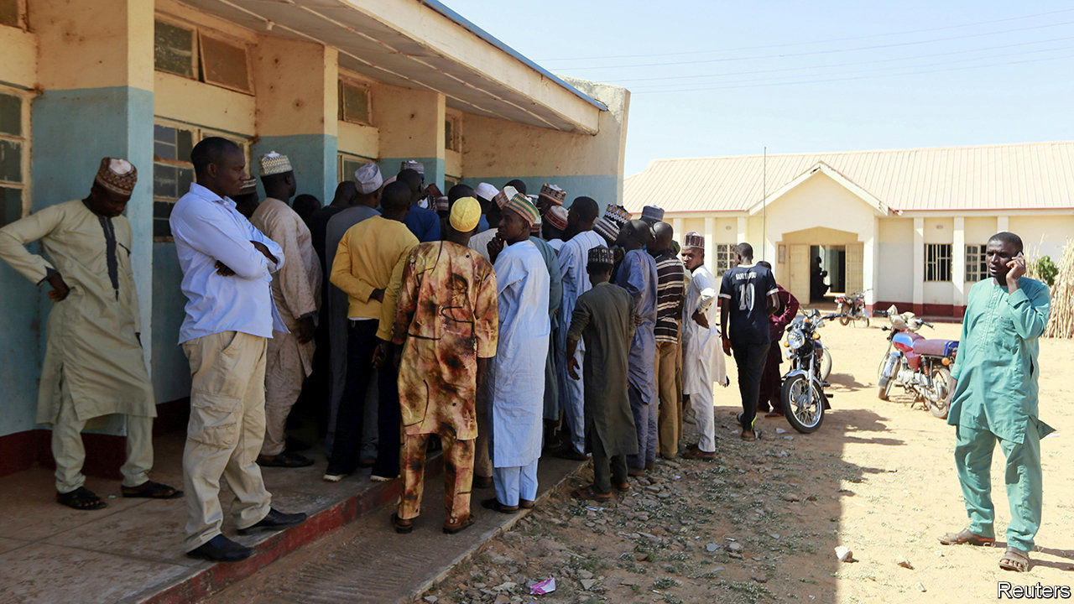

ON DECEMBER 11TH Nigeria’s president, Muhammadu Buhari, flew off to take a holiday at his country home in Daura, an ancient seat of Islamic learning in the northern state of Katsina. That night hundreds of gunmen riding on motorbikes stormed a boarding school in Kankara, also in Katsina state. Some schoolboys jumped over a fence and ran away when they heard gunshots. But more than 300 were rounded up and herded into the surrounding forest. One who later escaped told the BBC they were beaten, threatened and forced to walk through the night.

It was not immediately clear who the culprits were. Nigeria’s government says that the children were taken by bandits who have demanded a ransom for their release. But Boko Haram, a jihadist group, said it was behind the kidnapping. Both explanations are plausible.

Criminal gangs in Nigeria have long been experts at “express kidnaps”, in which wealthy locals and foreigners are grabbed at gunpoint and held until cash is handed over or their bank accounts are emptied through ATMS. In the past few years such gangs have become less discriminating, grabbing thousands of poor folk, including travellers on buses or people living in villages (see map). In some places they have demanded levies from farmers before they allow them to harvest their crops.

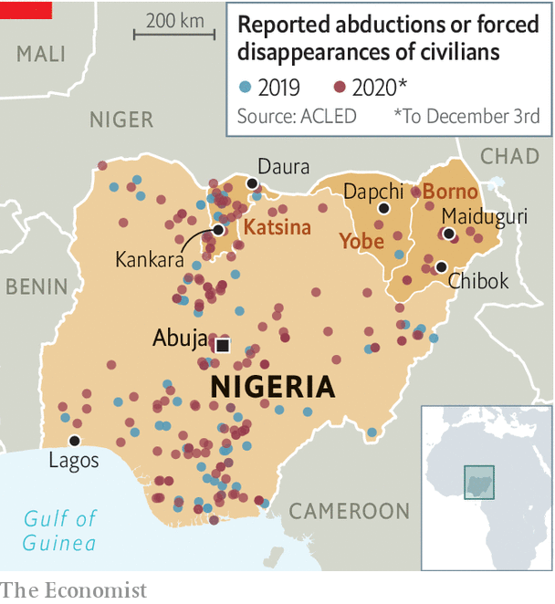

Moreover, this is not the first mass abduction by bandits in the president’s home state. Twenty-six girls kidnapped in October in another town in Katsina were freed after a ransom was paid. They said the kidnappers raped and beat them. Even so, the latest attack would suggest a hitherto unseen level of brazenness by bandits.

The leader of Boko Haram, Abubakar Shekau, offered no proof that his group was behind the kidnapping when he claimed responsibility on December 15th. (After earlier mass kidnappings Boko Haram provided photos or videos of the victims.) Some security experts therefore wondered if this was just a publicity stunt.

In 2014 Boko Haram gained the world’s attention by kidnapping nearly 300 schoolgirls from the town of Chibok in the north-eastern state of Borno, which is at the heart of Nigeria’s jihadist insurgency. In 2018 it snatched more than 100 girls from a boarding school in Dapchi, in neighbouring Yobe state, a move that intelligence officials said demonstrated its ability to mount sophisticated raids over long distances.

If the jihadists carried out the latest outrage, it would mark a big extension of the group’s reach and a deterioration of security across northern Nigeria, because Kankara is more than 700km by road from Maiduguri, the capital of Borno, where Boko Haram emerged. It is also just a few hours’ drive from Mr Buhari’s home in Daura. Yet days after the attack the president had not seen fit to interrupt his holiday and make the short journey to the school, where parents of the kidnapped boys have been camped, anxiously waiting for news. ■

This article was downloaded by calibre from <https://www.economist.com/middle-east-and-africa/2020/12/19/more-than-300-schoolchildren-are-abducted-in-nigeria>

|  |  |  |  |
| --- | --- | --- | --- |
| 上一项 | 文章 | 章节 | 下一项 |

|  |  |  |  |
| --- | --- | --- | --- |
| 上一项 | 文章 | 章节 | 下一项 |

#### Gold bars

# In Congo’s gold rush, the money is in beer and brothels

Pop-up entrepreneurs sell services to miners

Dec 19th 2020 | LUHIHI

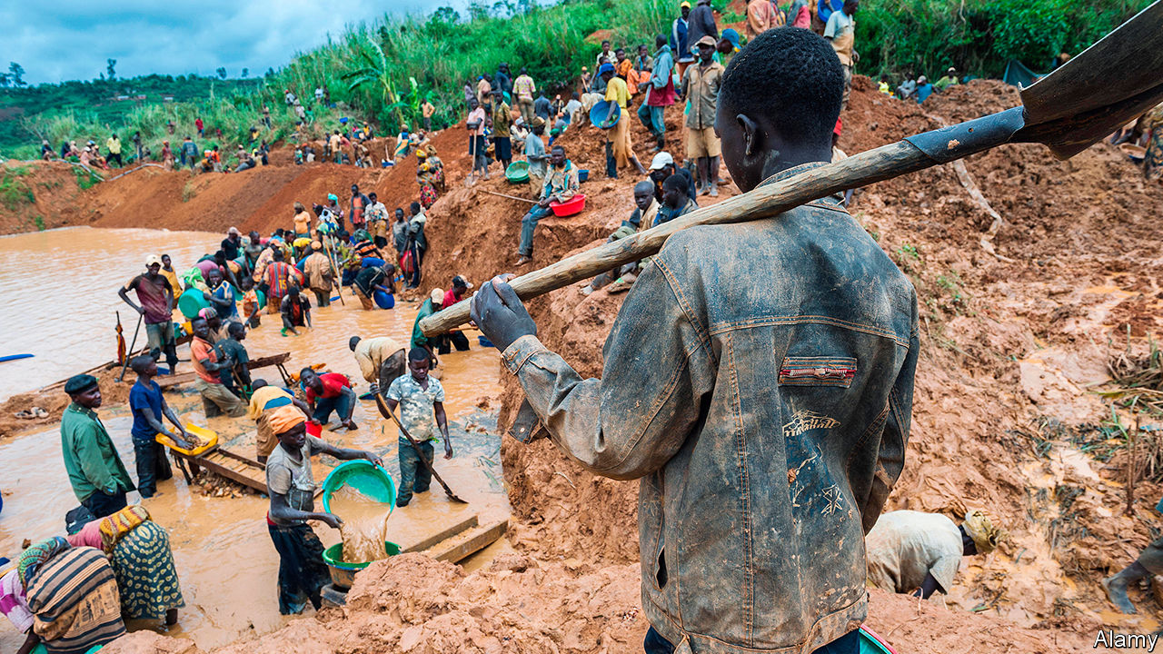

IT IS NOT yet noon but the streets of Luhihi, a tiny town in eastern Congo, are already full of revellers. Men fall about outside bars filled with prostitutes. Gamblers hover over draughtboards. Music blares from a makeshift club near the river where miners sift through mud for gold.

The precious metal was found in Luhihi in May. Artisan miners came rushing in from far and wide. A street of pop-up bars, brothels, shops and gambling dens has sprung up to cater to them. Many of the entrepreneurs running such businesses rove from mine to mine, moving on when the minerals dry up or rebels march into town. For two decades dozens of militias have fought over gold, tin and coltan mines in eastern Congo.

Bertun Mupenda, who runs a nightclub in Luhihi, first set up a bar at a gold-rush town elsewhere in South Kivu province. He left when it was plundered by rebels for a second time. “Seven of them came in the night with guns,” he says. “They beat up my workers, stole my beers and asked us for all the money we had.” Mr Mupenda had to hand over more than $2,000.

Luhihi is fairly safe, partly because it does not seem to have a huge gold deposit. The hill that looms over the town is pockmarked with tunnels. Frustrated men wearing head torches climb out of them, dragging sacks of mud and mumbling that they have not seen gold in weeks. Still, the miners seem keen to spend whatever earnings they have in town.

“The money is good,” says Jeanette Albertine, who runs a bar selling local brews made from fermented bananas and maize. “But I do not feel comfortable here.” Drunk clients try to grope her. They also get into brawls in her bar. She often has to call for help from local policemen, who then demand cash for chasing disorderly customers away. But Ms Albertine is used to such problems: she has spent the past decade moving between gold and coltan mines across North and South Kivu provinces. She earns about $10 a day, far more than she used to make as a farmer.

Luhihi also boasts a string of new hotels made from wood and tarpaulins where local gold traders stay. One miner grumbles that they do not give fair prices and that their scales are weighted to make the gold seem lighter than it really is. He adds that he does not know where the traders take the gold. Much probably goes to Uganda. Gold worth $300m-600m is smuggled out of Congo each year, estimates the Sentry, an American watchdog.

Many miners risk their lives in shaky tunnels because there are few other ways to earn a living. Most of them are still extremely poor. Luhihi’s makeshift bars may heave with clients, but many are there to drown their sorrows rather than celebrate. “Life in the mines is tough,” explains Ms Albertine, forgivingly. “People drink to help them relax.” ■

This article was downloaded by calibre from <https://www.economist.com/middle-east-and-africa/2020/12/19/in-congos-gold-rush-the-money-is-in-beer-and-brothels>

|  |  |  |  |
| --- | --- | --- | --- |
| 上一项 | 文章 | 章节 | 下一项 |

|  |  |  |
| --- | --- | --- |
| Middle East & Africa | 章节 | Britain |

Europe

The Vatican’s finances: Falling on hard times

.

The European Union budget: Locked and loaded

.

Health care: Flight of the white coats

.

Azerbaijan’s ghost towns: Bitterness prevails

.

Charlemagne: Sprechen Sie Tory?

.

|  |  |  |
| --- | --- | --- |
| Middle East & Africa | 章节 | Britain |

|  |  |  |  |
| --- | --- | --- | --- |
|  | 文章 | 章节 | 下一项 |

#### Living on a prayer

# The Vatican’s finances have been squeezed by covid-19

But they are so opaque it is impossible to say how badly

Dec 19th 2020 | ROME

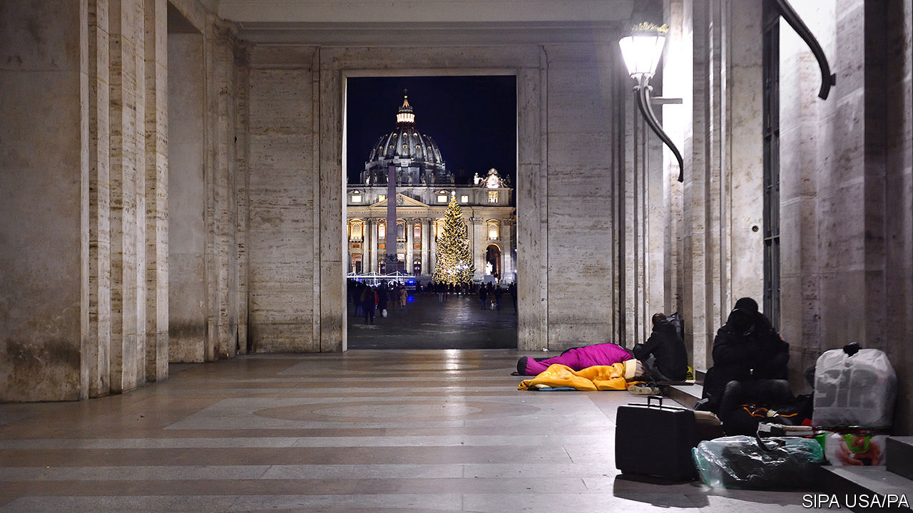

AS NATIVITY SCENES go, the one in St Peter’s Square unveiled on December 11th is a startling departure from tradition. Several of the 54 giant ceramic figures would not look out of place on a Star Wars set. “Ugly and demonic-looking,” one appalled Catholic called them on Twitter. But the crib, apparently inspired by Greek, Egyptian and Sumerian art, is of a piece with a year that has been as exceptional for Europe’s smallest state and its ruler, Pope Francis, as for the rest of the world.

Like most other countries, the Vatican City State will end 2020 with its public finances in a precarious condition. Just how precarious is hard to know, since the latest figures date from 2015 when it had a budget surplus of almost €60m ($73m). But what is known is that the city-state depends largely on revenues from the Vatican Museums to stay in the black. The Catholic News Agency rcently estimated that ticket sales alone bring in just over €100m. And, because of the pandemic, the museums have been closed for months. Even when they have been open, because of restrictions on the number of visitors and the scarcity of tourists in Rome, they have sold far fewer tickets than normal.

All this means that the city-state could well end up with a deficit of €15m or more for 2020. And unlike its bigger neighbours, it does not issue bonds to cover its debts. Nor can it rely on the EU to bail it out. But it doubtless has reserves.

The city-state’s surpluses have till now been used to help fund the spending of the other half of the Vatican: the Holy See, the central administration of the world’s biggest Christian church. Even after contributions from the city-state’s governorate, a dividend from the Vatican Bank and donations from the faithful, the Holy See ended 2019 €11m in the red. The Vatican’s “finance minister”, the prefect of the Secretariat for the Economy, Father Juan Antonio Guerrero Alves, said that, had it not been for extraordinary items, the deficit would have been twice as big.

The Holy See can count on a much increased dividend from the Vatican Bank, which made a profit of €38m in 2019. But, in reaction to the pandemic, Pope Francis has halved the rent on the properties that the Holy See owns and on which it depends for about a third of its revenue. It will also have lost much of its income from commercial activities, such as the sale of publications. And contributions from the Catholic church’s dioceses are likely to be lower too, since fewer worshippers have been able to attend church services. Il Sole-24 Ore, a financial daily, reported in June that the Holy See was bracing itself for a €53m deficit. With Italy now in the grip of a second wave of infection, that could prove to be an underestimate.

The Vatican’s financial difficulties are entangled with two other interconnected issues awaiting Francis in 2021, a year in which he will undertake a potentially hazardous visit to Iraq. The first is the outcome of a judicial investigation into a deal worth €200m involving the purchase of a property in London. Prosecutors are investigating whether the Holy See was swindled. The second is a report on the Vatican’s finances by Moneyval, the European anti-money-laundering watchdog, expected in April.

Though the investigation, which has dragged on for 14 months without charges being laid, appears to show a determination to clamp down on anything that might give rise to suspicions of jiggery-pokery in the Vatican’s notoriously opaque financial dealings, it has also cast doubt on the papacy’s capacity to regulate them. It has prompted the removal of the director of the Vatican’s financial regulator, who denies any wrongdoing, and turned the spotlight on a third, hitherto virtually unknown sphere of financial activity. This consists of funds running to hundreds of millions of euros that are managed by individual Vatican departments. (The property in London was bought not by the papacy’s sovereign-wealth fund, the Administration of the Patrimony of the Holy See, or APSA, but by the Secretariat of State, which combines the roles of a foreign and interior ministry.)

Management of the secretariat’s pot of gold has since been transferred to APSA, but the confusion and secrecy that still envelope the Vatican’s finances are symptomatic of an administration that is in many respects highly efficient, yet patently in need of modernisation more than 50 years after the last big reform, under Paul VI.

Francis was elected in 2013 as the candidate of cardinals who were urging a shake-up of the Holy See. One of his earliest moves was to delegate the job to a council of advisers drawn mostly from outside Rome and notably short on Vatican bigwigs—a sign of his preference for decentralising the church’s bureaucracy. That alone made him deeply suspect to many in the Holy See and is part of the explanation for a resistance to Francis’s papacy that often manifests itself as opposition to his theological ideas.

After seven years of effort, the pontiff’s advisers are currently working on the final draft that is expected to form the basis in 2021 for an Apostolic Constitution, the most solemn kind of papal edict. Its promulgation is likely to be the high point of the Vatican’s year. A draft of the edict that was circulated in Rome and sent to national bishops’ conferences in 2019 would diminish the status of the Vatican’s feared doctrinal enforcement body, once known as the Holy Office. Revolutionary? Certainly. But perhaps the message of those bizarre figures in St Peter’s Square this Christmas is that, under Pope Francis, nothing should be taken for granted. ■

Editor’s note: Some of our covid-19 coverage is free for readers of The Economist Today, our daily [newsletter](https://my.economist.com/user#newsletter). For more stories and our pandemic tracker, see our [hub](https://www.economist.com/news/2020/03/11/the-economists-coverage-of-the-coronavirus)

This article was downloaded by calibre from <https://www.economist.com/europe/2020/12/19/the-vaticans-finances-have-been-squeezed-by-covid-19>

|  |  |  |  |
| --- | --- | --- | --- |
|  | 文章 | 章节 | 下一项 |

|  |  |  |  |
| --- | --- | --- | --- |
| 上一项 | 文章 | 章节 | 下一项 |

#### Locked and loaded

# The EU gives itself a weapon to battle against rule-of-law violations

But will it use it?

Dec 19th 2020 | BERLIN

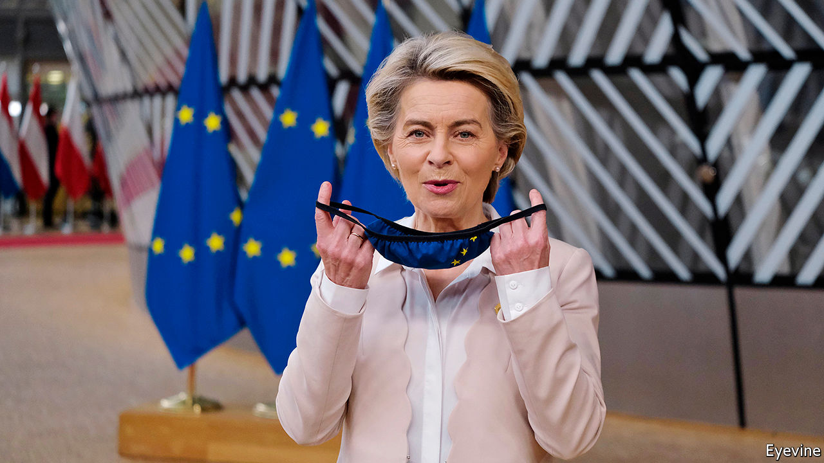

ANGELA MERKEL, Germany’s chancellor, has long applied two operating principles in Europe: to keep the club united, and to postpone resolving crises until the last possible moment. Both were evident in an eleventh-hour deal struck on December 10th in Brussels between the European Union’s 27 heads of government. With a fiscal crunch looming, the leaders at last gave the green light to a seven-year EU budget worth €1.1trn ($1.3trn) as well as a one-off €750bn fund, financed by joint borrowing, to speed recovery from the covid-19 crisis.

The sticking-point was a problem that has long bedevilled the EU: how to tackle corruption and other skulduggery in countries that benefit from EU transfers. At a gruelling four-day summit in July, the leaders backed the principle of attaching rule-of-law conditions to the vast EU spending they had approved. But Hungary and Poland, unhappy with the proposed legal regulations that followed in November, threatened to veto both the budget and the recovery fund. (Both countries are already facing EU rule-of-law probes over their government’s interference with national judiciaries and other matters.)

Faced with drastic cuts that would have applied had the EU begun 2021 without a budget in place, the European Commission considered the radical step of rebuilding the recovery fund outside EU structures, excluding the hold-outs. That threat, say diplomats, concentrated minds in Warsaw and Budapest. In a late flurry of diplomacy the German government, which holds the rotating presidency of the EU Council, issued a supplementary proposal. Viktor Orban, Hungary’s prime minister, flew to Poland to persuade his allies to sign on. Satisfied with Mrs Merkel’s work, the rest of the EU assented in Brussels.

Under the German proposal, the text of the rule-of-law regulation remains untouched. That enables the European Commission to block disbursements of EU money, including from the recovery fund, if it suspects recipient governments of corruption or other foul play, so long as a qualified majority of EU governments agree. That could pose a threat to the system of authoritarian cronyism Mr Orban has assembled on the back of EU funds amounting to around 3% of annual GDP. Poland’s system is cleaner but, notes Piotr Buras at the European Council on Foreign Relations in Warsaw, the government’s court-stacking could fall foul of the regulation’s references to judicial independence, if the commission thinks it interferes with the management of EU funds.

The biggest concession to the hold-outs was an agreement that no action would be taken under the mechanism until the EU’s top court had ruled on its legality, a process that could take up to two years (but which is likely to be accelerated). Critics, such as George Soros, a financier and Mr Orban’s bête noire, see this and smaller concessions as a sell-out to the rogues. Indeed, after the summit Mr Orban declared victory with typical bombast. But both his and Poland’s government had vowed to see off the regulation. Their failure even to water it down shows where the burden of compromise really fell. Poland’s hardline justice minister, who said the deal violated the constitution, even threatened to bring down his government, before backing down.

The EU’s previous attempts to tackle rule-of-law abuses in member states have signally failed. This one may have teeth—should the EU decide to apply them. That remains an open question: wary of shunting governments into an outer orbit, Mrs Merkel has long proved tolerant of Hungarian and, more recently, Polish excesses. (Mr Orban’s Fidesz party sits with the chancellor’s in the European Parliament.) That instinct remains intact, as her scramble to conclude Germany’s presidency with a budget deal demonstrates. Yet other politicians who have built careers opposing chicanery and money-grubbing are cautiously optimistic. Slovakia’s president, Zuzana Caputova, who was elected on a rule-of-law ticket in 2019, says she is glad that the principle is now legally binding at EU level. But, she adds, “having the mechanism to defend the rule of law in place is just the first step. Now we need to make it work.” ■

This article was downloaded by calibre from <https://www.economist.com/europe/2020/12/19/the-eu-gives-itself-a-weapon-to-battle-against-rule-of-law-violations>

|  |  |  |  |
| --- | --- | --- | --- |
| 上一项 | 文章 | 章节 | 下一项 |

|  |  |  |  |
| --- | --- | --- | --- |
| 上一项 | 文章 | 章节 | 下一项 |

#### Flight of the white coats

# Why Balkan doctors head for western Europe

Corruption bedevils those who remain in Romania

Dec 19th 2020 |

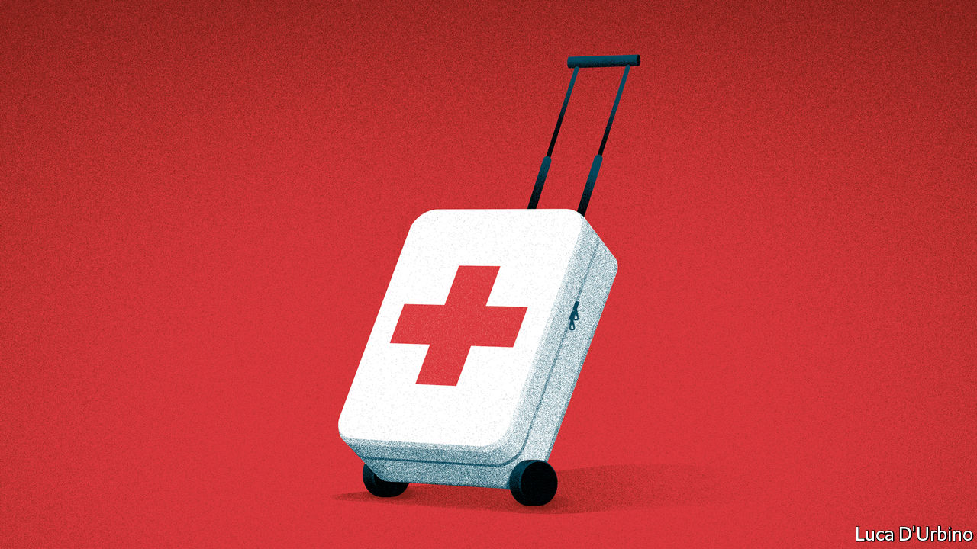

HEALTH-CARE systems everywhere are buckling because of covid-19. In south-east Europe, rising infection rates are hammering systems that were already run-down. Balkan doctors and nurses have been emigrating for years. The main reason is that conditions at home are poor. Pay is low, graft is rife and hospitals are often run by venal political appointees. Jobs in western Europe seem cushy by comparison.

In Bucharest, Romania’s capital, 27 people died when a nightclub caught fire in 2015, but four months later the toll had risen to 64. Many had been killed by hospital infections attributable to corruption. Disinfectants had been so diluted that they had virtually turned to water. In a new documentary about the scandal, Vlad Voiculescu, briefly Romania’s minister of health, says that since taking the top job he has realised that everything underneath him “is rotten…corrupt, demotivated. They don’t give a fuck about anything out there.”

One consequence is that nearly 5,000 Romanians now work for England’s National Health Service. But Mr Voiculescu could have been speaking for the entire region. In 2019 there were 50,000 citizens of the six non-EU Balkan countries working in Germany’s health-care system, two-thirds of them Bosnians and Serbs. In spring, when the pandemic struck and borders closed, Austria laid on special transport to bring in hundreds of Bulgarian, Croatian and Romanian health workers.

Balkan tabloids sometimes claim there will soon be no more doctors and nurses left in their countries. But the story is not as simple as that. Romania actually has 21% more doctors than it did a decade ago, while in Bulgaria the numbers are stable. Since 2013 almost 6,000 Bosnian nurses have gone to work in Germany on just one official scheme, yet more than 7,500 nurses back home are unemployed.

In the past few decades more people in the Balkans have been studying medicine than ever before, not least because it is a good way to land a well-paid job abroad. There are not enough jobs for those who stay behind, however, and those that exist are often unattractive. In Romania few doctors want to work in remote regions or be general practitioners, who are badly paid.

Some local medical training is poor. Serbian colleges churn out nurses with patchy knowledge. Gorica Djokic, a leader of Serbia’s doctors’ union, says that some who “can’t tell if a patient is asleep or in a coma” are employed in hospitals to make up for those who have gone abroad. As for doctors, she identifies two problems that are common across the region. Those most likely to emigrate do so at the beginning of their careers or are sought-after specialists. The average age of doctors who stay in Serbia, she says, is 55.

To stanch the flow of emigrants, health services have raised doctors’ wages. In Romania they have tripled in the past few years. Alexandru Radu, aged 22, is a fourth-year medical student. When he thought he would be paid only a couple of hundred euros a month in his first job, he “100%” planned to go abroad. Now, with a chance to earn €1,000 a month in his home country when he graduates, he says: “I really want to stay here.” ■

This article was downloaded by calibre from <https://www.economist.com/europe/2020/12/19/why-balkan-doctors-head-for-western-europe>

|  |  |  |  |
| --- | --- | --- | --- |
| 上一项 | 文章 | 章节 | 下一项 |

|  |  |  |  |
| --- | --- | --- | --- |
| 上一项 | 文章 | 章节 | 下一项 |

#### Ghost towns and grievances

# Azeris return to their ruined old homes

It will be hard to soften the hatred between Armenians and Azeris

Dec 19th 2020 | BAKU

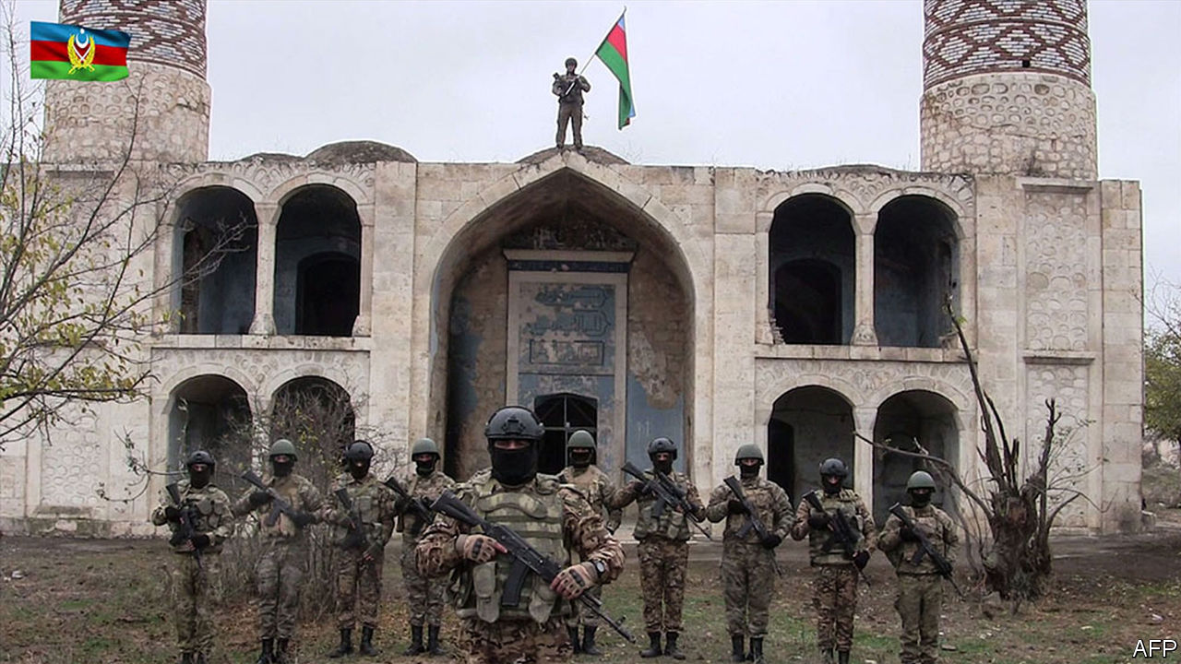

THERE IS PLENTY of farmland in Fuzuli, one of Azerbaijan’s districts that ring the disputed region of Nagorno-Karabakh. But there is nothing to harvest. Where wheat and grapes once grew, unexploded rockets sprout from the ground at odd angles, reminders of the vicious fighting that tore through the area in the autumn. The charred hulks of tanks remain. A cratered road snakes through a wasteland of villages and towns abandoned after an earlier bout of violence three decades ago. Thousands of landmines lurk underground.

Farther north in Agdam, once an Azeri city of 40,000 people, Aide Huseynova, a pensioner, snaps photos of a ruined 19th-century mosque. She escaped from Agdam in 1993, during the first Nagorno-Karabakh war, fleeing before an Armenian offensive. About 1m people, most of them Azeris, were displaced in the fighting. Now, for the first time since then, she is back. Yet there is nothing left for her to see, bar a sea of rubble and crumbling walls that stretches for miles in every direction, looking like the aftermath of a nuclear attack. The mosque is the only building left standing. “My heart aches,” says Mrs Huseynova. “I don’t want to see it at all.”

In a campaign that lasted over six weeks and ended with a ceasefire on November 9th, Azerbaijan recovered the seven districts, including Fuzuli and Agdam, that Armenian forces had occupied since the 1990s. (Most of Nagorno-Karabakh, still populated almost exclusively by Armenians, remains in the separatists’ hands.) At least 5,000 people were killed in the recent fighting. Human-rights groups have called on both sides to investigate reports of war crimes, including videos that appear to show executions and other atrocities committed by Azerbaijani troops.

The devastation inflicted on Azeri towns during the 27 years under Armenian control will be hard to undo. The Armenian separatists who ran Nagorno-Karabakh used the districts once occupied by Azeris as a buffer zone and a future bargaining chip, making many of them uninhabitable. Buildings were bulldozed. Looters took anything the former residents had left behind. Some put the cost of reviving these ghost cities at as much as $15bn, though Azerbaijan’s government has yet to make an estimate. It could take seven years to de-mine the districts, says Hikmet Hajiyev, an aide of Azerbaijan’s president.

Many Azeri refugees from the disputed enclave are destitute, while Azerbaijan’s upper class prospers because of plentiful oil. In a shabby block of flats on the edge of Baku, the capital, Aliyev Karim Hasimoglu, a former metal-worker from Fuzuli, shares a single room with four relations. He says he wants to live long enough to rebury a brother, who died in the first Karabakh war, in their ancestral village. He has spent the past 25 years in the same room; 20 other refugee families live on the same floor. Three communal bathrooms serve about 100 people. Paint peels from the walls, pipes leak and cigarette butts litter the staircases. Mr Hajiyev says his government spends $1bn a year on the refugees, but many say that is not enough.

Mrs Huseynova says she had Armenian neighbours before the war, but would curse them if she saw them again. “As an Azerbaijan citizen from Agdam, I don’t want to live next to them.” ■

This article was downloaded by calibre from <https://www.economist.com/europe/2020/12/19/azeris-return-to-their-ruined-old-homes>

|  |  |  |  |
| --- | --- | --- | --- |
| 上一项 | 文章 | 章节 | 下一项 |

|  |  |  |  |
| --- | --- | --- | --- |
| 上一项 | 文章 | 章节 | 下一项 |

#### Charlemagne

# Sprechen Sie Tory?

British Tories and European Christian Democrats don’t get each other. Hence the Brexit shambles

Dec 19th 2020 |

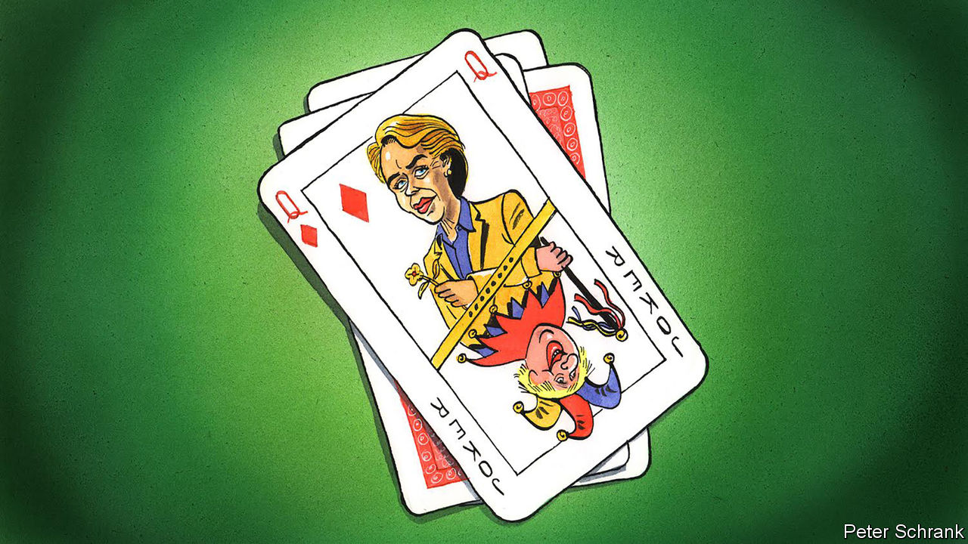

SQUINT A LITTLE, and Boris Johnson and Ursula von der Leyen look rather alike. The British prime minister and the president of the European Commission were both children of Eurocrats, partly brought up in Brussels. Both were written off in domestic politics, only to be catapulted into the biggest jobs of their lives. Both have enough children to fill a minibus.

Open your eyes fully, however, and the differences become clear. Whereas Mrs von der Leyen speaks like a technocrat, Mr Johnson speaks like a bloke telling jokes in a pub. Mrs von der Leyen is overseeing a much-needed deepening of the EU. Under Mr Johnson, Britain has left it. Mrs von der Leyen boasts of her seven children; Mr Johnson refuses to specify how many he has (Wikipedia opts for “at least six”).

The political traditions from which the two leaders come are also less alike than you might expect. Mr Johnson is a Conservative; Mrs von der Leyen is a Christian Democrat. These two philosophies have much in common. They both sit on the centre-right as natural parties of government, with reputations for fiscal prudence. Their ideologies are mushy. Each abhors big thinkers: there is no equivalent of Marx or Mill when it comes to either outlook. Pragmatism is a point of pride for both; generally, keeping lefties out of power—or at least constrained—is enough of a purpose. But it is their differences that help explain why Britain never sat easily in the bloc.

After all, the EU was a Christian Democratic invention. Its founding fathers—Alcide De Gasperi of Italy, Konrad Adenauer of Germany and Robert Schuman of France—were Christian Democrats, as were all six foreign ministers who signed its original treaties. Although no longer hegemonic, Christian Democratic parties still shape the EU. They bestride the European People’s Party (EPP), the group of centre-right parties, which carves up EU jobs, such as Mrs von der Leyen’s. Angela Merkel, Germany’s Christian Democratic Union chancellor, is comfortably the continent’s most powerful politician. Christian Democrats built Europe and they still, more or less, run it. To understand Europe, one must understand Christian Democracy. Unfortunately for Britain, the Conservatives—their closest cousins across the Channel—never have.

Sometimes these misunderstandings resulted in strategic errors. When running for the leadership of the Conservatives, David Cameron pledged to leave the EPP, the club of the mainstream right. For Mr Cameron, it was a simple decision. In general, the Christian Democrats who dominated the group wanted more European integration, whereas Mr Cameron and his Conservative party did not. The promise was meat for a hungry Eurosceptic membership, and helped Mr Cameron win. But to Mrs Merkel, it was an insult. The EPP was a broad church with a deeper purpose that has dominated Christian Democracy: to stop the socialists from running the show. Quitting was akin to desertion.

Individualism is either a goal or a horror, depending on whether one is speaking to a Conservative or a Christian Democrat. Margaret Thatcher once declared that there is “no such thing as society”, only individuals and families. Jacques Maritain, one of the few examples of a Christian Democratic political philosopher, put rampant individualism in the same breath as totalitarianism, suggesting that any form of Christian Democracy must be “opposed to both the idea of the totalitarian state and the sovereignty of the individual”. In this view, there is nothing but society.

Even the preferred methods of politics clash. The slow, grinding consensus-building at the heart of Christian Democracy and consequently the EU itself is anathema to Conservatives, for whom the term sounds too much like capitulation. Compared with the winner-takes-all system of British politics, the workings of the EU seem slow and unresponsive to Conservative eyes and just the ticket to Christian Democrat ones. “Merkel is not a Thatcher,” wrote Mr Cameron in his autobiography, not altogether approvingly. “Her favourite expression is ‘step by step’.” By contrast, the Conservative Party has a distinctly unconservative lust for creative destruction. Brexit, a project that radically overhauls the state, is simply the latest example. Rather than proceeding step by step, Brexit means taking a giant leap. Even the presentation of these policies is different. Dullness is a virtue for Christian Democrats. For Conservatives, it is a sin. Angela Merkel is far from the first Christian Democrat leader to revel in anti-charisma. For Mr Johnson, charisma is his main weapon.

## Not just the narcissism of small differences

The fundamental split in the Christian Democratic and Conservative worldview has dogged Brexit negotiations. Ultimately, Brexit is a project that puts the nation-state back at the centre of politics. By contrast, Christian Democracy is built on deep suspicion of it. Partly this stems from an analysis of the 20th century as either the triumph of the nation-state (the British view) or its tragedy (that of much of western Europe). In the Christian Democratic worldview, power should be diffuse, spread across local, regional and national levels. Adding another layer in the form of Europe was no big deal. “It was easy to give up parts of what was feared in the first place,” writes Jan-Werner Mueller of Princeton University. To Conservatives, however, a supranational layer of authority was an affront.

Arguments over “level playing-field” arrangements in Brexit may seem like technical wrangling. In fact, they are a clash between the Conservative and Christian Democratic view of the state. Conservatives want power yanked back; Christian Democrats struggle to understand why. Mutual incomprehension is a poor basis for a relationship. Yet that was the foundation of Britain’s relationship with the EU: the dominant ideology of both polities was unable to understand the other side. Like Mr Johnson and Mrs von der Leyen, Britain and its EU peers may look similar, but they are far from the same. Unless you squint. ■

For more coverage of matters relating to Brexit, visit our  [Brexit hub](https://www.economist.com/brexit)

This article was downloaded by calibre from <https://www.economist.com/europe/2020/12/19/sprechen-sie-tory>

|  |  |  |  |
| --- | --- | --- | --- |
| 上一项 | 文章 | 章节 | 下一项 |

|  |  |  |
| --- | --- | --- |
| Europe | 章节 | International |

Britain

Negotiations with the EU: An extra mile, a narrow path

.

Brexit-related disruption: Lorrypolitik

.

Heathrow expansion: Cleared for take-off

.

Animal welfare: The pet offensive

.

Bagehot: The wisdom of Scrooge

.

|  |  |  |
| --- | --- | --- |
| Europe | 章节 | International |

|  |  |  |  |
| --- | --- | --- | --- |
|  | 文章 | 章节 | 下一项 |

#### Brexit negotiations

# Britain and the EU edge closer to a trade deal

Lying behind the most contentious issues in the Brexit trade talks is a lack of trust

Dec 19th 2020 |

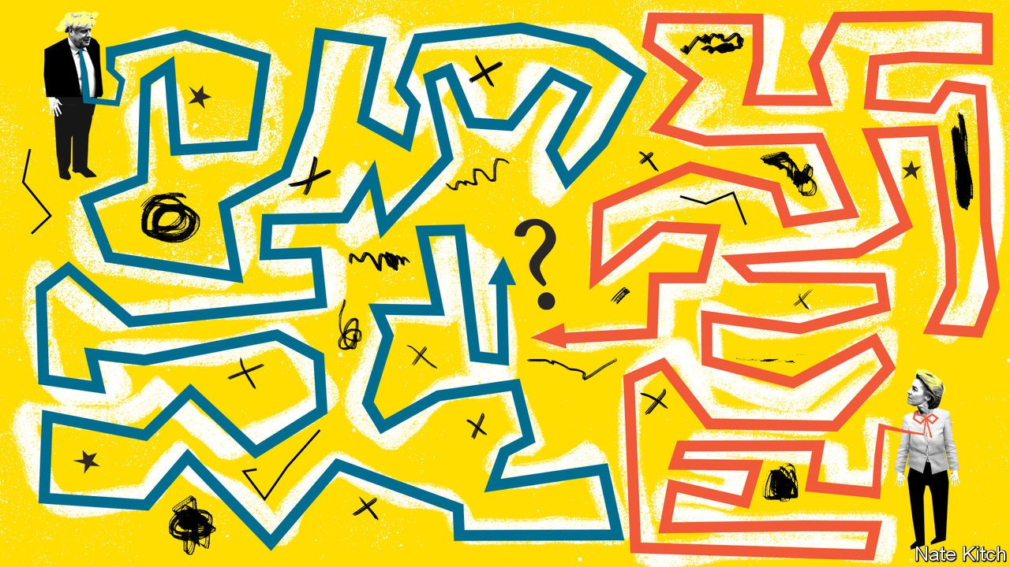

BORIS JOHNSON has often claimed that a story he wrote as a journalist in May 1992 entitled “Delors plan to rule Europe” helped swing Danish voters towards a narrow rejection of the European Union’s Maastricht treaty. That the article, like much that he wrote about the EU, bore little relationship to the truth has never appeared to trouble him much; yet the suspicions around his character which his coverage of Brussels engendered in the European Commission are now coming back to bite him, for they threaten to undermine his chance of doing a last-minute trade deal with the EU.

Britain’s year-long transition out of the EU ends on December 31st, and several deadlines for the two parties to complete a trade deal have already passed. On December 13th Mr Johnson marked another supposedly final deadline by agreeing with Ursula von der Leyen, the Commission’s president, that negotiations should continue for an “extra mile”. This deadline extension raised hopes that the two sides may be shifting from their entrenched positions. Michel Barnier, the EU’s chief negotiator, reportedly detected a narrow path to a deal. Yet Mr Johnson insisted that no-deal was still the most likely outcome, and both sides repeated that the gaps over the two toughest issues remained wide.

The highest-profile one is the EU’s desire to retain access to British fishing waters. This has prompted hysterical chatter about gunboat diplomacy in the channel. Yet the industry’s economic insignificance (it is worth barely 0.1% of GDP) and the fact that both sides sell much of their fish to each other means that fisheries were never likely to be a deal-breaker on their own.

The other big issue, the “level playing field” for competition, could be. Right from the start, the EU made clear that granting Britain tariff- and quota-free access to its single market (a more generous deal than Canada’s) required measures to guarantee a level playing field for social, environmental, labour and state-subsidy standards. Yet Britain insisted on its sovereign right, as a third country, to diverge from EU rules if it chose. The political declaration appended to the withdrawal treaty duly promised “robust commitments to ensure a level playing field”. But soon after its ratification, David Frost, Mr Johnson’s Brexit negotiator, declared in Brussels that the right to diverge from EU rules was the whole point of the Brexit project. In effect, Mr Johnson’s government is saying that the pain and dislocation it will entail is worthwhile in large part because of the future benefits of no longer being bound by the EU’s hidebound and inflexible regulations. On the other side the EU sees unfettered access to its single market as a prize that can safely be awarded only to those willing broadly to comply with its rules.

Despite such differences, it should be possible to find a compromise that acknowledges the trade-off that exists between full sovereignty on one side and unfettered access to the single market on the other. Early on Britain conceded the principle of “non-regression”, meaning a promise not to dilute existing regulatory standards. For its part, the EU backed away from its initial tough negotiating position that Britain must adhere strictly to any future changes to its rules against excessive state subsidies. But differences have persisted over the consequences of future divergence, over a mechanism to settle disputes and over the right of either side to retaliate swiftly if it deems the other to be stealing an unfair competitive advantage.

That’s where the trust problem comes in. An agreement over these issues depends on a degree of trust, which is essential for any comprehensive trade deal that relies not just on legal enforcement mechanisms but also on its signatories showing good faith in the commitments they have made. EU leaders believe they have every reason to distrust Mr Johnson, and not just because of his journalistic past. They think the Brexit referendum was won on the back of a campaign of untruths, and their confidence in him has been further undermined by this autumn’s saga of the internal-markets bill, in which Mr Johnson proposed unilaterally to amend the Northern Irish provisions that were part of the withdrawal treaty. Although he has now dropped this plan, the damage to the relationship lingers. It was little surprise that Mrs von der Leyen was moved recently to declare that “trust is good, but law is better”.

Britain is more vulnerable to the consequences of no-deal than is the EU, so if a deal is to be done it is Mr Johnson who will have to make concessions. But he is under pressure from hardliners in his own party not to concede anything on the principle of full sovereignty. And he knows that, even if a trade agreement is struck, disruption will be inevitable. It would be a lot easier to blame this on the malevolent EU if there were no deal than if he had acquiesced to one at the last minute.

Yet business is piling pressure on the government to avoid no-deal, which would mean not just disruption (see [article](https://www.economist.com/britain/2020/12/16/will-brexit-cause-disruption-in-britains-ports)) and broken supply chains but also tariffs that could bankrupt farmers and carmakers (who would be subject to tariffs of up to 40% and 10% respectively) and send unemployment rocketing. The distance between the two sides remains considerable and the path narrow. But the smart money is on Mr Johnson conceding just enough over retaliation under the level-playing-field provisions to secure a deal.■

For more coverage of matters relating to Brexit, visit our  [Brexit hub](https://www.economist.com/brexit)

This article was downloaded by calibre from <https://www.economist.com/britain/2020/12/19/britain-and-the-eu-edge-closer-to-a-trade-deal>

|  |  |  |  |
| --- | --- | --- | --- |
|  | 文章 | 章节 | 下一项 |

|  |  |  |  |
| --- | --- | --- | --- |
| 上一项 | 文章 | 章节 | 下一项 |

#### Trade

# Will Brexit cause disruption in Britain’s ports?

Imports are unlikely to be affected, but exports may well be

Dec 19th 2020 |

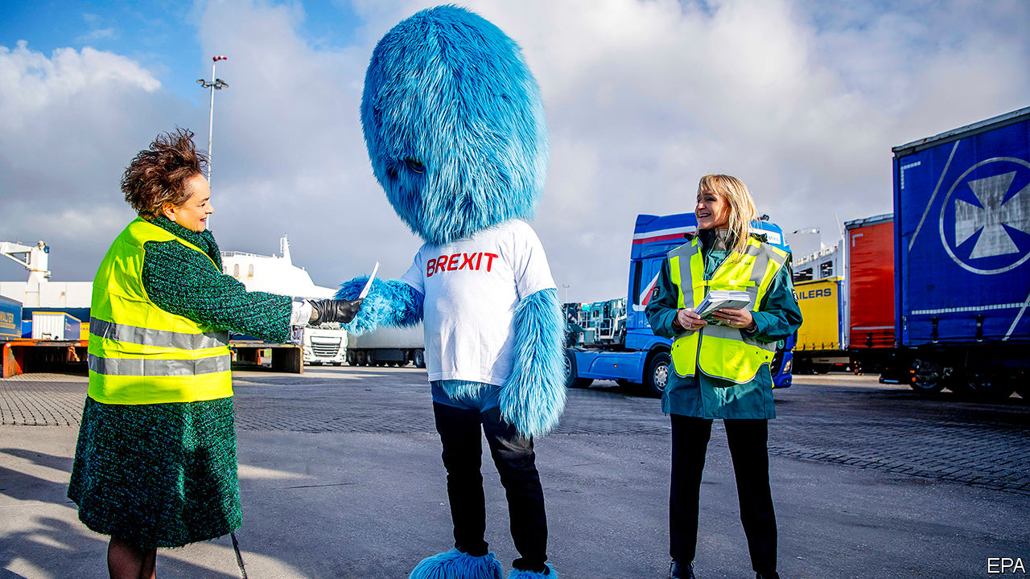

SINCE THE European Union’s single market took effect in 1992, goods have flowed freely across Britain’s border with the EU without the suite of checks normally carried out at a country’s frontier. When Britain leaves the union at 11pm on December 31st, this arrangement will end. Pol Sweeney of Descartes, a supply-chain technology company, estimates that Britain’s departure will create a requirement to inspect a volume of goods some five to ten times larger than are checked at present. Those checks will be required with or without a deal, but will have to be more detailed if no agreement is in place.

Such a sharp increase threatens to overwhelm British ports’ infrastructure. Three decades of freedom mean that most of Britain’s trade with the EU now takes place via “roll-on-roll-off” ferry ports, many of which, because they have never needed it, have no space to carry out newly required physical checks. In preparation, lorry parks have been built around the port of Dover, which accounts for 69% of all goods-vehicle movement between Britain and the EU. The tax office, HMRC, is building a new computer system, the Goods Vehicle Movement Service, to try to minimise disruption. In principle, instead of stopping lorries at the border to inspect their contents, the system allows for checks to be done digitally while they are on the move. The system is not finished, with Britain’s departure days away.

Britain has already said it will fudge its own enforcement on inbound goods for the first six months of 2021, a hedge against disruption. So, barring perhaps protest and other unpredictable outcomes that may arise in the event of no deal, there will be few changes for trade coming into Britain from the EU. A freshly Brexited Britain has the autonomy to continue that situation as long as it needs in the name of minimising disruption, although Mark Clough of Dentons, a law firm, notes that such leniency will probably violate World Trade Organisation rules. Mr Clough says Britain’s view appears to be that by the time any country complains about the lax treatment EU imports are receiving, it will have sorted out any problems and be operating under the rules. Tony McDonach of Hill Dickinson, a maritime law firm, calls the proposal to wave through goods in the name of minimising disruption a “smuggler’s charter”.

Goods moving from Britain to Europe are more vulnerable. France, Belgium and the Netherlands, the European countries into which British goods primarily flow, do not have Britain’s freedom to fudge. As EU members they are all bound by the Union Customs Code, which means, says Brian Mulier of Bird and Bird, a law firm, that 4% of all goods must be physically inspected. Europe’s Court of Auditors will be hovering over the proceedings to ensure that EU rules are followed. If Kent’s lorry parks fill up with outbound vehicles, backed up from the point where they gain entry to the EU, that may have a knock-on effect on inbound traffic, for European hauliers may refuse to take goods into Britain for fear of getting embroiled in the mess.

EU states already have some flexibility on the application of tariffs on pandemic-related supplies, as well as the power to suspend duties in the name of disaster relief. Given that existing flexibility, if disaster looms post-Brexit, Mr Clough sees no reason why the European countries might not also wave goods through to avert a crisis. Sadly for residents of Kent, the Garden of England’s transformation into a lorry park is unlikely to count. ■

For more coverage of matters relating to Brexit, visit our  [Brexit hub](https://www.economist.com/brexit)

This article was downloaded by calibre from <https://www.economist.com/britain/2020/12/19/will-brexit-cause-disruption-in-britains-ports>

|  |  |  |  |
| --- | --- | --- | --- |
| 上一项 | 文章 | 章节 | 下一项 |

|  |  |  |  |
| --- | --- | --- | --- |
| 上一项 | 文章 | 章节 | 下一项 |

#### Air travel

# Heathrow can build its third runway

But it may not want to

Dec 16th 2020 |

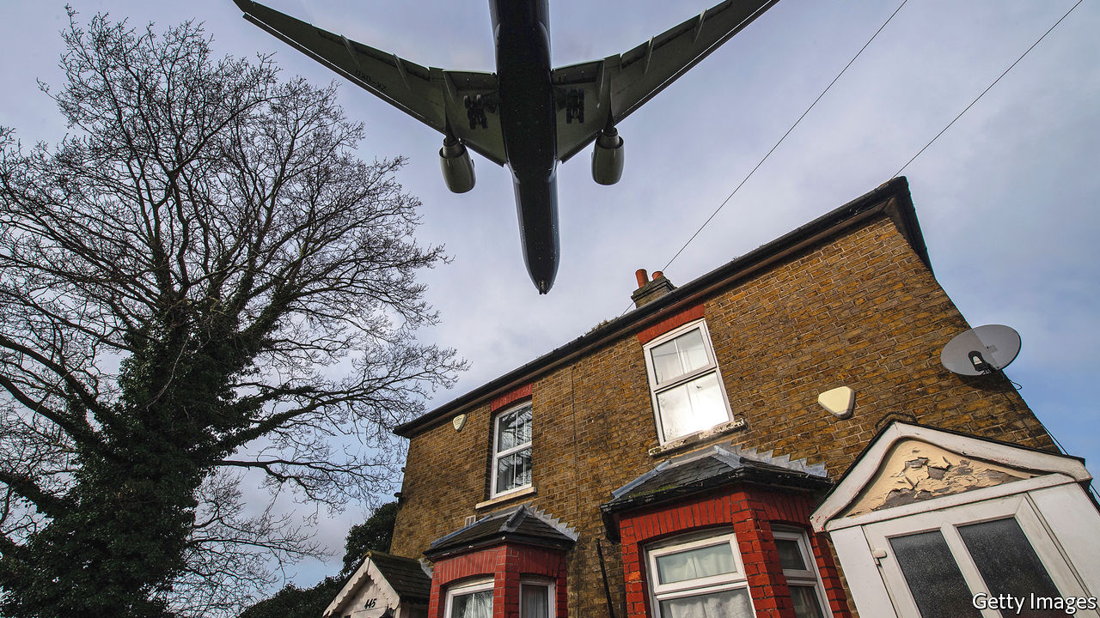

THE SAGA of the potential third runway at Heathrow, Britain’s largest airport, has been called the longest take-off in history. A commission in 1993 recommended expansion, and the government first endorsed the plan in 2003. But it was not until 2018 that the transport secretary finally gave the project the go-ahead. A Court of Appeal ruling in February 2020 that the runway was not compatible with Britain’s obligations under the Paris climate agreement of 2015 appeared to have finally scuppered the plans. But on December 16th the Supreme Court overturned that judgment and once more green-lit the project.

The initial Court of Appeal judgment found that the government’s decision to allow the expansion to go ahead was unlawful because Chris Grayling, then transport secretary, had failed to take the Paris agreement into account. While that was a blow to Heathrow, it helped get Boris Johnson’s government out of a tight spot. Mr Johnson, whose own constituency is near the airport, has been a fierce critic of the expansion plans, famously pledging to protesters that he would “lie down with you in front of those bulldozers and…stop the construction”. The government chose not to appeal, but Heathrow did; and the Supreme Court decided that the government had taken Paris into account, and the Court of Appeal was therefore wrong.

Even so, the expansion may not go ahead. While the airline industry has long championed a third runway, much has changed since February 2020. British Airways, Heathrow’s largest customer, has become sceptical about the plans. Earlier this year Willie Walsh, the chief executive of BA’s parent company, argued that “it was a Herculean task before covid and I think it’s impossible now”. Although air travel will almost certainly rebound as social-distancing restrictions are eased in 2021, the industry is not expecting a quick recovery. The International Air Travel Association, a lobby group, expects that global spending on air travel will be about half of 2019 levels in 2021. Short-haul flights from Britain are expected to rise sharply as the vaccine is rolled out and consumers dash off to sunnier climes, but the outlook for longer-haul flights remains highly uncertain.

Analysts reckon the big unknown is the future of business travel. Firms that have grown accustomed to Zoom meetings may well be less keen to splash out on high-priced tickets from London to New York. Although business flyers account for only around 10% of transatlantic custom they pay ten to 12 times as much per ticket as economy passengers. A substantial fall in their numbers would mean large rises in ticket prices for the rest, which in turn would dent demand. If long-haul flight volumes remain depressed, then the business case for a third runway at Heathrow starts to look ropy. Boris Johnson is unlikely to have to prostrate himself in front of those bulldozers soon, if ever.■

This article was downloaded by calibre from <https://www.economist.com/britain/2020/12/16/heathrow-can-build-its-third-runway>

|  |  |  |  |
| --- | --- | --- | --- |
| 上一项 | 文章 | 章节 | 下一项 |

|  |  |  |  |
| --- | --- | --- | --- |
| 上一项 | 文章 | 章节 | 下一项 |

#### Animal welfare

# Britain’s politicians can’t find enough pet-friendly laws

The pet offensive

Dec 16th 2020 |



MICHAEL JACKSON had Bubbles, a chimpanzee. Justin Bieber had OG Mally, a capuchin, until it was seized by German customs officials and put in a zoo. Rihanna has been photographed bottle-feeding a baby monkey on holiday. The trio of stars would find few fans in the British government, which on December 12th proposed new restrictions on keeping primates as pets. Somewhere between 1,000 and 5,000 marmosets, lemurs, tamarins and other little species are kept in private ownership in Britain, the government reckons, often bored to misery.

One of the benefits of cutting loose from the horse-eating continent is that Britain can give full rein to its passion for animals. Politicians are only too happy to oblige, for pet-friendly policies are cheap and popular. In last year’s election, the Tories promised to help councils reunite strays with their owners by making it mandatory to microchip cats and to tackle puppy-smuggling. (Sir Roger Gale, an MP, says bootleggers should have their cars crushed at Dover and be made to walk home.) It will end the live export of farm animals, a symbol for eurosceptics of EU inflexibility. Labour promised to ban the live-boiling of lobsters in restaurants, and to review the use of whips by racing jockeys.

Yet Britain’s animal-welfare laws are already among the most comprehensive in the world, according to the Animal Protection Index, a league table. The Animal Welfare Act of 2006, which imposed obligations on keepers to properly feed, house and stimulate animals, and to protect them from pain, disease and suffering, could be used to tackle monkey-keeping. The government is increasing the maximum penalty for abuse to five years in prison. But new laws offer more political mileage.

Wild animals in travelling circuses were banned by law last year, but a dwindling public appetite for parades of elephants and tigers balanced on stools had already put an end to the business. By the time the ban was imposed, only two licensed animal circuses were left in Britain, comprising a sad menagerie of six reindeer, four camels, four zebras, two racoons, a zebu, a macaw and a fox.

Private members’ bills are popular vehicles for pro-pet signalling. A bill proposed by Bill Wiggin, a Tory MP, last year would have criminalised the eating of dog meat. Selling dog meat is already illegal. Mr Wiggin conceded there was “no evidence” that people eat dogs in Britain, but said it would set a good example to China, where they do.

MPs are moved by the traumatic loss of pets to motor accidents. James Daly, the Tory MP for the ultra-marginal seat of Bury North, has proposed “Gizmo’s Law”, named after a constituent’s cat, the victim of a hit-and-run accident, which was cremated without its owner’s knowledge. The law would oblige councils that retrieve dead animals from the roadside to scan them for microchips, so that they can be reunited with their grieving owners rather than being anonymously incinerated. A draft bill in 2018 proposed criminalising drivers who failed to stop after striking a cat. (Hit-and-runs on dogs, pigs, goats and humans are already illegal.)

One of the most popular proposals, judging by two petitions to Parliament which have secured more than 250,000 signatures between them, is a new offence of pet theft, which would recognise that for owners, dognapping feels more like the abduction of a child than the purloining of a television. Stealing a pet is already punishable by up to seven years in prison under the Theft Act, and judges can already account for the emotional distress when passing sentence. Still, it could be just the thing for the next manifesto. ■

This article was downloaded by calibre from <https://www.economist.com/britain/2020/12/16/britains-politicians-cant-find-enough-pet-friendly-laws>

|  |  |  |  |
| --- | --- | --- | --- |
| 上一项 | 文章 | 章节 | 下一项 |

|  |  |  |  |
| --- | --- | --- | --- |
| 上一项 | 文章 | 章节 | 下一项 |

#### Bagehot

# Scrooge’s wisdom in modern Britain

Dickens is not just for Christmas, but for life

Dec 19th 2020 |

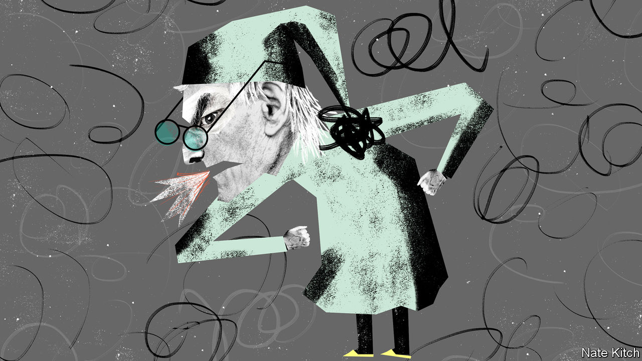

A BRITISH CHRISTMAS is inseparable not just from a jolly fat man in a red suit but also from a grumpy, thin “squeezing, wrenching, grasping, scraping, clutching, covetous old sinner”. Charles Dickens’s novella “A Christmas Carol” was an instant hit. Within two months of its publication in 1843 there were 12 adaptations on the London stage. Nearly two centuries on, its anti-hero retains his hold on the popular imagination. The internet offers a dancing Scrooge, a singing Scrooge, a woke Scrooge, a Scrooge with Muppets, and a Scrooge with Freudian “daddy issues”.

By all means enjoy “A Christmas Carol” in this season—better read aloud to the children, in Victorian fashion, than on the screen. William Thackeray, Dickens’s contemporary and rival, described it as a “national benefit and, to every man or woman who reads it, a personal kindness”. But don’t stop there: Dickens is an inexhaustible source of pleasure and instruction all year round. He was, after Shakespeare, Britain’s most creative generator of characters, with more than a thousand listed in Wikipedia. That they are as relevant today as they were in his time is testament not only to his ability to capture essential human traits but also to the parallels between the Victorian age and ours.

So many Dickens characters summon up the peculiar spirit of 2020 that it is hard to choose between them. In “Bleak House”, Old Krook spontaneously combusts, which feels like a fitting end to the year. In “Hard Times”, Mr Gradgrind tries to “weigh and measure any parcel of human nature”, neatly encapsulating modern officialdom’s obsession with targets and algorithms. In “Little Dorrit”, the Barnacle family controls the business of the Circumlocution Office much as well-connected Tories enjoy the benefits of government outsourcing today. But three characters tower over their rivals as embodiments of 2020.

John Podsnap, from “Our Mutual Friend”, is Brexit Britain made flesh. A pompous philistine of the narrowest kind—“particularly well satisfied with most things, and, above all other things, with himself”—he considers other countries “a mistake”, foreigners “unfortunately born”, and the British constitution the best in the world, “bestowed upon us by providence”. In sum, “no other country” is as “favoured as this country”.

Podsnap’s views reverberate around the Tory world. Gavin Williamson, the education secretary, told a radio audience that, among various nations under discussion, Britain is “a much better country than every single one of them”. Its speed in licensing the covid-19 vaccine was, he said, evidence that “we’ve got the very best people in this country and we’ve obviously got the best medical regulators”. It was Podsnappery that led Michael Gove to claim that Britain would “hold all the cards” when it left the European Union, and Podsnappery that persuaded Liam Fox that a trade deal with the EU should be “the easiest in human history”.

If Podsnap personifies nationalistic complacency, Madame Defarge in “A Tale of Two Cities” embodies revolutionary fervour, with her compelling mix of the monstrous and the mundane. She runs a wine shop while plotting against her enemies, and knits while watching one aristocrat after another going to the guillotine. Her victims’ individual humanity means nothing to her; they are mere representatives of a system that must be destroyed. “She saw not him but them,” as Dickens puts it. The knitting is more than an idle distraction from the work of vengeance. She knits the names of her victims in an act of revolutionary piety.

Today’s culture wars reprise these themes. Vengeance-obsessed revolutionaries dehumanise their opponents by hounding them off the stage in public meetings (“deplatforming”) or mobbing them on social media (“cancelling”). They get people sacked from their jobs, often rendering them unemployable, for digressions from an ever-changing orthodoxy. A veteran columnist, Suzanne Moore, left the Guardian newspaper because of a furore about an article she wrote on women and trans rights. An Oxford historian, Selina Todd, was disinvited from giving a lecture and forced to hire security guards because she offended some activists. People stay silent about newly sensitive issues because they fear the sound of today’s equivalent of Madame Defarge’s knitting needles clicking away as the professional guillotine comes down on their necks.

And what about Scrooge himself? It is unfortunate that, in portraying this upstanding citizen, Dickens allowed his most irritating vice, sentimentality, to get the better of him. “A Christmas Carol” degenerates. In its feelgood ending, a reformed Scrooge makes amends to those he has wronged and sucks up to all and sundry. Before his lamentable decline, however, he is one of the wisest figures in literature, blessed with a great insight: that the world is addicted to humbug. This powerful perception is even truer now than it was in the 1840s.

Today almost everything is the opposite of what it pretends to be. Companies claim that they are devoted to advancing gay rights, promoting multiculturalism or uniting the world in a Kumbaya sing-along, when they are in fact singlemindedly maximising profits. Chief executives claim that they are ever-so-humble “team leaders”—in homage to another great Dickens invention, the unctuous Uriah Heep—when they are actually creaming off an unprecedented share of corporate cash. Private schools such as Eton claim that they are in the business of promoting “diversity” and “inclusivity” even as they charge £42,000 a year. Future historians seeking to sum up our era may well call it “the age of humbug”.

Whether the purveyors of this sanctimonious guff actually believe it, or whether it is cynical doublespeak, is immaterial. Either way, spin doctors, sycophants and so-called thought leaders pump noxious quantities of it into the atmosphere. The nation is in desperate need of a modern-day Dickens to clear the air. Until one emerges, Britons should repeat his great creation’s Christmas mantra in every season: “Bah, humbug!” ■

This article was downloaded by calibre from <https://www.economist.com/britain/2020/12/19/scrooges-wisdom-in-modern-britain>

|  |  |  |  |
| --- | --- | --- | --- |
| 上一项 | 文章 | 章节 | 下一项 |

|  |  |  |
| --- | --- | --- |
| Britain | 章节 | Christmas Specials |

International

Waste-pickers: Down in the dumps

.

|  |  |  |
| --- | --- | --- |
| Britain | 章节 | Christmas Specials |

|  |  |  |  |
| --- | --- | --- | --- |
|  | 文章 | 章节 | 下一项 |

#### Down in the dumps

# Covid-19 has posed new challenges to the world’s waste-pickers

Those who are better organised have prospered more

Dec 19th 2020 | KAMPALA, LUSAKA, MUMBAI, SÃO PAULO AND YANGON

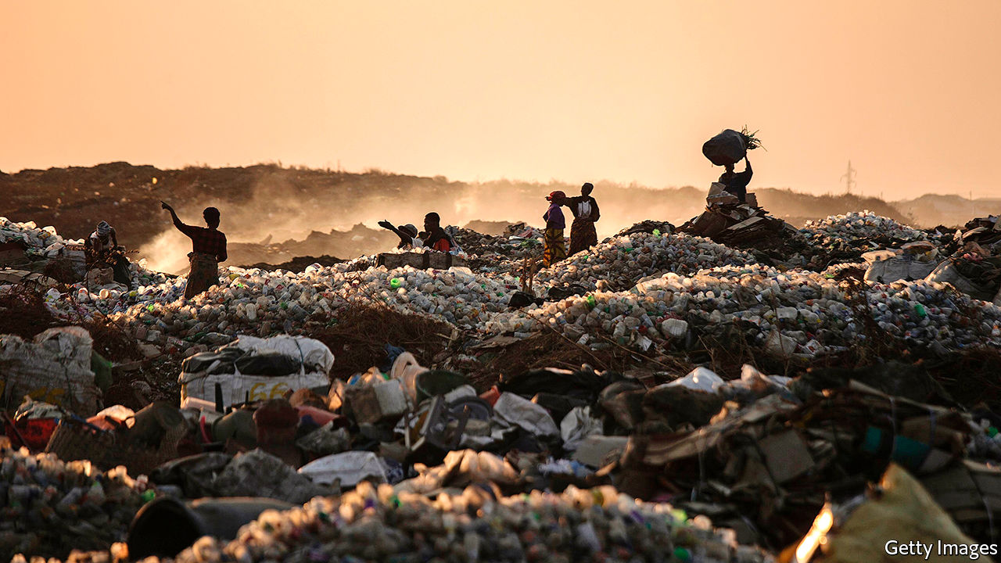

Editor’s note: Some of our covid-19 coverage is free for readers of The Economist Today, our daily [newsletter](https://my.economist.com/user#newsletter). For more stories and our pandemic tracker, see our [hub](https://www.economist.com/news/2020/03/11/the-economists-coverage-of-the-coronavirus)

AT THE NORTHERN edge of Lusaka, in Zambia, the 24-hectare Chunga landfill smoulders in the midday sun, its sour smoke scalding the nose and throat. Wesley Kambizi works nine-hour days on the dump with just a beanie and mismatched sneakers for protection: one slip-on, one lace-up, both caked in mud. Local authorities intermittently threaten to bar waste-pickers like him from the site. Worsening poverty in the city means both that more people are scavenging at the landfill and that fewer valuable scraps make it there in the first place.

The world’s cities produce over 2bn tonnes of solid waste every year. Even before the covid-19 pandemic local governments in poor countries struggled to keep their streets clean, clearing less than half the rubbish in urban areas and around a quarter in the countryside. Informal workers, who make up around 80% of the 19m-24m workers in the waste industry, have helped plug that gap. They both haul rubbish and scour municipal dumps and public spaces for things which can be re-used or sold, normally through middlemen, to recycling companies. In India waste-pickers divert over 40m tonnes of refuse away from landfills and into recycling every year, a task that would cost municipalities 15-20% of their annual budget. In South Africa they are responsible for recovering 80-90% of packaging.

Some, like Mr Kambizi, do the job full-time; others resort to waste-picking only when times are hard. The pandemic has enlarged their ranks. Birungi Hidaya lost her job as a teacher in Kampala, the capital of Uganda, soon after the pandemic struck. Now she works the Kiteezi landfill. She turns her nose up at the other scavengers on the dump, labelling them “ignorant” and “not civilised at all”.

The lay-offs that have come with the pandemic have seen more people like Ms Birungi eking out a living by collecting, sorting and selling rubbish. But the pandemic has also created new problems for waste-pickers.

The first is getting to the waste. South Africa failed to classify waste-picking as an essential service during this year’s lockdowns, leaving thousands stuck at home at risk of starvation. In Accra and Kumasi, cities in Ghana, those who live off the landfills worry that local governments will use the pandemic as an excuse to decommission the dumps, something they have long aspired to do.

Panicked citizens make matters worse. In Yangon, Myanmar’s commercial capital, Thiha used to make 500,000 kyat ($370) every month as an independent waste-collector in a working-class area. When a second wave of covid-19 hit in early September people began erecting makeshift barricades around their neighbourhoods, denying him access. His earnings fell by a third.

It is not just the people who are keeping Mr Thiha from the rubbish. The pandemic is producing a lot more medical waste. The amount of it produced in China’s Hubei province increased by 370% after the outbreak began. Manila and Jakarta are expected to produce an extra 280 and 210 tonnes every day, respectively. The Yangon City Development Committee (YCDC) is struggling to keep this sort of dangerous refuse away from the public in general and people like Mr Thiha in particular. It has been tasked with collecting, separating and burning the 50 tonnes of rubbish produced by hospitals and quarantine centres every day. (The sad duty of cremating victims of covid-19 has also fallen to the YCDC. “That’s a different job and also a stressful job for my people,” sighs Aung Myint Maw, deputy director of the sanitation department.)

Such care reflects a genuine concern. Some of the proliferation of pandemic-associated waste has been a benefit to litterpickers—think of all those tiddly little bottles of hand sanitiser. But in poor cities that lack the infrastructure to segregate medical waste it can be a real problem.

Scientists believe covid-19 is transmitted via tiny droplets that people exhale as they breathe, talk and cough. These virus particles can remain infective after a day spent on cardboard, at least two days on steel and three on plastic. Rifling through rubbish is never particularly safe from a health point of view; this year’s influx of infected material makes the business even riskier, particularly for those without personal protective equipment (PPE) and little understanding of how the disease spreads.

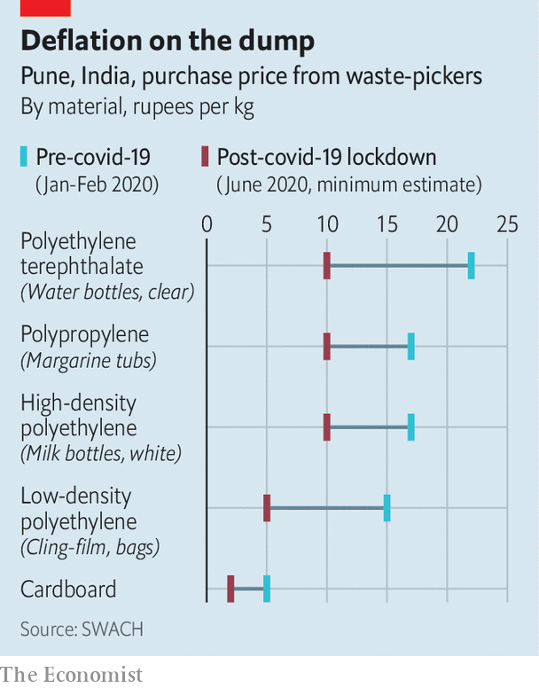

The falling price of recyclables presents a third problem. The formal recycling industry ground to a halt when countries closed their borders, making it impossible to ferry waste to the big plants which process it. There are fewer end-buyers for the plastic, paper and metal that scavengers collect. Data from the city of Pune in India show the price of polyethylene terephthalate, the plastic used to make water bottles, has dropped to as little as 10 rupees ($0.01) per kilogram from 22 rupees before the pandemic (see chart). Cardboard is two rupees per kilogram, half what it was.

That has been devastating for Rani Shivsharan, who has been collecting waste in Pune for over 25 years. Despite Prime Minister Narendra Modi’s signature Swacch Bharat, or Clean India, mission, the local authority does not recognise her work. Ms Shivsharan has not received any cash transfers or food rations since covid struck. There are days when she survives on tea. “I am scared, but what can I do?” she asks.

## Brothers and sisters

Organised waste-pickers are better off on all three counts. A survey of 140 waste-picking associations in Brazil found that after serious disruption in the first weeks and months of the pandemic, three-quarters were back in operation by May. Almost all of them were using PPE, almost 80% had sent vulnerable members into isolation and 45% were quarantining scrap before sorting it. In Belo Horizonte, in south-eastern Brazil, a waste-pickers’ co-operative successfully lobbied the mayor’s office for food baskets and hygiene kits to see them through the pandemic.

The Belo Horizonte association had learned to fight for its members well before the pandemic. It has been almost 20 years since a group of single mothers in the city started collecting plastic bottles. The co-operative has since won a contract with the local authorities, which pays 265 reais ($52) for each tonne of material they sort. Similar stories can be told all round the continent. Waste-workers in Latin American cities like Buenos Aires, Bogotá and São Paulo often operate in co-operatives. The fact that Latin America’s litter-pickers are better organised and better treated is not just a by-product of increased regional prosperity. It is also the result of pressure brought by the waste-pickers themselves and a strong social-justice movement supported by the Roman Catholic church.

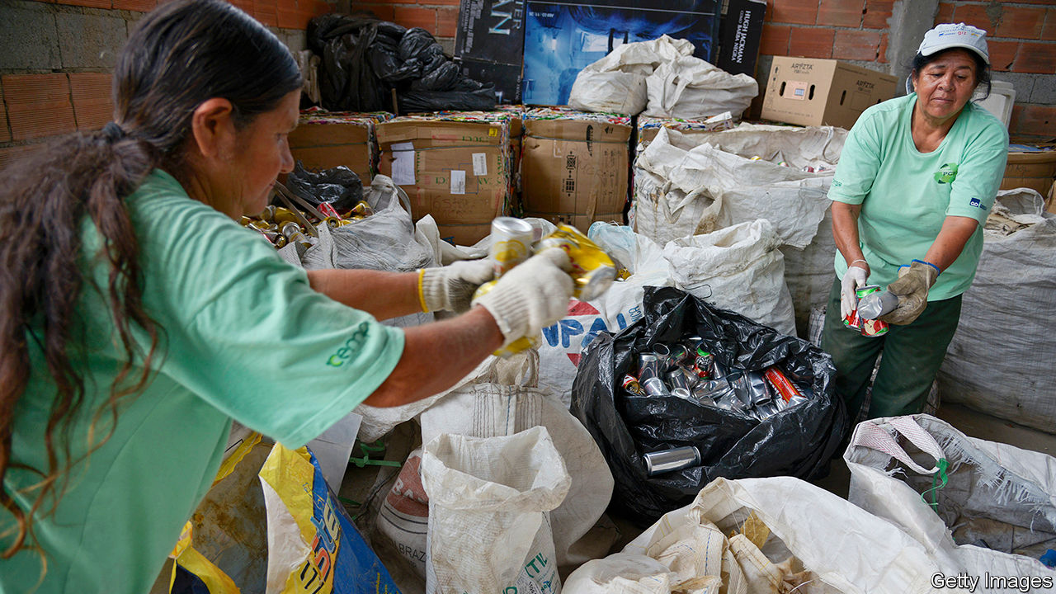

São Paulo has it sorted

This has seen waste-pickers achieve a formal recognition they lack in many cities in Africa. Brazil has been gathering data on the sector for almost 20 years, from the time when waste-picking became an occupation listed in the national registry. Argentina legalised waste-picking in 2002 and has since created a government agency dedicated to the sector: it has a multimillion-dollar budget. Working together, waste-pickers can lobby for contracts or invest in sheds where they sort the day’s harvest and store it until traders offer a good price. The many local names for collectors reflect a sometimes sophisticated division of labour. Cirujas, cartoneros, recicladores and chatarreros may each differ in responsibility and status city by city. By no means all of those who work on the dumps are in associations. But the successes of those who are often help those who are not, too.

None of this has been easy, says Martha Chen, a Harvard lecturer who advises Wiego, a non-profit focused on women in informal work. “Someone from the public or the government doesn’t wake up one morning and think: ‘Let’s think about the waste-pickers’,” she says. “These gains come from years and years of struggle.”

Other regions aren’t going to integrate informal workers into their waste-management systems overnight. But there is one way in which covid-19 might help them do their work and do it safely. In the midst of a public-health emergency, city folk across the globe have begun to appreciate those who put themselves at risk to keep the streets clean. India, with its entrenched caste system, has treated its waste-workers particularly badly in the past. But this year households in Pune have been handing out food packages and cash bonuses to the people who collect their rubbish. It is the same story on the streets of London, where children have adorned their windows with notes of thanks. Rainbows, hearts and smiley faces are dedicated to doctors, postal workers and binmen. ■

This article was downloaded by calibre from <https://www.economist.com/international/2020/12/19/covid-19-has-posed-new-challenges-to-the-worlds-waste-pickers>

|  |  |  |  |
| --- | --- | --- | --- |
|  | 文章 | 章节 | 下一项 |

|  |  |  |
| --- | --- | --- |
| International | 章节 | Business |

Christmas Specials

Newsletters: Season’s greetings!

.

Rural France: Fragments from a forgotten valley

.

Bloodsuckers: History, written by the vectors

.

Sidney Street: The one that got away

.

Digital humanities: The book of numbers

.

Sadie Tanner Mossell Alexander: The Alexander technique

.

Shingle art: A universe of stones

.

Essay: Awesome, weird and everything else

.

Erasmus: Citizen of the world

.

South Korean mountains: Race to the top

.

Crossword, etc: Cryptic and coniferous

.

Quiz: Try our Christmas quiz

.

Gay rights: A queer old tale

.

Travels in Zululand: Trust deficit

.

Extraterrestrial hiking: A short walk in Gale crater

.

Economies past: Factories and families

.

Shaolin monastery: The profession of renunciation

.

Reconstruction: Revolutionary embers

.

Military deception: Bodyguard of lies

.

Pleistocene Park: The prophet of permafrost

.

|  |  |  |
| --- | --- | --- |
| International | 章节 | Business |

|  |  |  |  |
| --- | --- | --- | --- |
|  | 文章 | 章节 | 下一项 |

#### Newsletters

# Christmas newsletters are a form of slow social media

Dispatches from when the newsfeed was refreshed once a year

Dec 19th 2020 |

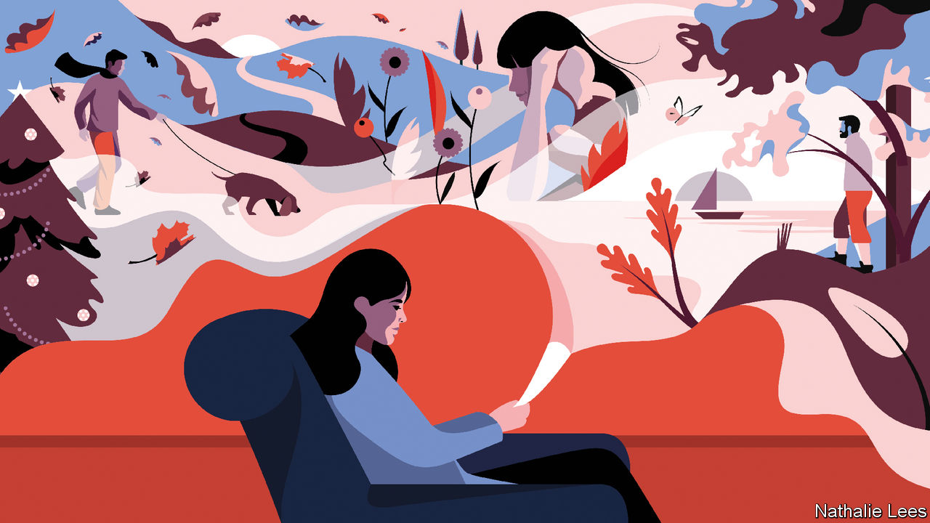

ON CHRISTMAS DAY in 1948, Marie Harris published the mid-century equivalent of a status update. In June that year, “lying on the beach watching the waves of the Pacific roll in”, she and her husband Bob had decided they needed more space for their young family. Through an ad in the local paper they found just the place: a rambling old farmhouse with green shutters in rural Shedd, Oregon. They swapped their crowded city digs for a retreat worthy of Instagram: five acres of land, thick with boysenberries, apple, pear and walnut trees. But apart from the 17 chickens, three geese, two cats, a cow, a duck and a collie called Mac, Shedd was not a sociable sort of place. So Marie’s three-page bulletin ended with something akin to a friend request: “We have lots of animals,” typed the 28-year-old, “but would like company of a more human sort—and mail.”

So concluded the first edition of the Harris Herald, a newsletter which Marie would publish every Christmas for the rest of her life. Usually typed on a side or two of letter paper and sometimes embellished with stick-man drawings, maps and photos, the Herald provided friends and family with news of high-school wrestling triumphs, tonsillectomies, hunting hauls and river voyages on a home-made cruiser, Noah’s Place (later renamed PITA , short for Pain In The Ass, after it overheated and broke down halfway up the Columbia river). Over 54 editions Marie chronicled the surprise birth of twins, the premature death of Bob, her return to college, remarriage (at which point the Harris Herald became the Bussard-Harris Christmas Annual), promotion to college professor and the arrivals of 18 grandchildren, as well as more great-grandchildren than most readers could keep track of.

The Herald is the oldest archived example of a Christmas newsletter, a medium that, long before the internet, allowed the sharing (and over-sharing) of carefully curated news and photos to a wide network of friends and family. Most Christmas letters linger for a few weeks above the fireplace before being thrown away in the New Year clear-out. But historians are increasingly interested in the few that are kept. Like modern social media, the bulletins offer a window into everyday domestic life—or at least the version of it that the authors presented to the world.

Marie Harris was among the pioneers of a medium that emerged on both sides of the Atlantic after the second world war. People had exchanged Christmas cards with loved ones since Victorian times, when a well-chosen card was considered a present in itself. As incomes rose in the second half of the 20th century, people sent more cards; by the 1970s it was common to buy them by the box. The more cards people posted, the more of a pain it became to hand-write long messages.

So when technology allowed an insert to be copied, people did so. Marie’s first Heralds were printed by mimeograph, a contraption that used a rotating drum to force blueish ink through a stencil made of waxed paper. Few people had access to such a thing (Marie used one at Oregon State College, where Bob worked as a lecturer). From the 1960s, photocopiers began popping up in offices. The smart new look of the Bussard-Harris Christmas Annual in 1961 was courtesy of the Xerox machine in the office of David Bussard, Marie’s second husband. In the 1980s home computers and printers made it easier still to make newsletters; Marie’s 1988 bulletin describes a “rash” of such missives.

As these letters became more common, people found ways to make them stand out. Photos began to appear (we first see the Harris-Bussards in 1975: Marie, in flares, reclining in an armchair as David perches by the fireplace). The 1990s brought an outbreak of Christmassy clip-art, with cheerful Santas sometimes incongruously placed next to reports of deceased pets. Around the same time, stationers began to sell Christmas-themed paper aimed at newsletter scribes.

Some authors expressed themselves in verse. A collection of newsletters held by Ann Burnett of North Dakota State University includes one written in 14 just-about-rhyming stanzas:

We travelled to Normandy Where the Allies did land And then on to London Where we stayed at the Strand

Others extracted contributions from their children. When the novelty of that wore off some wrote imaginary missives from their pets. A letter in Ms Burnett’s collection reads normally enough—one son is off to Yale, a grandchild is on the way, and so on—except that the notional authors are the family’s cat and dog, both long dead and stuffed. A haunting photograph of the glass-eyed pair rounds off the bulletin.

## A timeline of the years

As well as laughs, intentional and otherwise, letters like these provide a rich social history. In the 1990s paper sources began to disappear beneath a flood of e-mails and text messages. Susan B. Strange, an archivist at the Smithsonian Museum of American History, identified Christmas letters as an exception to this rule. In 1998 she began to collect them from friends, family and anyone else who had back issues to offload. The resulting haul of 1,500 missives, from about 100 families, ended up at Harvard’s Schlesinger Library on the History of Women in America. Women write about three-quarters of newsletters, Ms Strange estimates, providing an alternative historical perspective—albeit one that remains largely white and middle-class.

Health, work and travel are the enduring themes, and the archives illustrate how all three changed for Americans in the 20th century. In 1948 Marie recounted a brush with polio in which first her son, and then she herself, were forced to isolate in hospital. In a more recent letter from a different family, a 70-year-old marvels at her new prosthetic foot: “A super duper, space age, technological marvel that will never hurt, nor fail nor any other thing.” In 1948 Bob Harris took on a Saturday job as a mechanic, which “saved us from the very unpleasant effects of inflation”, running at nearly 10% that summer. Sixty years on the global financial crisis made its way into people’s Christmas reflections. “We are going to change our name to AIG-Chrysler in the hopes that the federal government will provide us with a bail-out,” joked one American family in 2008. As the jet age arrived, tales of holidays made more frequent appearances. “The trip to San Francisco takes less time than driving to the airport to catch the plane,” marvelled Marie in 1962. Her vacations branched out from a trip to Palm Beach to tours of Australia, Fiji and South Africa in the 1990s.

A new preoccupation is with busyness. As one newsletter in Ms Burnett’s collection puts it:

“I’m not sure whether writing a Christmas letter when I’m working at the speed of light is a good idea, but given the amount of time I have to devote to any single project, it’s the only choice I have. We start every day at 4.45am, launch ourselves through the day at breakneck speed (the experience is much like sticking your head in a blender), only to land in a crumpled heap at 8.30pm...wondering how we made it through the day.”

More than two-thirds of newsletters mention time, usually the lack of it, Ms Burnett finds. She attributes this to the quickening pace of modern life. But it is difficult to resist the suspicion that there is a hint of showing off in some authors’ complaints about their action-packed lives. The Christmas letter is, after all, the native environment of the humblebrag. “While I would like to take credit for this, in truth it was more the Lord,” writes a serial offender from Massachusetts. The next year he remarks: “I like to think they gave me this award for the great job I did, but it is more likely they gave it to me so I would finally go away!” Readers may wonder if that was indeed the case.

Comments like this explain why Christmas letters do not always spread good cheer. In 1954 an article in the Atlantic Monthly sent up the “campy humour and covert bragging” of the Christmas circular. By 1987 Marie felt the need to explain that “although we read about people who don’t like to receive Christmas letters, it is so hard to break old habits, especially one that started 39 years ago”. Debrett’s, a British etiquette guide, advises that such newsletters are “best avoided. They are impersonal and can seem boastful, especially if they are a rambling litany of the family’s achievements.”

Those who love to hate the “brag and gag” variety of letter have found innovative ways to get their revenge. Christmas Letter Swap, a website, organises an annual exchange of fictitious newsletters, as an antidote to the “seasonal plague”. Simon Hoggart, a Guardian journalist, asked readers to send in their most-hated letters and received several hundred each year, from the sickening (“The cutest, cleverest and most advanced baby in the world!!!!!!!!”) to the soporific (“The gas men finally came on January 11th. They were supposed to come at the beginning of December”). Some recipients were so infuriated that they had ripped their letters up, and taped them back together to send him. And unlike social media, which offer a variety of ways to block show-offs and bores, mailed letters offer no escape.

Weariness with the format, and the growth of alternative ways to keep in touch, mean the newsletter is in decline. People are sending less Christmas post in general: the average American household received ten Christmas cards in 2019, compared with about 30 at the end of the 1980s. In 2017 Ms Burnett surveyed 200 newsletter senders and found that two-thirds no longer planned to write one. The main reasons cited for giving up, besides busyness, were the alternative of social media and the fear of being considered boastful. Carlos Llanso of America’s Greeting Card Association says that his own company, Legacy, stopped selling Christmas-themed newsletter paper about five years ago, for lack of demand. “Maybe people started thinking it was too much,” he wonders.

## Slow social media

The move from annual printed bulletins to daily electronic updates means that people are documenting more of their everyday life than ever before. But archivists worry that today’s tweets and instant messages may prove harder to preserve than the stashes of newsletters. Even if the electronic musings survive, they record a different sort of history: a “daily dribble” of commentary, says Ms Strange, rather than the considered reflection on what mattered most that year.

Perhaps the bigger loss is not to posterity but to the authors themselves. Ms Burnett describes newsletter-writing as an opportunity for “retrospective sense-making”. As Marie scribbled to a friend in the margin of her circular of 1988, “For me it is a sort of ‘closure’ for each year.” In the same way that Christmas itself invites reminiscence and reflection—a year almost done, memories of past Christmases jogged by each bauble unwrapped from the tissue paper—composing a newsletter requires contemplation of the year just past.

One result of that reflection is an awareness of life’s finiteness. Whereas online posts are unlimited, life is capped at a few score annual letters. After launching the Herald when she was 28, Marie’s life spanned 54 more issues; she was determined to make each count. In 1968, the year she turned 48, became a grandmother, hosted a Japanese exchange student and helped David build a new headquarters for the family business, she reflected on how much more there was to do:

“Possibly Marie’s chief troubles is that she wants to be outside, wants to teach, wants to keep a good house, and be a good wife and mother. Life is too full of wonderful things to do, places to go, and people to know.”

The last Christmas letter of her life reflected on the couple’s long marriage and the companionship of grandchildren and great-grandchildren, concluding: “One could ask for little more than this.” Marie died on December 17th 2003, shortly after it was posted.

The Christmas newsletter isn’t quite ready to fold. This year, in particular, may inspire reflection: journal-writing is sometimes prescribed to manage stress, points out Ms Burnett, who wonders if more people will want to record their thoughts this Christmas. Lockdowns have encouraged people to stay in touch by different means: the US Postal Service sold more stamps than usual over the summer, and in the autumn Christmas-card manufacturers reported higher sales than usual. Newsletter content may be a bit thin, with fewer weddings or glamorous holidays to relate. But the weeks trapped at home have got people into weird hobbies that they want to tell the world about, if social media are a guide.

Even before the lockdowns, signs were emerging that young people were getting back into hand-written media. In America millennials recently began to outspend baby-boomers on greeting cards, chiefly because they go in for pricey individual ones for special occasions, rather than the $10 boxes designed for mass mailing. Electronic communication is so effortless that it makes it hard to convey thoughtfulness. “If you’re having a bad time at work, or a much-loved pet has died, another text doesn’t cut it,” says Amanda Fergusson, head of the British Greeting Card Association, who says British millennials are also spending more on cards than they did a generation ago.

Two of Marie’s children, as well as some of her grandchildren, now send Christmas newsletters of their own. And the first editions of the Herald continue to give pleasure. Robert Harris, the “big healthy boy” of six in 1949, recently re-read the back issues and saw his own early life through different eyes. “It seems to be that my mother found a major voice for facing her life that comes through in her letters,” he says. In that narrator, “I didn’t discover a different mother. I discovered a bigger mother.” Meanwhile, Marie’s newsletter lives on. Seventeen years after her death, and nearly three-quarters of a century on from the mimeograph and the green-shuttered farmhouse, Marie’s surviving husband David will this year send out its 72nd issue. ■

This article was downloaded by calibre from <https://www.economist.com/christmas-specials/2020/12/19/christmas-newsletters-are-a-form-of-slow-social-media>

|  |  |  |  |
| --- | --- | --- | --- |
|  | 文章 | 章节 | 下一项 |

|  |  |  |  |
| --- | --- | --- | --- |
| 上一项 | 文章 | 章节 | 下一项 |

#### Rural France

# Lockdowns have taught the world about isolation

In a remote French village it can mean solace as well as hardship

Dec 19th 2020 | BENIVAY-OLLON

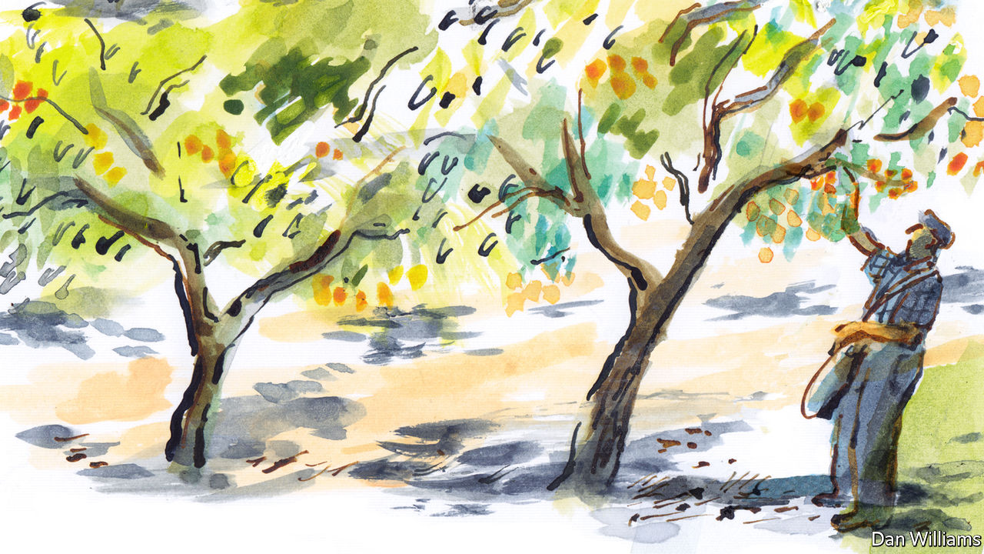

THE ROAD to Bénivay-Ollon leads to nowhere else. It winds up the valley along the course of the shallow Ayguemarse river, between craggy limestone outcrops and emerald-green forest, to a village of 66 souls. In summer the cicadas are insistent and the warm air is infused with the scent of wild rosemary. In winter morning dew gathers on the grass, and Mediterranean pines gleam defiantly in the watery light.

The village boasts no café, no shop, no post office, no boulangerie. Nobody passes through it by chance or even design. A visiting priest arrives up the road to celebrate mass at the church just twice a year. Once through the village, the road twists up to a ford over the water, and thenceforth turns into a dirt track that disappears into the forest. Perched improbably on a sheer-edged rock, accessible only by foot, the tiny 13th-century stone chapel of Saint Jean watches over the valley like a sentinel.

On a bright June morning, Daniel Charrasse is to be found outside the mairie, or town hall. Aged 73, a slight figure with thinning silver hair, he is a retired apricot farmer who was born down the road and grew up in the village. He is now the mayor, a role treated locally more as an elder than a politician. At the most recent municipal election, 39 voters dropped his name into the ballot box. That was 87% of those cast. For much of the post-war period, Monsieur Charrasse’s father Germain, who also grew apricots in the valley, was mayor. And in the 1920s so was Germain’s uncle, Camille.

Tradition and loss are baked into the land in this isolated corner of France, which lies in the folds of mountains between the foothills of the Alps and the Mediterranean hinterland. Five years before the first world war broke out, Monsieur Charrasse’s great-grandfather Florent, born in the village in 1837, died, leaving his wife to run the farm with their four boys. When Germany declared war on France, all four sons were sent from the orchards and olive groves of the Ayguemarse valley to the mud and horror of the front, nearly 1,000km (621 miles) away. Paul, their second son, never made it back.

Paul was killed on the battlefield in the Vosges mountains in August 1914, during the first bloody weeks of war. He was one of six villagers who lost their lives, their names engraved in stone on the wall next to the town hall. Albert, Daniel’s grandfather, and his two other brothers, Elie and Camille, all returned home to the valley, married and settled there. Albert’s veteran’s card shows a dapper young man with neat hair, in a wool jacket and waistcoat. Today their graves lie in Charrasse family plots in the square walled cemetery, a quiet spot up on the hillside, lined by cypress trees.

In remote villages and valleys across France, there are still communities like Bénivay, where the same family names can be found on the gravestones and the letterboxes. Craftmanship—the pressing of olives, the maturing of cheese, the training of vines—is passed on through the generations. France counts 8,780 communes with fewer than 200 inhabitants. To the metropolitan eye they are either places of community, tranquillity and tradition, or they are isolated and neglected parts of la France périphérique (peripheral France), constrained by narrowing options and a loss of population, living distrustfully on the margins. Bénivay suggests that neither view tells the full story.

The Charrasse family and the Bénivay valley are as intertwined as the farmers of this land are with the seasons and disasters they can bring. It doesn’t take long in a conversation for a villager to raise the devastating winter that descended on the valley over 60 years ago. “Until the frost of 1956, we produced a lot of olives and tilleuls (lime trees),” says Monsieur Charrasse. “But the frost hit the olive trees badly. For ten years, we produced no olives at all. That’s when my father decided to plant apricot orchards and vineyards.”

The olive trees eventually recovered. When the mistral blows in from the Rhône valley, their feathery ash-green leaves catch the sunlight. But today, for better and for worse, the farm is centred on apricots. Pests attack the fire-orange fruit. Wild boar—an estimated 150 of them roam the surrounding forests—yank down the branches to shake the apricots to the ground, breaking open the stones so that their young can feed on the kernels. They leave the flesh to rot in the ground. Nature dictates the orchards’ fortune, just as the seasons do the working rhythms. In summer, when apricots ripen, the farmers are on the upper slopes of the Ayguemarse valley shortly after dawn and finish as the sun sets late in the evening, breaking in the sweltering heat of the day only for lunch.

The smallholding farmer, wrote Gaston Roupnel in his “Histoire de la Campagne Française”, a history of the French countryside from 1932, is one whom “the silent earth has disciplined with quiet tasks, endowed with the peace of the fields and the calm of the strong.” He might have been writing about the Bénivay valley. Beauty collides with hardship. Farmers do what they can to make ends meet. The Charrasse family rents out rooms to guests. Another runs a campsite farther down the valley. Other farms struggle, their backyards filled with the odd discarded mattress, rubber tyre, broken washing rack and dusty toys.

It is not an existence for everybody. Bénivay, like much of rural France for over a century, has seen its young pack up and leave. In 1911 the village counted 120 people. When Monsieur Charrasse was growing up, it was home to a dozen farming families. Today just three remain. As a child, he went to primary school in Bénivay, sitting at a wooden desk in a single class for pupils of all ages. In the 1970s the school closed. Two of his adult children have moved away. “Their going is the most painful rejection”, wrote Daniel Halévy of the loss of the young from French villages, in his study of 1935, “Visites aux paysans du Centre.”

As Monsieur Charrasse reflects on these changes, a tractor clatters past, pulling a trailer filled with plastic fruit crates. The young man at the wheel waves. Monsieur Charrasse smiles. It is his younger son, Florian. It turns out that he, like his father and grandfather before him, has become a farmer, taking over the family holding and becoming the third generation Charrasse to tend apricots in the valley.

## The call of the wild

What keeps the 33-year-old Florian on the land? On an early morning in June, in a red baseball cap and bright blue T-shirt, he is to be found with his tractor up a dirt track on the hillside orchard for the cueillette, or fruit-picking. Daniel recalls that, in his time, the season used to last until late July or even into August. These days, warmer springs have brought the harvest forward. Every ripe apricot, creamy orange and tinged blush-red, is plucked by hand, and placed in a black plastic bucket suspended from a branch.

“Do you hear the sound of the leaves?” asks Florian, as he gently twists a fruit to test its maturity. Just the right rustle indicates a judicious choice. “It’s very delicate, you just pull a little bit. If there are two on the branch you must always pick them both, or the second will fall to the ground. Choosing a ripe fruit is about the position on the branch, not necessarily the colour. The ones on the end of the branch are the ripest, so you start at the extremity. If they are ripe, you move towards the middle of the tree.”

Daniel watches his son quietly. The orchard he is tending is over half a century old. The elder Monsieur Charrasse is a man of few words. The French village, wrote Roupnel, is a place of conviviality, but “over there, in the fields, the individual converses with silence, fed by dreams and solitude.” Yet he will say that he is “proud” his son has taken over. Florian always wanted to farm. “I started helping my grandfather, Pépé, pick apricots when I was eight,” he says. “When I was about 13, he let me drive the tractor up here. I’ve always known this is what I want to do.”

## The roots of belonging

“It’s more of a commune than a village,” reflects Simone Charrasse, the mayor’s wife, one hot afternoon in July when the bugs are out. She is sweeping the front porch of the farmhouse through a multicoloured cattail fly curtain, awaiting two friends from a neighbouring farm. Madame Charrasse, who is 64, grew up on a farm in Bourdeaux, a bigger village farther north. Bénivay, she thinks, which lacks a main street or square, is more of a hamlet or collection of farms, “although everyone here still knows each other.”

Does the word solitude speak to her? “A bit,” reflects Simone. “There are moments, especially during the fruit harvest, when everyone keeps to themselves on their own land. It’s the nature of the work.” Her friend and neighbour Edith Blanchard, who comes by for a cool drink, disagrees. “I would call it zenitude, not solitude,” she says. “There are no people here that we don’t talk to.” Neighbours drop in on each other. The town hall has a committee just for organising fêtes, or parties. Each year in June there is a village celebration when the lime trees are in flower. Edith and her husband, Jean-Claude, meet friends to play cards, or boules in the shade beside the ford over the river. “We don’t miss restaurants, or the cinema,” she says. Life under lockdown was traumatic for those in the city. In Bénivay it barely changed daily life.

Later on in the day, Florian arrives. “My impression is that there is less solitude in the country than in the city,” he ventures. “In the city, there are lots of people, but you speak to nobody you pass by.” Often, “the city”, or “Paris”, are thrown into conversation as abstract concepts: the incomprehensible source of rules, paperwork and condescension. Nobody ever spontaneously names the prime minister or the president. It emerges that for Florian, though, Paris is part of his routine. Roughly 30 times a year, he drives his van down out of the valley to sell his freshly picked apricots—at three times the local retail price—at markets in the capital. Since the fruit-picking in June, he has done the 1,400km round trip four times.

“People say we live in a pays perdu (forgotten land),” comments Simone. “But forgotten by whom?” In January a 4G-transmitter was built on the hilltop, supplying reliable mobile connection to the valley for the first time. Fibre-optic cable is on its way. Florian, who works with a farm-to-fork producers’ network, is constantly on his smartphone to clients—a technology that his father wryly describes as “a form of servitude”.

Real isolation, suggests Jean-Claude Blanchard, Edith’s husband, a retired farmer and former mayor of the village, was that experienced by his parents’ generation. Until a dirt road was dug up the valley in 1900, farmers would follow the river downstream, clambering in their leather boots over any rocks in their way. To take his produce to market, Monsieur Blanchard’s grandfather would head up the steep hills on foot, or with a horse and cart, via a mountain pass. Today the road up to Bénivay is tarmacked, shrinking the 10km-drive to the nearest shops to 15 minutes.

In recent times the road has brought new travellers: walkers, campers, even second-homeowners. They bring novel requests to the town hall, says Simone, such as better signposts for hiking trails. “They have come here for the calm,” she says, “but the countryside is also noises, cockerels, tractors. We’re working. Noises are everywhere.” One asked if the ringing of the church bell, which then began at 7am, could start a little later, she recalls. “It’s two different worlds.”

## Apricots and ancestry

August, and Florian is sitting in the shade outside the farmhouse, rolling a cigarette and looking glum. The season turned out to be dreadful—he lost 85% of the apricot harvest due to winter frost—and not for the first time. Living off the land is unpredictable, and wearying. The more he converts to organic, the more rules he has to respect. The more the apricots disappoint, the more he turns to cherries, grapes and olives, jams, juices and tapenade. But he cannot imagine another life.

A farmer, Florian reflects, doesn’t count in years. Time moves to a different beat. After the frost of 1956, his grandfather planted 1,000 olive trees. He talks of this grove as a custodian might of an heirloom. “We’ve had apricot orchards here for only about 60 years; to be attached to them would be weird,” Florian says. “But the olive trees, they will be here for centuries.”

The people of Bénivay wear the weight of history casually. It lies all around them, in the fields, the graveyards, even on their bookshelves. When the mayor opens the archives one morning it yields treasures: records of births, marriages and deaths, handwritten in cursive script and organised in leather-bound volumes, reaching back to 1733—more than half a century before the French revolution.

The village registers reveal no fewer than nine generations of the Charrasse family. The records from the Napoleonic years show Daniel Charrasse’s great-great-grandfather to be Jean-Baptiste Florent (born in the village in 1806). The brittle pre-revolutionary parish registers, which bear the royal seal of the Dauphiné province, identify his father as Jean-Baptiste (born in the village in 1774), also a farmer. He was the son of Jean-Joseph (born in the village in 1740), whose parents were Joseph Charrasse and Marie Martel. Married in 1733, Joseph is listed as “from Entrechaux”, a town all of 15km away—the original Charrasse newcomer to Bénivay.

Monsieur Charrasse seems only half-surprised to find his ancestors sitting silently at his side. C’est comme ça. It’s just the way it is. Family legend, he says, is that the Charrasse family came over from Italy during the Avignon papacy of 1309-76. There is a book about them, he says. A copy, it turns out, lies in the Avignon public library, housed in a 14th-century cardinal’s palace. Published in 1947, “Histoire des Familles Charrasse”, co-written by one Alain Charrasse, traces the family back to Antonio de Carrassa, a cardinal’s nephew, who settled nearby in around 1360. Despite the many Josephs, Jeans and Baptistes in the study, however, none matches the records for Daniel’s family. The news prompts neither surprise nor disappointment.

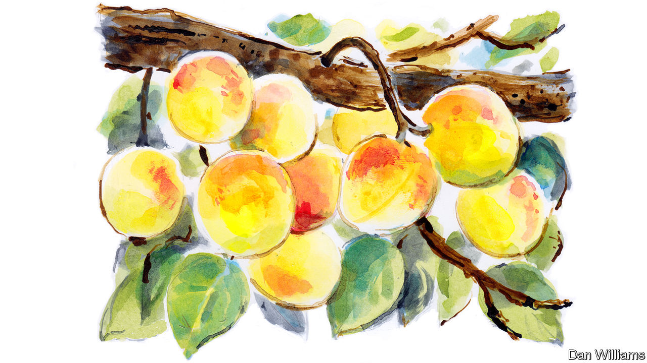

The centuries-long continuity of the Charrasse family in this valley, resistant to the forces of revolution, war, poor harvest and pests, is not unique. The Mège, Gras, Reynier and Blanchard families too are all still in the village, with ties to the past—and the future. One day Monsieur Blanchard mentions that his 23-year-old grandson, Ludo, is expecting a baby. Having grown up in Bénivay, where his father and grandfather still live, he has now settled there with his partner, Alexia Rousseau. Ludo went to what his grandmother calls “shepherd school”: an agricultural lycée, where he specialised in sheep-rearing. His dream is to buy a flock of his own—“beautiful ones”—and keep them near the mountain ridge.

“In the holidays, from the age of about seven or eight, I used to mind my great-grandfather’s sheep, and I would bring them in at night by myself,” explains Ludo, with his thick shock of black curly hair and beard. He is sitting with Alexia in their first-floor flat next to the mairie. Behind him, a pastoral scene of sheep in a valley is pinned to the wall. Ludo shudders at the evocation of city life: “Things go so fast.” Bénivay, he observes, is where he feels at home. “You can see people, but you can also go home and be alone.”

What does Alexia, who grew up in the city of Nantes on the Atlantic coast and used to enjoy hanging out in cafés, make of upland village life? The hunting, she confesses, has taken some getting used to. But the only thing she really misses, she says, is the sea. Could they imagine living anywhere else? Alexia laughs: “We looked around a bit, but he said he couldn’t live even in the next village down the valley.” Ludo concurs: “I’m used to this landscape. I need to see the mountains in the morning.”

A few weeks later, Ludo and Alexia have a baby boy, named Mistral. He becomes the fourth generation of Blanchards living in the village today. New life has come to the valley, and with it a comforting stability of the sort that villagers also draw from the gnarled olive trees that defy the seasons and the clear edge of the unchanging mountain ridge at dawn. Bénivay bears the scars of ache, disappointment and loss. But it is also a place of belonging, serenity and survival. Lost, solitary, forgotten, perhaps; but still defiantly alive. ■

Editor’s note: Some of our covid-19 coverage is free for readers of The Economist Today, our daily [newsletter](https://my.economist.com/user#newsletter). For more stories and our pandemic tracker, see our [hub](https://www.economist.com/news/2020/03/11/the-economists-coverage-of-the-coronavirus)

This article was downloaded by calibre from <https://www.economist.com/christmas-specials/2020/12/19/lockdowns-have-taught-the-world-about-isolation>

|  |  |  |  |
| --- | --- | --- | --- |
| 上一项 | 文章 | 章节 | 下一项 |

|  |  |  |  |
| --- | --- | --- | --- |
| 上一项 | 文章 | 章节 | 下一项 |

#### Bloodsuckers

# How malaria has shaped humanity

The parasite shows how history is partly created by non-human forces

Dec 19th 2020 | GOREE ISLAND, SENEGAL

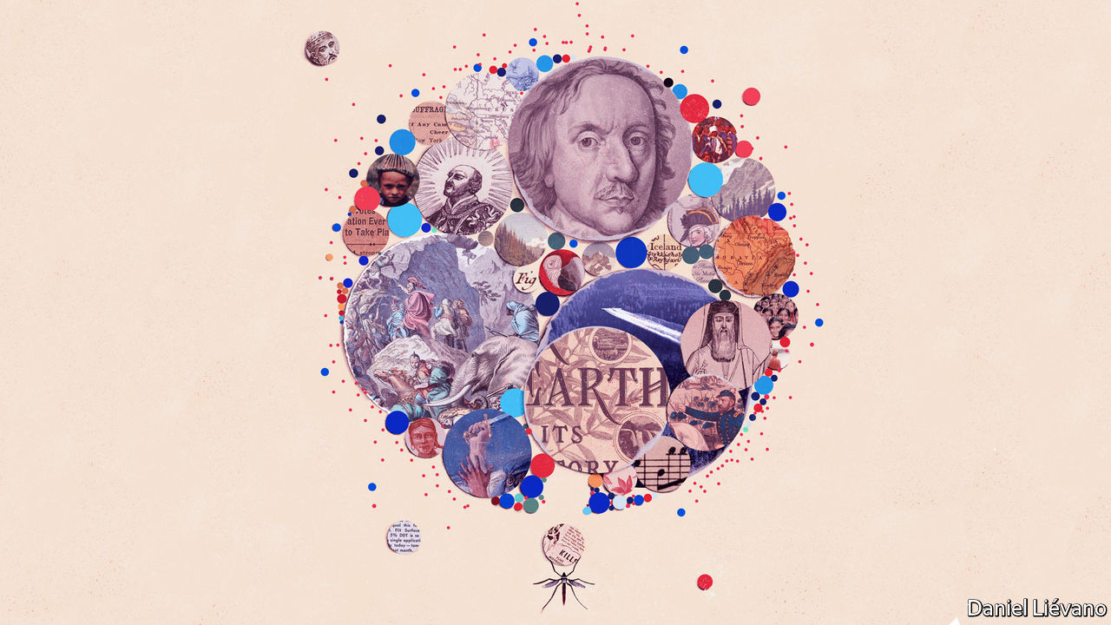

TWO CENTURIES ago, at Anna Pépin’s house on Gorée Island, off the coast of Senegal, ladies with fashionably pointed hats sashayed up the stairs to sip fine wines in an airy salon with a stupendous view of the Atlantic. Under the staircase was a windowless punishment cell for recalcitrant slaves. Young, fertile women were separated from the other slaves, for reasons as obvious as they are odious.

Pépin, an Afro-French trafficker, must have heard her captives rattling their shackles as she shared canapés with her guests. If she looked down from her balcony, she must have seen them being pushed through a narrow opening—the “door of no return”—and loaded onto ships bound for the Americas.

History is partly shaped by human choices. An evil institution cannot exist without evildoers. But history is also shaped by non-human forces. Why did plantation owners in the New World specifically want African slaves, rather than, say, Native Americans? One reason is malaria, notes Eloi Coly, the curator of the museum of slavery that Pépin’s house has become.

Malaria was introduced to the Americas as part of the 16th-century Columbian exchange. Parasites crossed the ocean in the blood of slaves and settlers. Local Anopheles mosquitoes spread them. Soon, natives and Europeans were dying in huge numbers. But Africans tended to survive, even when forced to work in mosquito-infested sugar plantations, because of an inherited resistance to malaria. Planters in the West Indies would pay three times more for an African than for an indentured European, notes Sonia Shah in “The Fever”. The mosquito, which also transmits other diseases, “has played a greater role in shaping our story than any other animal,” writes Timothy Winegard in “The Mosquito”.

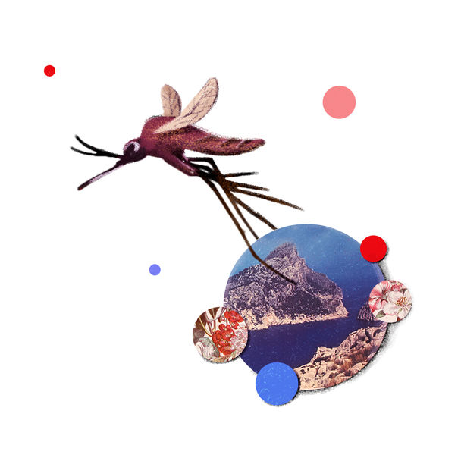

Stand again on Gorée Island and look in a different direction. Look past the children cooling in the surf, and the masked shopkeepers waiting for the covid-deterred tourists to come back. Stare towards the African mainland. Today the view is of skyscrapers and container ships—Dakar, Senegal’s capital, is a thriving port. Back in 1805, when Mungo Park, a Scottish explorer, looked across this same narrow strait, he would have seen a small settlement and a vast expanse of forest. He spent a few weeks on Gorée before setting off for the continent’s interior. It is not known whether he met Pépin, who would have been around 18 at the time.

He trekked inland, with tons of baggage loaded on donkeys, and then down the Niger River. Of the 40-odd men on his expedition, all but one died, many of fever. Park himself avoided death by malaria by leaping out of a canoe to escape a hail of arrows and drowning in rapids in what is now Nigeria.

Park’s troubles illustrate a crucial fact about colonial history. Africa was—and remains—the continent where malaria is most virulent. European settlers tended to die of it. So they settled in large numbers only in the least malarial places: South Africa, with its cold winter nights that kill mosquitoes; the highlands of Kenya and Zimbabwe; and the Mediterranean coast of North Africa. In parts of west Africa, by contrast, settlers had a 50-50 chance of dying each year.

In the highly malarial parts of Africa, imperialists ruled indirectly, through local potentates, who were persuaded with threats and bribes to throw in their lot with the French or British empires. In non-malarial zones Europeans settled en masse, creating institutions, many of which last to this day, along with racial injustices that caused centuries of grievances. Malaria helps explain why modern South Africa, with 4.7m white citizens, is so different from Nigeria, which has only a handful of white expatriates. South Africa gave the world a universally recognisable euphemism for white supremacy. A quarter-century after apartheid ended, its scars still linger. Nigerian politics has different faultlines: Muslim versus Christian, and so on.

Malaria has shaped other continents, too. It was once widespread in Europe. One reason why ancient Rome was so hard to conquer was that it was protected by the Pontine marshes. The Romans thought the fevers people caught there were caused by noxious fumes. Hence the name mal’aria, from “bad air”.

In 218BC Hannibal crossed the Alps. He routed the Romans at the Trebia, Trasimene and Cannae, but full conquest eluded him because of malaria, which cost the Carthaginian general his right eye, his wife, his son and much of his army. Later invasions by assorted barbarians met a similar doom. “The world still lives among the mosquito-haunted shadows of the Roman Empire,” notes Mr Winegard—many countries speak a Latin-based language, while several political systems have adapted Roman law. Indeed “the Roman Empire first martyred and then eased the passage of Christianity across Europe”.

Malaria shielded Rome for centuries. But nature does not stand still. Some time around the fifth century, a new breed of mosquito brought a new and deadlier parasite to Rome: Plasmodium falciparum, the malarial strain that blights Africa today. Unlike P. vivax, to which the Romans were inured, P. falciparum could have demoralised and destabilised an empire that was already under barbarian siege, speculates Ms Shah. The theory that it contributed to Rome’s decline and fall, as well as its rise, is unproven, but plausible.

## Parasites and people

A millennium later, malaria buffeted and then empowered another Roman institution: the Catholic church. Five popes probably died of it between 1492 and 1623. After it killed Pope Gregory XV, cardinals came to Rome to choose his successor. Six died of malaria. Eventually, the ailing head of one faction, Cardinal Scipione Borghese, was so desperate to go home that he backed a compromise candidate just to end the conclave. Thus, a mosquito helped elect Pope Urban VIII, as Fiammetta Rocco, an Economist writer, describes in “The Miraculous Fever-Tree”.

Then, around 1630, Jesuit missionaries found a cure. In the mountains of Peru, they noticed that natives ingested the powdered bark of the cinchona tree when they were shivering with cold. They wondered if it might also treat malarial shivers. It did. The active ingredient was quinine. Soon it was known that the Jesuits could treat malaria—for a price. They jealously guarded their secret, and parlayed it into influence by healing kings and lords whose favour they desired.



In Britain, malaria may have ended a Protestant dictatorship. Oliver Cromwell, the man who had King Charles I beheaded, ruled as Lord Protector from 1653-1658. His puritanical decrees sucked the joy out of life as surely as mosquitoes suck blood. He closed theatres and banned make-up and Christmas decorations. He hated Catholics, which may be why he angrily refused an offer of “Jesuits’ powder” to cure his malaria. The fever killed him, and merriment was re-legalised.

For centuries, there was never enough cinchona bark. Gradually, however, technology improved. In 1820 French chemists discovered how to extract quinine from cinchona. In 1865 a native braved execution to slip Bolivian cinchona seeds to a British trader. The Dutch government got hold of them and, after 30 years, figured out how to grow them in what is now Indonesia. By 1900 the Dutch were producing more than 5,000 tonnes of quinine a year.

When the second world war broke out, the Germans invaded the Netherlands and seized the Dutch stockpiles of quinine. The Japanese invaded Indonesia and seized the cinchona plantations. Suddenly the Axis powers had 95% of the world’s quinine. This gave them a huge military advantage. Japanese forces occupied China, their much larger, mosquito-ridden neighbour, armed with malaria pills. (They also hired old ladies to tuck in sleeping soldiers’ bednets.) Allied troops had far less protection. Malaria afflicted 60% of them in South-East Asia. On the island of Bataan, 85% of American and Filipino troops were malaria-struck when they surrendered to the Japanese. It was the largest surrender to a foreign power in American history. The New York Times noted that the battle was lost not for want of bullets, “but because the quinine tablets gave out”.

Wartime demand spurred a race to invent a good substitute. German scientists got there first, with chloroquine. After the war, chloroquine was so widely used that parasites grew resistant to it. The race between science and evolution continues today.

The post-war period saw a big push to exterminate the Anopheles mosquito itself, by spraying its habitat with DDT, an insecticide so effective that America’s Centres for Disease Control called it “the atomic bomb of the insect world”. Prolific spraying caused mosquito populations to crash. By 1951 malaria had vanished from the United States. By 1964 the number of cases in India had fallen from 75m a year to fewer than 100,000.

But DDT also had side-effects. It persisted in the environment, and moved up the food chain. In America DDT was found in milk, after cows munched insecticide-laced grass. And mosquitoes evolved that could resist the chemical. In 1962 Rachel Carson published “Silent Spring”, a book on the dangers of using pesticides without understanding their long-term effects. It led to a ban on DDT and helped kick-start the modern environmental movement.



It is intriguing to speculate how the world might look, had malaria never existed. If Hannibal had conquered Rome, would Europeans today speak languages derived from Punic instead of Latin? If the transatlantic slave trade had not been so lucrative, would America have avoided civil war and segregation? If the quinine-fortified Japanese army had not battered the Chinese nationalists so badly, would Mao Zedong’s communists have been able to seize power?

Such questions are unanswerable. But humankind may one day discover what a world without malaria is like. The annual global death toll has roughly halved since 2000, to around 400,000. Rich countries have eliminated the disease: by draining swamps, spraying insecticide and sleeping in air-conditioned rooms.

In Africa malaria still kills multitudes of children and sickens adults, making it harder for them to work and obstructing the continent’s path to prosperity. Yet it can be beaten. Senegal has all but conquered the disease in some regions and hopes to wipe it out nationwide by 2030. Despite the disruption of covid-19, that is feasible, thanks to a combination of bednets, pills and genomic technology.

An short drive from Dakar, in a district called Madina Fall, wide puddles fester on an unpaved road. Malaria has ravaged the area for thousands of years, but now it has all but gone. “My older brother died of it. My younger sister died of it. I nearly died of it, too,” says Bada Niang, a local worthy. “Now, we have bednets, and it practically doesn’t exist here any more.” ■

This article was downloaded by calibre from <https://www.economist.com/christmas-specials/2020/12/19/how-malaria-has-shaped-humanity>

|  |  |  |  |
| --- | --- | --- | --- |
| 上一项 | 文章 | 章节 | 下一项 |

|  |  |  |  |
| --- | --- | --- | --- |
| 上一项 | 文章 | 章节 | 下一项 |

#### Sidney Street

# A stand-off in London’s East End in 1911 still echoes today

It paired Winston Churchill with an elusive radical known as Peter the Painter

Dec 19th 2020 |

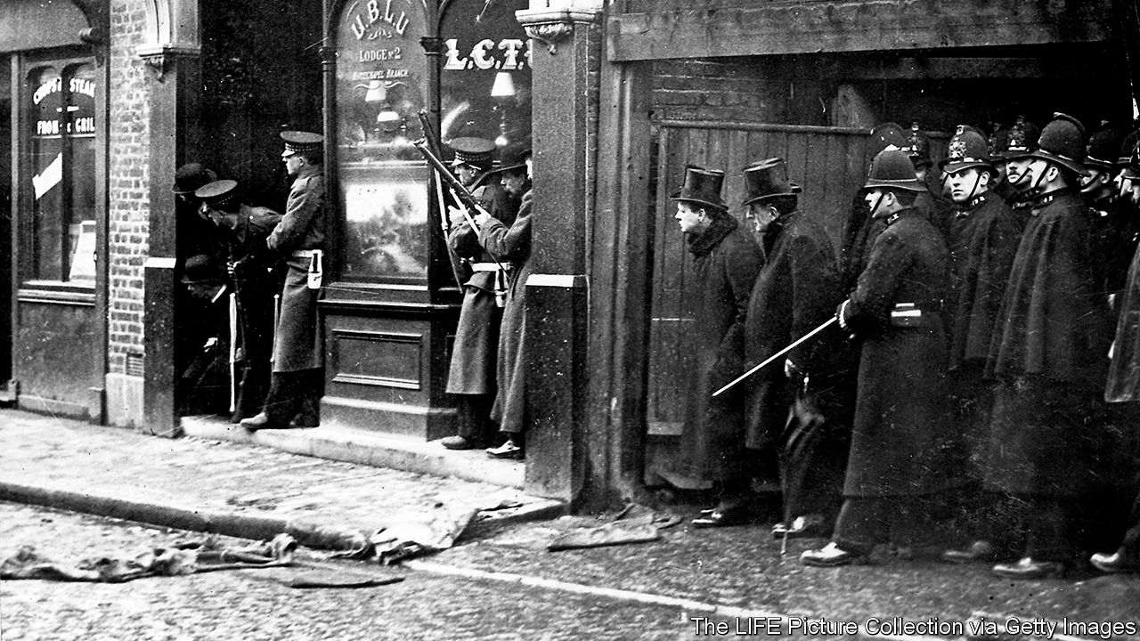

TURN OFF the Mile End Road in London’s East End, walk a hundred metres and go back in time. It is January 3rd 1911, and in place of the block of flats with black railings stands a redbrick Victorian terrace. Just after dawn, policemen throw pebbles at a second-floor window. From inside comes a volley of bullets—the opening shots in six hours of mayhem. A sergeant collapses, struck in the chest.

So began the Siege of Sidney Street, a pyrotechnic showdown that sparked headlines and manhunts around the world. The anxieties it dramatised—over immigrants, extremism and the welcome both receive in London—remain acute today. So do the questions it raised about violence by and against the police, and over the perils of political grandstanding, in this case by Winston Churchill, then home secretary in Britain’s Liberal government.

In one of history’s arbitrary ricochets, the events paired Churchill with another figure destined to become a legend: a revolutionary known as Peter the Painter, once notorious from Canada to Australia yet so shadowy and elusive that some doubt he ever existed. Unfolding over a chilly Christmas season, the episode shows how villains can turn into heroes, flaws become virtues, and the past morph into myth.

In an urban landscape transformed by slum clearances and the Luftwaffe, you have to look hard for traces of this sensational affair. But they are there. A mile to the west of Sidney Street in Devonshire Square is a plaque honouring Robert Bentley, Charles Tucker and Walter Choate, police officers slain in the line of duty. This is where the story begins.

Their killers included veterans of prison breaks and guerrilla warfare in modern-day Latvia, victims of tsarist torture who expected the same treatment if they were caught again. In London they inhabited a milieu of radical ideas and exiles (including, a few years earlier, Lenin, Stalin and Trotsky). In their correspondence, obtained by police and kept in the London Metropolitan Archives (LMA), the desperadoes come alive. They aver love and loyalty, defy death and solicit patience and money—in pursuit of which they planned “expropriations”, otherwise known as robberies. In 1909 some of their number perpetrated the “Tottenham Outrage”, a payroll heist that left four people dead.

On the night of December 16th 1910 the target was a jeweller’s in Houndsditch, a commercial thoroughfare delineating the City from the East End, since remade in glass and steel. The gang rented premises behind the shop and set about breaking in. But they chose a Friday night, and the largely Jewish neighbourhood was quiet. Reports of suspicious noises attracted a policeman, then several, all unarmed. As well as the three fatalities, two officers were hurt when the criminals opened fire, in what was the worst-ever peacetime loss for British police. One robber, George Gardstein, alias Morountzeff, alias Milowitz, was hit in the melee. As he was dragged away, a passer-by took him for a drunk—until his comrades brandished their guns.

Follow the gang’s getaway route, and for all the brash new towers you find that some things haven’t changed. There is still a vertiginous drop in wealth as you head east from the City; the textile business still flourishes, albeit in South Asian rather than Jewish hands, the street markets offering kebabs instead of pickled herrings. Gardstein was left in squalid lodgings, where he was found, dead, the next day, along with weaponry and a membership card for an anarchist group named Leesma, meaning “The Flame”.

In British public opinion and newspapers, the crime reinforced the link between immigrants and revolutionaries, who, as some are now, were organised into slippery cells and cherished a transnational cause. Thousands lined the streets for the victims’ funeral at St Paul’s Cathedral. The police posted a reward for the alleged kingpins in English, Russian and Yiddish—among them Peter the Painter. In wanted posters bearing that name, a moustachioed man poses insouciantly for an elegant studio portrait.

## Blood and death

This “dashingly handsome” figure, says Nadia Valman of Queen Mary University of London, would enter the city’s mythology, straddling the border between felon and icon. According to the posters, Peter went by the surnames Piatkow and Schtern. He was “a native of Russia, an anarchist”. If the conspiracy was international, so was the chase. French police claimed Peter had lived in Marseilles. The Russians implicated him in a bomb plot in Crimea. A source placed him at an anarchist club in Paris, for which the password was “Blood and death”. He spoke several languages and played the violin. He corresponded with subversives in Baku; a sweetheart pined for him in Kyiv.

That alliterative nickname contributed to his mystery. What did he paint—houses or portraits? (The sets for amateur dramatics, some suggested.) Was he an artist or a working man, ordinary or exceptional—or one disguised as the other? In a stroke of catchy branding, his moniker echoed that of the monster who had haunted London a generation earlier: Jack the Ripper.

The East End had a penumbra of informers, double agents and provocateurs. On New Year’s Day an acquaintance tipped off police that the fugitives were hiding at 100 Sidney Street. Two days later Peter the Painter—the idea, if not the man—collided with Churchill and his own, carefully cultivated image.

He was in the bath when he got the call. Before dawn the police had evacuated the many other tenants of number 100; in the archives you can see a scrawled map they used to plan their ambush. But it was soon clear that their antiquated service weapons were no match for the brigands’ pistols, and Churchill’s authority was needed to summon a detachment of Scots Guards from the Tower of London.

Today, to imagine the carnage that ensued, you have to substitute the crack of bullets for the noise of the construction site across Sidney Street—occupied, in 1911, by a brewery, from the windows of which marksmen fired as others took aim from doorways, behind chimney pots or crouching in the slush. Inside the house the doomed men rushed between floors and windows to shoot back.

Though only 36, Churchill was a veteran of combat, with (like Peter the Painter) an adventurous and embroidered past. He had ridden into battle at Omdurman and helped relieve the siege of Malakand. He had been captured on an armoured train and broken out of a Boer prison. He dressed, hurried to the Home Office and was quickly on the scene, impelled by both “convictions of duty” and “a strong sense of curiosity which perhaps it would have been well to keep in check”.

His cameo is preserved on jerky newsreel footage that played in cinemas almost immediately: the cameras made the siege “the first breaking news story in history”, says Andrew Roberts, Churchill’s most recent biographer. You can see the soldiers marching in, horses drawing up artillery, the puff of gun smoke and journalists huddling on the roof of the Rising Sun pub (since demolished, along with the Three Nuns, the anarchists’ local). Police struggle to restrain the huge crowds that gathered—rooftop seats were going for ten shillings. And there, sheltering around a corner, is a youthful Churchill, expostulating theatrically in a top hat and an astrakhan-collared coat.

One story has it that Churchill’s topper took a bullet—unlikely, says Mr Roberts, since “if it had, he’d have kept it”. His presence was controversial, first among the spectators, some of whom lambasted his liberal approach to immigration, later in Parliament. “I understand what the photographer was doing,” chided Arthur Balfour, leader of the Conservative Party, which Churchill left in 1904 and would later rejoin. “But what was the right-honourable gentleman doing?”

The answer, according to a newsreel caption, is that he was “directing operations”. He suggested seeking metal plates in preparation for storming the house. When, in the lurid finale, the building caught fire—nobody knows how—Churchill approved the decision to keep the fire brigade away. “I thought it better to let the house burn down, than spend good British lives in rescuing these ferocious rascals,” he told Herbert Asquith, the prime minister. Newsreels show gallant firemen rushing in after the roof collapsed. One, Charles Pearson, died after being hit by falling masonry. (The policeman shot at daybreak survived.)

Two charred corpses, identified as William Sokoloff and Fritz Svaars, were found inside. One had been shot in the head; the other succumbed to the smoke. “Everybody knows he must die some time,” Svaars had written to relatives in Latvia on the eve of the siege. “I know that if they catch me they will hang me.” There was no trace of Peter the Painter.

As shocking crimes can, the siege opened eyes. The police were given better weapons (Churchill oversaw the test firing). The chief constable of Sheffield sent down a bullet-proof shield, “which may be of use when you find ‘Peter the Painter’.” The investigation re-alerted the public to the overcrowded slumlands of the East End; Russia appealed for unity against the anarchist peril. Yet, as can also be true of such spectaculars, precisely what had happened was and remains unclear.

In May 1911 four members of the gang were tried at the Old Bailey in connection with the Houndsditch murders: Peter the Painter was not among them. The judge sank the charges by asserting that the three chief culprits had already “met their doom”. Blaming Gardstein, Svaars and Sokoloff was certainly convenient for their comrades in the dock, and, after the extravaganza of Sidney Street, for the government. In fact, the role and whereabouts of the last two during the fatal robbery are still disputed.

Only Nina Vassileva, a Russian whose glamour and love-life inspired much comment, was convicted. Fingerprint evidence earned her a two-year sentence for conspiracy to rob—but even that was soon quashed. The others walked, including Jacob Peters, a cousin of Svaars who had been collared before the siege. He became a much-feared official in the Cheka, the Soviet secret police, before meeting a sticky end in 1938. Donald Rumbelow, a former policeman and author of a book about the case, reckons Peters and Gardstein did the shooting in Houndsditch.

## Angleshot Flavorum Enomotarch

“Don’t be cross,” Churchill implored a colleague after the siege, “it was such fun.” But his rush to Sidney Street was among the misjudgments held against him until he became prime minister—whereupon, notes Mr Roberts, Churchill’s “almost obsessive need to be at the scene of the action” became an asset. His direct observation of battles bolstered his grasp of the second world war (he would have joined the flotilla on D-Day had the king not intervened). His visits to districts shattered by the Blitz, during which he watched bombing raids from the roof of Downing Street, were “extraordinarily good for morale”. In retrospect the siege, says Mr Roberts, was “vintage Churchill”.

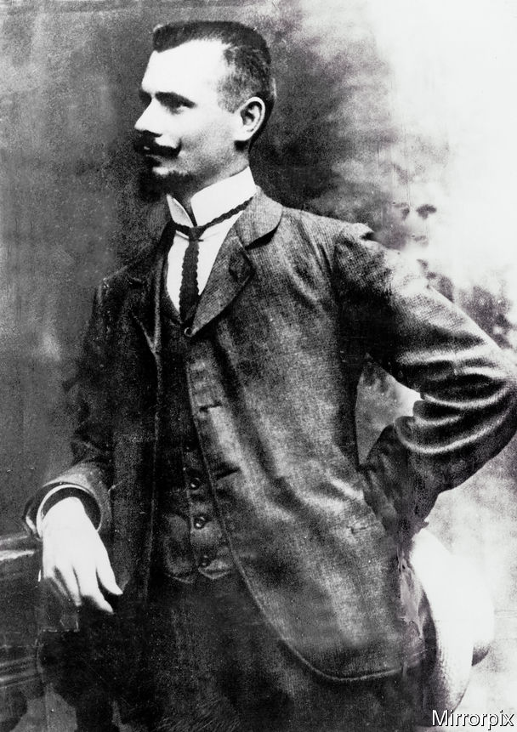

Peter the Painter evaporated. Exchanges with their foreign counterparts indicate that, lacking “conclusive proof” to tie him to the crimes, British detectives quietly stopped looking for him. Police forces from Naples to Winnipeg thought they had him. He was said to be working as a chef in Melbourne, “posing as a Frenchman” yet “an excellent hand at throwing a knife or using a revolver”. The coded reply to Australia is stored in the LMA. “Angleshot Flavorum Enomotarch”, the police telegrammed from London: “not to be arrested”, as there was “not sufficient evidence” for an extradition.

It was too late: the fascination stirred by the wanted poster and sustained by rumour could not be stifled. Peter was widely held to have been in the burning house but somehow escaped. He was spotted in Denmark. He had moved to America. A police informer all along, his handlers had spirited him away.

Soon the saga was transfigured by art. Alfred Hitchcock grew up near Sidney Street, and in his original version of “The Man Who Knew Too Much” (1934), assassins hole up in a London house, spectators gather, a brave policeman knocks... In “The Siege of Sidney Street” (1960) Peter is a suave fanatic trailed by an undercover Donald Sinden. Trapped in the siege, Peter sets the fire, breaks through the walls and melts into the crowd. “I wonder who it was that got away,” Sinden’s character muses when the bodies don’t tally. In a TV drama of 2012 Peter leads an uprising of third-class passengers on the Titanic. In Emanuel Litvinoff’s novel “A Death out of Season” (1973), he is sent by the tsarist secret police to plot the king’s assassination, and so curtail Britain’s tolerance of political refugees. But his heart is with the renegades.

Amid the hearsay and embellishments, records the “Dictionary of National Biography”, doubts arose “as to whether he existed at all”. Nothing about his life “is altogether reliable”. In his book “A Towering Flame”, Philip Ruff insists Peter was real. Citing tsarist files and unpublished memoirs, Mr Ruff says he is “100% certain” that the man in the poster was Janis Zhaklis. A social-democrat-turned-anarchist, Zhaklis had led a raid on a prison in Riga, robbed a bank in Helsinki and started a radical journal in America. Only peripherally involved in London, he fled to Brussels before, thinks Mr Ruff, becoming a businessman in Australia.

Maybe. But at this distance, identifying the “real” Peter the Painter is akin to finding the real Robin Hood, or perhaps King Arthur, both of whom his quicksilver image resembles—an indomitable will-o’-the-wisp who lives to fight another day. The fable spread: Irish insurgents called the type of pistol used by the anarchists a Peter the Painter. The flesh-and-blood man was subsumed by legend.

All this happened “many moons ago”, says a resident of the flats in Sidney Street. But it is not entirely forgotten. Another plaque commemorates the fireman who perished. Walk away from the corner where Churchill huddled, passing women in headscarves who are heirs to the Edwardian immigrants, and you find two more blocks of flats: Siege House—and Painter House. Justifying that name, the local housing body said there was no evidence Peter had killed anyone. “There is some doubt as to whether he existed,” it stated, “but his is the name that East Enders associate with the siege.” The man who wasn’t there now always will be. ■

This article was downloaded by calibre from <https://www.economist.com/christmas-specials/2020/12/19/a-stand-off-in-londons-east-end-in-1911-still-echoes-today>

|  |  |  |  |
| --- | --- | --- | --- |
| 上一项 | 文章 | 章节 | 下一项 |

|  |  |  |  |
| --- | --- | --- | --- |
| 上一项 | 文章 | 章节 | 下一项 |

#### Digital humanities

# How data analysis can enrich the liberal arts

But despite data science’s exciting possibilities, plenty of other academics object to it

Dec 19th 2020 |

IT ALL STARTED with a preposition. In 1941 Father Roberto Busa, a Roman Catholic priest, started noting down as many uses of the word “in” as he could find in the Latin work of Thomas Aquinas, a medieval theologian and saint. Eight years and 10,000 handwritten cards later he completed his linguistic analysis of Aquinas’s “interiority”—his introspective faith—at Rome’s Pontifical Gregorian University. By then he had a suspicion that his work could be done far more efficiently. He started hunting for “some type of machinery” to speed up his new project, recording the context of all 10m words written by Aquinas.

Father Busa’s zeal took him to the office of Thomas Watson, IBM’s chairman. Soon he had switched from handwritten cards to IBM’s punch-card machines, before adopting magnetic tape in the 1950s. In the 1960s dozens of full-time typists were involved. By 1980, when his team finally printed the “Index Thomisticus” in 56 volumes, they had spooled through 1,500km (930 miles) of tape. A CD-ROM containing 1.4GB of data came out in 1992, with a website following in 2005. The 97-year-old priest died in 2011. But not before he had initiated a new quest, to annotate the syntax of every sentence in the Index Thomisticus database.

Such is the creation story of the digital humanities, a broad academic field including all sorts of crossovers between computing and the arts. The advances since its punch-card genesis have been “enormously greater and better than I could then imagine,” remarked Father Busa in his old age. “Digitus Dei est hic! [The finger of God is here!]” Almost every humanistic composition imaginable has been rendered in bytes. Aquinas’s works are a speck in the corpus of Google Books, which contains at least 25m volumes and perhaps two trillion words. Naxos, a music service, has annotated 2.4m classical pieces with authorial biographies and instrumentation. Spotify, a streaming service, has 60m tunes, each with metadata about tempo, time signatures and timbre.

What started as a niche pursuit is growing rapidly. Google Scholar now contains about 75,000 academic articles and essays that mention “digital humanities”. That total is already bigger than for “Napoleon Bonaparte” (57,000) or “Romeo and Juliet” (66,000). Nearly half of the 75,000 articles were published since 2016.

## Time and the machine

Digitisation’s clearest benefits are speed and scale. Because of decades of exponential growth in computing sophistication, projects that once lasted a lifetime—literally, for Father Busa—now require a fraction of it. Take the work of Barbara McGillivray at the Alan Turing Institute, Britain’s national centre for data science. Having done her PhD in computational linguistics on the “Index Thomisticus”, she wanted to create a similar resource for ancient Greek. After starting as the institute’s first humanist in 2017, she and a colleague needed just three months to convert 12 centuries of classics into an annotated corpus of 10m words. The final product compresses Homer, Socrates and Plato into 2.5GB of tidy Extensible Markup Language (XML), complete with the grammatical properties of each word.

Curating such enormous archives is just the starting-point. The trick is to turn the data into interesting findings. Researchers have been trying to do that from almost the time when Father Busa began punching cards. From the late 1950s Frederick Mosteller and David Wallace, two statisticians, spent several years using a desk-sized IBM 7090 to calculate the frequency of words in the Federalist papers, written by Alexander Hamilton, James Madison and John Jay. They inferred that 12 anonymous essays were probably written by Madison, based on certain tics. He rarely used “upon”, for example, whereas Hamilton often did.

Advances in machine learning have given Ms McGillivray a far shinier array of tools. Along with four co-authors, she tested whether an algorithm could track the meaning of Greek words over time. They manually translated 1,400 instances of the noun kosmos, which initially tended to denote “order”, then later shifted to “world” (a celestial meaning that survives in the English “cosmos”). Encouragingly, the machine agreed. A statistical model reckoned that in 700BC kosmos was frequently surrounded by “man”, “call” and “marketplace”, a cluster suggesting “order”. By 100AD a second cluster emerged, suggesting “world”: “god”, “appear” and “space”.

The thrill of getting “a computer to blindly agree with us”, explains Ms McGillivray, is that she could now apply it easily to the 64,000 other distinct words in the corpus. She has already spotted that paradeisos, a Persian loan-word for “garden”, took on its theological context of “woman”, “god” and “eat” around 300BC, when the Old Testament was first translated into Greek. At a few keystrokes, the algorithm tapped into one of history’s great intellectual exchanges, between Judaistic theology and Greek literature.

## Take a byte

The most compelling number-crunching of this sort has focused on English writing from 1750-1900, thanks to that era’s rapid expansion of printed texts. Such Victorian data-mining has mostly taken place in America. The Stanford Literary Lab was established in 2010. In contrast to “close reading”, by which humans spot nuances on a couple of pages, the lab’s 60-odd contributors have pioneered “distant reading”, by getting computers to detect undercurrents in oceans of text.

An early project dredged through nearly 3,000 British novels from 1785-1900, to examine which types of language had gone in and out of style. The authors, Ryan Heuser and Long Le-Khac, developed a tool called “the Correlator”, which calculates how frequently a given word appeared in each decade, and which other words experienced similar fluctuations. Though the maths was crude, it provided some surprisingly coherent clusters: “elm”, “beech” and “branch” closely tracked “tree”, for example. In order to detect broader trends, the authors then hunted for clusters that demonstrated sustained rises or falls in popularity.

First they took the words “integrity”, “modesty”, “sensibility”, and “reason”, and built a cohort of 326 abstract words correlated with them. These sentimental and moralistic terms fell increasingly out of fashion, from providing roughly 1% of all words in 1785 to half that in 1900. To provide a contrast, they then looked for a cohort of concrete terms. They found 508 correlates of the word “hard”. These fell into distinct sub-clusters: actions (“see”, “come”, “go”), body parts (“eyes”, “hand”, “face”), physical adjectives (“round”, “low”, “clear”), numbers and colours. Across the period, this “hard” cohort rose from 2.5% of words to nearly 6%. This was a pattern that led from Elizabeth Bennet’s decorous drawing room to Sherlock Holmes’ shady alleys. Strikingly, the trend-lines suggested that the movement from abstract words to concrete ones had been steady, rather than a sudden Dickensian shift.

Such quantitative studies don’t have to overturn grand theories to be interesting. The Correlator’s findings could sit comfortably within many books about the rise of novelistic realism. Sometimes, the benefit (and pleasure) of crunching literary data comes simply from measuring the strength and timing of historical tides. A second study from the Stanford Literary Lab concurred that 19th-century British novelists gradually removed sentimental words. The author, Holst Katsma, found a steady decline in melodramatic speaking verbs. “Exclaimed”, “cried” and “shouted” accounted for 19% of utterances in around 1800, but only 6% by 1900. (Novelists became fonder of “said”.)

Nonetheless, digital humanists enjoy going against the grain. Few have found as many quirky statistical patterns as Ted Underwood, a lecturer in English and computer science at the University of Illinois. In 2016 Mr Underwood decided to try to see what percentage of descriptions in contemporary novels are about female characters, and how this changed over time.

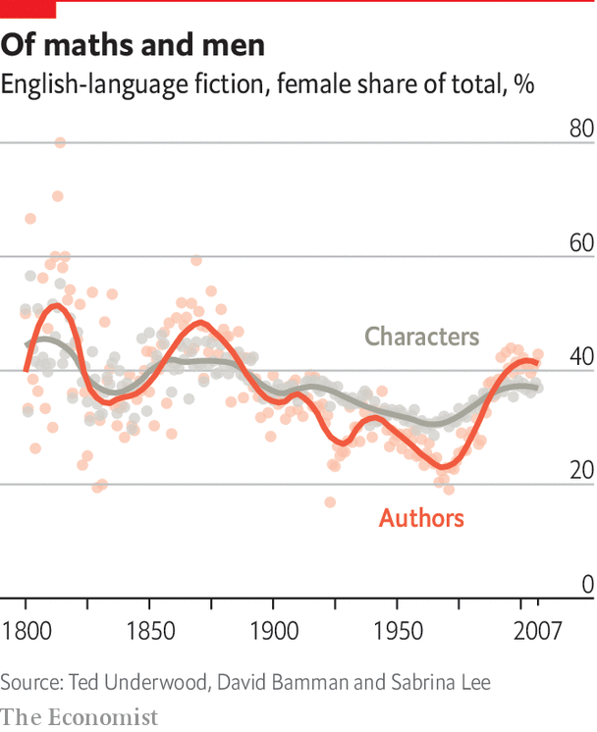

Mr Underwood took nearly 100,000 novels from 1800-2009 and an algorithm that apportions nouns, adjectives and verbs to specific characters. He found that women received about 50% of descriptions in 1800, but barely 30% by 1950 (see chart 2). This mirrored a similar fall in the share of novels by female authors. As writing became more lucrative, it veered away from the world of genteel ladies to that of grubby men. It was only after 1950 that female authorship and characterisation rebounded. Sabrina Lee, one of Mr Underwood’s colleagues, notes that this coincided with the rise of paperback publishing and romance imprints. Even so, women’s share of writing and description remained around 40% in 2010.

Some of Mr Underwood’s investigations require little modelling and a lot of counting, such as an article that examined a sweeping literary claim by Thomas Piketty, an economist. Mr Piketty reckoned that widespread inflation after 1914 made people warier of wealth, and so “money—at least in the form of specific amounts—virtually disappeared from literature”.

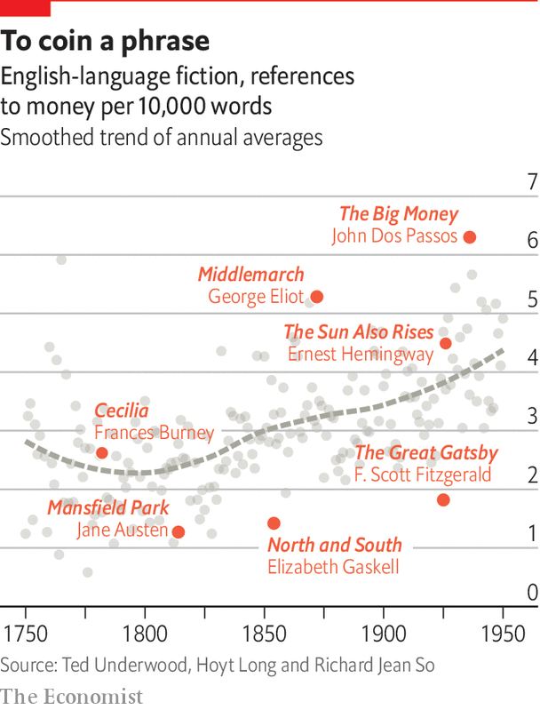

Instinctively, Mr Piketty’s claim may feel true. Victorian characters often agonised over inheritance or debt, such as reckless Fred Vincy in “Middlemarch”, who constantly counts the pounds and shillings he has gambled away. By contrast “The Great Gatsby”, a modernist meditation on the “young and rich and wild”, mentions dollars just ten times. However, after combing through 7,700 novels from 1750-1950, Mr Underwood and his co-authors found that these were outliers. The rate at which authors referenced specific amounts of cash nearly doubled in that period (see chart 3). One explanation is that their characters tended to use pocket change more often. The median amount mentioned fell from nearly 60% of annual income to less than 5%.

Because e-books are abundant and computational linguistics dates back to the dawn of the digital age, most humanistic number-crunching so far has been literary in nature. But other subjects are starting to produce peer-reviewed quantitative studies, too. In history, Proceedings of the National Academy of Sciences published a paper in 2018 that found Maximilien Robespierre was the most influential rhetorician of the French revolution. The authors judged this by how often members of the National Constituent Assembly copied his innovations during 40,000 speeches. In anthropology, a team of researchers published an article in Nature in 2019 that examined how religions developed, using a 10,000-year dataset of 414 civilisations. They found that societies tended to adopt moralising gods after they had already created complex hierarchies and infrastructure. This challenges the idea that humans needed divine rules in order to band together.

Similarly, a study on painting from 2018 found that Piet Mondrian, a Dutch modernist, dabbled with a much wider range of colour contrasts during his career than his European contemporaries. And a paper from 2020 calculated that Sergei Rachmaninoff composed the most distinctive piano pieces relative to his peers, using a similar measure of innovation to the one in the Robespierre paper (but judging by groups of notes, rather than words).

Despite data science’s exciting possibilities, plenty of academics object to it. The number-crunchers are not always specialists in the arts, they point out. Their results can be predictable, and the maths is reductive and sometimes sketchy. So too are the perspectives often white, male and Western. Many also fear that funding for computer-based projects could impoverish traditional scholarship. Three academics complained in the Los Angeles Review of Books in 2016 that this “unparalleled level of material support” is part of the “corporatist restructuring of the humanities”, fostered by an obsession with measurable results.

## Brave new world

The arts can indeed seem as if they are under threat. Australia’s education ministry is doubling fees for history and philosophy while cutting those for STEM subjects. Since 2017 America’s Republican Party has tried to close down the National Endowment for the Humanities (NEH), a federal agency, only to be thwarted in Congress. In Britain, Dominic Cummings—who until November 2020 worked as the chief adviser to Boris Johnson, the prime minister—advocates for greater numeracy while decrying the prominence of bluffing “Oxbridge humanities graduates”. (Both men studied arts subjects at Oxford.)

However, little evidence yet exists that the burgeoning field of digital humanities is bankrupting the world of ink-stained books. Since the NEH set up an office for the discipline in 2008, it has received just $60m of its $1.6bn kitty. Indeed, reuniting the humanities with sciences might protect their future. Dame Marina Warner, president of the Royal Society of Literature in London, points out that part of the problem is that “we’ve driven a great barrier” between the arts and STEM subjects. This separation risks portraying the humanities as a trivial pursuit, rather than a necessary complement to scientific learning.

Until comparatively recently, no such division existed. Omar Khayyam wrote verse and cubic equations, Ada Lovelace believed science was poetical and Bertrand Russell won the Nobel prize for literature. In that tradition, Dame Marina proposes that all undergraduates take at least one course in both humanities and sciences, ideally with a language and computing. Introducing such a system in Britain would be “a cause for optimism”, she thinks. Most American universities already offer that breadth, which may explain why quantitative literary criticism thrived there. The sciences could benefit, too. Studies of junior doctors in America have found that those who engage with the arts score higher on tests of empathy.

Ms McGillivray says she has witnessed a “generational shift” since she was an undergraduate in the late 1990s. Mixing her love of mathematics and classics was not an option, so she spent seven years getting degrees in both. Now she sees lots of humanities students “who are really keen to learn about programming and statistics”. A recent paper she co-wrote suggested that British arts courses could offer basic coding lessons. One day, she reckons, “It’s going to happen.” ■

This article was downloaded by calibre from <https://www.economist.com/christmas-specials/2020/12/19/how-data-analysis-can-enrich-the-liberal-arts>

|  |  |  |  |
| --- | --- | --- | --- |
| 上一项 | 文章 | 章节 | 下一项 |

|  |  |  |  |
| --- | --- | --- | --- |
| 上一项 | 文章 | 章节 | 下一项 |

#### Sadie Tanner Mossell Alexander

# Economists are rediscovering a lost heroine

Sadie Tanner Mossell Alexander was the first African-American to earn a PhD in the subject

Dec 19th 2020 |

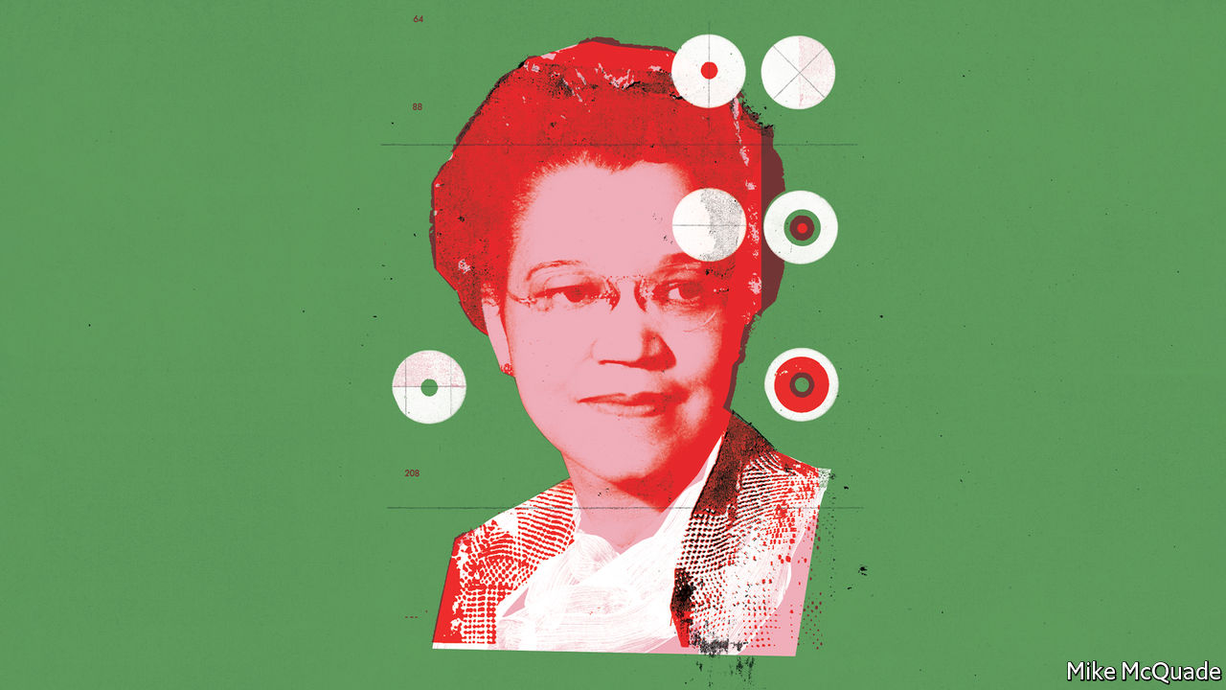

IN THE GOLDEN age of comic books, American children devoured stories about fantastical superheroes. The National Urban League, an organisation devoted to racial justice, published a comic of its own, Negro Heroes, filled with inspirational black people it had no need to invent. Its 1948 issue featured Jackie Robinson, who had recently broken baseball’s colour bar, on the cover. But it also celebrated a less obvious figure: Sadie Tanner Mossell Alexander, one of the league’s leading lights and the first African-American to earn a PhD in economics. “You will get a real thrill as you read about these people,” it promised.

Economists are reviving Alexander, born in Philadelphia in 1898, as a heroine for today. In 2018 a pair of young black women formed the Sadie Collective to help others pursue careers in the field. In 2021 the National Economic Association, a group supporting minorities, will celebrate the centenary of Alexander’s PhD award at their annual gathering. Nina Banks, author of a forthcoming biography, notes that economists have done a poor job of including women or African-Americans in the history of economic thought. Alexander’s career shows what they are missing.

Like many comic-book heroes, she combined an illustrious lineage with early adversity. Her grandfather was a much-published bishop, her uncle was a renowned painter, her father was the first black American to graduate in law from the University of Pennsylvania and her aunt was the first black woman certified to practise medicine in Alabama. She attended the prestigious M Street High School, which often hosted the country’s leading black intellectuals. “We studied Negro history from living exhibits—not history books,” she said. But her father ran off when she was only a year old, vanishing so completely from her life that she assumed he was dead until her teenage years.

Starting as an undergraduate in Penn’s School of Education in 1916, she faced disdain for her ambitions, followed by resentment at her achievements. No one told her how to find the right classroom or the right books. Her first-year classmates barely spoke to her—except one, who befriended her, then tried to copy her exams. A fellowship to pursue graduate work was initially denied to her after a librarian accused her of meddling with another student’s books. He had mistaken her for another black woman on campus. “Such circumstances made a student either a dropout or a survivor so strong that she could not be overcome, regardless of the indignities,” Alexander later said.

Her heroism was of the quiet sort. She responded to slights with an almost militant courtesy. At a regular tea organised by the students, she was not trusted to contribute sandwiches but asked to bring olives instead. In response, she asked her grandfather’s cook (who had previously worked at the governor’s mansion in Bermuda) to prepare something special. When she unwrapped the beautiful sandwiches, “all eyes were agog and mouths watering”.

Alexander was awarded her PhD in a blaze of publicity. She recalled marching down Broad Street with photographers “shooting her from every side”. She and the press initially thought she was the first black American woman to get a PhD in any subject—a misconception she was not always careful to correct. (Georgiana Simpson, a teacher at M Street High School, received her PhD a day earlier.) Alexander’s elation faded quickly when she tried to get a job worthy of her talents. She spent two lonely years with an insurance firm in North Carolina, then another year as a housewife (“I...almost lost my mind”) before returning to Penn to get a law degree.

Her subsequent career as a lawyer and activist was full of zap and pow. After joining her husband’s law firm in 1927, the pair helped desegregate Philadelphia’s hotels, theatres and cinemas, offering to represent, without charge, any victim of segregation prepared to show up in court. They had the manager of the cinema opposite their law office arrested so often he eventually appeared before them waving a handkerchief in surrender. In 1947 she was appointed to President Harry Truman’s committee on civil rights, alongside Charles Wilson, the boss of General Electric, and Franklin Roosevelt, son of the previous president. (Even so, the Hotel Statler in Washington, DC would not seat her for lunch until Mr Wilson intervened.)

It is tempting to see Alexander’s exit from economics as an early example of the discipline’s particular difficulty in retaining black scholars. That would be a mistake, argues Ms Banks. Alexander’s years as an economics PhD student were her happiest at Penn. “I was the pet, the darling of the faculty,” she recalled. The head of the university’s insurance department was incensed that he could not find her a better job. The obstacles she faced were imposed by society at large. The two black women who received PhDs in the same year in other subjects took years to find university jobs.

Although she had to leave academic economics, the discipline never left her. Her many speeches and writings show that she continued to think of herself as an economist. She cited statistics more often than legal cases. She believed that steady, productive employment was both an index of racial justice and a means of attaining it. And her ideas evolved in response to the economic trends of the day.

## A neglected stream

Her dissertation was prompted by the migration of 40,000 southern blacks to Philadelphia’s factories during the first world war. Alexander wanted to know whether the mostly “untrained, illiterate” newcomers would adapt to an industrial economy or drag down Philadelphia’s existing black population, a community “of culture, education and some financial means”.

As a black woman, she won intimate access to the financial lives of 100 migrant households, documenting their spending on everything from kerosene to vaudeville tickets. The migrants were corralled into overcrowded, overpriced homes. Alexander noted falling plaster, broken floorboards and the “vile” odour from toilets in disrepair. But the households did not rely on charity. And 64% earned enough to afford a fair standard of living, as she calculated it, provided they could rent housing on the same terms as white families and avoid “unwise” spending decisions, such as buying things in smaller quantities than necessary.

Her foray into field work and her eye for behavioural quirks fit surprisingly well with today’s fashions in economics. The discipline has moved on from armchair theorising about rationally optimising agents. But fashions can be circular, and her dissertation was in keeping with its own times as well as today’s. The distinction between economics and sociology was fuzzier than it became after the second world war. Similar surveys had been carried out by black scholars like W.E.B. Du Bois, who published “The Philadelphia Negro” in 1899. If Alexander’s work now seems novel it may be only because economists have lost sight of this tradition. Perhaps not coincidentally, the work was often carried out by scholars—black, female or both—who were themselves marginalised, says Dan Hirschman of Brown University.

After leaving university, Alexander wove her economic ideas into her speeches and articles. She argued that factory jobs were more dignified than household drudgery, which was priceless and therefore thankless. She welcomed the fact that many black women worked outside their homes, but complained that they were often employed “unproductively”. Two-thirds earned a pittance as servants, she reported during the Great Depression. The remainder were mostly farmhands. “We still find barefoot Negro women hoeing, planting and picking the crops. Theirs is not even an existence; it is a fight for…survival.”

Some policies designed to relieve the Depression neglected black workers. New pensions and unemployment insurance introduced in 1935 left out both servants and farm labourers. “It is clear that in his years of planning for Social Security of the common man, Mr Roosevelt never had in mind the security of the American Negro,” she said. Other policies made things worse. Many blacks in the South could get only jobs that whites did not want at pay they would not accept. When the National Industrial Recovery Act lifted the wages and prestige of these jobs, blacks lost them. Roosevelt’s national recovery act, she thought, might as well be called the “Negro Reduction Act”.

In a downturn, when people are reluctant to spend, there are only so many jobs to go round. White workers vie with blacks—one source of racial friction between them. But mobilisation for the second world war showed that another economy was possible. The huge increase in wartime spending created 10m jobs, vindicating the Keynesian ideas that Alexander also embraced. To maintain full employment in peacetime, she argued that the government should tax idle profits (spending the proceeds on public investment) and bolster the purchasing power of idled workers. This spending would contribute to high employment and high employment would sustain liberal spending.

The need for full employment featured prominently in the National Urban League’s annual conference in 1944. Black workers were “the last to be hired and the first to be fired” when employment was anything less than full, as Alexander pointed out. With steady jobs, blacks could acquire seniority, skills and the solidarity of union membership. By removing white workers’ “fears of economic rivalry”, full employment would also ease racial prejudice and repair American democracy. Economic insecurity, on the other hand, would encourage people to support demagogic leaders, lured by the “vain promises of a self-proclaimed messiah”. Her warning, Ms Banks says, “speaks to our time”.

As the country prepared to demobilise in 1945, Alexander urged black workers to act with a “deep sense of responsibility” to each other. She worried that “absenteeism, lateness, loafing on the job” by any black worker would harm the prospects of all. She felt the same heavy burden of responsibility in her own professional life. Her grades were as eye-catching as her sandwiches. Her court petitions were fastidious. Her proposal to Philadelphia for a civil-rights commission was accepted “without removing a comma”. After becoming pregnant, she stayed at her legal post for as long as possible, “both for myself and for all women”.

Her response to the unreasonable demands placed on her was not to reject them but to exceed them. “I felt the burdens of the world on my shoulders,” she once said. Alexander is being rightly revived as an inspirational hero for today. But few could follow her example. And none should have to. ■

This article was downloaded by calibre from <https://www.economist.com/christmas-specials/2020/12/19/economists-are-rediscovering-a-lost-heroine>

|  |  |  |  |
| --- | --- | --- | --- |
| 上一项 | 文章 | 章节 | 下一项 |

|  |  |  |  |
| --- | --- | --- | --- |
| 上一项 | 文章 | 章节 | 下一项 |

#### Shingle art

# How one man made art out of nothingness

Rory McCormack, known as the Pebble Sculpture man, has been working on Brighton beach for 25 years—but few residents have ever seen him

Dec 19th 2020 | BRIGHTON

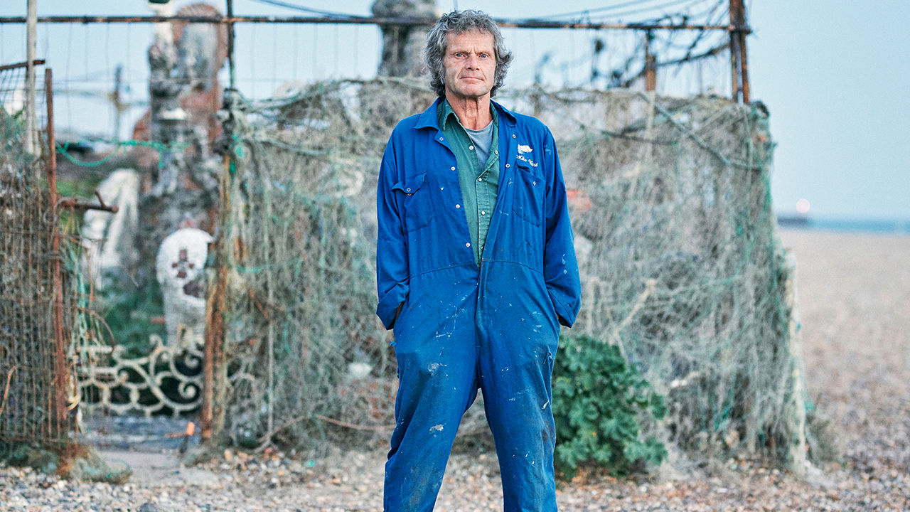

AT AROUND HALF past eight on a warm late-summer morning, Rory McCormack trudges across the shingle of Brighton beach. He is a short, solid figure in baggy clothes and walking boots, with a duffel bag on his shoulder. Everything about him is weathered, tanned and worn, but livened with an air of independence. His greying brown hair blows round his face, which is as weathered as a fisherman’s would be. And a fisherman he is, the last still working from the beach in a city that long since gave itself over to pleasure rather than fish. But to folk in Brighton—few of whom have ever seen him—he is the Pebble Sculpture man.

He is making for his compound, a rusty wire-mesh enclosure perhaps 25 metres square, crammed with what seem to be lively stalagmites but are, in fact, tall statues made of stones. On the way he pauses to pick a pebble up. It is something almost everyone does instinctively, drawn by their contours, their colour, or the way they catch the light. But some people do it obsessively, with purpose, in quantity, and he is one. As he says, it’s very hard to stop looking.

Pebbles, as opposed to stones, have certain qualities. They are smoothed by wind or water, and mostly of a size that fits the hollow of the palm of a hand. There are plenty here—614,600,600, pub-quizzers say—graded as the beach descends. The largest, those offering the best grip to the waves, are flung above the high-tide line; the smallest congregate and chorus at the edge of the sand. A shingle beach is a transient thing, edged continually sideways by longshore drift that follows the wind. Each pebble is also a work in progress, from commanding cliff to silt, being to nothingness.

Most beach pebbles, like this specimen, are the size of a new potato. Rory appraises it carefully, then discards it. At the wire gate, barred with several windings of heavily rusted chains, he pauses again to kick away the accumulated shingle that stops it opening. The fascination of pebbles is balanced by the nuisance of them. He loves them and hates them and, either way, they fill his life.

He opens the gate only as far as is needed to grab a spade. Then he walks back across the shingle to the ridge that marks the drop to the tideline, and starts furiously digging. The ridge, like others along the beach, has been thrown up by exceptional tides and storms; the bigger the storm, the higher the ridge, and the deeper the load of stones that can bury wrecks, foundations of houses or the stumps of ancient forests. The space between each ridge marks an interval of time. It is history itself that Rory is digging through. A passing cyclist watches him in awe. But what he is also doing is restoring the slipway from his compound to the sea, to get his boat out. Covid-19 stopped him fishing, but for a couple of months now he has presumed he can go.

His family came down to Brighton in the 1960s; he took up fishing and got a concrete standing for his boat on the beach. Gradually all the other fishermen died or departed, but he stayed, with his flotsam of gear expanding round him. And, surrounded by pebbles as he was, he began to give them his consideration—or, as he usually puts it, play around with them.

## Arranging nothingness

Not many would bother. A shingle beach appears to have no features at all, and to sustain nothing living. The “Observer’s Book of Sea and Seashore” dismisses these beaches as “the nearest approach to a desert our islands can show”. Rory disagrees with that. It may be nothingness but, as he puts it, “Nothingness can be rearranged.” It can grow things, for a start. Just outside his fence there are sizeable clumps of sea-kale and silver ragwort. (Blanched sea-kale stems, according to Richard Mabey, doyen of foraging, are very good with sauce hollandaise.) Inside he has a vegetable bed with more kale, sea-beet and horseradish. He admits that he has cheated here, importing some topsoil from municipal flower-beds to help. But he didn’t have to, for the long taproots of these plants can reach three feet or more through the shingle to fresh water. And a mulch of seaweed, as much as you can get, will do instead of soil. There are places right out on the Kemp Town shingle, the deepest part of Brighton beach, where dandelions grow. He knows some spots, towards Hove, where there are wild tomatoes. The desert can flower.

Is it good for anything else? At first, he thought he might build a house. He had done dry-stone walling for a spell. Primitive coal, full of sulphur, stinking as it burns, is sometimes brought in on the tide; he could mix coal-ash, sand and chalk together to make mortar. Most of the pebbles are rugged, durable nodules of flint washed out of the local chalk cliffs. But they are still too slippery and smooth for house-building. Plenty were incorporated, with other rubbishy ingredients, into the speculative Regency builds that became the grand terraces of Kemp Town; this blend, called “bungaroosh”, was so unstable that much of Brighton, it is said, could be demolished with a well-aimed hose.

A pebble house, then, was not a good idea. Even his pebble sculptures seemed unfeasible at first, just an insecure mound of stones. But once he had cracked the flints open with a hammer, to get a flat face with more angular edges, he could build an outside frame and pack it with pebbles into big, durable shapes. He began about eight years ago, in a bad winter, by making a simple workbench to clean his fish on. Then he thought he might make it prettier with pebbles of different sorts. And so the enterprise has gone on, and on.

His compound is now crammed as tightly as it can be with sculptures of every size and shape. Monumental figures of flint and brick pebbles alternate with smaller, friskier humanoids who dance among them. He has to turn sideways in places, ducking under a heavily decorated arch and along a pathway of flints inlaid with medallions of seagulls. Flint is naturally the dominant theme, ranging through black, blue and grey; red brick comes next; but then everything is picked out with the other hues the beach has to offer. Shingle seems merely brown from a distance, or at best an array of pointillist browns and greys. But Rory knows where to get pure yellows, purples, greens (and, for whites, the ubiquitous stone-like shells of slipper-limpets). He has found mysterious chunks of pink marble, stones with crystal in them, and a greenish flint that looks like obsidian. Anything you want, he says, is just sitting there waiting.

In Victorian times collectors combed this beach, looking for—and finding—amethyst, chalcedony, carnelian, jasper and onyx. A national craze began as they broke these semi-precious stones open with small hammers, polished them and put them in cabinets to display. The Bible of pebble-picking, Clarence Ellis’s “The Pebbles on the Beach” of 1954, was reissued in 2018 as if, with the growth of green consciousness, the pastime might be fashionable again. But Ellis already expected to find nothing of great interest left in Brighton. The Crystal Shop in the city’s North Laine, round which the smell of joss-sticks lingers thick, sells azurite from Morocco and amethyst from Brazil, but advertises nothing local. When local pebbles find their way to the city’s boutiques they have been strangely denatured, painted with flowers and birds, or mounted in a collage as the bodies of dogs and cats. Rory has no time for this “jewellery”. He likes them as they are.

Besides, his inspiration is quite different. It is ancient civilisations, figures from the distant past: figures, in other words, as ancient as the pebbles are. Most of his statues are modelled on figurines from the Bronze Age, sometimes from the Stone Age, and scaled up. To these he has added gods and goddesses from pre-Classical Greece, with excursions into the Incas, the Sumerians and the Egyptians. He never learned any of this at school, which he left at 16 to fish; but between his trips to get bass, mackerel or spider crabs he has read deeply in these subjects. His towering Pan-pipe player, ten feet tall, is a Cycladic figure of the Bronze Age. The Venus of Willendorf looms along the path, her ample backside supported by a bone-chewing dog. A Cycladic harpist plays by the fence, and beside his rickety shed a Sumerian goddess cradles her child. From the midst of the figures a stone seagull peers out, a portrait of a persistent friend. He is wearing the double crown of Horus, the Egyptian falcon-god.

For Rory these close-packed gods seem alive. If he deviates just a bit in his copying of their forms, they lose their power. Seen by the light of a full moon, especially, he finds “an air of mystique” about them. He is not inclined to get much more philosophical than that. The idea that a pebble with a hole through it represents the Buddhist idea of sunyata, the emptiness from which anything may come, earns only a grunt. He would not keep a pebble on his desk, as some folk do, to represent stillness or silence or the near-infinite compression of vast time. For him a pebble has to have a practical, if artistic, use. But he likes the thought that in cave-tombs collections of pebbles that look like faces, horses or hearts are often buried with the dead, because that is how modern humans sort them, too.

Now, however, he has work to do before the beach gets fuller. In an average year as many as 11m people pour onto it. The shingle does not put them off. Many, indeed, prefer it to sand: less intrusive, and (though painful to feet) quickly moulding to the form of a reclining body. People spend hours on it, losing things more easily than they lose them on sand, leaving treasure for the detectorists who swing slowly over in the mornings. What they leave behind—spoons, earrings, rope, broken toys—works its way into Rory’s statues, too. As the trippers sit and chat, their hands instinctively find pebbles, caress them, knead them, and ultimately throw them—as if the only use of pebbles is to hit a target, and occasionally to fell giants.

## Marking time, stone by stone

Rory sometimes thinks even less of them. They make a rotten beach to fish from, wearing out the bottom of his boat and obstructing its passage. He thinks ruefully of tractors, even oxen, that do the job on other shores. Much of his dogged digging today seems to have gone for naught; his slipway is almost obliterated already by the ever-shifting stones. But there is a shapely, appreciable dip in the ridge. So, fetching from a rusty biscuit box the key to a separate section of his compound, he hauls his boat out.

It is battered, but a beauty: an aluminium rowing boat with a brown hull and a bright blue, red and yellow trim, big enough for one man only or two at a squeeze. Inside, it’s a bit of a mess of gear and needs a bail-out. But outside he has painted it with scenes from Greek history and mythology, black figures on red, just as they appear on ancient vases. Again he found his references in books, especially Jane Ellen Harrison’s “Prolegomena to Greek Religion” (1908), which he picked up second-hand in Hove. The siege of Troy is his principal theme. The hull dances with warriors in crested helmets, hunters, Harpies with their bird-bodies and women’s heads, wrestlers and lovers. On the starboard side Priam’s daughter is sacrificed to the flames; snake-haired Medusa glares from the prow, and on the stern is the motto “IEXYE” (Be Strong): the prayer, he says, of an early Christian martyr as he was thrown to the lions. He goes back now to fetch a great weight of ropes and five-foot lengths of plastic pipe, and walks off towards the sea. The burden unspools: an extra slipway, joined with ropes, to make a boat-path across the shingle. Again comes the sense of the nuisance of all those pebbles, the inhospitable place. The ropes tangle; painstakingly he unknots them. Then, when all is straight, he walks down the line applying grease to every pipe, to make the journey smoother. Only then will the shingle let him pass.

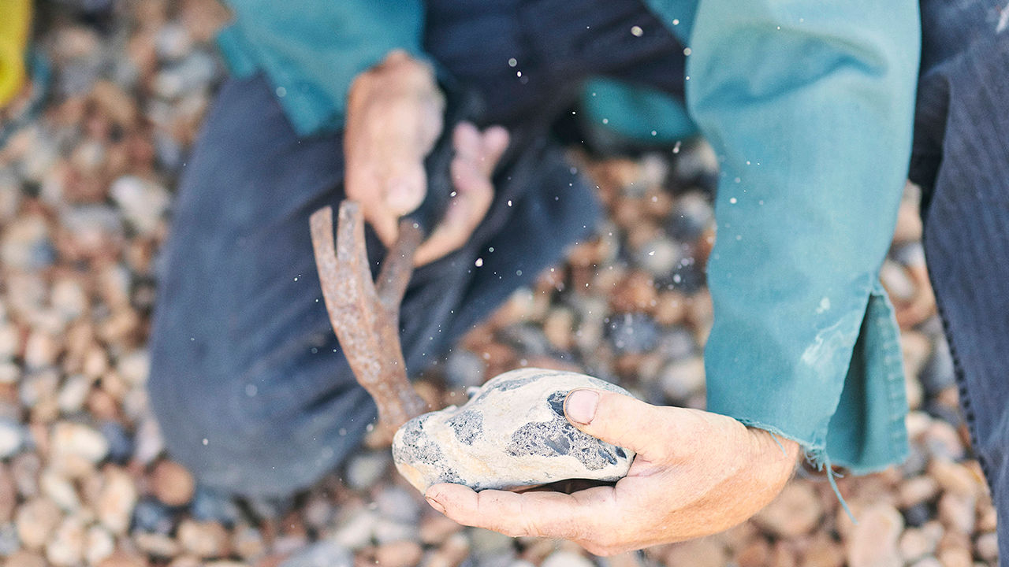

Like his erstwhile colleagues, he could go off to the marina at the eastern end of town, to a berth by a quay in a maze of modern apartments. It doesn’t appeal. The fishing boats seem to be barely tolerated there, crammed in the farthest corner where their pungent, shabby presence will not offend the bronzed weekenders on their yachts. The nets are spread neatly, the crab-pots stacked, the ropes properly coiled. His compound, by contrast, celebrates serendipity and sprawl; and he can find anything if he needs to.

Besides, he needs to stay close to guard it. After 15 years of the wire enclosure standing, with perhaps 2,500 beach patrols passing nonchalantly by, the City Council in 2015 ordered him to take it down, because it had been built without consent. As for the sculptures inside it, those too had to be cleared away as a hazard to health and safety. Then things went quiet, and he clung on. Because he is on the static section of the beach, above the high-tide line, he is gloomily aware that he is perching on a big bit of real estate which the council, at any point, might sell. But he hopes, because it is “very unpredictable”, that it will forget about him.

After all, the shingle causes far bigger headaches. Every year, obedient to the west-east drag of the English Channel, thousands of tonnes of it are worn away from Shoreham Port, six miles west along the coast, and deposited at Kemp Town, at the eastern extremity of the beach by the Western Breakwater. For decades every spring and autumn have seen the ceremony of “recycling and bypassing”, when—at a cost of around £1m a year—about 10,000 cubic metres of pebbles are scooped from the east and dumped in the west. For around two weeks, loaded lorries drive past Rory’s compound and rattle, emptied, back again. Since Shoreham’s beach is steadily eroding, and Kemp Town’s increasing, there is no reason why this Sisyphean task should ever end; unless either the sea, or the shingle, simply rises to overwhelm everything.

The boat is by the shore. Its prow is in the waves, and he is knocking away with an oar the last pebbles that obstruct it. It will be the only rowing boat among the trawlers, about a mile out, which have already started fishing. But he is in no rush.

He heaves the nets in, then the fish-boxes, then the oars. Next he pulls on waterproof trousers and an orange life-jacket. Then he loops the prow-rope round his shoulders and, like a human ox, pulls the boat farther into the sea. A final push or two from the stern, and he can jump in and start rowing.

His route takes him across the tide, which is unusually flowing east-west today; but the surface is completely calm. He pulls strongly, the boat’s only motor, and is soon almost lost to view. A small boat, small as a pebble, in the huge blue sea. ■

This article was downloaded by calibre from <https://www.economist.com/christmas-specials/2020/12/19/how-one-man-made-art-out-of-nothingness>

|  |  |  |  |
| --- | --- | --- | --- |
| 上一项 | 文章 | 章节 | 下一项 |

|  |  |  |  |
| --- | --- | --- | --- |
| 上一项 | 文章 | 章节 | 下一项 |

#### Essay

# Awesome, weird and everything else

Being a girl is special, difficult and better than it used to be

Dec 19th 2020 | Amsterdam, Boulder, Denver, London, Rotterdam and Zoom



ON THE ROOF of a derelict building in a Dutch city Frankie and Dora sip Taiwanese bubble tea as they bask in the summer sun. “People have parties here all the time,” Frankie says knowingly, nodding to broken bottles and rolling her eyes at a loud group farther along. The two girls are dressed in vintage jeans, self-decorated sneakers—they prefer “customised”—and T-shirts with a message. Frankie’s celebrates an art exhibition, Dora’s Billie Eilish, a singer whom she likes because she speaks her mind “on things like Black Lives Matter and justice and stuff.”

The girls discovered this spot through TikTok, an app which they think should be banned because “there’s so much bad stuff on it now, like rape.” They learned about the tooth-achingly sweet bubble tea—popular with teenage girls from Chengdu to California—from “Insta” (Instagram). The naughtiest thing they have done recently is sneak out to a BLM protest their parents said they could not go to because of lockdown. They do not think there is anything they cannot do because they are girls. “I think that’s from another time,” says Dora.

Frankie, Dora and their tens of millions of 11- to 16-year-old peers in the rich world are having a girlhood like none before. Their mothers have been far closer to social and economic equality with their fathers than in previous generations; they have a bewildering online world of social media to navigate; and they are exposed to a world changing, politically and climatologically, in a way that provokes and resonates with all manner of emotional uncertainties. Like all adolescence, this new girlhood is both intensely personal and universal. Talking to dozens of these girls in Europe and America over the past year, in person in some cases and over a lockdown Zoom in others, sometimes one-to-one and sometimes in loud joyful groups, The Economist heard of TikTok and bubble tea, anger and activism, make-up tutorials and trampolining, anxiety (both theirs and their parents) and big plans for the future (ditto). What came out most strongly was the girls’ sense of shared identity and shared potential.

One of the changes is that being a girl is now seen as a thing in itself. For centuries, much of girlhood was defined in opposition to boyhood; being nice when they were nasty, quiet when they were loud, social when they were sullen, pretty when they had personalities. Briefly, late last century, things went the other way, with girls increasingly encouraged to be sporty, loud and assertive.

One of the ways you can see that boyhood has now become increasingly irrelevant to girlhood is that girlhood is changing in ways that boyhood is not. Girls are allowed, and allow themselves, a range of interests, behaviours and attitudes that is broad, varied and flexible. Boyhood remains more narrowly defined both by society at large and by boys themselves.

Those who sell things to children and parents have noticed the change. Debi Clark from Bizzykidz, a child modelling agency, says advertisers demand a broader spectrum of “types” than they used to when looking for girls; for boys one size still fits all. Axel Dammler of iconkids & youth, a German research firm, says, “There is almost no point in advertising to girls because they now have such wide-ranging interests and identities.” Most boys can be sold football and a handful of popular video games, but “today’s girls are into everything”, he says with a mix of exasperation and admiration.

The girls we talked to confirmed what researchers have found: that, by and large, this broadening is working out well for them. This does not mean everything is awesome. Girls in most rich countries consistently report being slightly sadder than boys do, particularly from puberty onwards. They can be mean to each other, and to themselves. Frankie says she sometimes “just suddenly feel[s] so ugly that I break down.”

Things can be made harder by a world that does not yet know quite what to make of these new girls. The response to their still frequent exploitation is often to treat them simply as innocents in need of protection against bad men, social-media manipulation and, of course, their naive selves. At the same time they are celebrated as an empowered army of Greta Thunbergs on which the world can pin its hopes for the future.

Being liberated from a specific girl “mould” or a boy “anchor” does not mean girls do not assign themselves, or have forced on them, a large range of sometimes contradictory roles. They are friends; daughters; possessors of bodies; activists; and tomorrow’s women. Each role provides a glimpse of their future—and a feeling for the richness of their present.

2. Friends

The friendships between girls have provided rich subject matter for female artists from Jane Austen to the Spice Girls to Elena Ferrante. The intensity and closeness of girl-friendships is an experience that many women feel shapes their lives. It is also one of the first things girls mention when asked what they like about being a girl.

What makes Frankie and Dora friends is trust. The two girls (whose names, like those of all the other girls in this piece, have been changed to preserve their privacy) have been friends since they became buurmeisjes (neighbour-girls) at the age of two. They “just know” that they can count on each other when life, and other relationships, get complicated. Dora tells Frankie everything “because she’s Frankie. She’s like my diary.”

Confiding in each other is a key part of girl-friendship. That said, anyone who has—or once was—an adolescent daughter knows that this girlish intimacy is not an unmitigated blessing. Girls are more likely than boys to be the object of nasty rumours and to be excluded by their peers. Yet girls’ closeness arms them with invaluable support. “It reassures them that they are likeable,” says Julia Cuba Lewis, from Girls Empowerment Network, an American non-profit. “A strong friendship helps create a stronger girl.”



For many girls their first proper friend is their first introduction to love beyond their family. Even if “I love Gary” eventually takes over, girls often start with scribbling “Sharon and Lina, best friends forever” on notebooks and bathroom-stall doors. Where previous generations were tied to the landline, even if they stretched its cord as far away from prying parents as they could, the mobile phone has freed friendship from all shackles of distance and time. Frankie once spent an entire night FaceTiming a friend (her parents now confiscate her phone every evening, “to protect me against myself”). Almost all the girls we spoke with said that not seeing their friends was the hardest part of lockdown. A survey by Britain’s Children’s Society confirms this was the case across British 10- to 17-year-olds, and that girls struggled more than boys.

Where boys’ friendships are typically formed “side by side” around shared activities, girl-friendships tend to form “face to face” around emotional self-disclosure: hence the increased drama, hence the increased importance.

Hence, also, durability. Many studies in various countries have confirmed that female friendships are more intimate and supportive. There is a reason why, at least in America, grown women still refer to their “girlfriends”. Boys in close friendships often drift apart in their teens even though, when asked, older boys often express an unmet need for close fellowship. At the same age girls tend to come closer together than ever.

“We fully understand each other, we can rely on each other. If we have a bad day we help each other,” says Cyrene, a 15-year-old in the break room of a Denver high school. “Boys just don’t do that.” Her friends Kya, Grace and Orenda agree vigorously. They are sharing a pizza as they discuss what makes them friends. They laugh a lot. They enjoy “being weird” together—a phrase girls across countries and backgrounds use to denote an unconstrained silliness they prize. Many formative experiences were shared: their first trip to the cinema, their first visit to an Asian restaurant, and, as they reveal a few months later over Zoom, their first online activism. The word “support” comes up a lot. When they discuss tough subjects they rub each other’s shoulders, squeeze each other’s hands, whisper reassuringly and hug liberally.

3. Daughters

All four Denver girls list their mums as their role models, and say they always have. How parents treat their daughters, and how those daughters respond, is perhaps the thing which most clearly sets this generation of girls apart from those who came before. For many girls home is now the place they feel least likely to encounter sexism. In 2018 a survey found that over half of American girls between 10 and 19 felt that they were treated differently in sports, and around a third in school and online. Just one in eight said that happened at home. In 2014 a household survey found only 6% of adult American respondents disagreed with the statement that “Parents should encourage just as much independence in their daughters as in their sons.”

In the 1970s American parents who had only boys spent significantly more on their children than parents who had only girls. By 2017 the difference had disappeared, according to Sabino Kornrich of NYU-Abu Dhabi. Girls today enjoy more parental spending on things like tutoring, art supplies and music lessons than boys. In China parents of children in high school are more likely to hire a tutor for daughters than sons and to expect them to go to university. “Because girls often perform better than boys, parents start to have higher expectations and invest more in girls than boys,” explains Jean Yeung Wei-Jun, a researcher at the National University of Singapore.

Ironically, some old gender stereotypes may now be helping girls. When girls are toddlers they are read to more than boys. Their fathers are five times more likely to sing or whistle to them and are more likely to speak to them about emotions, including sadness. Their mothers are more likely to use complex vocabulary with them. Most of this gives girls a leg up in a world that increasingly prizes “soft skills”. Girls still have less leisure time than boys, but nowadays that is primarily because they spend more time on homework and grooming, rather than an unfair division of chores. And in the time left for themselves they have far more freedom.

Girls are also brought up by single mothers at a historically unprecedented rate. Most of the Denver girls have a (step) father somewhere in the picture, but they call their mothers their “reason to be good” and “the man of the house”. Kya says that when she was born her mother was only a year older than Kya is now; she beams when she says she now runs her own car-body repair shop. Like Cyrene’s mother, also a mother in her teens, she has been to night school, too, a further source of daughterly pride. “She is just unbelievably strong.”

The mother-daughter relationship is formative whether or not a father is present. Young girls whose mums reject gender stereotypes about maths do better at maths (dads’ opinions on the matter appear to have no effect). Girls whose mothers speak openly with them about periods and sex are significantly less likely to engage in risky sexual behaviour.

But when there are two parents both matter. Research suggests that girls may be more sensitive to parental encouragement than boys; those whose parents built up their confidence were significantly less likely to feel tense about school, more likely to perform well, less likely to drop out of sports and less likely to have body-image issues.

Sarah, a 12-year-old, wants to become a surgeon. She dials in from her purple bedroom surrounded by pillows with pictures of dogs. She loves rock climbing (“the adrenalin is amazing”), baking cookies and “dissecting stuff”. Her proudest accomplishments include a frog, a squid and a dogfish. Her dad helped fuel her interest in the cookies and the corpses. Her mum makes challah with her every Friday. Her favourite thing about being a girl: “Surprising people”. She cannot think of anything she does not like.

Daughters can change parents’ values too, particularly fathers’. Researchers at the London School of Economics have found that having school-age daughters decreases fathers’ likelihood of holding traditional attitudes on gender roles and makes them more likely to pull their weight at home. Separate studies have shown that having daughters affects decisions by politicians, judges and CEOs. Men with daughters are more likely to hire women for their boards.

One thing most girls agree on is that their parents take too one-sided an approach to technology. “My parents think it’s all a bunch of drama and distraction and that we’re all addicted to social media,” complains Ida, “but it can be really inspiring, too. There are lots of women...standing up for things.”

Ofcom, Britain’s communications regulator, has found parents increasingly worried that the risks of the internet outweigh its benefits. Unrealistic beauty standards, self-harm, eating disorders, celebrities who glorify plastic surgery, porn, sexting and predatory men all keep them up at night. They are more likely to restrict girls’ phone use than they are boys’, and they are more likely to wander in and check on their daughters while they are online (with sons they prefer to check their internet history afterwards).

One American mother imposes similar rules on her son as on her daughter, but worries more about the exposure her 14-year-old daughter gets. “She’s far more mature and curious than he is,” she says; since she got a phone a year ago she has used the internet for “wonderful art projects” but, confronted with “Fifty Shades of Grey”, also learned a bit about bondage. Another makes a point of trying all the apps her daughter gets into, “including dancing on TikTok”. She is amazed by the breadth of information. “We just had magazines,” she says of her childhood in India. “They have access to everything, everything.”

4. Bodies

Despite all the liberation and broadening identities, there is one thing that girls still feel narrowly judged on: their bodies. More than half of 10- to 19-year-old girls in America think attractiveness is the trait that society values most in girls. Seven in ten of those between 14 and 19 feel judged as a sex object.

Random men have shouted “pornoblondje” (little porno blonde) at Frankie when she passed on her bike. “I’ve been called all sorts of things while walking down the street just because of what I was wearing,” says 13-year-old Ana from New York, who never knows what to say even though it makes her angry inside. Amy, 14, was sent “something bad” by a man on Instagram. She did not tell her parents and does not want to talk about it. The number one reason American girls give for sexual comments going unreported is a fear of being less liked (“kindness” is second only to attractiveness in what they think society values most in them).

When asked what they like least about being a girl, most of the girls we spoke to mention their bodies: “periods, blegh”, “my thighs, yuck”, “crazy emotions”. But even more mention how they are perceived; “being looked at in a certain way”, “having to be ladylike”, “being told to smile”.

That girls have issues both with their bodies and the way those bodies are perceived is not new. In 1950 a study titled “Adolescent concerns with physique” noted widespread worries among girls over “fatness, thinness, tallness, shortness, lack of development, exceptionally early development, blackheads, pimples, bad eyes, irregular teeth, ugly noses and receding chins.” Girls in Britain have consistently been unhappier with their appearance than with any other aspect of their lives, according to the Children’s Society. In the 1990s a series of panic books, led by Naomi Wolf’s bestseller “The Beauty Myth”, claimed consumer culture’s obsession with the female form was causing an “epidemic” of anorexia among girls and women. A study in the journal Eating Disorders found that Ms Wolf’s statistics were on average inflated by a factor of eight.

That worries are exaggerated and sensationalised, though, does not mean they lack foundation. Girls very rarely kill themselves; they are less likely to do so than older women or boys and men of any age in many rich countries. But the number of 10- to 14-year-olds who have done so in America has more than tripled since 1999. In England hospitalisations due to self-harm by girls have risen by nearly two-thirds over the past 12 years. The rate of girls reporting depressive symptoms has increased. Researchers disagree about how much of the documented rise in mental-health problems among girls is down to symptoms being more readily recognised than they used to be and how much is down to girls’ lives having changed. “There are lots of reasons to be hopeful about this generation of teen girls,” says Candice Odgers, a researcher at UC Irvine. But “they are sadder. Maybe that’s because of the world we’ve built.”

Some changes to the world, though, offer respite. Take sports: more than a century after the reinventor of the Olympic games, Pierre de Coubertin, deemed including females “impractical, uninteresting, unaesthetic and improper”, more girls are playing sports than ever before. Those who do have fewer mental-health problems and are happier about their bodies.

Girls can and do feel good about themselves online, too. Where a negative relationship between social-media use and girls’ well-being has been found, it was small, about the same as the impact of wearing glasses, says Amy Orben, at the University of Cambridge. And the direction of the relationship is unclear. A recent Canadian study found that early mental-health problems in young girls can be a predictor of social-media use later, but not the other way around. Social media may make things worse for girls experiencing problems already, but for most they are fine.

And they are valued. Girls balk at the idea that there is anything wrong with taking selfies and are keen to show how creative TikTok and Tumblr can be. They are clear that “my body, my choice” extends to being allowed to care about their looks. Ziggy, in London, says some people have an attitude that “you can either be Instagram-famous or smart but not both.” She rejects it. “You can be like the male-fantasy version of a girl and you can be interesting and have depth...Posting pictures of yourself does not take away your depth.” Nor do the images need to be of a particular type. “Being a girl means I can be as girlie as I want to be or not,” says Alyssa, a 13-year-old from California.

The known negative impact of traditional media—long home to airbrush and photoshop—is greater than that of social media, well stocked with “normies”. The idea that photo-editing tools on phones are inciting a plastic-surgery boom is baseless. “I think my parents think I’m some idiot who believes everything I see online,” says Isla, from Brighton, with an eye-roll. In general, girls don’t. (A pertinent example, if one from a small study: whereas one in five older boys think online porn is a realistic portrayal of sex, only 4% of girls do.) When a class of girls in another school in Denver is asked to respond to a set of statements about social media, none of them agrees with “I think all depictions on social media are realistic.” Most assent to “Social media has impacted how I feel about myself.” All support “I’ve complimented someone else on social media.” The online world is a place to act, not just absorb.

5. Activists

The annual “We Are Girls” conference, held at a high school in Austin, Texas, offers sessions such as “Robotics and You”, “My Changing Body” and “Divas and Diversity”; the girls who attend have the opportunity to be taught football tackles in full gear and to decorate wands with glitter while discussing Disney princesses. But first they must get their girl power on.

At the opening rally 1,000 girls stamp their feet in the high school’s gym as a woman in 1970s fitness gear spurs them on with Tigger-like energy. Some girls take out phones to film, others look embarrassed and cling to friends or hide in their hoodies. Latecomers look startled. But soon the bleachers are rattling as the majority shouts and whoops and jumps.

“Who run the world?” the keynote speaker asks.

“Girls,’’ roars the crowd.

“Who?”

“GIRLS!”

A little boy in soccer kit—taken along by his mother because practice was cancelled—covers his ears.

Girls are increasingly told—and increasingly feel—that they wield power. And if they do not, in truth, believe that they run the world, they certainly want to improve it. Ask them about role models and their mothers tie with Greta Thunberg and Malala Yousafzai, campaigners for climate action and education. No one else comes close.

Most of those we talked to call themselves activists, even if they are not all pushing petitions to set up recycling schemes or exploring the application of AI to the environment (both activities we came across). Sexism, racism, LGBT discrimination, poverty, animal cruelty, homelessness, climate change, littering, universal health care, environmental destruction, beauty standards and inequality all get them riled up. Many are livid about “idiots” not following covid-19 rules and causing unnecessary death and suffering. “The one good thing about covid is that it’s good for nature and the environment and dolphins,” says Sarah, “but I wish it wouldn’t kill so many people in the process.”

Carol Gilligan, a psychologist, points out that young girls have long been seen as voices of outspokenness and honesty, from Iphigenia in Euripides’ tragedy to Claudia in Toni Morrison’s “The Bluest Eye” to Jane Eyre. As they hit their teens, though, they used to have a tendency to stop speaking up, pressured as they were to become “likeable” young women.

Today’s girls still care about being liked. “What’s changed,” says Ms Gilligan, “is the enormous resonance their voices now have.” Strong currents in society are telling them that, now they have the tools needed to speak louder—from education to the internet to freedom to leave the house—their voices will be heard. That makes continuing to speak out both a duty and a thrill: a bold new way to be a “good girl”.

Some of their concerns are close to home. In early March the Denver girls told us that they felt more judged by their race than their sex. “I think girls are more understood than black people,” says Grace. “They instantly think I’m ghetto, I’m loud, I have no intelligence because that’s how we’re seen.” Like several teens we spoke to during lockdown, she and her friends were frustrated at not being able to join BLM protests. But they have been “signing petitions, reading articles, sharing information and calling for and demanding justice,” Kya says in an email.

The internet is both a resource for their activism and a venue for it. Jo, a 12-year-old from London, complains that being “only allowed a Nokia—it doesn’t even have emojis” makes it hard to gather signatures for her online petition about period poverty. (She understands why her parents worry but still says “it’s really annoying”.) The other key venue is school. In California Naomi, who is 14, says the racism she witnessed during the response to covid and the killing of George Floyd moved her to collect experiences from other students and write a letter to her school asking for classes to cover racism from fourth grade, that is around the age of nine or ten. Martha, Ana’s 15-year-old sister in New York, has moved from pushing teachers at her school to include climate change in the curriculum to lobbying for climate education nationwide. Whenever she and her friends talk to someone powerful, they post a picture on social media, tagging it and “thanking them for agreeing to whatever they agreed to do. It’s a good way to hold them accountable.”

Some, like Jo, fight for issues related to their gender. All the girls are angry about the gender pay gap and sexual harassment. This does not mean they see themselves as feminists, a term which only 28% of 10- to 19-year-old-girls in America use to describe themselves, according to a Plan International survey. “The word [feminism] tends to elicit really negative responses,” says Mies, an 11-year-old from Amsterdam. “Especially from boys.” They much prefer to talk about gender equality—or more-than-equality. “Women are superior,” Cyrene says matter-of-factly. “They just are. You know, you’re a woman.

“I know boys are biologically stronger,” she adds thoughtfully. “But no one cares about farms anymore.”

6. Tomorrow’s women

Girls’ adolescence does not just offer a wider range of possibilities than it used to. It also lasts longer. In the West girls now start puberty around the age of ten. The age has dropped mostly, it appears, because of better diet. For black girls, who typically have a higher body-mass index and lower birth weight, things come even earlier. Nearly one in four African-American girls has started puberty by the age of seven, compared with 15% of Latina and 10% of Caucasian girls.

The onset of sexual activity, though, is getting later (and being handled better: teen-pregnancy rates are falling across the world). And education is lasting longer. There is thus room for girlhood to stretch out. But not indefinitely.

In 1972 a group of working-class girls in Ealing, London, were asked to rank their life priorities. They ticked love, a husband and a career in that order. When the same survey was repeated in 1994 the outcome had more or less reversed. We asked the girls we talked with to rank their priorities for the future on a form. “Interesting job”, “Change the world” and “Financial independence” were reliably found near the top. “Love” was in the middle; “Marriage”, “Get rich” and “Have children” were low—and sometimes crossed out.



A capacity for self-reliance is seen as crucial. “I want a good education and a good plan for the future,” says 11-year-old Ela in California, before adding that she also really wants two dogs. “I definitely want enough money to support myself and however many kids I have,” says Martha in New York. The girls in Denver need any families they have to be financially independent more than they need them to include a man. “I could get the fancy dessert, but I don’t need it,” declares Cyrene. Kya agrees: “If I do end up alone, I’ll just have my best friends.”

An hour’s drive north, in Boulder, a group of girls who had just pulled an all-nighter for an extra-credit maths class is equally lukewarm about love and marriage—but clear about other aspects of their future. Jennie plans to major in chemistry and piano, then go to med-school and become a surgeon or a medical professor (teen girls in the OECD are nearly three times as likely as boys to say they want to be doctors). Lou says she will double-major in computer science and engineering and then work in aerospace engineering “on AI stuff”, perhaps at NASA. Like the Denver girls, several imagine adopting one day, with or without a partner.

Personal goals and aspirations for the world are closely bound up. Girls in America are more likely than boys to say that they want to make the world a better place; they are also more likely to say they want to be a leader. Jo, in London, says she hopes that when she leaves university ten years from now the world will be more equal—“and also that it hasn’t exploded.” Asked if this worries her she frowns: “Well yeah, because of global warming. Greta Thunberg says there’s quite a real chance of some ginormous catastrophe that we’re never going to be able to solve.” Her government’s handling of covid has made her “very angry”; she is considering a career in politics, though, she confides, “I’m not sure I’ll manage as I have quite a lot on my to-do list.”

High expectations are undoubtedly a risk. “Society still tends to see girls as either in crisis or as superheroes. We’re still looking for a happy medium where girls can just be human and are allowed to make mistakes,” says Angelica Puzio, a doctoral candidate at NYU. Deborah Tolman, an author who has studied girls for decades, notes that girls often cannot see the scaffolding and support behind “sheroes” like Greta and Malala, and worries that “if they are not saving the world they’ll feel bad for letting people down.” When you ask girls what makes them anxious, many indeed mention pressure: pressure to do good, look good and be good. “There’s a constant pressure to be polite and kind and out there and confident,” says Ziggy: in reality, she feels at best “confident-ish”. Telling girls they need to develop more confidence is just code for another thing they need to fix and be better at, writes Rachel Simmons, an educator, in “Enough as She Is”.

But that is not to say that they cannot find confidence in themselves, or bring it out in each other. When she is asked “Do you think you can change the world?” Sarah looks panicked. “By myself? Oh God no. What if I can’t fix all the problems?”

Then she realises the “you” is plural, which changes everything.

“Oh, you mean all girls,” she says with a sigh of relief. “Of course we can.”■

This article was downloaded by calibre from <https://www.economist.com/christmas-specials/2020/12/19/awesome-weird-and-everything-else>

|  |  |  |  |
| --- | --- | --- | --- |
| 上一项 | 文章 | 章节 | 下一项 |

|  |  |  |  |
| --- | --- | --- | --- |
| 上一项 | 文章 | 章节 | 下一项 |

#### Erasmus

# Erasmus’s teachings are still pertinent today

He was a champion of moderation who had the misfortune to live in a revolutionary era

Dec 19th 2020 |

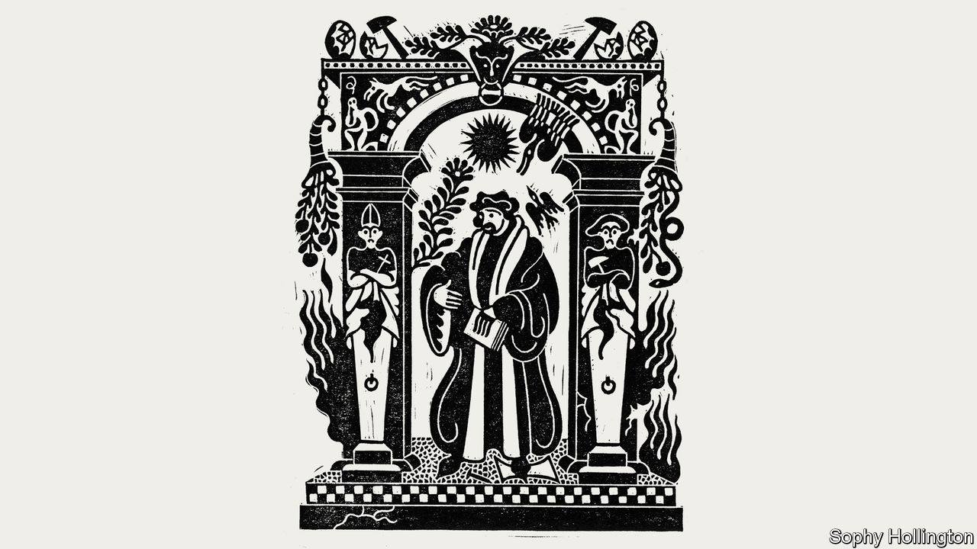

DESIDERIUS ERASMUS was the last great intellectual of a united Christian Europe: a scholar of universal renown, a friend to kings and tutor to princes, and a self-proclaimed “citizen of the world”. He produced a translation of the New Testament that changed the way Christians think about their faith. He also shaped popular culture. His dictionary rescued phrases such as “breaking the ice”, “teaching an old dog new tricks” and “leaving no stone unturned” from obscurity. His “In Praise of Folly” (1511) was hailed as a comic masterpiece.

In an age when birth was generally destiny, he was a self-made man. Born in the small provincial town of Rotterdam in 1466, the illegitimate son of a priest, he was dumped in a local monastery at the earliest opportunity. He grew up far from the centre of the Renaissance in northern Italy. His subsequent stardom was purely the result of his extraordinary intellectual gifts.

Unlike so many other great thinkers, in his time and since, Erasmus never fell prey to extremism. He believed in the healing power of moderation and reason, and in the civilising power of wine and conversation. This was partly a matter of personal style. He craved a life of scholarly comfort: “He lived in his study and died in his bed,” as the historian Hugh Trevor-Roper put it. Confronted with a king—and potential patron—he bent the knee; challenged by a bully, he changed the subject.

It was also a matter of conviction. Erasmus loathed the certitude of ideologues and worried about the tendency of extremists to goad one another into greater acts of fanaticism. In place of revolutionary certainty, he preached the Middle Way. The best way to reform the establishment was from within, he argued. The Catholic church should be reinvigorated by calling it back to its original purpose; society should be reformed by educating princes in the art of government.

But this moderate champion had the great bad luck to live in a zealous era. Soon after climbing to the intellectual and social pinnacle of Europe, Erasmus was thrown down and condemned. Only after his death was he given his due. His story is a warning to modern moderates, but also an inspiration.

When Erasmus left his monastery and began to explore the world, he was astonished by the sorry state of the church. Nepotism was rife. Popes fathered children and advanced them, disguised as nephews, into well-paid jobs. The largest businesses in Rome were the wine trade and prostitution. The papacy preyed on the credulity of the laity by selling indulgences—“forged pardons for real sins”, in Erasmus’s words. Leo X, pope during Erasmus’s glory years, was the spirit of corruption made pudgy and pampered flesh.

The church’s material self-indulgence was equalled by its intellectual desiccation. Universities were self-perpetuating oligarchies of obscurantists and suck-ups. A doctorate in theology at the Sorbonne took a minimum of eight years to complete and an average of 18. Erasmus described his teachers there as “quasi theologians” whose “brains are the most addled, tongues the most uncultured, wits the dullest, teachings the thorniest, characters the least attractive, lives the most hypocritical, talk the most slanderous, and hearts the blackest on Earth.”

How could the church be rescued from its torpor? Erasmus believed that the answer lay in rediscovering the spirit of Christ. He did not believe, as some Christians did, that it was necessary to get rid of your property and devote yourself to the poor. Rather, for Erasmus it meant producing a perfect translation of the Bible based on the best texts available, assembled from libraries across Europe. For how could you hope to imitate Christ unless you knew exactly what he had said and how he had lived? Renaissance scholars in Italy had provided a model of how to revive classical studies by producing improved classical texts. Erasmus’s great scholarly achievement was to import these techniques to northern Europe and apply them to biblical texts.

This inaugurated one of the great love affairs of his life, with ancient Greek. At the age of 30 he determined to make his Greek as good as his Latin (which was regarded as the best in Europe). He was astonished by what he found as he read classical Greek texts as well as fragments of the Bible. Whereas “we Latins have but a few small streams, a few muddy pools,” he wrote, “the Greeks possess crystal-clear springs and rivers that run with gold.” His “Novum Instrumentum” was the first Greek New Testament ever published. He put the Greek text next to the Latin Vulgate and his own “pure” Latin translation, which extirpated what he saw as linguistic corruptions in the church’s approved text.

Like the Protestants who would soon convulse Europe, Erasmus believed that Christ’s message should be taught by and to everybody. Forget the waffling of the theologians: a “few truths are enough.” And forget the superstructure of the church: what really matters is the Word. “I would have women read the Gospels and the Epistles of St Paul...I would have the ploughman and the craftsman sing them at work; I would have the traveller recite them to forget the weariness of his journey...True theology is possessed by every man who is possessed of the spirit of Christ, be he digger or weaver.”

Erasmus’s scholarly distinction brought him success in the secular world as well as the religious one. His admirers included almost all the crowned heads of Europe—the kings of France and Portugal were correspondents and the king of Scotland a pupil. He was a particular favourite of the ruler of his native state, Archduke Charles, who, as Charles V, went on to become Holy Roman Emperor and the most powerful man in Europe. Hans Holbein the younger, whom Erasmus supported, painted several portraits of him. Though he enjoyed the flattery, Erasmus used his connections to pursue a higher goal—to persuade the rulers of Europe to lead their people into an era of Christian enlightenment. What better way to reform government in an age of royal power, he calculated, than to educate the royals themselves?

His “Education of a Christian Prince” (1516) was written as practical advice to Archduke Charles. Erasmus argued that the king is a servant of the people and must rule according to the principles of honour and sincerity, a revolutionary notion disguised as flattery. In “The Prince”, published three years earlier, Machiavelli had argued that it was better for a ruler to be feared than loved. Erasmus argued, on the contrary, that it was better to be loved than feared, and suggested that the way to create a lovable prince was to give him a well-rounded humanist education. A ruler should be learned (“man unless he has experienced the influence of learning and philosophy is at the mercy of impulses that are worse than those of a wild beast”) and should cultivate the habits of gentleness and public service.

He proceeded to dish out advice to the class of educated Europeans who operated the machinery of the state. “Enchiridion Militis Christiani” (“Handbook of a Christian Soldier”) argued that Christianity was above all an ethical system of charity, love and generosity. A succession of school textbooks were designed to show that classical learning was a joy rather than a chore. In place of mechanical grammar books he produced selections of the great classical authors. Technology helped spread his fame. The printing press had been invented a quarter of a century before his birth and the great printers of his day (Thierry Martens of Lausanne, Jose Badius of Paris and Aldus Manutius of Venice) had established international distribution networks. “In Praise of Folly” was one of the first secular bestsellers, with more than 30 Latin editions appearing during Erasmus’s lifetime.

He thus embodied a new social ideal: the humanist scholar who rejected monkish asceticism and the arid scholasticism of the university professors. He was genial and civilised: after books, he liked nothing more than good food, good wine and good conversation. He had a gift for friendship, enjoying an intellectual romance with the English humanist Thomas More. But he also had a talent for mockery, which he wielded against the pompous, pedantic and closed-minded. “In Praise of Folly” attacked everyone from doctors (quacks and flatterers, in his eyes) to monks (donkeys braying out psalms that they had memorised because they could not read). This earned him a legion of fans: the Erasmians who thrived in courts across Europe and who pored over his every pronouncement.

## Bulldozing the Middle Way

Erasmus’s happy world began to crumble in October 1517, when Martin Luther, his junior by 17 years, nailed 95 theses to the door of the Wittenberg Castle church. Erasmus sympathised with many of the young monk’s criticisms of the church. But he disliked Luther’s dogmatic temperament and feared the consequences of smashing the institution that, for all its faults, sat at the heart of European civilisation. Surely Luther’s extremism would provoke counter-extremism? And surely the battle would destroy the Christian humanism that Erasmus had spent his life cultivating?

Both sides of the emerging schism initially tried to win the great man’s approval. This put him into an impossible bind. He could not repudiate Luther without repudiating some of his own criticisms of the church. But he could not support the pope wholeheartedly without endorsing corruption. Reluctantly, Erasmus stuck with the Catholic church on the grounds that institutions are easier to reform than fanatical mobs inspired by a charismatic preacher. That soon seemed like bad judgment. Rather than taking Erasmus’s Middle Way, the church embraced religious orthodoxy, empowering the most reactionary elements in the hierarchy and stretching every sinew to destroy heresy.

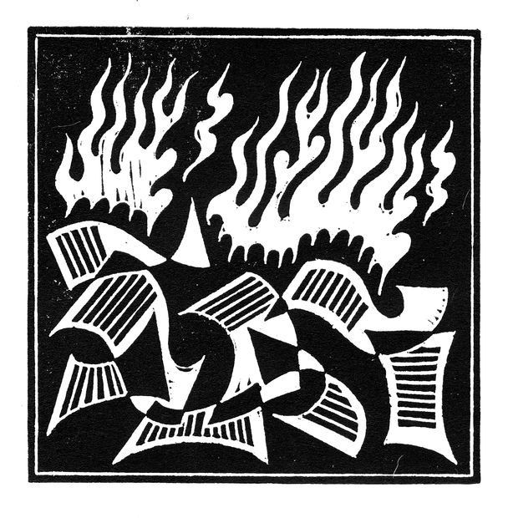

Erasmus was reduced from hero to bogeyman. “My popularity, if I had any, has either cooled off so far that it scarcely exists, or has quite evaporated, or even has turned into hatred,” he wrote in 1523. Luther denounced him as an “enraged reptile”, “vainglorious beast” and “instrument of Satan”. The Catholic church denounced him as a proto-Luther. “Erasmus laid the eggs,” a monk from Cologne wrote; “Luther hatched them. God grant that we may smash the eggs and stifle the chicks.” One of his translators was burned at the stake. In 1546, ten years after Erasmus’s death, the Council of Trent exploded his life’s work by declaring that the Vulgate was the only acceptable translation of the Bible. In 1559 the Index of Prohibited Books banned his entire oeuvre, along with the works of 550 other writers. The edict was not withdrawn until 1966.

As Michael Massing shows vividly in “Fatal Discord: Erasmus, Luther and the Fight for the Western Mind” (2018), the growing religious battle destroyed Erasmianism as a movement. Princes had no choice but to choose sides in the 16th-century equivalent of the cold war. Some of Erasmus’s followers reinvented themselves as champions of orthodoxy. The “citizen of the world” could no longer roam across Europe, pouring honeyed words into the ears of kings. He spent his final years holed up in the free city of Basel. The champion of the Middle Way looked like a ditherer who was incapable of making up his mind, or a coward who was unwilling to stand up to Luther (if you were Catholic) or the pope (if you were Protestant).

Yet the next hundred years of European history bloodily confirmed Erasmus’s warnings about the dangers of religious extremism. Luther denounced the pope as the Antichrist while comparing Rome to Sodom and Gomorrah; the pope called Luther a “roaring sow”. Then came the book-burning and the statue-smashing. Finally, the fanatics graduated to burning their fellow human beings at the stake. The cycle of intolerance was matched by a cycle of self-righteousness. Protestants competed with their fellow Protestants, and Catholics with their fellow Catholics, to see who possessed the purest heart and the fiercest faith. The test of being a good Christian ceased to be decent behaviour. It became fanaticism: who could shout most loudly? Or persecute heresy most vigorously? Or apply fuel to the flames most enthusiastically?



Erasmus had predicted that Luther’s theological complaint would lead to war. In time, he wrote, “the long war of words and pamphlets” would be waged “with halberds and cannons”. He was proved right many times over as fanatical passions fired terrible conflicts. The Thirty Years War killed more than a third of the German population and featured every imaginable atrocity, from torched villages to mass rapes to widespread torture, including waterboarding.

But great ideas are harder to kill than people. At first Erasmian ideas went underground—an astonishing fate for a philosophy that had thrived on the patronage of princes. Intellectuals preserved Erasmianism in private and talked about it in whispers. Then it began to resurface. The Jesuits smuggled elements of Erasmianism into their Catholic philosophy: Ignatius of Loyola based his “Spiritual Exercises” on Erasmus’s “Enchiridion”. Supporters of a more tolerant style of Protestant Christianity, such as the one that emerged in Britain after the Puritan revolution, dusted off their Erasmus. The most intellectually accomplished reviver of the Erasmian tradition was arguably a Jew, Spinoza, who put the notion of scepticism at the heart of his great treatise, the “Tractatus Theologico-Politicus”.

## A world of folly

Erasmus is now celebrated by people of all religious inclinations and none. In his native city of Rotterdam a university, a grammar school and a subway station have been named in his honour. The European Union’s ambitious student-exchange programme, from which more than 10m have benefited, bears his name. The University of Toronto has produced an 89-volume edition of Erasmus’s collected works, one of the greatest scholarly projects of our time. Fittingly, one of the editors, James McConica, is a Roman Catholic priest who embodies Erasmus’s learned, epicurean style.

The spirit of the Middle Way has not conquered all—far from it. The West is now in the grip of rival extremisms that mock every principle that the great man held dear. Everywhere ideologues are breaking eggs and murdering chicks. In Britain, Brexiteers denounce “citizens of the world” as “citizens of nowhere” and cast out moderate politicians with more talent than they possess, while anti-Brexiteers are blind to the excesses of establishment liberalism. In America “woke” extremists try to get people sacked for slips of the tongue or campaign against the thought crimes of “unconscious bias”. Intellectuals who refuse to join one camp or another must stand by, as mediocrities are rewarded with university chairs and editorial thrones.

But the 16th-century humanist should give hope to those who resist competing bigotries. Erasmus shows that moderates are right to warn about the awful consequences of extremism and intolerance. He also proves that you can triumph in the long term even if you are crushed in the short term. Modern advocates of the Middle Way may not be rewarded with an 89-volume edition of their collected works. But they at least have the comfort that they were on the right side of history when their fellow intellectuals were taking the line of least resistance or maximum fanaticism. ■

This article was downloaded by calibre from <https://www.economist.com/christmas-specials/2020/12/19/erasmuss-teachings-are-still-pertinent-today>

|  |  |  |  |
| --- | --- | --- | --- |
| 上一项 | 文章 | 章节 | 下一项 |

|  |  |  |  |
| --- | --- | --- | --- |
| 上一项 | 文章 | 章节 | 下一项 |

#### South Korean mountains

# South Korea’s hiking culture reflects its social pressures

And offers a reprieve from them

Dec 19th 2020 | SEORAKSAN



A TYPICAL DAY on a South Korean mountain starts much like a typical day in a South Korean office: with a subway journey. At a station in southern Seoul, scores of people emerge into the crisp dawn air carrying backpacks and hiking sticks, and walk towards a long row of coaches. Kim Sun-hui, an efficient woman in wire-rimmed glasses and a red woolly hat, checks names against a list next to the bus chartered by “Wanderung”, a club named after the German word for hike. Soon Mr Park, the driver, closes the doors. The bus trundles past high-rise apartment blocks before turning east towards Seoraksan, the country’s favourite national park, some 200km (124 miles) away.

Hiking is South Korea’s most popular pastime. Two-thirds of its citizens own a pair of hiking boots and tackle a mountain at least once a year; nearly a third go once a month. In 2018 they spent $2.3bn on hiking gear, more than on cinema tickets or cosmetics. The country’s 22 national parks welcome around 45m visitors every year. During holidays, newspapers print pictures of long queues of people waiting to take photographs next to the national flag that marks many peaks.

Ask a South Korean about the allure of mountains and you are soon deep into nationalist mysticism. “We like to think of ourselves as descendants of the mountain god,” says Choi Won-suk, who directs the centre for mountains and culture at Gyeongsang National University in Jinju. Dangun, the mythical founder of Korea, is said to have been born on the slopes of Mount Paektu, on the border between China and North Korea. He was the son of the sky god and a bear who became a woman after subsisting for weeks on garlic in a cave. The mountain features in the national anthems of both North and South Korea.

A simpler explanation is that going hiking is easy. South Korean mountains are not too high: the tallest peak, Hallasan, is just short of 2,000 metres. And they are everywhere. Unlike in Europe or America, few people live more than an hour or two from one of the 18 “mountainous” national parks. Seoul, where half the population lives, contains several mountains that can be conquered during a long lunch break. “It’s just a very obvious thing to do in your spare time,” says Park Mi-suk, who teaches at a mountaineering school on the slopes of Bukhansan, just north of the capital.

The country got its national parks in a hurry. The first, in Jirisan, was designated only in 1967. By the end of the 1980s South Korea had protected more than 6,000 square km, amounting to 6% of its land area. It was inspired by America’s national parks, and advised by American experts. The two countries continue to co-operate on signage, nature preservation and safety. But South Korea has developed a hiking culture quite unlike the American (or the European) one.

The coach that Ms Kim and Mr Park are piloting to Seoraksan (snow mountain) hints at some of the differences. The mostly middle-aged men and women snoring lightly on board have signed up through an online forum, where hikers swap tips on logistics, equipment and routes. Many South Koreans are members of hiking clubs, or book places on coach tours to get to the mountains. On the footpaths, you see large groups of people more often than families or lone hikers.

That could be a legacy of military rule. Park Chung-hee, the strongman who ruled South Korea in the 1960s and 1970s, encouraged conglomerates to push their employees out onto the trails as a community-building activity. He also insisted on military drills not unlike those still practised north of the border. Corporate culture has become a little more relaxed since then, although an ambitious executive may still find it expedient to scale the occasional mountain with the boss.

A culture of long working hours and short holidays encourages efficient hiking. Mountain paths tend to head directly for the summit, and rarely feature the switchback turns seen in other countries. South Korea has a whole infrastructure designed to get stressed leisure-seekers to, up and back down the mountains as speedily as possible. The plan on Ms Kim’s bus, which sounds distinctly ambitious to anyone used to a more leisurely pace, is for the hikers to tackle Seoraksan’s highest peak before it gets dark and return to Seoul well before the last subway train heads for the suburbs.

Some mountain enthusiasts disapprove of this approach. “A lot of people only care about getting to the top and down again as quickly as possible,” says Ms Park, the hiking instructor. “That’s not really the point.” Ms Park, who abandoned a career as a nursery teacher to teach people about mountains, thinks that people should pause to take in the surroundings. “For me, mountains are about contentment—I’ve had so many hobbies, but whenever I look back at pictures of myself on a mountain I just look happy.”

## Stairway to heaven

Mr Choi, the geographer, concurs that the focus on reaching the top is misguided. “It’s a very modern thing, this haste and competitiveness,” he told your correspondent on another, more gentle hike up a small mountain overlooking Jinju. “Mountains are intertwined with life, including at the end,” he explained, as he pointed out small mounds of graves lining the path. Mr Choi argues that the desire to rush uphill was imported to South Korea by Japanese colonisers—who, in turn, got it from the West.

He harks back to centuries-old conceptions of the hills as spiritual places, home to hermits and mountain spirits. To him, they are places to work towards pungsu, a traditional Korean system of thought close to the Chinese idea of feng shui, which stresses harmonising people with their environment. In the past, he says, climbing mountains was about finding harmony with nature and reflecting on your own shortcomings. “It’s not about getting up to the top and winning but about looking up to the top thinking, I’m not there yet. I need to grow more.”

More than four hours and several traffic jams into the journey to Seoraksan, some of the passengers on Ms Kim’s bus seem to be reaching similar conclusions. As midday approaches, the plan to reach the summit and return to the bus before sunset is beginning to seem foolhardy. The mood on board has darkened. Voices are raised. But the delay does not prompt anyone to reconsider. When Mr Park at last pulls up at the pass where the hike begins, people rush for the door and jog towards the stairs that lead up the mountain.

The stairs hint at what is to come. For the first couple of hours, the path climbs steeply towards a granite ridge, now hidden in clouds, now gleaming in the sunshine. A stiff breeze blows, prompting hikers to zip up their jackets. The leaves on the trees have begun to turn deep shades of red and orange. The higher the path climbs, the easier it becomes to forget how steep it is. With every turn, the views over the peaks grow more spectacular.

It was views like this, along with his dislike of the rat race, that prompted 65-year-old Cho Myung-hwan to quit his job as a computer salesman to spend his time hiking and taking pictures of mountains, trees and flowers. “You know that feeling when you’re tired and restless and there are all of these people in front of you—and then you catch sight of the view,” he says. After quitting his job, Mr Cho lost touch with many friends. His wife, who disapproved of his decision, has grown fed up with accompanying him on his hikes. He says he does not mind: “I’ve never been very sociable, and I enjoy just being with the mountain.”

As the hikers climb Seoraksan, the crush of people disperses. Soon whole stretches of the trail are deserted. “It opens my heart coming up here,” says Go Eun-mi, an accountant from Suwon who is hiking with her husband. “You can forget things in the mountains, particularly now during the pandemic.”

Farther up on the ridge, a group of men are sitting under a tree eating lunch. They have brought miniature folding chairs, beef jerky and tangerines, which they offer around. Lee Jun-gyu, a video editor, aims to climb as many peaks as possible in the Paektu mountain range that runs through the Koreas like a spine. “Hiking the range is bound up with my hopes for reunification,” he says.

As the afternoon wears on and the wind picks up, it becomes clear that the plan to reach the peak was indeed overambitious for many of Mr Park’s passengers. Having turned around at various points along the ridge, they trickle back down the mountain in the waning light. Your correspondent calls time on her ascent at a jagged rock about halfway to the peak (she later returned to conquer it). She catches a glimpse of the sea, the dome of an observatory and what look like radio towers—a reminder of the other Korea just a few miles to the north. On the way down, the sweeping views are obscured by fog. She stumbles down the final set of stairs to the car park as darkness falls.

A long, cold hour later, Mr Park’s bus appears, carrying the hardy souls who managed to rush all the way to the top of the mountain. On the way back to Seoul the mood is jolly, helped along by swigs of makgeolli, a local rice wine that some hikers are sipping surreptitiously. When a suspicious whiff of orange peel begins to mingle with the smell of sweaty boots, Ms Kim intervenes: “Stop eating, and put your masks back on.”

A typical day on a South Korean mountain ends much like a typical day at a South Korean office: with a bleary-eyed late-night subway ride. But Ms Go is right: the head feels clear, and the heart remarkably open. ■

This article was downloaded by calibre from <https://www.economist.com/christmas-specials/2020/12/19/south-koreas-hiking-culture-reflects-its-social-pressures>

|  |  |  |  |
| --- | --- | --- | --- |
| 上一项 | 文章 | 章节 | 下一项 |

|  |  |  |  |
| --- | --- | --- | --- |
| 上一项 | 文章 | 章节 | 下一项 |

#### Crossword

# Test yourself with our Christmas crossword

A cryptic challenge for all cruciverbalists

Dec 19th 2020 |

CRYPTIC CROSSWORDS look tricky, but there are conventions that can help newcomers. Most clues comprise a cryptic part and a straight definition (often a synonym of the answer). Consider the following:

Nip back before weekend to find shade (4)

To solve it, write ‘nip’ backwards before the letter ‘k’ (the ‘end’ of the word ‘week’) to get ‘pink’ (a shade or colour). In this example, ‘shade’ is the definition (or straight part of the clue), and the rest is the cryptic part. All of the clues below have at least one definition, which you can highlight all at once using the ‘Show definitions’ button, or individually by hovering over or tapping each clue then selecting the ‘Define’ button. There's also an explanation of how each clue is constructed, and if you're still stuck, you can see the solution too. Your answers will be automatically saved.

You can also download a [printable version](https://docs.google.com/gview?embedded=true&url=https://media.economist.com/sites/default/files/pdfs/XmasXword.pdf) of the crossword plus a bonus cut-out-and-create tree ornament, and don't forget the [Christmas quiz](https://www.economist.com/quiz2020).

This article was downloaded by calibre from <https://www.economist.com/christmas-specials/2020/12/19/test-yourself-with-our-christmas-crossword>

|  |  |  |  |
| --- | --- | --- | --- |
| 上一项 | 文章 | 章节 | 下一项 |

|  |  |  |  |
| --- | --- | --- | --- |
| 上一项 | 文章 | 章节 | 下一项 |

#### Quiz

# Try our Christmas quiz

Test your knowledge of ten great cities

Dec 19th 2020 |



THIS YEAR’S quiz is based on ten global cities. The first four answers of each series are linked to a theme, and readers have to find that theme to answer the fifth question.

Send answers to xmasquiz@economist.com by Monday, January 4th 2021. Three winners, chosen at random, will receive a copy of “Unconventional Wisdom”, The Economist’s new book. The answers will appear online on January 8th.

## London

1. Which British military hero is commemorated with a 52-metre high column in the middle of London?  
2. Which Roman emperor named his son Britannicus after his conquest of much of Britain?  
3. Which Robert Harris novel, made into a film starring Pierce Brosnan, features a prime minister who closely resembles Tony Blair?  
4. The life of which British stage performer was turned into the 1968 film “Star!” with Julie Andrews?  
5. What theme (apart from London or Britain) links these answers?

## Berlin

1. What was the name of the famous crossing-point between East and West Berlin, which is now a tourist attraction?  
2. What is the name of German carmaker Volkswagen’s bestselling model, also known as the Rabbit in North America?  
3. In which month and year did Kaiser Willhelm abdicate and Germany become a republic?   
4. What was the name of the music prize presented by the Deutsche Phono-Akademie between 1992 and 2018?  
5. What theme links the previous four answers?

## New York

1. Which iconic New York commercial building, on Fifth Avenue, was completed in 1902?  
2. Which film musical, the most successful to star Fred Astaire and Ginger Rogers, opened at Radio City Music Hall in New York in August 1935?  
3. What breed of dog was owned by the former governor of New York, and 32nd president, Franklin Roosevelt? (It is depicted in a statue of FDR in Washington DC.)  
4. What historic weapon is displayed on the south shore of Manhattan, formerly known as Battery Park?   
5. What theme links the previous answers?

## Paris

1. What is the nickname of Paris, a translation of la ville lumière?  
2. What device is Frenchman Joseph Nicéphore Niépce generally credited with inventing in 1816?  
3. Which far-right group, led by Charles Maurras, was one of the leading anti-Dreyfusard groups before 1914?   
4. What was the name of the government that ran France from 1795 to 1799 before being overthrown by Napoleon?  
 5. What theme links these answers?

## Sydney

1. What is the name of the harbour in Sydney where Captain Cook first landed, marking the discovery of Australia by Europeans?  
2. Which Australian businessman, once chief executive of Fortescue Metals, has become a major philanthropist, through the Minderoo Foundation?  
3. Which Australian novel, written by Colleen McCullough, was turned into a very successful 1980s miniseries starring Richard Chamberlain?  
4. What is the main diet of the koala, one of Australia’s best known mammals?  
5. What theme links the previous answers?

## Beijing

1. What is the name given to the ancient overseas trade route from China?   
2. Which martial-arts star, born in Beijing, appeared in the films “Once Upon a Time in China” and “Lethal Weapon 4”?  
3. One of the fastest-growing parts of the Chinese credit markets is high-yield debt. What is the colloquial name for such debt?   
4. What piece of Chinese infrastructure, a UNESCO World Heritage site, dates back to the fifth century BC?   
5. What theme links the previous answers?

## Rome

1. What nickname for Rome dates, appropriately enough, all the way back to the first century BC?   
2. What is the normal translation of Summus Pontifex, one of the pope’s many titles?  
3. What holy title was bestowed on Pope John XXIII and Pope John Paul II in April 2014?  
4. La Spezia is the name of an Italian city and province. But what culinary ingredient does spezia mean in Italian?  
5. What is the theme linking these answers?

## Barcelona

1. There is a 60-metre monument to which explorer in the city of Barcelona?  
2. Catalonia held a controversial referendum on which issue in 2017?  
3. What is the official title of the prime minister of Spain?  
4. What kind of service for covid-19 victims did the Spanish king attend in July 2020?  
5. What theme links these answers?

## San Francisco

1. Which 1960s pop group, based in San Francisco, featured Grace Slick on vocals?  
2. Which cartoonist, who worked as a management trainee in San Francisco, pens the Dilbert strip?  
3. Which Silicon Valley entrepreneur co-founded Google Maps, became chief technology officer at Facebook and is now president of Salesforce?  
4. Which San Francisco district was noted for its jazz clubs in the 1940s and 1950s and was dubbed “the Harlem of the west”?  
5. What theme links these answers?

## Amsterdam

1. Which Amsterdam football team has won the European Cup or Champions League four times, most recently in 1995?  
2. And which is the oldest Dutch professional football team, based in Rotterdam?  
3. The son of which cartoon character, after witnessing his father eat a bunch of flowers, exclaimed “So that explains his mysterious trip to Holland”?   
4. Amsterdam is a centre for jewellery production. What traditional unit for measuring the weight of precious metals is equal to roughly 31 grams?   
5. What theme links these answers?

This article was downloaded by calibre from <https://www.economist.com/christmas-specials/2020/12/19/try-our-christmas-quiz>

|  |  |  |  |
| --- | --- | --- | --- |
| 上一项 | 文章 | 章节 | 下一项 |

|  |  |  |  |
| --- | --- | --- | --- |
| 上一项 | 文章 | 章节 | 下一项 |

#### Gay rights

# How a little-known Welsh politician helped gay rights in Britain

Sometimes history is made circuitously

Dec 19th 2020 |

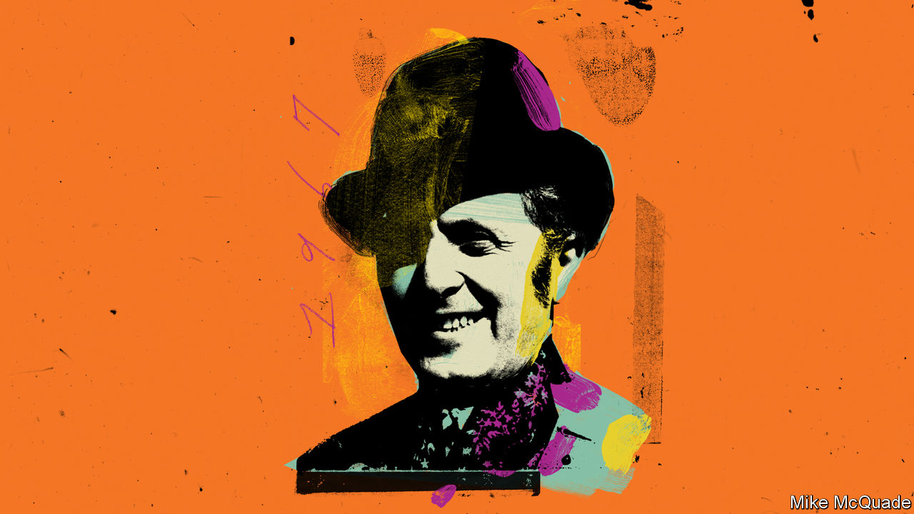

A LITTLE AFTER 10pm on Monday July 3rd 1967, just as most sensible Britons were turning in for the night, the member for Pontypool was warming up. Leo Abse (pronounced Ab-zee) had been working the tea rooms of the House of Commons all day, charming and cajoling his fellow MPs in his rococo tones—a little flattery here, a white lie there. Now he slipped into the chamber, turning heads as always in spite of his short frame. Settling in his usual perch on the Labour government’s benches, his mischievous eyes darted about the place, searching out both his “stout fellows” and his foes. If his bill were ever to get through, tonight was surely the night.

The House had already been sitting for 12 hours. It had found time to note the teacher shortage in Scotland, the need for better provision for heroin addicts and the lack of geriatric hospital beds in the Hull area. It had mused on the sorry state of the river whose waters sploshed against the Palace of Westminster. The lack of moorings and amenities on “Old Father Thames” was a disgrace. At last Big Ben, that parliamentary alarm clock, struck ten, and it was Abse’s turn.

His bill, printed on the green pages each MP clutched, was plain enough: that, in England and Wales, “a homosexual act in private shall not be an offence provided that the parties consent thereto and have attained the age of twenty-one years”. Beside him on those green-leather benches sat his staunch supporters, a new generation of youngish, whipsmart Labour MPs more familiar with cloisters than coal mines. There was Dick Taverne, a 38-year-old barrister, and Shirley Williams, a passionate liberal who had run the Fabian Society, a leftish think-tank. And Roy Jenkins, home secretary and fellow Welshman, who cherished the idea of Britain as a “civilised society”.

The benches opposite were sparser, but their occupants no less determined. There was Ray Mawby, a moralising drinker not yet unmasked as a communist spy, Harold Gurden, a dairyman before his election 12 years earlier, and Ian Percival, who promised—or threatened—“to speak through the night if necessary”. To them, gay sex remained “the abominable crime”; legalising it after 434 years would be yet more damning evidence that England was becoming not a civilised society but a permissive one. They intended to propose amendment after amendment, and to greet each in turn with another lengthy, digressive speech. All they had to do was keep talking.

To make any progress, the proposers had to call a “closure motion”—a proposal to curtail discussion and move to a vote—on each amendment. But Parliament’s rule book dictates that such motions can pass only if they are supported by at least 100 MPs. So Abse had to keep enough of his supporters in the chamber not just for the final vote but to see off each amendment in turn. As the night wore on, his enemy was not so much those on the opposite benches as sleep: “It only needed one or two people to go home...to say ‘To hell with this, I can’t stay until the dawn,’ and we were undone.”

It would hardly have been the first defeat. Craning over from the Commons gallery to get a better view of the chamber below were a band of men well used to having their hopes dashed. They were no strangers to Parliament. They had awaited eagerly its debate in 1958 on the Wolfenden Report, an official review that recommended nixing the ban on gay sex that had held since the Buggery Act of 1533. Nothing came of that. Harold Wilson, the Labour prime minister, told colleagues that loosening the law would lose their party 6m votes.

## You can live your life lonely

Few men were successfully prosecuted for sex in private, but the threat ensured that blackmail flourished and the closet door remained firmly closed. Some formed loveless marriages; others sought medical help. As Abse worked on his bill, John Wells, a 27-year-old phonetician at University College London, began attending weekly psychotherapy sessions to deal with the “problem” of his homosexuality. The year before he had split up with his first boyfriend, who—under pressure from his family—had then married a woman.

Into this vacuum came the House of Lords, Parliament’s unelected second chamber. Stuffed with crusty aristocrats who had inherited their fathers’ titles (and voting rights), it was an unlikely crucible of social reform. Yet, virtually irremovable as they were, there was little to stop their lordships speaking their minds. The eighth Earl of Arran (“Boofy” to his chums) had persuaded his fellow peers to vote for reform in 1965. He never told them his likeliest motivation. His older brother, whom he succeeded to the earldom, took his own life at the age of 55. Years later, Abse met a man who claimed to have been the seventh earl’s lover. In public, Lord Arran’s rationale was more pragmatic, and characteristically Wodehousian. “It simply needed someone to grasp the nettle. And a damned prickly nettle it was, too.”

Most MPs still feared its sting. The Lords provided momentum, but support in the Commons was necessary for a bill to become law. No government would risk backing such a contentious measure, so it could reach the statute book only via a private member’s bill, a mechanism that allows MPs to put forward their own laws. Such bills rarely pass, since little time is allotted to them. By 1967, Abse and Humphry Berkley, a Tory parliamentarian, had already proposed some measure of liberalisation three times without success.

## One more try

Still, this time might be different. After all, Abse had friends in high places. Jenkins was one of a new breed of Labour MP who wanted the party to marry bread-and-butter leftism with social liberalism. As one wag had it, Labour should be the party of “full enjoyment” as well as full employment. Each time Abse’s bill was frustrated, Jenkins persuaded the government to lend it some of its own time in the Commons, albeit sometimes at ungodly hours. Which is why the gas lamps outside the Palace of Westminster were burning, casting shadows along its Gothic façade, as, inside, the Speaker finally called the House to order that night.

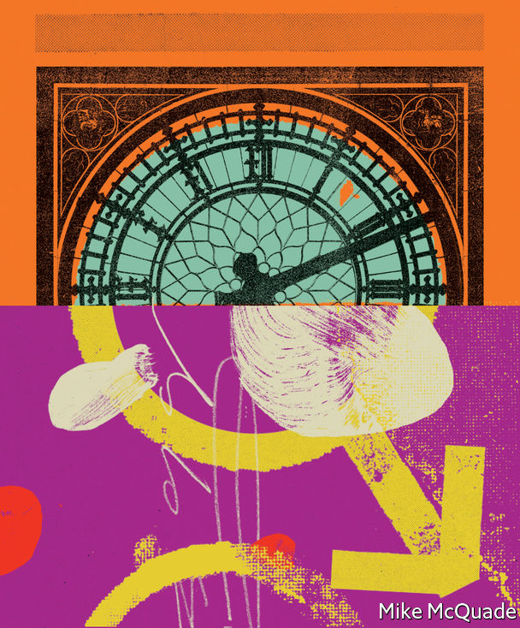

Big Ben was about to sound the next hour by the time Abse got to his feet for the first time. His opponents had already made the running for three-quarters of an hour and he was anxious to get on. “If I am brief in speaking to this amendment,” he began, “I am sure that it will be appreciated that it is out of no discourtesy to the House but because we are dealing with a matter which has been well canvassed.”

Abse was not normally so ready to pass up a chance to expound. The limelight was, if anything, a little dark for his liking. He embraced the old Commons tradition of dressing up for Budget day. Out came the top hat and cane, a fresh bloom in his buttonhole. The rest of the year, he favoured a dark green jacket over a mustard waistcoat and maroon trousers. He would stick one thumb in his waistcoat pocket during his lengthy and ornate speeches, enveloping the House in his lyrical, somehow religious, embrace. The Welsh have a pretty word for such oratorical magnetism: hwyl. Abse had bags of the stuff.

His interests, too, were colourful, stretching far beyond Pontypool, the mining town in south Wales that he had represented since 1958. He was a successful criminal solicitor, relishing representing suspected murderers, and a keen amateur psychoanalyst, emulating his hero Sigmund Freud. He would go on to publish a slew of eccentric “psycho-biographies”, attributing John Maynard Keynes’s “bold economic theorising” to his affairs with men, and Margaret Thatcher’s steely resolve to the “deprivation she felt at [her mother’s] breast”. The title of one of his later books indicated the range of his interests: “Fellatio, Masochism, Politics and Love”.

Given the need to overcome opposition from sober-suited moralisers, Jenkins was understandably wary of Abse’s involvement: “He wasn’t exactly the person I would have chosen to be the sponsor of the bill.” Yet it proved a profitable partnership. Jenkins squared the cabinet and spoke publicly in favour of the bill, all the time claiming that the government remained neutral. Meanwhile, Abse put his self-avowed guile to work, enlisting his allies and circumventing his opponents.

He contrived an argument with himself over whether to exclude the merchant navy from the bill, whipping up the issue in the press. As he hoped, his opponents seized on this. So confident were they that it would take up the first few hours of the bill’s consideration by a parliamentary committee that they did not plan to turn up and table their own amendments until the next session. In the event, Abse swiftly agreed to that amendment—as he had always planned to do—and the committee stage was over within an hour. Before this final debate, he had spent the day circling the tea rooms and bars of the Commons, bestowing wide smiles, witticisms and promises of future support. “It’s not just house-to-house fighting,” he liked to say. “It’s room-to-room.”

## Praying for time

The night wore on. Again and again, that great clock tolled. Still, the diehards spoke on, each digression pootling along until chancing upon another.

First came the member for Bromsgrove: “When we last discussed this unpleasant subject, I raised the history of two young people who were taken from this country to the south of France...”

MR SPEAKER: “Order. I hope that the honourable gentleman is not going to repeat the story. We have a long debate ahead of us.”

The member for Birmingham, Selly Oak, chipped in: “I am not clear on what my honourable friend is saying about this sentence. He referred to it as a sentence for five years...”

MR SPEAKER: “Order. When an honourable member is trying to get back into order, an intervention should not encourage him to go out of order again.”

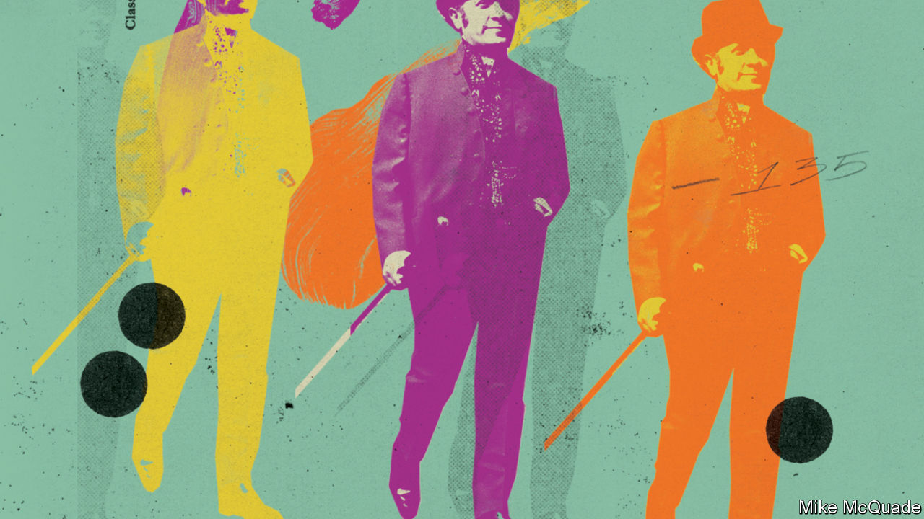

Then the member for Southport, anxious lest his long and rambling speech be misinterpreted: “I hope that we shall have no more of the nonsense that we have had in the House and the press that if someone dares to have a different point of view—on detail, for I am keeping to the amendment—and dares deploy an argument about it, that is filibustering. I am sorry to see those, self-styled, of enlightened opinion being so intolerant of the opinions of others. That was, in fact, my last but one general observation...”

MR SPEAKER: “Order.”

## How am I gonna get through?

One by one, Abse’s supporters were shuffling off to bed. Fatigue was winning. On the first motion to halt discussion and move to a vote on an amendment, at 11.37pm, Abse had 135 supporters, comfortably more than the threshold of 100. By the second, at 1.25am, he had only 116. It was, he said, “on a razor’s edge”.

And still the opposition went on talking. Every argument was advanced. Any possibility to run down the clock was seized. Since the bill would decriminalise gay sex only in private, what would happen, the member for Bromsgrove wanted to know, if two men were spotted through their hotel window?

The member for Birmingham, Selly Oak speculated on the motivations of the bill’s supporters. “According to the figures we have heard and seen published, there is quite a percentage of people who practise homosexual acts. It would be strange indeed, in a place of 600 members, if there were not some here…” (Lord Arran, whose other great cause was badgers, reached the same conclusion. Asked why his badger-cruelty bill failed, he replied: “Not many badgers in the House of Lords.”)

Big Ben was about to ring out again by the time the member for Bromsgrove turned his attention to the matter of sleeper trains:

“Two passengers who occupy adjoining sleepers after boarding a train at Euston are committing no breach of British Railways by-laws if they indulge in this practice, but as soon as the train crosses the border and goes into Scotland they are committing an offence. Is this the right way to leave a bill? Are British Railways sleeping-car staff to receive instructions to blow a whistle at the border?”

At length, seven and a half hours into the night, the bill’s opponents had exhausted all their arguments. Or perhaps they were just exhausted. In the end, there was no need for another closure motion. The member for St Albans made one last attempt to stall. Now that the amendments had been considered, he argued, the debate should be adjourned to another day. The Speaker refused, and a substantive vote was finally called, at 5.44am. Fourteen diehards had lasted all night, voting against the bill to the bitter end. Across the lobby, there were 99 “Ayes”. Abse had won, by attrition.

It had been a long road. For Jenkins, who would have little sleep before Independence Day drinks at the American Embassy and an afternoon at the Wimbledon tennis championships. (Full enjoyment, indeed.) For Lord Arran who, under such strain for so long, had been “permanently if slightly pickled” for more than a year. Once, when someone scrawled “Arran homo” on the walls of his club, he “hardly dared to hold my head high. Indeed I thought of resigning from my club until I woke up and said to myself ‘Why the bloody hell should I?’” And, of course, for Abse, who went on to champion more private members’ bills than any other parliamentarian of his generation. He wanted to be remembered as “the member for happiness”.

## With many a winding turn

His bill was imperfect. Since it made a specific offence of sex in public toilets, prosecutions rose in the decade after the bill was passed. By modern standards, the arguments he and Lord Arran deployed were themselves prejudiced: homosexuality was a “condition” to be pitied and not to be “flaunted”. And gay sex remained illegal in Scotland until 1980 and in Northern Ireland until 1982. It is still outlawed in 68 countries. Still, that night those stout fellows—men and women—loosened the shackles a little. Blackmail grew rarer; the closet door was left ajar.

As Abse, shattered, triumphant, emerged into Westminster Palace Yard, the gas lamps were still burning. Collapsing into his second-hand Rolls-Royce, he drove home to his wife, Marjorie, “who was in bed, still awake, anxiously awaiting me and my news. She took me into her arms.” It was a year before Mr Wells, the phonetician, met another man, Gabriel. They moved in three weeks later. With Gabriel’s support, he stopped going to psychotherapy; he realised it was society, not him, that had a problem. Today, 52 years on, they are still together. In 2006, as soon as they were able to, they signed a civil partnership. That long night was at an end. At long last, daylight was coming. ■

This article was downloaded by calibre from <https://www.economist.com/christmas-specials/2020/12/19/how-a-little-known-welsh-politician-helped-gay-rights-in-britain>

|  |  |  |  |
| --- | --- | --- | --- |
| 上一项 | 文章 | 章节 | 下一项 |

|  |  |  |  |
| --- | --- | --- | --- |
| 上一项 | 文章 | 章节 | 下一项 |

#### Travels in Zululand

# How an apartheid-era deal still afflicts the land of the Zulus

Sizani Ngubane hopes to bring an end to one of the most controversial institutions in South Africa

Dec 19th 2020 | JOZINI

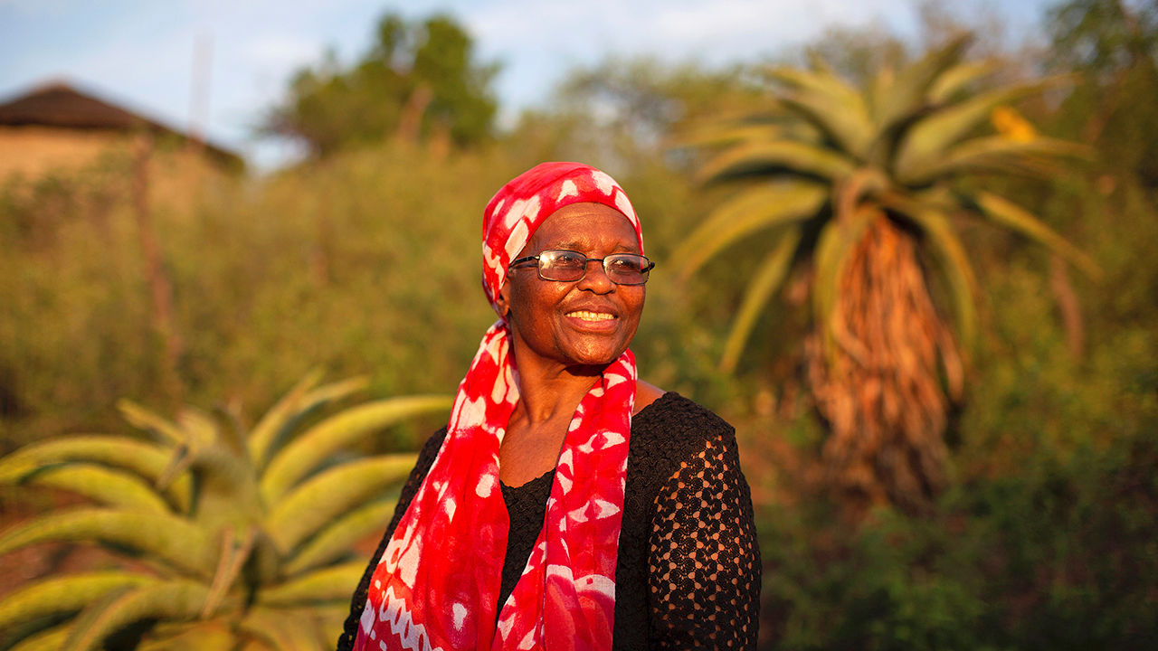

AT THE AGE of 74, with barely enough feet and inches to peer over the steering wheel, Sizani Ngubane makes for an unlikely racer. Yet one afternoon in October she hurtles up the N2 motorway, which hugs the east coast of South Africa before heading inland through the heart of the former Zulu kingdom, swerving past trucks and errant cattle.

Not for the first time, Ms Ngubane (pictured above) is on a mission. She and your frazzled correspondent arrive in the town of Jozini as the sun wanes behind hills dotted with fever trees. We are just in time to meet applicants in a court case co-led by Ms Ngubane’s organisation, the Rural Women’s Movement, that could strike a blow against one of the most controversial institutions in South Africa.

The Ingonyama Trust Act was enacted three days before the election in April 1994 that brought apartheid to a close and Nelson Mandela to power. The act made a special case out of the ancestral lands of the Zulus, the largest ethnic group in South Africa. The law vested trusteeship of the land in the Zulu king, currently Goodwill Zwelithini, and established the Ingonyama Trust to manage it. According to the act the trust must serve the people who live on the land—a population of more than 5m across an area about the size of Belgium. But its critics allege that the trust acts more like a punitive feudal landlord.

In the case brought by Ms Ngubane, which was heard on December 9th and 10th, lawyers for the applicants argued that the trust acted unconstitutionally by undermining residents’ property rights. During apartheid many black South Africans in rural areas were given “permission to occupy” (PTO) certificates: an informal right less secure than a freehold but that a post-apartheid law said could not be withdrawn without the holder’s consent. By allegedly cancelling PTOs and requiring residents to sign leases instead, the trust acted unlawfully, according to the applicants’ lawyers. They want the leases of their clients—and anyone else affected—cancelled and PTOs reinstated.

The trust denies that it coerced anyone into signing leases, which it claims are entirely lawful. It says they are in fact more secure than PTOs. But if the judges disagree with the trust when they return a verdict early in 2021, the decision could change the lives of some of South Africa’s poorest people for the better. It could also provoke a fierce backlash among powerful figures who benefit from the status quo.

## All around me a voice was sounding

The unlikely epicentre for this potential upheaval is a sparsely populated settlement a few minutes’ drive from the centre of Jozini. Getting out of her car, Ms Ngubane shuffles into a one-room concrete house to greet the applicants in the case. At the threshold a young boy spritzes hand-sanitiser into our hands; behind him an older girl squeezes past with a few coins to buy electricity credit to illuminate the room.

Ms Ngubane introduces the grandmother of the children, Hluphekile Mabuyakhulu, who is recovering from a stroke (pictured below). She sits upright in bed, framed by a red velour headboard. She explains that her family moved to the plot in the mid-1980s, when the induna, or headman, allocated them the land. Though water is scarce she has done her best to make do, planting fruit and vegetables in her yard.

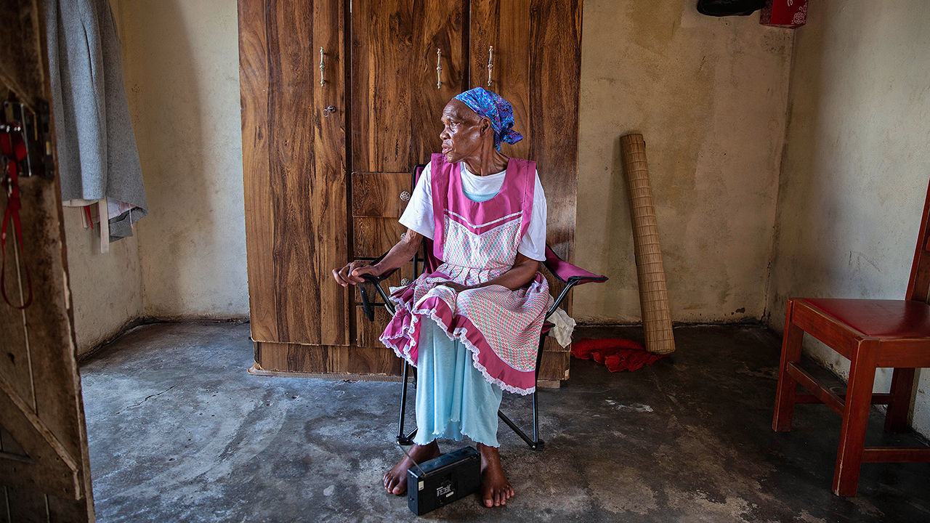

According to her affidavit, in 2011 she was summoned to a meeting at which residents were told they must sign leases for their properties “or we would not be recognised by the king as being part of this community”. The contracts were in English, which she cannot speak fluently. Only afterwards did she discover that she had to pay 1,500 rand ($95) per month, more than her monthly pension, to live in a house she considers hers. “I feel like I was scammed by the trust,” she says.

By her bedside is Linah Nkosi, a neighbour and fellow applicant. She has lived in the same house in Jozini since 1974. In 2012 she was informed that she, too, would have to sign a 40-year lease and pay rent. And the lease had to be in her then-boyfriend’s name, as he was deemed the head of the household. (The trust insists that no applicant was duped.) “In Zulu culture women are kept down, down, down,” she says.

That reality has gnawed at Ms Ngubane since she was a girl. In 1956, when she was nine years old, her mother was evicted by her uncle. The incident led her to dedicate her life to campaigning for the rights of poor rural Zulus, especially women. It is a job that has not got easier since apartheid ended. “It’s very sad,” she says. “We’ve really dropped the ball as a country.”

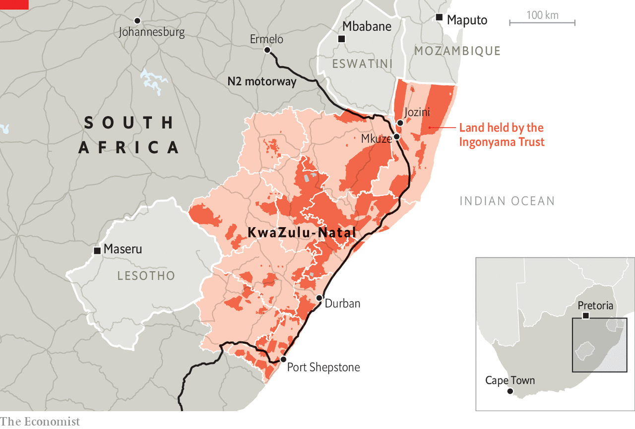

In the early 1800s the Zulus were one of many cattle-herding clans in the south-east corner of the continent. But under King Shaka they conquered surrounding groups to form a political entity unusual in its size, sophistication and military prowess. By the time of his death at the hands of his half-brothers in 1828, the Zulu kingdom encompassed around 30,000 square km (12,000 square miles). During the rest of the 19th century fratricidal rivalries weakened the empire from within. The expansion of the Boers and the British destroyed it from without. After many battles the kingdom became part of Natal, one of the two British colonies that in 1910 joined with two Boer-run territories to form the basis of modern South Africa.

As in other parts of Africa the British colonists introduced a system of indirect rule, in this case by the Zulu king and his inkozi, or chiefs. This provided the foundation for later policies, including the apartheid-era “homelands”: ten ethnically homogenous pseudostates used to confine, disenfranchise and impoverish black South Africans. When KwaZulu, the semi-autonomous homeland of the Zulus, was formally hewn from Natal in 1977, it drew on deep institutional roots.

In KwaZulu the government was effectively a one-party state, sponsored by the apartheid regime and led by the Inkatha Freedom Party (IFP). Under Prince Mangosuthu Buthelezi, the uncle of the current king, the IFP promoted a conservative Zulu nationalism with the monarch as a figurehead. As apartheid neared its end in 1993, Human Rights Watch, an NGO, described KwaZulu’s political arrangements as “dictatorial”.

Growing up, Ms Ngubane felt under a double layer of oppression—that of apartheid and the petty chiefly dictatorships. Over coffee she recalls how she was shaped by these experiences. “I was a bad child,” she says, with a grin. During the day she would eavesdrop on elders’ conversations about village iniquities. At night she would clutch a radio to her ear and hear about the atrocities of white rule.

When she was 16 she took a job as an assistant in a dress-material shop, where she had to hide behind the changing-room curtain until any Zulu-speakers entered. Other aspects of apartheid were less farcical. The proximate cause of her father’s suicide, in 1959, was the breakdown of his marriage. But Ms Ngubane cannot shake the idea that apartheid contributed indirectly. Like millions of black South Africans, in order to find work, he spent most of his time far from his family.

## This land was made for you and me

“I knew something had to be done to stop the oppression of black people,” says Ms Ngubane. She grew up in a family affiliated with the African National Congress (ANC), ultimately becoming a recruiter for the party. Since the ANC was banned until 1990, she had to operate stealthily. IFP saw the ANC as an existential threat to its hold on KwaZulu—a state of affairs that suited the apartheid regime, which gave it money and guns. In the decade after 1985 the ANC and IFP fought a low-intensity civil war. Approximately 15,000 people, including one of Ms Ngubane’s brothers, were killed. The spectre of further violence, and Mr Buthelezi’s threat to boycott the 1994 elections, led to the last-minute deal that created the Ingonyama Trust. (The national government became the custodian of the land of the nine other homelands.)

Since 1994, to stay on the right side of rural power-brokers, ANC-led governments have strengthened “traditional leadership” in the former homelands, including KwaZulu. Several laws have underscored the old systems of indirect rule, for example by creating “Traditional Councils”. These institutions, which have roles in allocating land and delivering services, have 60% of their members appointed by chiefs.

The arrangement seems out of place in democratic South Africa. But defenders of such laws argue that they are necessary to protect traditional cultures, such as that of the Zulus. To explain what that means, in an area a couple of hours from Jozini, Bonga Mdletshe, the local chief, has convened a meeting of his headmen.

Those with an imperial imagination may imagine Mr Mdletshe in traditional garb—cow-hide shield, spear, headband, and so on. But that is like expecting the leader of Edinburgh City Council to go to work everyday in a kilt. Instead Mr Mdletshe has the get-up of a beleaguered provincial civil servant. He is dressed in jeans, a checked shirt—and drives a lurid orange pick-up truck. After one of his induna says a prayer, he begins to describe his role.

“I’m an extension of his majesty, the king”, he says. “I administer the tribe on his behalf and protect the Zulu culture.” That means keeping track of the family trees that make up the canopy of surrounding clans and telling stories of battles won and lost. Military culture is central to much of Zulu culture. Indlamu, a warrior dance, is performed at weddings. Rural boys still learn the art of stick-fighting. Also important is “protecting the structure of our community”—the hierarchy that descends from the king to chiefs and headmen to the paterfamilias. For critics this is a smokescreen behind which women are kept second-class citizens, for instance in polygamous marriages.

No data exist on how many Zulu men still marry multiple wives but it remains relatively common among chiefs. One induna argues that it is part of Zulu history: when many men died in battle it ensured women could still get hitched. Another says it reflects a belief that when a woman has her period she is “dirty” and should refrain from work. Rather than chip in, goes the logic, a man needs another wife to fill the gap.

Travelling around the former homeland it is possible to find women who are happy with such arrangements. Boneni Maphanga was one of six wives of a local businessman; he gave each spouse her own grocery shop. There was no jealousy, she says, or at least no more than in a monogamous marriage. “We were like sisters.” Mr Mdletshe insists that women are “greatly respected” in Zulu culture. “Anyone who visits my mother”, he adds, “will crawl across the floor to greet her.” Ms Ngubane scoffs at such talk. She points to enduring customs such as virginity testing, and the annual reed-dance where thousands of bare-breasted girls parade before the king in a celebration of chastity.

It would strengthen the case of traditional authorities if they were any good at administration. But the former homelands are among the worst-run parts of the country, with devastating effects for the one-third of South Africans who live there. South Africa’s ten poorest municipalities are all in former homelands. Analysis published in January 2020 estimated that 62% of working-age adults in ex-homelands have no job, versus 38% in the rest of the country.

A paper published in 2019 by Dieter von Fintel and Johan Fourie explains why destitution has persisted. The economists from Stellenbosch University argue that after the arrival of Europeans, Africans “were at the mercy of two extractive regimes”. The first were systems of white rule culminating in apartheid. The second were the homelands and their antecedents. Both had narrow elites—one white, the other black. The pillars of apartheid have crumbled but those of the homelands remain.

In KwaZulu, the trust must administer the land “for the benefit, material welfare and social well-being of the members of the tribes and communities” of the former homeland. Yet in village after village there is little sign of it doing that. Conditions are often squalid. This is not all the fault of traditional institutions—municipalities are failing, too—but they share the blame.

An hour from Jozini, near the town of Mkuze, B.F. Mgwenya, another chief, shelters inside his makeshift headquarters: a dilapidated farm long abandoned by a white landowner. He says that the main challenge is getting clean water. Droughts have worsened, but neither the local municipality nor the trust has offered any help, he says. “We used to rely on God,” he says, recalling when nearby mountain streams gushed. “Now we rely on government.”

Mr Malinga argues that chiefs can be suspicious of development. An induna in his village, he says, once claimed that the arrival of electricity would damage cows’ eyes. “If you want to resist change it makes sense to pretend it undermines your culture.” These views are not universal, however. On more than one occasion your correspondent was asked by chiefs or headmen whether he could help bring investment to the area. They wanted the best for their kith and kin, but they did not know how to go about it. “We’re the poorest of the poor,” says one of Mr Mdletshe’s aides.

It would help if the trust lived up to its mandate. Under statute 10% of its proceeds can go to its board for administration, but the rest should benefit local communities. Yet the public does not know what it owns, spends and earns. It is unclear whether any of this money goes to the king himself. He receives a taxpayer-funded stipend of more than 70m rand. Occasionally there are glimpses of the trust’s finances via reports of the trust board to parliament. In 2018 the board reported that, in the latter half of the previous year, 96% of the board’s budget went on “administration”, versus 0.16% for “rural development”.

Yet, according to the court papers lodged by the applicants’s lawyers, the trust’s rental income soared from 8m rand in 2008-09 to 107m rand in 2016-17. Meanwhile the national government is investigating the trust board amid allegations of bribing chiefs and Mr Ngwenya for alleged self-enrichment, and is conducting an audit of the board’s finances. (Mr Ngwenya says the probe “lacks the necessary legal foundation”.)

Reformists worry, though, that the ANC will not take on the trust. In a major review of the nation’s ills published in 2017, Kgalema Motlanthe, a former president, concluded that the trust should be repealed or amended. He later called chiefs “village tin-pot dictators”. But when he became president a year later, Cyril Ramaphosa swiftly visited the king to assure him that KwaZulu would not be touched.

Because of Ms Ngubane’s campaigning work, she has faced multiple death threats and has had to go into hiding on several occasions. “Don’t be surprised if you come back in more than one piece,” she recalls an induna telling her when she visited his community in the 2000s. Not that such words scare her. Since she was a child she had a preternatural sense that taking on injustice is her life’s mission. She has been told countless times that her work undermines the culture of the Zulus. To that argument, she has a bracing reply: “What they’re doing is not our culture—it’s greed.” ■

This article was downloaded by calibre from <https://www.economist.com/christmas-specials/2020/12/19/how-an-apartheid-era-deal-still-afflicts-the-land-of-the-zulus>

|  |  |  |  |
| --- | --- | --- | --- |
| 上一项 | 文章 | 章节 | 下一项 |

|  |  |  |  |
| --- | --- | --- | --- |
| 上一项 | 文章 | 章节 | 下一项 |

#### Extraterrestrial hiking

# Following the tracks of NASA’s Curiosity rover

A short walk in Gale crater

Dec 19th 2020 | THE SOUTHERN



HOW YOU came to be on this flat desert plain at this time does not matter. What matters is the landscape around you.

To the north there is what appears to be a rim around the world, brightened by morning-lit dust at its base, darker as it rises into the sky. In some places it is a disordered, stepping-stone staircase of hummocky hills; in some it has a steep, solid face. However they are reached, though, its heights are strangely continuous and peculiarly even in stature: a scarp, not a mountain range, one that curves as it stretches to the left and right, the east and west.

You turn and face the mountain, broad and daunting. It is both nearer than the rim which encircles it and higher—taller and more wide-shouldered than Mont Blanc, Mount Rainier or Mount Fuji. Around its base, dunes sweep past flat-topped mesas. Behind and above them, a layered reddish rock rises a kilometre or more, its sturdy ridges casting stripes of shadow in the oblique light. The slopes immediately above are brighter and more chaotic, like a soft wood savagely chiselled. Higher still, towards the snowless peak, you think you pick out layers again, perhaps, of some sort. But it is hard to say: the air, though thin, is dusty, and the heights are far away.

You adjust your straps, square your shoulders, and start to walk towards it.

The encircling scarp to the north of you is the rim of Gale crater, a circular basin 150km in diameter which, though only five degrees from the Martian equator, is part of what scientists call the southern highlands. It was formed by the impact of an asteroid between 3.8bn and 3.5bn years ago. The crater-bottom plain over which you are walking is Aeolis Palus; the mountain towards which you are headed is known officially as Aeolis Mons, but colloquially as Mount Sharp.

The heights of Mount Sharp are unlike those of any Earthly mountain. Its roots are older than any Earthly continent. The rocks under your feet, though, have no such strangeness to them. Only an expert geochemist could distinguish them from the rocks of some Earthly desert. The mountain-in-a-crater landscape has been shaped by forces never expressed this way on Earth. But the details and textures that meet your eyes are entirely familiar. Indeed, the rocks are doubly familiar: familiar from analogues on the Earth; familiar from prior inspection. Everything you see here in Gale crater has already been examined and appreciated through eyes from Earth. Just not through human ones.

It is not its height which makes Mount Sharp special. Olympus Mons rises almost 25km above the lowlands of Amazonis, three times the height of Everest. The great peaks of Tharsis and Elysium rise considerably higher than Hawaii’s Mauna Loa does above the abyssal plains of the Pacific. Mount Sharp is modest by comparison. But unlike Mars’s highest heights, it was created in a uniquely Martian way.

Earth’s mountains come in two forms. There are chains like the Alps and Himalayas, pushed up when two tectonic plates collide, and there are volcanoes, built up by hot rock rising from below. But both types, like empires, go through a rise and fall. The forces that drive them into the sky eventually abate; erosion takes care of what is left behind.

Mars’s greatest mountains, and many of its smaller ones, are volcanoes of a particular type—built up by flow after flow of dark, basaltic lava driven to the surface by heat from the mantle far below. They can be higher than Earth’s because, perhaps ironically, Mars is a smaller planet. Being small, it started off with less internal heat than Earth; it has lower gravity; and it has been unable to hang on to the thick atmosphere it once seems to have had: that is all good news from the point of view of mega-mountains.

A lack of internal heat means that the planet’s stiff, cold crust is thicker than Earth’s, and not divided into jostling tectonic plates. On Earth a hotspot in the mantle can feed magma to a mountain on the surface above for only a few million years before the movements of the crust sever the link. On Mars the crust stays put, so a mantle hotspot can feed the growth of a single volcano for a billion years, maybe more.

On Earth, the crust would buckle under such loads. On Mars, where the crust is thicker and basalt weighs less, it supports them. And the thin, dry atmosphere means their heights see hardly any erosion. Ice and running water quickly erode away Earth’s proudest peaks. Troubled only by the thinnest of winds, Mars’s great volcanoes suffer no such levelling. They stood as high as they do today when the rocks of Everest first started their rise from the bottom of the Indian Ocean: they will be all but unchanged when erosion has returned the Himalayas to the plains and seas below.

At lower altitudes, though, the weak but insistent wind can have its way with softer rocks, and that is the unearthly way in which Mount Sharp was made. When Gale crater was formed, Mars had not yet become the cold, dry, all-but-airless world it is today. Looking at pictures taken from orbit in the 20th century, scientists saw that soon after Gale’s formation its rim, then considerably higher than the remnant away from which you are walking, was ground down in the way that mountains on Earth are, with rivers and streams spreading its remains over the crater’s floor.

When the water and ice ran out, wind-blown sediments were piled on top of these water-borne ones. Not long after the planet’s comparatively warm, wet youth was fully spent, Gale’s great basin was filled, perhaps to the brim, with sediments hardened into rock—as, it appears, were craters across the Southern Highlands. Mars boasts the only such sedimentary rocks yet seen anywhere beyond Earth.

Having given, the wind then began to take away. For geologists interested in wind-shaped landscapes Mars is very heaven. For billions of years its thin winds have been building dunes, carving yardangs, polishing desert pavements and endlessly redistributing dust. All these processes take place on Earth. But on Earth the rain raineth, if not every day, at least every century, and deserts bloom or vanish as climates and continents shift. None of that happens on Mars. The wind has world enough and time to do all that it could wish.

At Gale, and in other filled-in craters, it excavated. But it did so unevenly, scouring harder near the rim, paying less attention to the middle. Consequently the central sediments began to stand proud. The presence of this protuberance encouraged the wind to pass around it, reinforcing its tendency to dig more deeply closer to the rim, hollowing out a doughnut trench. And so, over aeons, Mount Sharp was cut out of the once-even plain, a mountain not added to the surface from below like those of Earth, but created by subtraction from above.

In carving out Mount Sharp, the winds laid bare the planet’s history. Its higher slopes are all but certainly made of compacted dust, and maybe some volcanic ash. Its lower strata are part of the original sedimentary infilling, washed into place from the eroding rim. So are the lowlands. You are walking on a lake bed that dates to a time when the Sun was but a quarter of its current age. The thought makes you both proud and slightly uneasy as you scuttle across the silent floor.

At the dawn of the 21st century, when the sedimentary deep past of Mars was first beginning to be appreciated, geologists realised that the aeolian landscape of Gale crater offered a pair of attributes that made it a particularly promising site for study. The sedimentary strata of lower Mount Sharp might record both the planet’s early environment and the chemical changes that accompanied its subsequent desiccation. And the adjacent crater floor offered a nice big patch of smooth terrain on which a spacecraft could land.

So on August 6th 2012 a hovering “sky crane” that had parachuted down through the Martian sky lowered a rover called Curiosity onto the surface. The sediments that had been hoped for were there in abundance. “I’d expected mudstones,” said one geologist. “I hadn’t expected to spend most of the mission looking at them.” Within a couple of years Curiosity had confirmed that the inside of Gale crater really had been a lake, one with a rich history of its own. It had emptied and filled up again. There were coarser rocks closer to where the sediments had washed down from the rim; there were what seemed to be stream beds filled in by later muds, their rocks preserving ripples created by the gentle flow of water aeons ago. It was the best evidence ever seen of a habitable environment beyond Earth.

## Daring to disturb

Curiosity crept forward a few metres at a time. It took years to reach the mountain. You are covering the distance a thousand times faster. But your walk is still rather slow. This is not due to dawdling or awe, though maybe it should be. It is a matter of physics. The lower gravity of Mars slows things down. When you walk at a natural pace, the leg that is off the ground swings forward like a pendulum: that is what makes walking so energy-efficient. Pendulums swing slower under the low gravity of Mars, and thus so do legs; your walking pace is about two-thirds what it is on Earth.

But other gaits are available. One involves pushing your lighter-than-it-should-be body into the air with your forward foot so that both legs are out of contact with the ground as the trailing foot swings forwards. When you land on the same foot with which you pushed off, the other foot comes down ahead of it, giving you a split second of doubly-footed steadiness before you push off again with that second, now forward, foot. This is a gait that comes naturally to five-year-olds but which adults on Earth forsake; it takes up more energy than walking. On Mars it is both speedy and practical. And also rather fun. To reach the mountain faster, you start to skip.

As the land begins to rise, it also begins to break up. When the wind’s scouring reaches a particularly tough layer of sediment, it deepens cracks within that layer and eventually gets to work on softer rocks beneath, undermining the overlying stratum. The land takes on a shattered look. Some bits collapse sooner than others, the hold-outs balancing, for a while, on plinths of softer rock below. The most dramatic such forms on Earth look like petrified pseudo-mushrooms: broad, tough caps on thin stems.

Curiosity never saw such pedestal formations. But you are not following directly in its tracks—they are protected as part of Martian heritage. And you can clamber over obstacles the rover would have had to circumnavigate. The ease with which you can jump up is the strongest reminder that this landscape is not an Earthly desert. That, and the lack of detritus. “The only way you know that you’re not in the American West”, said one of the Curiosity scientists, “is that there are no old cars that have been used for target practice.”

When you come to the dunes, though, they add some otherworldly strangeness. Mars’s nearly omnipresent, iron-oxide-rich, wind-blown dust imposes a palette of tan and reddish browns on almost all the planet’s landscapes, not to mention its skies. The thin line of dunes around the mountain’s base is an intervention of near perfect black, its slopes and crests like calligraphy in India ink.

This is because the dunes, unlike almost every other aspect of the Martian surface, are active. They are composed of sand from outside the crater blown against the mountain’s base, accumulating in drifts which are flowing around to the west. And those rolling sand grains gather no dust. They maintain the colour of the basalt that makes up most of the Martian crust: tarmac black.

Curiosity had to look carefully for a safe passage through this Stygian flow. Active sands are no friends to rovers; one of its predecessors, Spirit, lost contact with Earth after it got stuck in a sand trap in Gusev crater. With the benefit of legs as opposed to wheels, and with muscles much stronger than is necessary in this weak gravity, you have no such fears. You can clamber up the dunes’ shallow stoss sides and slide down their steep slipfaces. You can lie down and make sand angels that sharp-eyed satellites can see from space.

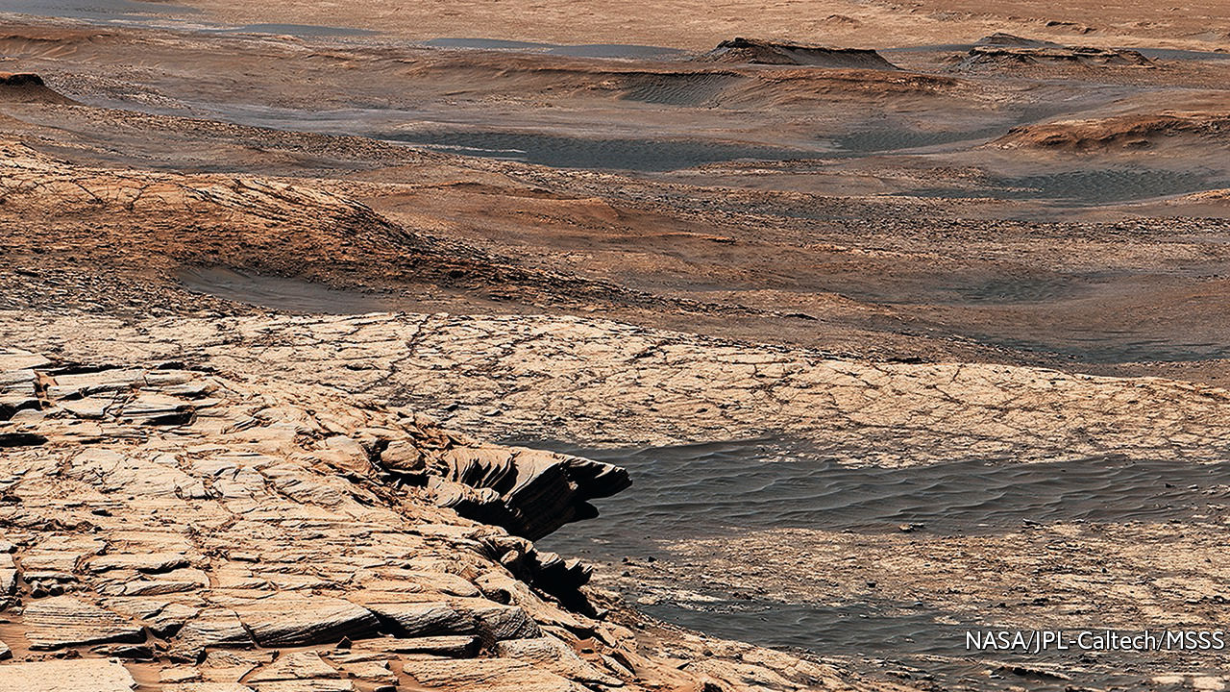

The pervasive out-of-placeness engendered by Mars tends to inhibit such frolics. Being alive in this barren, alien landscape is a triumphant achievement, but it is also an incipient pollution: matter out of place should know its place. But in the dunes it is different. Here Mars moves, and Mars forgets. The sands’ journey around the flanks of Mount Sharp will erase all trace of your passing.

And so to the harder, steeper rock of Mount Sharp’s slopes. They are still sedimentary, but geochemically distinct from the rocks below. Curiosity spent the early years of the 2020s making sense of those distinctions as it headed towards the intriguing gully of Gediz Vallis. You are content simply to climb them, headed up towards the wind-formed, wind-shaped strangeness of the higher reaches, your steps passing over unwitnessed and unmeasured spans of time.

## Come and go

Late in the morning, you come to a sandstone ledge and pause; almost a kilometre above the dunes, you look around again. The rim, now lit evenly from the south, looks more uniform than it did earlier. The textures of the plain are richer looked down on than they were when you stood amid them. You can no longer look up at the peak without looking directly at the Sun, and so you don’t. But it still beckons.

Curiosity’s diligent explorations did not exhaust human curiosity about this place, nor dent the wonder to be felt here; in fact they whetted both. Mysteries remained, and still remain, spread out through the silent rocks and over all the planet’s strange history. So much remains unknown.

But the rock you stand on and the slopes ahead: they are real and present, as solid beneath your feet as they were clear in Curiosity’s cameras. The weak wind at your back, you continue the climb. ■

This article was downloaded by calibre from <https://www.economist.com/christmas-specials/2020/12/19/following-the-tracks-of-nasas-curiosity-rover>

|  |  |  |  |
| --- | --- | --- | --- |
| 上一项 | 文章 | 章节 | 下一项 |

|  |  |  |  |
| --- | --- | --- | --- |
| 上一项 | 文章 | 章节 | 下一项 |

#### Economies past

# Home-working had its advantages, even in the 18th century

And there exist surprising parallels with today

Dec 19th 2020 |

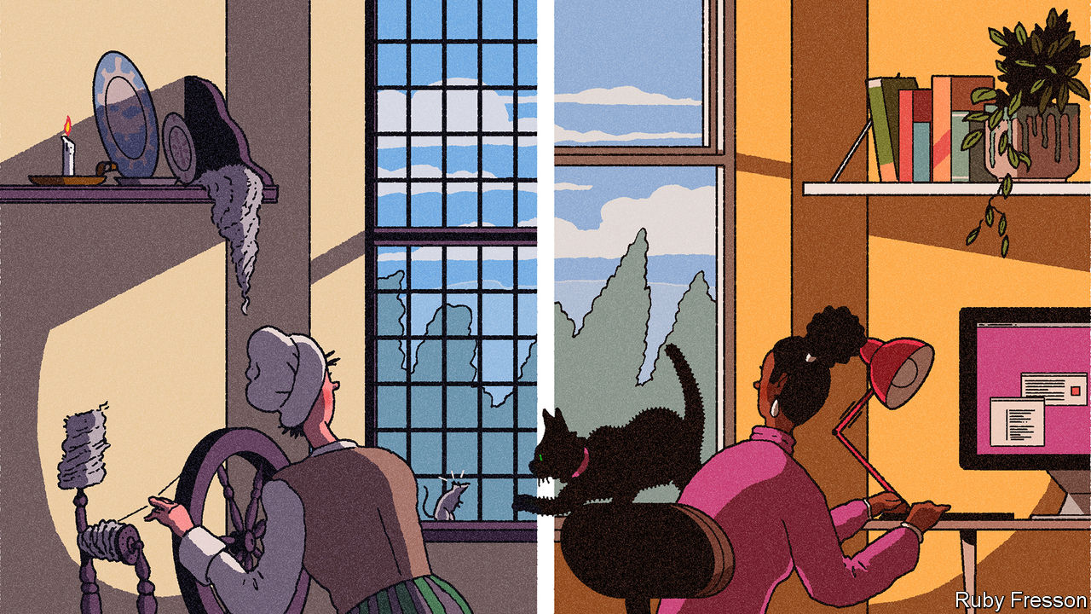

SALLY BROWN, who was born in Vermont in the early 1800s, had a typically varied schedule for a working woman of the time. As her diary shows, one day she is finishing stockings; another she is milking a cow; another she is refining wool. All of her jobs were done from home.

The shift from offices to kitchen tables among white-collar workers in 2020 seems unprecedented, and only possible with Slack and Zoom. But it is nothing new. Indeed, the history of home-working suggests some surprising parallels with today.

The emergence of capitalism in Britain and elsewhere from the 1600s to the mid-19th century did not take place primarily in factories, but in people’s houses. Workers made everything from dresses to shoes to matchboxes in their kitchens or bedrooms. When Adam Smith wrote “The Wealth of Nations” in 1776, it was perfectly common to work from home. Smith famously described the operation of the division of labour in pin-making, but not in a dark, satanic mill. He was describing a “small manufactory” of perhaps ten people—which could well have been in or attached to somebody’s house.

It is not easy to put exact numbers on how many people have worked from home during different historical periods. Even in Britain, where economic data reach farther back than in any other country, little reliable labour-force data exist until the mid-1800s. Other sources left clues, however. One relates to the meaning of the word “house”. Today it connotes domesticity. But up until the 19th century it had a much broader definition, with the suffix “-house” encompassing economic production, too. In “A Christmas Carol”, Scrooge works in a “counting-house”. Architecture offers other hints. In Britain, many 18th-century houses still have unusually large upstairs windows; cloth-weavers, who worked there, needed as much light as they could get.

Around 1900 French administrators took the lead in asking people about their place of work, not only what they did. They found that one-third of France’s manufacturing workforce worked from home. Danish surveys around the same time found that a tenth of the total workforce did so full-time at home. These research efforts took place at the high point of the factory-based system of production; in previous decades the share of home-working would have been far higher. According to one estimate for America, using official data, in the early 1800s more than 40% of the total workforce laboured from home. Only by 1914 did the majority of the labour force work in an office or factory.

The emergence of an at-home industrial workforce had two main causes. The growth of global trade and the rise in per-person income from the 1600s onwards raised demand for manufactured goods such as woollens and watches. But the emerging new technology was more suited to small-scale working than large-scale factories (the spinning jenny, the machine which kickstarted the industrial revolution, was not invented until the 1760s). Homes were the obvious place to be.

What emerged was called the “putting-out system”. Workers would collect raw materials, and sometimes equipment, from a central depot. They would return home and make the goods for a few days, before giving back the finished articles and getting paid. Workers were independent contractors: they were paid by the piece, not by the hour, and they had little if any guarantee of work week to week.

Accounts of what it was actually like to work from home in the 18th and 19th centuries are few and far between. Many putting-out workers were women, who were less likely to write autobiographies (women’s dominance in the putting-out system also explains why generations of historians have not paid it much attention). Some characteristics nonetheless emerge from the archives. Average working hours were longer (see chart). Unlike today, where most people have one job, people flitted from one task to another, depending on where money could be made, like Sally Brown.

## With fingers weary and worn

Some economic historians suggest that workers were mercilessly exploited under the putting-out system. Those who owned the machines and raw materials enjoyed enormous power over those they employed. With workers dispersed across a county, it was difficult for them to team up against exploitative bosses to demand better pay, let alone form trade unions. Bosses “could easily gang up against the rural spinner who faced a take-it-or-leave-it offer of work,” argue Jane Humphries and Ben Schneider of Oxford University, in a paper from 2019. Some workers truly struggled. Thomas Hood’s poem “The Song of the Shirt” evokes a home-working woman labouring in poverty.

As a result, some historians welcome the development of the factory system from the late 18th century onwards. Workers moved from a place where domestic life intermingled freely with economic production to a place solely dedicated to the pursuit of efficiency. It is hardly surprising that labour productivity was higher in the factory, nor that the factory system gradually outperformed the putting-out system and came to replace it. Crammed together in a factory, workers could more easily club together to ask for higher wages; trade unions started to grow from the 1850s onwards. According to English data, factory workers were paid 10-20% more than home-workers.

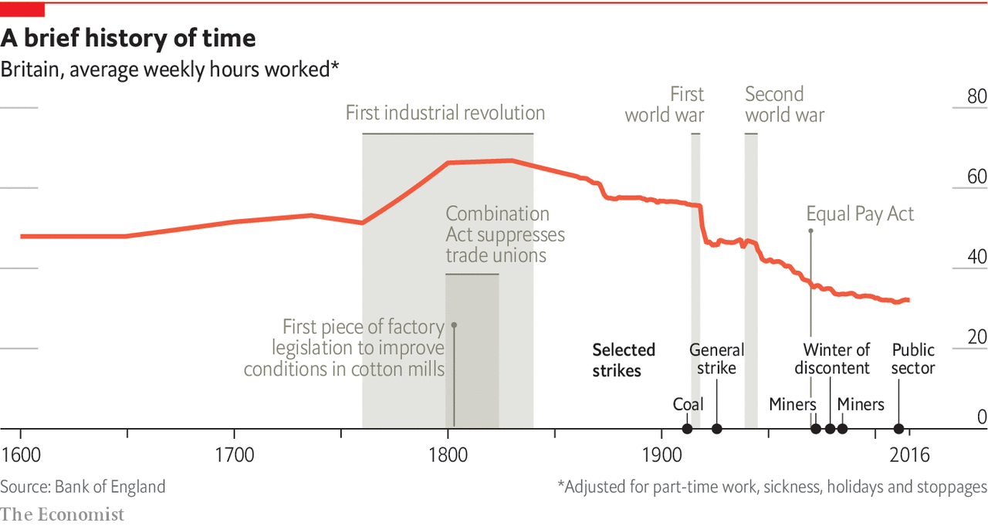

But is that the whole story? Some home-workers resisted the shift to the factory system—most notably by joining the Luddites, a society of English textile workers in the 19th century who smashed up machines which they perceived were putting them out of a job. Another explanation is that factory owners, at least in the short term, had little option but to offer higher wages in order to entice workers from their homes. That suggests that home-working had its advantages.

One such advantage was economic. Home-workers may have been poorly paid relative to factory folk, but they could earn income by other means. Wool-industry home-workers would receive a given quantity of material and were then supposed to return the same weight of material fashioned into stockings. But by exposing the wool to steam, it would weigh more, allowing the workers to keep some of the raw materials.

That was not the only advantage. Home-workers in rural or semi-rural areas could forage for fuel and food, and so boost their meagre incomes. One observer in 1813 noted sniffily that women in Surrey, a county close to London, were making three shillings a week from cutting down heath to make brooms—“miserable productions and trifling employments”, in his view. But three shillings a week was not far off average female earnings at the time.

Home-workers also had more control over their time. So long as the work was done to the required standard and on time, they were not told exactly when or how to do it. That was in sharp contrast to the factory, where every aspect of life was planned in advance and workers were closely monitored. And home-workers could decide on the exact mix between work and leisure—in contrast to factory workers, who either worked the 12- or 14-hour days stipulated by the factory owner or none at all. Average working hours in the 18th century were shorter than they became in the 19th. After drinking heavily on Sunday evening, home-workers often took the day off before they went “reluctantly back to work Tuesday, warmed to the task Wednesday, and laboured furiously Thursday and Friday”, as David Landes, an economic historian at Harvard University, put it. People also got more sleep.

This greater autonomy was especially important for mothers. In a world where men did little by way of family work, women could combine child care with contributing to the family income. It was far from easy. Sometimes women would give their infants “Godfrey’s Cordial”, a mixture of sugar syrup and laudanum, to knock them out for a while. But home-working allowed for the combination of paid work and family work in a way that the factory system did not. As factories spread, female labour-force participation fell.

In 1920 Max Weber, a German sociologist, argued that the separation of the worker’s place of work from their home had “extraordinarily far-reaching” consequences. The factory was more efficient than the home-based system which had preceded it—but it was also a space in which workers had less control over their lives, and where they had much less fun. Depending on how permanent it proves to be, today’s pandemic-induced shift back to the home could have similarly far-reaching effects. ■

Editor’s note: Some of our covid-19 coverage is free for readers of The Economist Today, our daily [newsletter](https://my.economist.com/user#newsletter). For more stories and our pandemic tracker, see our [hub](https://www.economist.com/news/2020/03/11/the-economists-coverage-of-the-coronavirus)

This article was downloaded by calibre from <https://www.economist.com/christmas-specials/2020/12/19/home-working-had-its-advantages-even-in-the-18th-century>

|  |  |  |  |
| --- | --- | --- | --- |
| 上一项 | 文章 | 章节 | 下一项 |

|  |  |  |  |
| --- | --- | --- | --- |
| 上一项 | 文章 | 章节 | 下一项 |

#### Shaolin monastery

# Tales of a “CEO monk” obscure the business of faith in China

Shaolin is the cradle of kung-fu and Zen Buddhism. Under its abbot it has opened international branches and made plans to list on the stockmarket

Dec 19th 2020 | DENGFENG

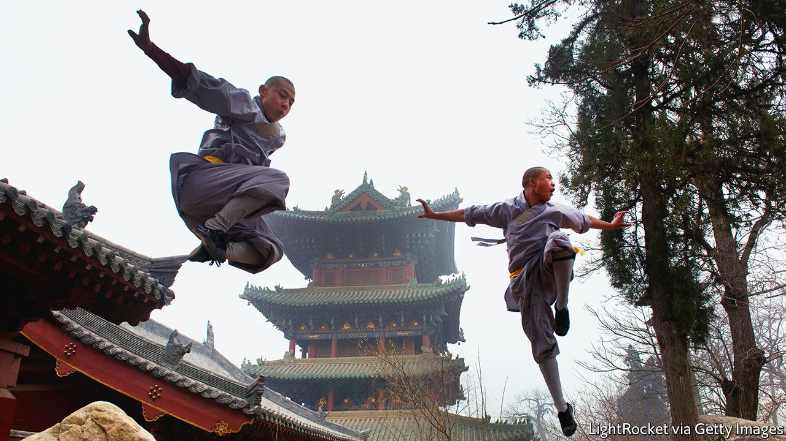

FOR NEARLY two hours the monks sit folded in the lotus position, motionless and silent. All are robed in grey apart from the cherubic man in saffron, their leader. When the last joss-stick burns down, he glides out of the room without a word, later offering a brief explanation of the meditation: “True wisdom emerges not from a calculating mind but from the wellspring of your heart.” It is the kind of line that might appear on a motivational poster. Voiced by this man, Shi Yongxin, the words sound heavier, weighed down by scandal.

Mr Shi is abbot of Shaolin Monastery, one of the world’s best-known Buddhist shrines. Tourists flock there to see its warrior monks, impossibly flexible young men who fell imaginary foes with flying kicks beneath the craggy peaks of Mount Song. Founded 1,500 years ago, it is the cradle of kung fu and Zen Buddhism. But in recent years it has had more infamy than honour. Mr Shi has been criticised for transforming hallowed ground into a crass business venture. “CEO monk” is his moniker, appearing in headlines again and again. Who could resist it? Under Mr Shi, a monk with an MBA, the monastery has expanded abroad and made plans to list on the stockmarket.

In 2015 the extent of his hypocrisy seemed to be revealed. Police opened an investigation after an accuser claimed that Mr Shi had enriched himself and violated his vows of celibacy. It was easy to dismiss the abbot as a sham, a venal man cloaked in religious garb. But Buddhist parables are rarely so straightforward.

Five years on, Mr Shi is still at Shaolin, cleared of all charges. He lives in a windowless room in its centre, looking less like a cunning mastermind than a quiet man of faith—one who may have renounced earthly desires but remains at the mercy of earthly forces. Religious institutions everywhere must negotiate between the articles of their belief and the realities of the world. In China that negotiation can get especially fraught.

When Mr Shi arrived at Shaolin at the age of 16, life there was much harsher. It was 1981, not long after the Cultural Revolution, when Mao Zedong had suppressed Buddhism and Red Guards had destroyed temples. Mr Shi found it in partial ruin. Just 20 monks lived there, subsisting on two steamed buns a day. Soon he had established himself as a lieutenant to its aged, nearly blind abbot. They trekked to government offices in Dengfeng, the monastery’s home county, seeking permission to rebuild temple halls, to perform Buddhist rites and, crucially, to sell tickets.

In a remarkable twist of karma, Shaolin became a hot destination. In 1982 “Shaolin Temple”, Jet Li’s debut, hit the cinemas, depicting a foundational story: how 13 monks, supposedly skilled in kung fu, saved a future Tang dynasty emperor in battle. The monastery went from 50,000 visitors a year to 2m in 1984.

Kung fu is just one aspect of Shaolin—a physical discipline that accompanies chanting and meditation—but easily the most distinctive. Tales of its warrior monks have been popular since the 16th century. Knowing that kung fu was Shaolin’s best hope for appealing to secular society, Mr Shi helped create a performing troupe in 1987.

From the outset, cross-cutting interests complicated matters. The main conflict was between the monks and the Dengfeng officials. For the monks, tourism was a financial lifeline to restore their monastery. For the officials, overseeing a poor county with half a million people, it was a kick-start for development. They squabbled over ticket sales. When the monks sold tickets at the temple’s entrance, the officials erected a new gate 1km up the road, controlling access.

Shaolin also became a magnet for profiteers. People flooded in from nearby villages to open guesthouses, shops and karaoke parlours outside its walls. In the 1990s the streets around it turned into a small city, with 20,000 residents. Dozens of kung fu schools, claiming to be the heirs of its fighting tradition, sprung up. Companies around China used the monastery for branding: with “Shaolin” cigarettes, cars and, most gallingly for the vegetarian monks, ham and beer. “We did not seek commercialisation. It was thrust upon us,” says Mr Shi.

He sought advice from officials in Henan, Shaolin’s province, about how to safeguard the monastery’s image. The only answer, they concluded, was for Shaolin to lay claim to its name. In 1998 it established the Henan Shaolin Industrial Development Co as a vehicle to file for trademarks—for tea, furniture, hardware and more. Today, Shaolin owns nearly 700 trademarks.

Having swatted away the impostors, Shaolin emulated some of their techniques. The monastery produced a kung fu teaching mobile app, backed a fighting-monk movie and launched a line of traditional Chinese medicine. Mr Shi also joined a dozen monks on a short MBA, a publicly funded course to hone their managerial skills. To its detractors Shaolin embodied the worst of modern China, an ancient religious order debased on the altar of riches. For Mr Shi the logic was—and remains—undeniable. “This is how to make Buddhism relevant.” If the pope can televise daily mass, why can’t a Shaolin monk seek publicity?

## Karmic cycle

For a time Mr Shi was riding high. He was officially named abbot in 1999. The monastery grew to more than 200 monks. He worked out an agreement with Dengfeng county: 70% of ticket sales to the government, the rest to the monastery. Officials razed the streets around the temple, relocating the residents in town—a move that solidified Shaolin’s bid for UNESCO world-heritage status, obtained in 2010. Shaolin became a weapon in China’s soft-power arsenal. Mr Shi met Queen Elizabeth and Nelson Mandela. He was also skilled at aligning the monastery with the Communist Party. He made the case that Shaolin was not a religious threat but the government’s humble servant, promoting Chinese culture. From 1998 to 2018 he was a deputy to the National People’s Congress, the first representative of China’s Buddhists in the rubber-stamp legislature.

Yet trouble was brewing. Dengfeng county officials wanted greater economic dividends from Shaolin. In 2009 they formed a joint venture with China National Travel Service (CNTS), a big state-owned company. Dengfeng would inject its share of Shaolin ticket revenues into the venture; CNTS would invest in local tourism infrastructure. Pointedly, the abbot did not show up at the company’s inauguration ceremony. Word soon spread that Shaolin wanted to list on the stockmarket, raising as much as 1bn yuan ($150m). Media reported it as another extravagant example of the abbot’s worship of mammon. There was just one problem: he was adamantly opposed, fearing it would make Shaolin a for-profit business. He asked questions that reached Beijing. Wen Jiabao, then China’s prime minister, quashed the listing, saying it would harm Shaolin’s identity.

The Dengfeng officials were furious. They saw Mr Shi as “a monk who won’t obey authority”, according to one intermediary. They started building a rival temple, to lessen their reliance on Shaolin. In May 2015 national authorities halted the project over concerns that it might damage the area’s cultural heritage. Local media reported that it was the abbot who had again foiled the plans, though he denied that. Three months later, salacious accusations surfaced online. They were posted by “Shi Zhengyi”, a self-described Shaolin monk whose pseudonym meant “justice”. He accused the abbot of raping a businesswoman, having two children and embezzling millions.

The Henan government investigated Mr Shi but in 2017 exonerated him of all the main accusations. Evidence in the public domain had always been thin. Paternity tests revealed that neither child was Mr Shi’s. Being China, though, doubts persisted about the investigation’s credibility. Perhaps the abbot had mighty backers. Or perhaps China did not want to sully Shaolin’s image. Yet those doubts were hard to square with the government’s zest for corruption prosecutions in recent years. Xi Jinping, China’s leader, has repeatedly shown that he believes that institutions matter more than any person (with the notable exception of himself). Surely, the same logic could apply to Shaolin.

With the abbot’s name officially cleared, the obvious question was whether someone had framed him. Local police told him that they had identified suspects and asked whether they should pursue them. It was as if they were looking for his blessing to let the conspirators off the hook. Mr Shi obliged. “What could I do as a monk? So long as I’m fine, I hope everyone is fine.”

For all the controversy about Shaolin, its most striking feature is its smallness. On an autumn afternoon, yellow leaves swirling around, a woman prostrates herself outside its gate, howling inconsolably. Inside, several buildings have warped roofs. The monks urinate in an open trough before entering the Chan Temple, its holiest site. “Jing’an [a gold-trimmed temple in Shanghai] is worth ten Shaolins,” says one.

And for all the headlines about Mr Shi’s business acumen, there exist many examples of his restrained, even naïve, approach to commerce. Shaolin’s most notorious project was a $300m temple-and-hotel complex in Australia, including a 27-hole golf course. Mr Shi had thought the temple would bring Shaolin more followers. Instead, the golf plans—pushed, the abbot says, by local partners—brought scorn. Moreover, Shaolin never had the money to complete the project. It lent its name and seed funds, trusting its partners to raise the rest. Construction has yet to start.

There is money to be made in all the kung fu schools near Shaolin. One has more than 30,000 students. But Shaolin has no involvement in the big schools. They offer no Buddhism instruction and their graduates go on to serve in the armed forces or as bodyguards. Some members of the much smaller Shaolin fighting troupe have left to found their own schools. Mr Shi has limited sway over them. Occasionally he asks for donations—more supplicant than master.

CNTS put its stake up for sale in October. It has lost money on Shaolin this year, with tourism hurt by the pandemic. But a dearth of bidders so far points to a deeper reason for the sale: the abbot has outmanoeuvred the investors. He has also read the changing political winds in Xi Jinping’s China. In 2018, for the first time in its history, monks raised the national flag over Shaolin. At the ceremony Mr Shi pledged to do more to fuse Buddhism and Chinese culture, a message perfectly aligned with Mr Xi’s prescriptions for religion.

At lunch the monks gather in a hall, sitting in neat rows. Mr Shi is alone on a raised platform, with a painting of a lion, jaws agape, on the wall behind him. For a second or two he looks fearsome. Then young monks come by with pots of rice and vegetable stew, slopping some into his bowl. Head down, he eats silently and quickly. In the afternoon a line-up of locals want to see him, to discuss personal problems and matters of faith. Some bring sweet potatoes as gifts; others apples or tea. Visitor numbers may be down, but those entering the monastery are, the abbot says, more serious about their Buddhism. “This is what we want to see.” ■

This article was downloaded by calibre from <https://www.economist.com/christmas-specials/2020/12/19/tales-of-a-ceo-monk-obscure-the-business-of-faith-in-china>

|  |  |  |  |
| --- | --- | --- | --- |
| 上一项 | 文章 | 章节 | 下一项 |

|  |  |  |  |
| --- | --- | --- | --- |
| 上一项 | 文章 | 章节 | 下一项 |

#### Reconstruction

# Reconstruction reshaped America along lines contested today

The promises glimpsed in 14 years of the country’s history, between 1863 and 1877, remain unfulfilled

Dec 19th 2020 |



ON APRIL 13TH 1873 a group of armed white men rode into Colfax, Louisiana, a town around 200 miles north-west of New Orleans. Included in their number were members of the Ku Klux Klan and Knights of the White Camelia, both terrorist groups devoted to maintaining white rule across the American South. They were coming to seize the courthouse, then occupied by black and white Republicans who claimed victory in a disputed election the year before (Republicans were the party of Abraham Lincoln and emancipation). Republicans called on their supporters, most of whom in Colfax were black, to defend them.

The invaders were better armed, and laid down an enfilade of cannon fire. Some of the defenders fled. They were pursued and shot to death. Around 70 retreated into the courthouse, which the whites set ablaze. The courthouse’s defenders extended from a window the sleeve of a shirt as a white flag. Emerging unarmed, 37 were taken prisoner. After dark, they and other prisoners were marched two-by-two away from the courthouse, told they were going to be set free. They too were shot, and left unburied for days. As many as 150 black Louisianans died that day.

The Colfax Massacre, as it came to be known, was not an isolated incident. In the late 1860s and early 1870s, racist terrorism swept across the South, targeting newly freed black Southerners and the whites believed to be helping them. This violence hastened the end of Reconstruction. Most historians define the period as beginning with the enactment of the Emancipation Proclamation in 1863, before the end of the civil war, and ending when Rutherford Hayes withdrew federal support in 1877 as part of a political bargain that put him in the White House.

## Southern trees bear a strange fruit

Reconstruction began with unbridled enthusiasm among those who saw, in the defeat of the Confederacy and the end of slavery, a chance to remake the South, and compel America to live up to the promise of its founding documents. It ended in cowardice and compromise. Hayes’s decision led to almost a century of white-supremacist rule across the South, which only began to crumble in the mid-20th century, as civil-rights activists won court cases and pressured Congress and the president to pass and enforce legislation.

Reconstruction tends to get less attention than other foundational periods in American history, such as the founding and the civil war. Perhaps that is because, as an attempt to create an enduring multiracial democracy, it failed. But in the three Reconstruction amendments, and more broadly in the idea that the federal government should act as a guarantor of individual liberties, it planted the seeds of such a democracy. For that reason it remains central to American politics.

Reconstruction was a deeply contested undertaking. For lawmakers and elected officials, it was an attempt to answer a question that neither the constitution nor American history had encompassed. Eleven states—in order of their secession, South Carolina, Mississippi, Florida, Alabama, Georgia, Louisiana, Texas, Virginia, Arkansas, North Carolina and Tennessee—seceded from and waged war against the United States. They were defeated. On what terms, how and when should they be readmitted to the Union?

Moderate Republicans favoured a quick reconciliation. Though Lincoln himself had a personal aversion to slavery, his principal interest as president was not ensuring equal rights for all Americans; it was winning the civil war and keeping the United States together. As he wrote to Horace Greeley, a publisher, in 1862, “If I could save the Union without freeing any slave I would do it, and if I could save it by freeing all the slaves I would do it...What I do about slavery, and the coloured race, I do because I believe it helps to save the Union.”

Many abolitionists—among them Frederick Douglass, born enslaved in Maryland and by the 1860s one of America’s most celebrated authors and orators—recognised this position as untenable. To Douglass, “the very stomach of this rebellion is the Negro in the condition of a slave.” He wanted enslaved Americans not just freed, but armed and trained to fight for the Union.

## Blood on the leaves and blood at the root

But Lincoln came to emancipation slowly, led by events more than principle. The border states (Delaware, Maryland, Kentucky, Missouri and West Virginia after its creation in 1863) declined his entreaties for gradual emancipation backed by compensation to slave owners. His push to send African-Americans to Liberia, the Caribbean or Central America found few takers.

As the war progressed, the Union’s need for soldiers grew. Lincoln’s Emancipation Proclamation not only freed the enslaved, it also welcomed them into the army. Abolitionists recruited free African-Americans in the North, and in the South the Union’s fighting forces included the formerly enslaved. According to Eric Foner, a historian, by the war’s end 180,000 African-Americans had served in the Union Army.

Emancipation also bound the Union’s success to slavery’s demise. It seems obvious today that the two were always linked. After all, Alexander Stephens, the Confederacy’s vice-president, called slavery the “natural and normal condition” of “the Negro,” who “is not equal to the white man”. But, as Lincoln’s vacillation demonstrates, it was then not so clear, and many hoped for some sort of political reconciliation between northern and southern states under which slavery would somehow naturally die out.

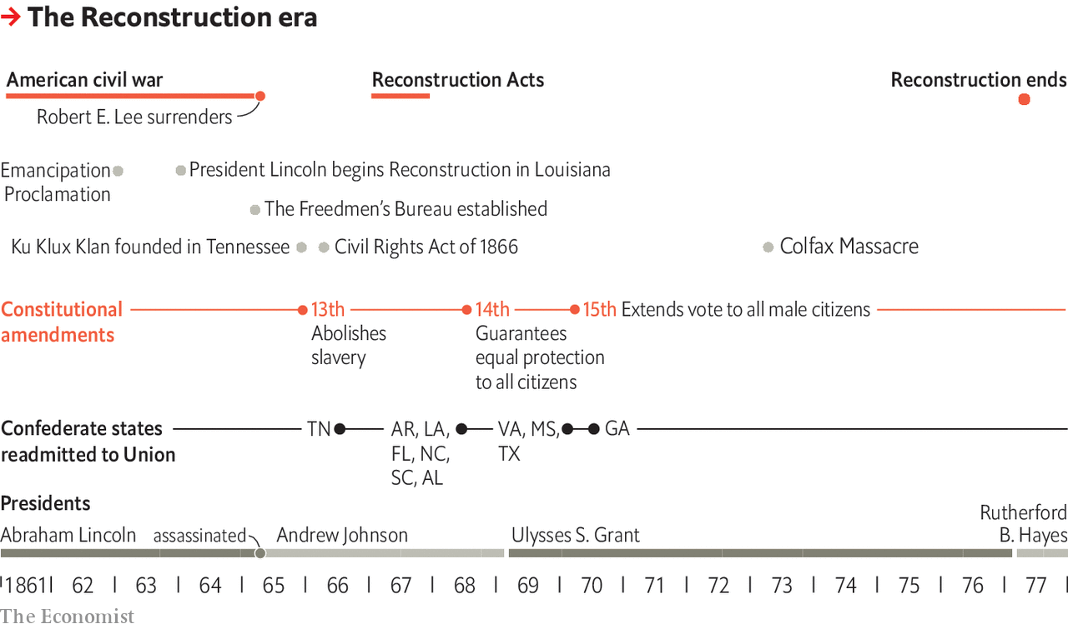

Almost a year after the Emancipation Proclamation took effect, Lincoln released his Proclamation of Amnesty and Reconstruction. This moderate plan promised readmission to Confederate states once 10% of their voters accepted abolition and swore loyalty to the Union. Once readmitted, states could draft new constitutions, form new governments and send federal representatives to Washington, DC.

The radical wing of Lincoln’s party abhorred the plan. Wendell Phillips, an abolitionist, said that it “frees the slave and ignores the Negro”, meaning that it made no provisions to aid the formerly enslaved, and said nothing about suffrage. But the border states also bristled; as Mr Foner notes, some Marylanders “felt compelled to deny that voting for abolition implied ‘any sympathy with Negro equality’”. This was not unusual; for many, abolition did not entail a belief in actual racial equality, just opposition to slavery.

Radical Republicans hoped that Andrew Johnson, who ascended to the presidency after Lincoln’s assassination in 1865, would hew more closely to their view that Reconstruction required more than just emancipation. They were disappointed. Johnson, a Democrat whom Lincoln made his running-mate on a unity ticket, disliked “slaveocracy”. He was also a bigot and a poor politician, and led his party to defeat in the elections of 1866 and 1867.

Though Radicals never made up a congressional majority, they held strong convictions and voted together while others wavered. They demanded full civil rights for freedmen, which few moderate Republicans did, and opposed compensating slaveholders. They also opposed any accommodation to slavery, such as the measures that would have preserved the Union at the cost of allowing slavery in newly admitted states.

After the 1867 elections, with Johnson weakened and Republicans holding a congressional majority, the Radicals’ solidarity put them in charge of Reconstruction policy. The most prominent among them was Thaddeus Stevens, a congressman from Pennsylvania. He saw the former Confederacy as conquered territory and believed “the whole fabric of southern society must be changed, and never can it be done if this opportunity is lost.” The Radicals divided the South into five military districts. They required the states to write new constitutions; ratify the 14th amendment, which granted citizenship to anyone born on American soil or naturalised in the United States; and allow black men to vote.

In the South, black political mobilisation was already under way, having begun before the war’s end. During Reconstruction, black electoral turnout often approached 90%. Former Confederate states elected over 2,000 black state and local officials and 185 black federal elected officials, including two senators from Mississippi (Hiram Revels and Blanche Bruce) and 14 members of Congress, with the largest number coming from South Carolina. Louisiana’s first and still only black governor, P.B.S. Pinchback, took office in 1872.

African-Americans in the South did not only vote for and seek office. Alongside white Republicans, they also rewrote their state constitutions, which as well as doing away with racially discriminatory laws also expanded state responsibility and civil liberties. Some established the South’s first state-funded schools and made attendance compulsory. Others opened state-run orphanages and asylums, reduced the number of crimes punishable by death, recognised a wife’s property rights independent of her husband and, in one state, authorised divorce.

The constitutional conventions and sizeable number of black elected officials were the fruits of rising black political mobilisation. Much like the civil-rights activists of the mid-20th century, they advocated for equal rights, and called on America to live up to its stated ideals. As one Alabama convention proclaimed, “We claim exactly the same rights, privileges and immunities as are enjoyed by white men...The law no longer knows white nor black, but simply men.”

## Pastoral scene of the gallant South

Northerners, both black and white, came south to organise, teach and help. Many of the newly emancipated joined branches of the Union League, a Republican-affiliated organisation. Others formed and joined organisations of their own. They built schools and churches, and advocated for land reform. As W.E.B. Du Bois, a sociologist and civil-rights activist, noted in his magisterial “Black Reconstruction in America”, “Black folk wanted two things—first, land which they could own and work for their own crops...In addition to that, they wanted to know...They were consumed with curiosity at the meaning of the world.”

Freedmen’s desire for land made sense. They and their families had cleared and worked it without recompense, giving them a moral claim, and there was plenty of it. Much of the South was sparsely populated, and the war left many planters devastated and without the free labour that built their wealth. Mississippi and Louisiana auctioned off land in small parcels. But most states did little.

The new constitutions did not resolve every question that they raised. Most took no position on whether state-run schools should be integrated, though in every state, African-Americans opposed separating black and white pupils into different schools. Some used racially neutral language to facilitate discrimination. Georgia required jurors to be “worthy and intelligent”—subjective terms that permitted local officials to bar African-Americans from juries. This pattern—broad agreement on principles, but backsliding over implementation—was a hint of the problems to come.

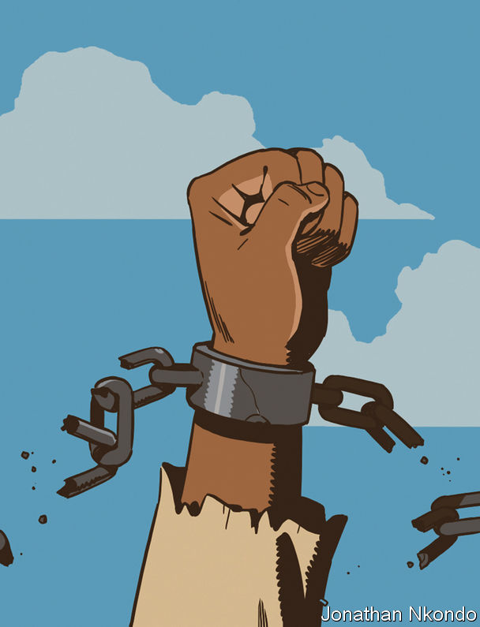

Recalcitrant white Southerners also fought against Reconstruction in three main ways. First, they aligned with moderate Republicans, who were less insistent on sweeping social changes than the Radicals. This cleaved southern Republicans in two camps, leaving the Radicals isolated, and brought Democrat-backed moderates into power across much of the South in the 1860s. And then, in the aftermath of the war, southern legislatures passed an array of “Black Codes” that curtailed freedom for the newly emancipated. These codes authorised arrest and forced labour for pseudo-crimes such as “vagrancy” and “malicious mischief”.

Mississippi required African-Americans to hold written proof of employment for the year. Any worker who left his employer before year’s end would forfeit wages and be subject to arrest. South Carolina barred African-Americans from any job other than farmer or servant unless they paid a “tax” of up to $100 (over $1,600 today). In both cases these Black Codes did not take effect—the robust federal presence imposed by the Radicals and protests from Congress prevented it. But they indicated the depth of southern white opposition to racial equality, presaging the practices that came to be known as “Jim Crow” laws.

White Southerners also embarked on a campaign of racist terrorism, led by groups such as the Ku Klux Klan. Nowhere in the South did African-Americans escape terror’s shadow. The terrorists were not, as legend maintained for decades, poor, uneducated whites, but as a newspaper editor from North Carolina remarked, “men of property [and] respectable citizens”. State and local governments did little to stop the violence, which made them look weak and ineffective—a shared goal of the terrorists and the Democrats.

The elections of 1872 returned Republicans to power in the White House and across much of the South. But Radical power was waning. Soon after winning re-election, President Ulysses Grant’s support for their policies grew tepid. In the next presidential election, Reconstruction was not part of Republicans’ platform; their candidate, Rutherford Hayes, promised to restore “honest and capable local self-government” to the South if elected. The threat of terrorism left many southern Republicans, as one from Mississippi complained, feeling “helpless and unable to organise”.

Hayes’s opponent was Samuel Tilden, the Democratic governor of New York, who like Hayes was not terribly popular. The election’s results were disputed, marred by widespread violence and accusations of corruption. While Congress set up a commission to settle the dispute, Hayes’s moderate Republican allies began negotiations with Southern Democrats. The two sides struck a bargain, the terms of which remain unknown, but which resulted in Hayes’s inauguration, and an end to federal support for Reconstruction. This left the South, as a black Louisianan noted, in “the hands of the very men that held us as slaves”.

## Here is a strange and bitter crop

Many black Southerners feared that “Redemption”, as whites called the end of Reconstruction, would lead to their re-enslavement. The 13th amendment, which outlawed slavery, prevented that—but only just. Men convicted of the flimsiest of crimes were leased to agricultural and industrial projects and forced to work without pay. Debt peonage kept rural African-American families bound to planters and merchants.

The 15th amendment barred explicitly denying black people the right to vote. Yet literacy requirements or poll taxes were often imposed in a racist way. An African-American could be deemed unfit to vote, for instance, if he failed to tell a white county clerk how many bubbles were in a bar of soap. When such tests failed, whites could always resort to violence without fear of conviction by all-white juries. By the mid-20th century, just 7% of Mississippi’s black adult population was registered to vote.

Denial of the franchise led to a decline in the number of black officials. By the turn of the 20th century, Congress had just one black member: George Henry White of North Carolina, who left office in 1901 after his state, like the rest of the South, enacted laws restricting black suffrage. After Blanche Bruce of Mississippi left office in 1881, 86 years would pass before the next African-American—Edward Brooke of Massachusetts—served in the Senate. Not until 2013 would two elected African-Americans (Tim Scott of South Carolina and Cory Booker of New Jersey) serve in the Senate together. After John Lynch lost in 1882, it took almost a century for Mississippi, America’s blackest state by share of population, to elect another black congressman, Mike Espy. After P.B.S. Pinchback left office in 1873, America would not see another black governor until 1990 when Virginians elected Douglas Wilder.

For years, the prevailing historical interpretation of Reconstruction—known as the Dunning School, after William Dunning, a professor who propounded it in the early 20th century—argued that it failed because black Southerners, in his words, “exercised an influence in political affairs out of all relation to their intelligence”. In this view, slavery was not an inexcusable evil and a betrayal of America’s founding ideals, but “a modus vivendi through which social life was possible…[between] two races so distinct in their characteristics as to render coalescence impossible.”

By placing the blame for Reconstruction’s failure on African-Americans, the Dunning School justified Jim Crow and legal segregation. It also undergirded the “Lost Cause” mythology propounded by the defeated South, which argued that it waged a defensive struggle against a tyrannical invader rather than an offensive war (the South fired the civil war’s first shot) for the right to enslave others. Part of the cost of reconciliation was that in the decades immediately following Reconstruction’s end, the civil war came to be seen as a battle between equally brave soldiers now at peace with each other, rather than, as Douglass wrote, “a contest of civilisation against barbarism”.

Du Bois’s study of Reconstruction, published in 1935, took aim at the Dunning School. Du Bois argued that Republicans and black Southerners laid the groundwork for a new and more activist conception of the state. They were the principal agents, politically and intellectually, of their own liberation. It was not their corruption or unpreparedness that condemned Reconstruction; it was implacable white opposition to democracy and devotion to racist rule backed by violence. That view, built upon by Mr Foner and others, now predominates.

Even so, some of the battle lines drawn by Reconstruction remain. President Donald Trump’s exploitation of white racial grievance echoes that of the Redeemers, as does his fondness for Confederate iconography. Some on the right, including Mr Trump, oppose birthright citizenship. Revanchist white Southerners spent a century keeping African-Americans from voting, in defiance of the 15th amendment; as recently as 2013, Republicans in North Carolina tried to pass a voter ID law that “target[ed] African-Americans with almost surgical precision”, in the words of the judge who struck it down.

Although Reconstruction was a failure, it shaped the country in positive ways. After the civil war ended, the newly emancipated formed their own political organisations and churches—the latter of which would come to play a central role in the civil-rights movement of the mid-20th century and beyond. States such as Georgia, which had no state-funded school system before Reconstruction, would retain it after Redemption, though not until 1954 would the Supreme Court bar racial segregation in schools. The 14th amendment’s Equal Protection Clause—which forbids “any State [from denying] to any person within its jurisdiction equal protection of the laws”—has been used to abolish segregated schools, anti-miscegenation rules and other racist laws.

Still, anyone who believes in American ideals will find it difficult to ponder Reconstruction’s unfulfilled promise without grief and anger. The lament with which Du Bois ends his masterpiece remains sadly true today: “If the Reconstruction of the Southern states, from slavery to free labour, from aristocracy to industrial democracy, had been conceived as a major national programme of America, whose accomplishment at any price was well worth the effort, we should be living today in a different world.” ■

This article was downloaded by calibre from <https://www.economist.com/christmas-specials/2020/12/19/reconstruction-reshaped-america-along-lines-contested-today>

|  |  |  |  |
| --- | --- | --- | --- |
| 上一项 | 文章 | 章节 | 下一项 |

|  |  |  |  |
| --- | --- | --- | --- |
| 上一项 | 文章 | 章节 | 下一项 |

#### Military deception

# Democracies need to re-learn the art of deception

Although countries continue to spy, propagandise and sabotage, military deception appears to be declining

Dec 19th 2020 |



FIVE HUNDRED dummies descended on the French coast on the night of June 5th 1944. The crack of gunfire sounded from each one, courtesy of a small pyrotechnic device. As they thumped to the ground, explosive charges mimicked paratroopers setting their parachutes ablaze. The hessian invaders were the vanguard of a phantom army, the most ambitious conjuring trick in military history.

The Allied powers wanted to invade France, but did not want Germany to know where or when. So they put George Patton, a real general, in charge of the First United States Army Group, a made-up unit. The deception campaign was named Bodyguard, a sly reference to Winston Churchill’s remark that: “In wartime, truth is so precious that she should always be attended by a bodyguard of lies.”

Wooden landing craft, inflatable tanks and fake radio traffic hinted at a landing in Pas-de-Calais, some 300km (186 miles) from the Normandy beaches where the real troops would land. Set designers constructed a mock fuel depot in Dover, lent an air of authenticity by visits from King George and Dwight Eisenhower. An actor resembling General Bernard Montgomery, commander of the Allied land forces, was sent to North Africa to show that nothing was afoot. The trickery worked. Germany was taken by surprise on D-Day. Weeks later it still believed that Patton’s imaginary force was poised to strike elsewhere.

Deception is still practised in war. In its conflict with Azerbaijan, Armenia has bamboozled drones with dummy missiles. During a stand-off with India, China published images of missile launchers that, on closer inspection, turned out to be wobbly inflatables. Indian and Chinese forces alike covered equipment with multispectral nets, which block visible light and other electromagnetic emissions. Engineers keep working on new gadgets. BAE Systems, a defence firm, boasts that its Adaptiv camouflage—a set of thermoelectric tiles that change temperature to match their surroundings—amounts to a “cloak of invisibility”.

But the operatic legerdemain of D-Day seems unlikely to be repeated. “Deception in the West has become something of a lost art,” laments General Sir Richard Barrons, who commanded Britain’s joint forces until 2016. “We’ve done some of these things in the past, like in World War II for example,” reflected General Charles Q. Brown, the head of America’s air force, in December 2019, “but it’s not something that we think about as much anymore.” The last major American effort was in the first Gulf war, when America tricked Saddam Hussein (and its own sailors) into expecting an attack from the sea. That comparatively simple feint involved showy amphibious exercises and the use of agents to spread misleading stories.

Although countries continue to spy, propagandise and sabotage, military deception—meaning fooling adversaries into doing things that harm their interests—appears to be declining. Three developments are to blame. Material factors have trumped human ones in war, technology has improved, and liberal democracies have become squeamish.

Modern war is a profession, waged by complex machines and officers capable of wielding them. By contrast, deception is closer to an artistic enterprise. It was zoologists, equipped with the lessons of animal colouration, and artists, inspired by Cubism and its shattering of perspective, who developed the avant-garde patterns of early camouflage. The most striking was the zebra-like dazzle applied to warships during and after the first world war, which obscured their speed and heading. Pablo Picasso claimed credit for the French army’s adoption of camouflage.

During the second world war, Britain’s Camouflage Development and Training Centre gathered what Peter Forbes, author of “Dazzled and Deceived: Mimicry and Camouflage”, calls “a strange medley of characters”, including architects, naturalists, Surrealist painters and a magician. In America, a “Ghost Army”, whose work was classified until 1996, hired actors and artists to generate special effects on the battlefield, such as speakers to simulate the sound of approaching tanks. Many went on to careers in art and fashion, says Jennifer McArdle of the Centre for a New American Security, a think-tank in Washington, DC.

But melding such madcap experimentation with the discipline and order of military culture is difficult. The ending of national service and conscription in most large Western armies has deepened the fissure between military and civilian life. And America’s sheer power has led it to a direct way of war. “The US has the tendency to use technology and brute force in the absence of creativity,” says Ms McArdle.

At the same time, technology has made grand ruses harder to sustain. Warfare is increasingly “a competition between hiding and finding”, noted Britain’s chief of defence staff in September. The ability to find has advanced considerably. Satellites and drones gaze down, antennae-laden soldiers and vehicles hoover up electronic emissions and amateur plane-spotters track military movements on social media.

Had today’s commercial satellite industry existed 30 years ago, Saddam could have purchased high-resolution images that would have revealed American troops massing on his border. And today’s sensors see details that human eyes miss. A thermal infrared camera on a drone can easily tell a cool rubber decoy from a hot metal tank; long-wavelength infrared sensors can detect buried weapons by the different reflectance of disturbed soil. Even sophisticated decoys could become vulnerable to machine-learning algorithms that, fed with sufficient examples, tease out anomalies too subtle for a human analyst to spot. And a deceiver must successfully deceive in more ways. Conjuring a phoney battalion now requires generating not only fake radio traffic but also social-media activity.

Would-be deceivers can also invest in technology, perhaps by putting temperature-changing tiles on tanks. But human errors are a perennial problem. “If a soldier gets bored and walks out from their position with thermal screens to go to the toilet, an enemy will find it very amusing to suddenly have someone appear from nowhere,” says Jack Watling of the Royal United Services Institute, another think-tank. Western armies are particularly dependent on radio communications, he says, leaving a tell-tale map of electronic signatures.

Yet some of the old ruses still work. As late as 1999, during the war over Kosovo, when NATO jets flew at high altitudes to avoid being shot down, Serbia showed that they could be fooled into wasting bombs on fake tanks. Russia’s forces have platoons that spray smoke and aerosols designed to block ultraviolet, infrared and radar. And as BAE’s Adaptiv shows, active camouflage is improving.

Instead of achieving security through obscurity, the best hope for modern deceivers may be to drown their pursuers in noise, forcing them to waste expensive precision weapons on cheap decoys. Flocks of drones and ground robots might spew forth electromagnetic emissions, challenging enemy sensors to pick the wheat from the chaff. Armies might even seek to exploit what is called “adversarial” artificial intelligence to generate camouflage patterns and designs that confound object-detection algorithms.

## Little green men

The biggest problem is not that brute force is supplanting artistry, or that technology is denuding secrecy. The complaint heard most often in Western armies is simply that rivals have more of a stomach for deception. Perhaps, they suggest, open societies that prize the rule of law and transparency at home are inherently less good at trickery.

European and American military officials describe Russian and Chinese practices with a mixture of distaste and envy. Whereas America’s use of decoys “is currently at a low after two decades of neglect”, notes Walker Mills, an officer in the US Marine Corps, China has invested in them, including a 35kg tank that fits in a backpack and inflates in four minutes. One report by America’s army says that Chinese forces “have the highest fidelity decoys seen to date”.

The laws of armed conflict are fairly clear about battlefield deception. Whereas “perfidy” (such as faking surrender to lure an enemy into an ambush, or disguising a tank as a Red Cross ambulance) is forbidden, “ruses” like decoys, feints and ambushes are fair game. But other laws can be bent or bypassed. Russia snatched Crimea from Ukraine in 2014 by cleverly using unmarked personnel—the so-called little green men—and a synchronised blitz of disinformation. The entire campaign was a deception: an invasion masquerading as a nationalist uprising.

Western armies want to catch up, in some ways at least. “We’ll re-learn deception,” promises General David Berger, head of America’s Marine Corps, who is reforming his force to better evade Chinese sensors in the Pacific. But this cuts against the grain. “There’s a cultural problem here,” says a veteran CIA officer who specialised in deception. “I do think you’ll find generals who would feel that it’s fundamentally not a very respectable activity.”

Such anxieties point to a deeper fear that despotic rule-breakers will steal an edge. In 1943 Britain tricked Germany into believing that the Allies would invade Greece by dressing a dead homeless man as a Royal Marines officer and releasing the corpse, stuffed with misleading orders, onto the coast of neutral Spain. “We’d still be prepared to use a dead enemy soldier,” says a NATO officer. “But the Russians and Chinese would be prepared to kill him to do it.” ■

This article was downloaded by calibre from <https://www.economist.com/christmas-specials/2020/12/19/democracies-need-to-re-learn-the-art-of-deception>

|  |  |  |  |
| --- | --- | --- | --- |
| 上一项 | 文章 | 章节 | 下一项 |

|  |  |  |  |
| --- | --- | --- | --- |
| 上一项 | 文章 | 章节 | 下一项 |

#### Pleistocene Park

# One Russian scientist hopes to slow the thawing of the Arctic

Sergei Zimov is a polarising figure, but the results from his Pleistocene Park seem promising so far

Dec 19th 2020 | CHERSKY

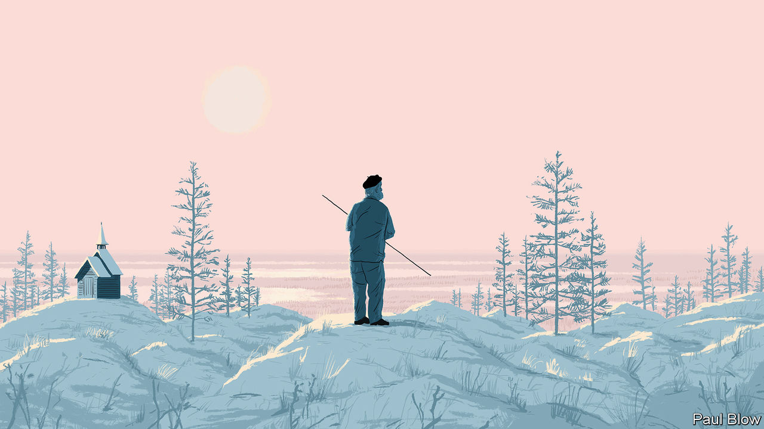

PERCHED ON top of a cliff on the northern edge of Russia, Sergei Zimov doffs his beret, letting his long grey hair tumble down his back. His eyes glow as he leans his weathered face toward the frozen ground. Under the haze of never-ending northern days, he looks like a figure lifted from the golden background of a Russian Orthodox icon.

Mr Zimov, whose name comes from the Russian word for “winter”, lives with his wife Galina in a simple wooden house outside Chersky, an outpost in Russia’s outer reaches, farther north than Reykjavik and farther east than Tokyo. Inside their home, woolly-mammoth tusks lie scattered across the bedroom floor. The Kolyma river beckons from the window. This is a land unsuited for human life, where temperatures dip below minus 50ºC in winter and where mosquitoes blacken the skies in summer. “To be a prophet, you must live in the desert,” says Mr Zimov.

In the Soviet era, few travelled down the Kolyma of their own volition. The region had a reputation as one of the harshest, iciest corners of the gulag. By the time the Zimovs moved there in 1980, the camps had shut down but the frost remained. For the first few years, they lived without electricity, using kerosene lamps and drawing water from the river. Chersky’s remoteness had its benefits. “We felt very free here,” Galina says, away from the eyes of the Communist Party. Drawing on a degree in geophysics and a contrarian spirit, Mr Zimov co-founded the Northeast Science Station (NESS) for Arctic research, and began a lifetime of studying the far north.

In the mid-1980s, he predicted that the Soviet Union would collapse. He stocked up on supplies. “When there’s a drought, the farthest branches dry up first,” he explains. He boasts of other premonitions, such as the oil-price crash in 2014. He tells anyone who will listen to invest in gold.

## Kolyma tales

But it is the ecological apocalypse that worries Mr Zimov most. For more than 20 years, he and his son, Nikita, have been populating a stretch of 160 square km (62 square miles) that they call Pleistocene Park with yaks, horses, sheep, oxen and other grazing animals. Mr Zimov reckons the beasts will uproot and trample the shrubs, moss and larch trees that cover the area, clearing the way for grasslands of the kind that spread during the Pleistocene epoch, the glacial geological period that began 2.6m years ago and ended 12,000 years ago. He argues that this will slow the thawing of permafrost, a process that leads to the release of greenhouse gases that could accelerate climate change. “I am building an ark,” he says, describing his project in grand metaphorical terms—and without a hint of irony.

Nearly one-quarter of the Northern Hemisphere, an area twice the size of America, sits on top of ground made up of soil that remains frozen for at least two years at a time. One 18th-century explorer described iron spades breaking when they hit it. Mikhail Sumgin, a Soviet-era scientist who pioneered the study of the frozen earth, often referred to it as “the Russian sphinx”. The technical term for it, permafrost, is a translation of Sumgin’s Russian turn of phrase, vechnaya merzlota, or the eternal frost.

It is not as permanent as once believed. While Earth is warming at an alarming speed, the Arctic is warming more than twice as fast. Across the region, the ground is beginning to give way, warping roads, buildings, pipelines, coastlines and river banks.

The damage to infrastructure and livelihoods above ground is worrying enough. But another danger lies below the surface: rich deposits of organic material, such as old plant roots and animal carcasses, which have been preserved in the ice over millions of years. When permafrost thaws, that organic material turns into food for microbes, which convert it into carbon dioxide and methane. Those gases accelerate the planet’s warming, which speeds the thawing of permafrost, a feedback loop with potentially disastrous consequences. “We can get off fossil fuels, we can stop chopping down trees, but with permafrost it’s a secondary effect,” says Robert Max Holmes, deputy director of the Woodwell Climate Research Centre, an American think-tank. “It’s not anything we’re doing directly, and that makes it far harder to control.”

## Cold as ice

Northern permafrost contains as much as 1,600bn tonnes of carbon, or twice as much carbon as is currently found in the atmosphere and three times as much as is locked in the world’s forests. That carbon pool is often referred to as a “bomb”, but permafrost behaves more like a leaky pipe. How much and how fast the pipe will leak depends on myriad factors—not least humankind’s willingness to reduce its own greenhouse-gas emissions.

Estimates vary widely. Some argue that if climate-change mitigation efforts succeed, permafrost could sequester more carbon than it releases; others see permafrost becoming a net emitter, albeit a tiny one compared with human beings. But if humans continue spewing greenhouse gases at current rates, widely accepted models predict that 5-15% of the permafrost’s carbon reserves could be released this century, increasing global warming by as much as 0.27ºC. To even have a chance of limiting global warming to 1.5ºC above pre-industrial levels, the Intergovernmental Panel on Climate Change, a UN body, gives society a carbon “budget” of 580bn tonnes; the emissions from permafrost could use up roughly one-quarter of that amount.

Even the best estimates struggle to capture the complexity of how permafrost thaws, a process researchers are only beginning to understand. Most climate scientists’ models assume that it will thaw evenly, a few centimetres at a time over decades across vast areas, a process known as “gradual thaw”. But permafrost experts also worry about melting pockets of ice causing rapid erosion, or “abrupt thaw”. Landscapes collapse and sinkholes open up, exposing layers of permafrost with richer stores of carbon to ever warmer temperatures. Water can also pool in those collapsed areas, forming “thermokarst” lakes above layers of unfrozen soil. Such environments tend to attract microbes that produce methane. The more permafrost is studied, the more scientists find “surprises out there that we don’t know enough about”, says Ted Schuur of Northern Arizona University.

Along the river south of Chersky, Mr Zimov demonstrates how different some parts of permafrost are from one another. The permafrost’s structure here is more honeycomb than layer-cake. Rather than melting evenly across a flat service, water drips between and forms ice around polygon-shaped cores. When the ice begins to thaw, it exposes the gaps between the pylons, leaving the ground looking like a mogul course on a ski slope. Mr Zimov compares the process to “cracks spreading in clay, or on the canvases of Old Masters”.

Few people have done more to unravel the riddles of the Russian sphinx. “Every scientist now appreciates the importance of the carbon in the permafrost,” says Mr Holmes. “A lot of that can be traced to Zimov.”

In 1993 Mr Zimov and a group of Russian co-authors published a paper in the American Geophysical Union’s Journal of Geophysical Research, arguing that carbon was escaping from Arctic permafrost’s active layer in the winter, not just in the summer, as previously believed. Scientists began travelling to Chersky to conduct their own research. Together with a group of American collaborators, Mr Zimov published a series of papers showing that permafrost contained far larger stores of greenhouse gases than previously thought. “Every time we talked to Sergei about something that just seemed off the wall, sooner or later he’d convince us,” says F. Stuart Chapin, an ecologist at the University of Alaska Fairbanks, and one of his co-authors.

Mr Zimov also privatised the NESS and built it into a global hub. Managing an international research station in the Arctic presents a logistical challenge in the best of circumstances. In post-Soviet Russia, it required a combination of resourcefulness and wiliness. Bruce Forbes of the Arctic Centre at the University of Lapland recalls “post-apocalyptic scenes of kids setting fire to abandoned buildings for fun” during a visit to Chersky in the 1990s. “At the time he went to that place, it was the end of the world,” says Vladimir Romanovsky, head of the Permafrost Laboratory at the University of Alaska Fairbanks. “He turned it into one of the best research stations in the permafrost area.”

Nonetheless, Mr Zimov remains a polarising figure. His brusque demeanour has alienated many. “My father is not a very diplomatic man,” Nikita sighs, with the weight of experience. His brash persona and wild theories about the wider world can overshadow his scientific insights. Mr Zimov hails from a scientific tradition in Russia that tends towards grand, sweeping theories that span disciplinary boundaries. He evokes early 20th-century Russian polymaths, such as Vladimir Vernadsky, who made pioneering advances in geochemistry, developed the concept of the biosphere and embraced Russian Cosmism, a movement that sought to cure death and conquer the stars. Mr Zimov tends to begin from his ideas and to measure only enough to persuade himself that he was right. “He’d be fine with a sample size of one,” says Mr Chapin. That can unsettle Western scientists, who place a premium on data and who operate within hyper-specialised fields.

What Mr Zimov lacks in rigorous data, he just about makes up for with a deep engagement in the environment. At one of his test sites downriver, he taps the earth with a long metal pole to show where permafrost begins. He can tell what state the ground is in by the sound it makes. In 2018 the Zimovs observed that the active layer of permafrost was no longer freezing over in the winter. The average temperature at their test sites was eight degrees warmer than just a decade ago, rising from -6ºC to +2ºC. Across the Bering Strait in Alaska, Mr Romanovsky has been observing similar phenomena at dozens of sites.

To peek underneath the active layer, Mr Zimov travels a few hours downriver to a site called Duvanny Yar. A sulphurous stench fills the air. Millions of years of geological history stand exposed along the river. Mr Zimov picks up a bone: “Mammoth.”

Back when woolly mammoths roamed Earth, the far north resembled a modern-day African Savannah. Thick grasslands stretched across Siberia, Alaska and the Canadian Yukon, where herds of herbivores grazed. Along with mammoth, there were bison, horses, elk and reindeer. Wolves and cave lions kept the populations in check. Yet as the Pleistocene gave way to the Holocene, the large herbivores died out. And as they disappeared, the landscape was transformed. The dry grasses turned into wet, mossy tundra.

One long-standing explanation for the mass extinction holds that the warming climate was the culprit. Mr Zimov, however, believes that the milder climate only facilitated the arrival of the true villains. Writing in American Naturalist in 1995, he argued that human hunting led to the extinction of the megafauna throughout the far north.

As Mr Zimov sees it, reversing that process and reviving the grasslands could be the key to preserving permafrost. Doing so would mean reintroducing large mammals that could tamp down moss, knock down trees, and churn up the soil, allowing the grass to flourish again. Grass could reflect more light and reduce the amount of heat absorbed by the soil; it could also capture more carbon in its roots than today’s flora.

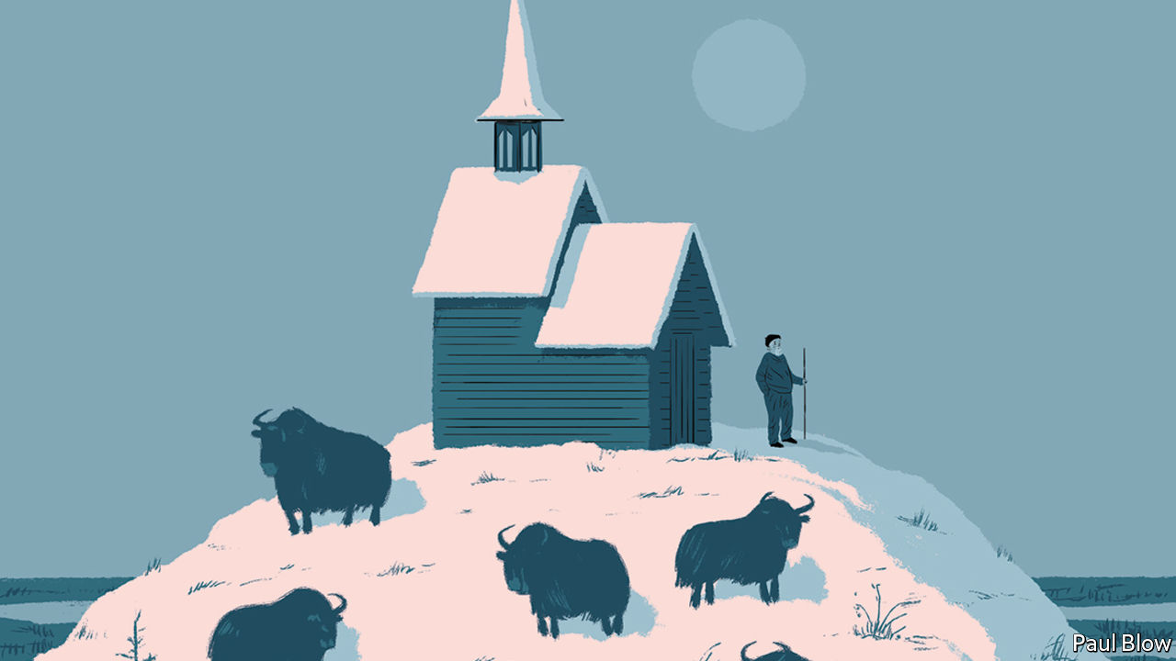

That logic underlies Pleistocene Park. Mr Zimov wants to extend the park through Alaska to Canada. He and his son even dream of hosting woolly mammoths one day, and have formed a partnership with George Church, of Harvard University, who hopes to revive the ancient beasts using CRISPR gene-editing technology.

Several aspects of Mr Zimov’s theories seem to hold up, though they may appear paradoxical. Take the trees he wants to eradicate. In temperate regions, trees sequester carbon, and cutting them down releases it into the atmosphere. In the far north, more carbon is stored below ground than in the sparse forests. Removing trees there could have a net positive effect by keeping permafrost cooler and preventing the organic material trapped in it from breaking down. So, too, with the warming effects of snow, which Mr Romanovsky calls “a huge insulator”. At his test sites around Fairbanks, thick winter snow can raise ground temperatures by between three and five degrees. Mr Zimov reckons the animals could also help to pack down the snow in the winter, reducing that effect.

## The ark of history

Results from Pleistocene Park are promising. The current mixture of Yakutian horses, bison, musk oxen, elk, reindeer, sheep, yak and Kalmyk cattle have helped grasslands re-emerge. Average annual soil temperatures are 2.2°C cooler in grazed areas. More carbon is also being sequestered in the upper layer of soil in those areas, too.

For advocates of radical rewilding, the Zimovs suggest a tantalising sense of possibility. “The issue now is scaling,” says Mr Forbes of the University of Lapland. “How many animals would you actually need?” A group of researchers from the University of Oxford, working with Nikita, published a study in 2020 that concluded that rewilding the Arctic to a degree that would have a major impact on emissions would be a “mammoth task”. It would mean reintroducing thousands of animals and would need support from governments and residents. A ten-year feasibility study involving roughly 3,000 animals would cost $114m.

Some see all this effort and expense as a distraction from the focus on reducing overall emissions, the surest way to keep the planet—and permafrost—from warming. Sceptics wonder whether grasslands will work to preserve permafrost, or whether the grazing animals will not have other side-effects, too.

The Zimovs remain determined to continue. Their operations depend largely on their sheer force of will. Nikita once raised more than $100,000 through crowdfunding to bring a herd of 12 bison to the park, driving them himself from Denmark to Chersky, where they arrived on a barge just after midnight one night in mid-June 2019, when your correspondent was visiting.

After the bison were released, the Zimovs retreated to the mess hall of the research station to celebrate. They poured a round of samogon, a potent Russian homebrew, and toasted the animals’ health. (All the bison survived their first winter.) Mr Zimov stepped outside to smoke, taking a seat below the giant satellite dish that has crowned the station since Soviet times. “Before it was for connecting with the Party, now it’s for connecting with God,” he laughs, pointing to the dish. “God is sending us signals: gather the animals.” ■

For more coverage of climate change, register for The Climate Issue, our fortnightly [newsletter](https://www.economist.com/theclimateissue/), or visit our [climate-change hub](https://www.economist.com/news/2020/04/24/the-economists-coverage-of-climate-change)

This article was downloaded by calibre from <https://www.economist.com/christmas-specials/2020/12/19/one-russian-scientist-hopes-to-slow-the-thawing-of-the-arctic>

|  |  |  |  |
| --- | --- | --- | --- |
| 上一项 | 文章 | 章节 | 下一项 |

|  |  |  |
| --- | --- | --- |
| Christmas Specials | 章节 | Finance & economics |

Business

Big oil: Brown v broad

.

Cinema and streaming: Big bets on the small screen

.

Bartleby: Straight talking

.

Schumpeter: The parable of Ryanair

.

|  |  |  |
| --- | --- | --- |
| Christmas Specials | 章节 | Finance & economics |

|  |  |  |  |
| --- | --- | --- | --- |
|  | 文章 | 章节 | 下一项 |

#### Brown v broad

# Big oil’s diverging bets on the future of energy

No strategy is foolproof

Dec 19th 2020 | NEW YORK

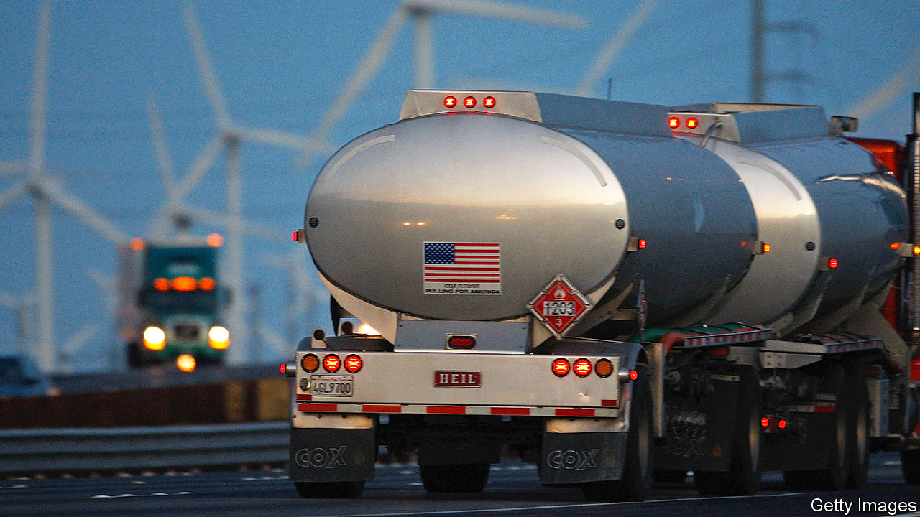

EXXONMOBIL, ONCE the world’s most valuable publicly traded oil company, is not easily swayed. As green investors urged it to develop cleaner energy, it planned instead to pump 25% more oil and gas by 2025. As rivals wrote down billions of dollars in assets, it said its own reserves were unaffected. But in the maelstrom of 2020 even mighty Exxon had to budge. On November 30th it announced a write-down of between $17bn and $20bn, and cuts to capital spending of up to a third in 2022-25, implicitly scrapping its production goal. On December 14th it pledged to cut carbon emissions from operations, if only per unit of energy produced, by as much as 20% within five years.

These declarations are a sign that pressure on ExxonMobil is mounting. It lost half its market value between January and November. Investors have gripes beyond covid-19. In May BlackRock, the world’s biggest asset manager, supported a motion to relieve Darren Woods, ExxonMobil’s chief executive, of his duties as chairman. In December D.E. Shaw, a hedge fund, sent the firm a letter demanding capital discipline to protect its dividend. New York’s state pension fund, America’s third-largest, is considering divesting from the riskiest fossil-fuel firms. California State Teachers Retirement System (CalSTRS), the second-largest public pension fund, backs a campaign to replace nearly half of ExxonMobil’s board. “It’s critical to their survival that they change,” says Christopher Ailman, CalSTRS’ chief investment officer.

Still, Mr Woods hangs on to both jobs. And, for all its latest pronouncements, his firm is betting on its old business, even as European rivals seek to reinvent themselves for a climate-friendlier era. This points to a widening transatlantic rift, as the world’s oil giants try to win back investors after a year when demand for crude collapsed and its future became murkier. Each approach is riddled with risk.

Supermajors’ returns have mostly been middling for years. In the decade to 2014 they overspent, furiously chasing production growth. As shale transformed the oil market from one of assumed scarcity to one of obvious abundance, many struggled to adapt. The return on capital employed for the top five Western firms—ExxonMobil, Royal Dutch Shell, Chevron, BP and Total—sank by an average of three-quarters between 2008 and 2019. In 2019 energy was the worst-performing sector in the S&P 500 index of big American firms, as it had been in 2014, 2015 and 2018.

The past 12 months brought new indignities. All told, the big five have lost $350bn in stockmarket value. They talk of slashing jobs, by up to 15%, and capital spending. Shell cut its dividend for the first time since the second world war. BP said it would sell its posh headquarters in London’s Mayfair. In August ExxonMobil was knocked out of the Dow Jones Industrial Average, after nearly a century in the index. Energy firms’ share of the S&P 500 fell below 3%, from a high-water mark of 13% in 2011.

In 2021 a covid-19 vaccine will eventually support demand for petrol and jet fuel—but no one knows how quickly. Leaders of the world’s two biggest oil markets, China and America, have made it clear they want to curb emissions, but not when or by how much. Petrostates such as Russia and the United Arab Emirates are keen to defend their market share and wary of sustained production cuts that may boost American shale by inflating prices. The Organisation of the Petroleum Exporting Countries agreed in December to raise output modestly in January, but declined to promise further price support.

Further out, expectations vary hugely. Legal & General Investment Management, an asset manager, reckons that keeping global warming within 2°C of preindustrial temperatures may halve oil demand in ten years. That is unlikely, but highlights risks to oil firms. While BP thinks demand may already have peaked, ExxonMobil has expected it to climb until at least 2040, supported by rising incomes and population.

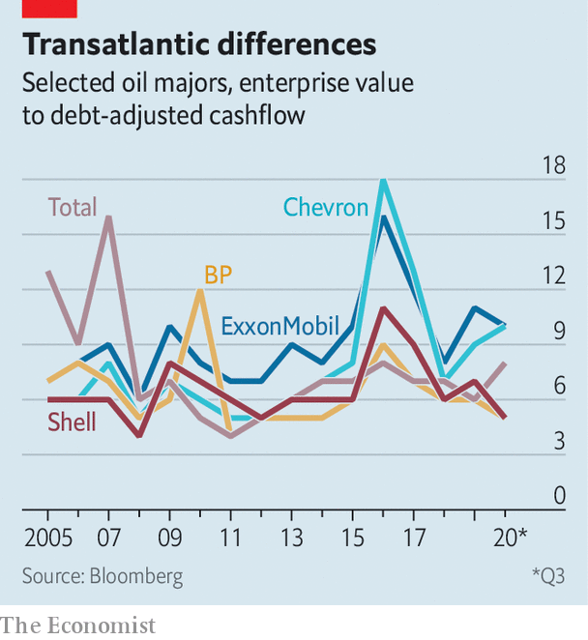

Given all the uncertainty and underperformance, the question is not why investors would flee big oil. It is why they wouldn’t. The answer, for now, is dividends. Morgan Stanley, a bank, reckons the ability to cover payouts explains some 80% of the variation in firms’ valuations. That is a reason why those in America, which have resisted dividend cuts, are valued more highly relative to cashflow than European ones, which succumbed (see chart).

## Well-laid plans

Shareholder returns in the next 5-10 years will be determined by two factors, reckons Michele Della Vigna of Goldman Sachs, another bank: cost-cutting and the management of the old business. Take Chevron, ExxonMobil’s American rival. It has some low-carbon investments but no pretence of becoming a green giant. “We have been pretty clear that we are not going to diversify away or divest from our core business,” Pierre Breber, its finance chief, affirmed in October. Its low-cost oilfields pump out cash. A $5bn takeover of Noble Energy, a shale firm, will help it consolidate holdings in the Permian basin, which sprawls from west Texas to New Mexico. Morgan Stanley expects Chevron to generate $4.7bn of free cashflow in 2020.

This path is not risk-free. If oil demand declines more rapidly than the companies anticipate, they might struggle with a rising cost of capital and stiff competition from the likes of Saudi Aramco, Saudi Arabia’s oil colossus, or its Emirati counterparts. ExxonMobil shows the danger of spending too much on fossil fuels and losing sight of returns. Its free cashflow in 2020 is already negative. The alternative, embraced by European firms, is to increase the efficiency of the legacy business while venturing into new areas.

The challenge for that model, says Muqsit Ashraf of Accenture, a consultancy, is proving they can generate strong returns from their green businesses—and outdo incumbents. Europe’s utilities are already renewables giants. Investors have doubts. When BP vowed in September to ramp up investment in clean energy tenfold and reduce production of oil and gas by at least 40% by 2030, the market saw not a bold leap but a belly-flop. BP’s market capitalisation kept sliding, to a 26-year low in October, until successful vaccine trials pepped up the oil price—and with it energy stocks.

Even in Europe incentives remain muddled. According to CarbonTracker, a watchdog, as of 2019 Shell and BP continued to reward executives for increasing oil and gas output. Shell and Total have set emissions targets that let them increase total production of oil provided their output from renewables and cleaner (though still polluting) natural gas rises faster. Shell sees gas as crucial to efforts to reduce its products’ carbon intensity, and a complement to intermittent power from the wind and sun. In the third quarter its integrated gas business accounted for 22% of cashflow from operations. Total also views the fuel as strategic, with plans to nearly double its sales of liquefied natural gas by 2030. Goldman Sachs calculates that in 2019 low-carbon power accounted for just 3% of BP’s capital spending, 4% of Shell’s and 8% of Total’s.

These figures are rising—even in America, though at a slower clip. Mr Della Vigna predicts that renewable power might account for 43% of capital spending by 2030 for BP and generate 17% of revenues. By 2025 Total plans to increase its installed solar and wind capacity from 5 to 35 gigawatts. On December 15th Norway’s government approved funding for a big project to capture and store carbon that Shell will develop with Total and Equinor, Norway’s state oil company. The prize for gaining scale in green energy is bigger than merely maintaining it in the dirty sort, says one seasoned investor. “But”, he adds, “the risk is also bigger.” ■

This article was downloaded by calibre from <https://www.economist.com/business/2020/12/19/big-oils-diverging-bets-on-the-future-of-energy>

|  |  |  |  |
| --- | --- | --- | --- |
|  | 文章 | 章节 | 下一项 |

|  |  |  |  |
| --- | --- | --- | --- |
| 上一项 | 文章 | 章节 | 下一项 |

#### Made for TV

# Disney and Warner make big bets on the small screen

Hollywood’s biggest studios are staking everything on streaming

Dec 16th 2020 |



IF ANY INDUSTRY could use help from Wonder Woman, it is cinemas. Lockdowns and a dearth of new releases have reduced worldwide box-office takings by about 70% in 2020. Thankfully for theatre owners, the corseted crusader will charge to the rescue on Christmas Day, giving audiences a reason to go back to the movies.

Yet in a plot twist, AT&T, the telecoms giant that owns the film’s producer, Warner Bros, has announced that “Wonder Woman 1984” and the 17 feature films on Warner’s release slate for 2021 will be made available on its HBO Max streaming service on the day they are released in cinemas, which historically have had an exclusive run of a few months. Purists are aghast. “The future of cinema will be on the big screen, no matter what any Wall Street dilettante says,” declared Denis Villeneuve, whose sci-fi epic, “Dune”, is among the affected films.

Warner is not the only studio shifting its focus to the small screen. In July Universal Pictures, part of Comcast, a cable company, did a deal with AMC, the world’s largest cinema chain, to give theatres just 17 days before its films are made available online (AMC will get a cut of streaming revenues). Paramount Pictures, owned by ViacomCBS, has sold several films to Netflix this year rather than release them to empty auditoriums. And on December 10th Disney, Hollywood’s biggest studio, signalled that it, too, sees its future in streaming.

In a presentation to investors the studio announced a blitz of new content for its Disney+ streaming service: ten “Star Wars” series, ten more based on Marvel comic books, 15 other new original series and 15 feature films. By 2024 Disney+ will be spending $8bn-9bn annually on content, up from $2bn in 2020. Add ESPN+, which shows sports, and Hulu, another Disney streaming channel, and the company will splurge $14bn-16bn a year, nearly as much as the $17bn that Netflix, which pioneered streaming, earmarked to spend in 2020.

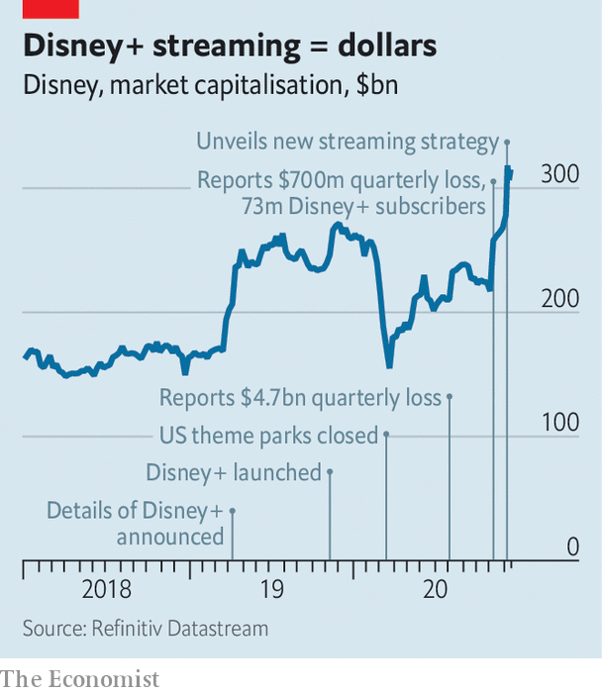

Disney’s “content tsunami” is “frightening to any sub-scale company thinking about competing in the scripted entertainment space”, wrote Michael Nathanson of MoffattNathanson, a media-research firm. The Wall Street dilettantes swooned: Disney’s share price leapt by almost 14% the day after its presentation, reaching an all-time high and adding $38bn to its stockmarket value (see chart).

Disney now expects 230m-260m Disney+ subscribers by 2024—more than treble its previous target. The extra viewers, and a planned price rise, put the service on track to break even in 2024, despite more content spending. Across all its streaming channels Disney expects more than 300m subscribers by 2024—maybe enough to overtake Netflix, currently on 195m. Disney will take Netflix on more directly via a new service, Star, with a wider range of programming, including a new show starring the indefatigable Kardashian clan.

Two months ago Disney began a corporate restructuring to increase its focus on streaming. Since then it has trimmed jobs at ABC News and announced the winding up of its radio business. The plans for Disney+ imply that by 2024 streaming will be the company’s single largest business by revenues, notes Benjamin Swinburne of Morgan Stanley, a bank. Whatever some directors may think, “made for TV” is no longer a slur in Hollywood. ■

This article was downloaded by calibre from <https://www.economist.com/business/2020/12/16/disney-and-warner-make-big-bets-on-the-small-screen>

|  |  |  |  |
| --- | --- | --- | --- |
| 上一项 | 文章 | 章节 | 下一项 |

|  |  |  |  |
| --- | --- | --- | --- |
| 上一项 | 文章 | 章节 | 下一项 |

#### Bartleby

# What if CEOs’ memos were clear and honest?

Straight talking

Dec 19th 2020 |

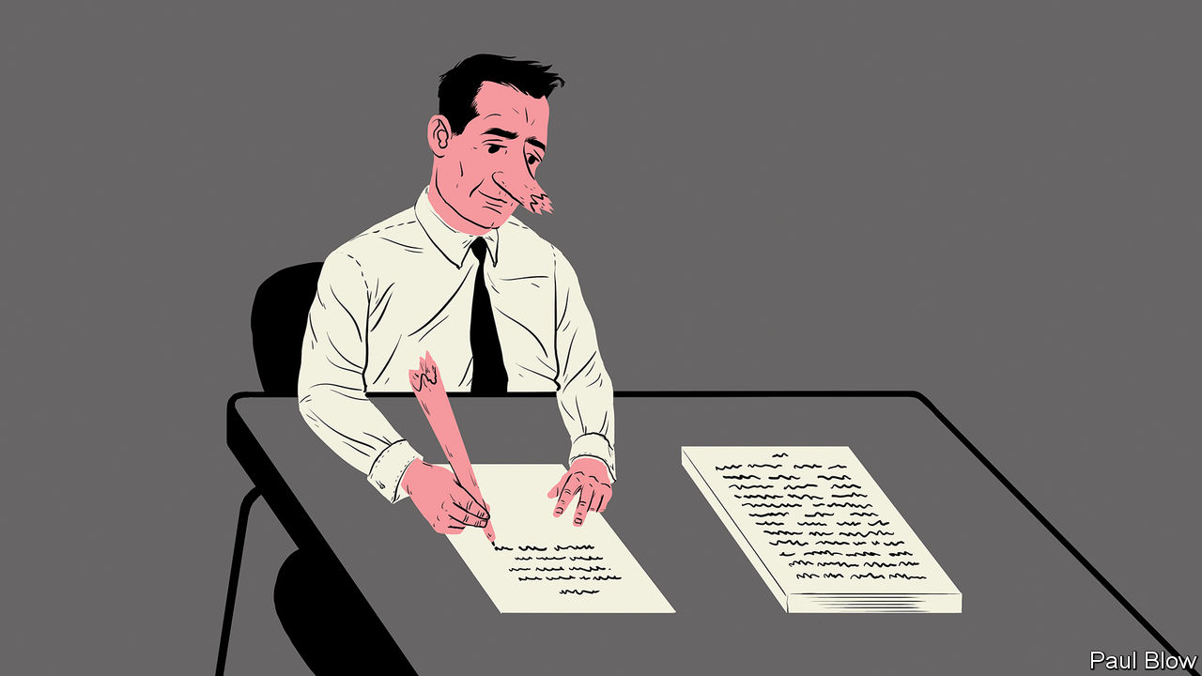

Editor’s note: Some of our covid-19 coverage is free for readers of The Economist Today, our daily [newsletter](https://my.economist.com/user#newsletter). For more stories and our pandemic tracker, see our [hub](https://www.economist.com/news/2020/03/11/the-economists-coverage-of-the-coronavirus)

FOLLOWING THE tragic yachting accident that killed my predecessor, Buck Passer, the board decided on a change of direction at Multinational United Subsidiary Holdings (MUSH). As the new chief executive, I would like to live up to my nickname, “Honest Harry” Hunter and tell it to you straight.

We had a dreadful 2020. To be fair, nobody could have reasonably expected the executive team to predict a global pandemic which resulted in widespread economic shutdowns. But by the same token, if managers aren’t at least partly responsible during the bad times, they shouldn’t take full credit for the good times. Most executives are riding on the backs of central bankers who have slashed the cost of capital and on technology pioneers who have made it easier to transact and communicate.

So, given that my fellow executives took bonuses in the boom years, we are slashing their salaries by half. That will give us more money to save jobs in the rest of the group. This may upset people in the C-suite and prompt some of them to leave. We will miss them—and wish them well finding a new job in the current labour market. We also know that many of you had to keep coming into our factories and warehouses during the pandemic while most of the office staff have been able to work from home. So as budgets are tight, we are making sure that the salaries of those essential workers keep pace with inflation this year. For everyone else, there will be a pay freeze.

Another cost-saving measure will be the elimination of my predecessor’s use of management consultants. I have nothing against the profession, which is full of bright people. But if my executive team needs advice on how to do their jobs, that raises the question of why they were hired in the first place.

What about 2021? There is no point in making economic predictions; the best approach is to clear up the mistakes made in the past. First of all, my predecessor bought too many companies without considering whether they would fit well with the rest of the group. Chief executives like acquisitions: to expand their empires and give them news to announce when they are talking to investors. Time the purchase right and you can boost both earnings and the share price.

But all too often these are vanity purchases, like the middle-aged man who buys a Porsche to reclaim his lost youth. When combining companies, it is possible to make savings in areas like procurement but these are often more than offset by the loss of morale that occurs when managers try to mesh organisations with completely different cultures. So we are not going to make any acquisitions in 2021. Instead, we are going to see if some of our subsidiaries can be spun off as stand-alone organisations. They can probably manage their businesses far better than we can.

Speaking of management changes, too much staff time is taken up by meetings. From now on, team leaders will have a 15-minute catch-up every morning; if there is important news, they can message employees directly. Most of the staff should not be expected to attend an internal meeting more than once a month. That should give them more time to meet the important people, our suppliers and customers, or just to get on with their jobs.

Other changes are required to end the gobbledygook that plagued the previous regime. We will no longer have a “human resources” department: our employees are people, not resources. That section has been renamed personnel. Similarly, the whole concept of a “thought leadership” division is both pretentious and Orwellian; clients are not impressed by this waffle and in order to save money I will shut our unit down.

Finally, there is a lot of talk about corporate purpose, and a lot of grandiose language tends to be used by other executives. So let me tell you the purpose of this business under my leadership. It is to create a company that provides products and services that customers are eager to buy. In turn, that depends on ensuring that our employees are both well-rewarded and committed to their tasks. If we can achieve those goals, then the returns to shareholders will look after themselves.

So enjoy your holiday break—you have earned it. I can’t promise you that things will be better in 2021. But if they aren’t, it won’t be for lack of effort from me or the rest of the management team. Thanks for all you have done this year.

Best wishes,

Harry Hunter

This article was downloaded by calibre from <https://www.economist.com/business/2020/12/19/what-if-ceos-memos-were-clear-and-honest>

|  |  |  |  |
| --- | --- | --- | --- |
| 上一项 | 文章 | 章节 | 下一项 |

|  |  |  |  |
| --- | --- | --- | --- |
| 上一项 | 文章 | 章节 | 下一项 |

#### Schumpeter

# The parable of Ryanair

When David becomes Goliath

Dec 16th 2020 |



Editor’s note: Some of our covid-19 coverage is free for readers of The Economist Today, our daily [newsletter](https://my.economist.com/user#newsletter). For more stories and our pandemic tracker, see our [hub](https://www.economist.com/news/2020/03/11/the-economists-coverage-of-the-coronavirus)

SOMETHING HAS changed since your columnist first met Michael O’Leary, boss of Ryanair, over a no-frills sandwich lunch almost two decades ago. He still talks blarney at supersonic speed. He still rails against an unholy trinity of flag-carriers, governments and regulators. But his tone is different: less cursing (only three “fucks” in an hour) and even a moment of half-joking humility (“I would like to think I have emerged like Scrooge on Christmas morning realising the error of my ways”). Most notably, his views have mellowed about three constituencies which for decades he would reliably berate, if chiefly for publicity purposes: customers (“usually wrong”), unions (“busted flushes”) and environmentalists (“shoot them”).

The reason for this newfound magnanimity, as he explains it, is Ryanair’s size. Bad-mouthing everyone was fine when he led a scrappy upstart fighting flag-carriers lavished with state aid. But now Ryanair is Europe’s biggest airline, worth almost as much as the owners of British Airways, Lufthansa, Air France and EasyJet combined. In 2019 it carried 152m people, comfortably ahead of Southwest Airlines, the American low-cost carrier on which it is modelled. “We have to be more sensible,” Mr O’Leary says.

“Sensible” is a broad term. Ryanair has just put in a huge order for Boeing’s 737 MAX jets, which are only beginning to come back into service after being grounded in the wake of two tragic crashes in 2018 and 2019. It may be one of the rashest moves of Mr O’Leary’s career. Or it could signal that, like any insurgent-turned-incumbent, Ryanair now has a huge stake in maintaining the system it helped create. In effect, by increasing its MAX order from 135 to 210 (admittedly at a hefty discount from Boeing), the airline is betting that within a few years aviation will return to just the way it was before the covid-19 pandemic bludgeoned travel. It is a wager on the preservation of the status quo.

It is not the first time Mr O’Leary has thrown the dice at a time of historic convulsion. The sandwich lunch in 2002 followed Ryanair’s order of 100 Boeing 737-800 jets just four months after the 9/11 terrorist attacks in America. It was a lifeline for Boeing—and made Mr O’Leary a hero in Seattle, the aeroplane-maker’s hometown. It was a roaring success for Ryanair, thrusting it into the big leagues in Europe. In two ways, he is hoping history will repeat itself.

The first is that, if you offer people low-enough fares, not even safety concerns will keep them from travelling. The threat of terrorism did not put off passengers for long. Mr O’Leary is sure the same will happen again following the recertification of the 737 MAX by America’s Federal Aviation Administration in November, and draft approval by European regulators the same month. Ryanair calls the MAX “the most audited, most regulated [aircraft] in history”. Its more numerous seats and lower fuel costs allow Ryanair to make tickets ultra-cheap. Anyone who does not want to board it will be put on a later flight on another aircraft, Mr O’Leary promises. But, he says, “€9.99 [$12] fares will cure an awful lot of customer apprehension.”

Mr O’Leary’s second assumption is that the need to restore Europe’s battered tourism industry, combined with pent-up demand for travel, will mean fewer curbs on airlines, as they did after 9/11. This Christmas and new year Ryanair plans to bombard Europeans with adverts enticing them to fly abroad next summer, capitalising on hopes for the covid-19 vaccine. It assumes that other large carriers, such as British Airways and Lufthansa, will continue to suffer from subdued long-haul and business-class travel, a big source of revenue, reducing their ability to subsidise cheaper flights within Europe for a few years. With hotels, bars and beaches empty, Mr O’Leary thinks that European regulators will be reluctant to push more “anti-aircraft” environmental taxes. As Ryanair takes delivery of more 737 MAXes, by the summer of 2026 it expects to have almost 150 more aircraft flying than it did in 2019. In the meantime, its boss predicts, some European carriers will go bust or be acquired, further consolidating the industry—with Ryanair at the front of the pack.

Not everything will be the same as before. Mr O’Leary admits he was “much too cavalier” in his treatment of customers. These days he is more respectful. He is proud of deals he has struck with pilot and cabin-crew unions, with which he once picked fights. In the pandemic they have mostly taken pay cuts in exchange for keeping their jobs. And he notes that the MAX emits less carbon and less noise than its forerunners, which he hopes will ease concerns among green-minded passengers and people living near runways.

## Be leery

The danger for Ryanair is that a supreme leader who thinks he has seen it all before fails to see that some things may have fundamentally changed—especially on climate change. Asked about the move by Airbus, Boeing’s European arch-rival, to develop zero-carbon hydrogen planes by 2035, Mr O’Leary is unimpressed. He loses interest over such engineering matters, he admits. He adds that Europe does not have the luxury of constraining air travel anyway; its lack of industrial competitiveness means services, especially tourism, are more important than ever and need low-cost flights.

He may be right. In the battle between Europe’s “flight-shaming” ecowarriors and those wanting cheap holidays abroad, the second lot may prevail. Over the next decade or so Europe’s priority may be to curb car emissions more than those from aviation. But Mr O’Leary may also be complacent. He risks locking Ryanair into a dirty technology—and a partnership with Boeing—that may be out of step with the times. He may underestimate the EU’s desire to crack down on carbon. And he may overlook the greener alternatives that could support tourism in Europe: trains, buses and increasingly electrified cars. Once Ryanair was a David, wielding its slingshot with deadly accuracy against industry Goliaths. The danger is that it may now be the one with the blind spot. ■

This article was downloaded by calibre from <https://www.economist.com/business/2020/12/16/the-parable-of-ryanair>

|  |  |  |  |
| --- | --- | --- | --- |
| 上一项 | 文章 | 章节 | 下一项 |

|  |  |  |
| --- | --- | --- |
| Business | 章节 | Science & ... |

Finance & economics

High-tech finance: Quantum for quants

.

Market mania: Froth or fundamentals?

.

Counterfactual economics: Panned

.

Free exchange: Location, location, location

.

|  |  |  |
| --- | --- | --- |
| Business | 章节 | Science & ... |

|  |  |  |  |
| --- | --- | --- | --- |
|  | 文章 | 章节 | 下一项 |

#### Quantum for quants

# Wall Street’s latest shiny new thing: quantum computing

A fundamentally new kind of computing will shake up finance—the question is when

Dec 19th 2020 |

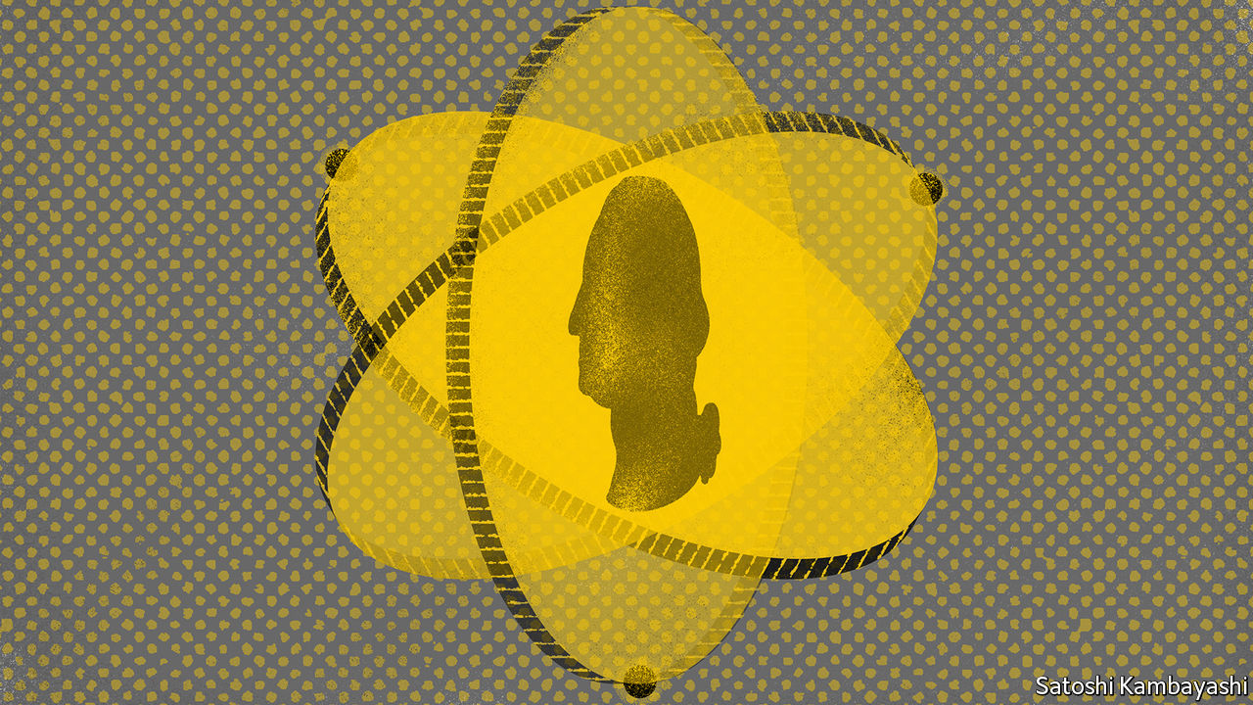

THE FINANCE industry has had a long and profitable relationship with computing. It was an early adopter of everything from mainframe computers to artificial intelligence (see timeline). For most of the past decade more trades have been done at high frequency by complex algorithms than by humans. Now big banks have their eyes on quantum computing, another cutting-edge technology.

This is the idea, developed by physicists in the 1980s, that the counter-intuitive properties of quantum mechanics might allow for the construction of computers that could perform mathematical feats that no non-quantum machine would ever be capable of. The promise is now starting to be realised. Computing giants like Google and IBM, as well as a flock of smaller competitors, are building and refining quantum hardware.

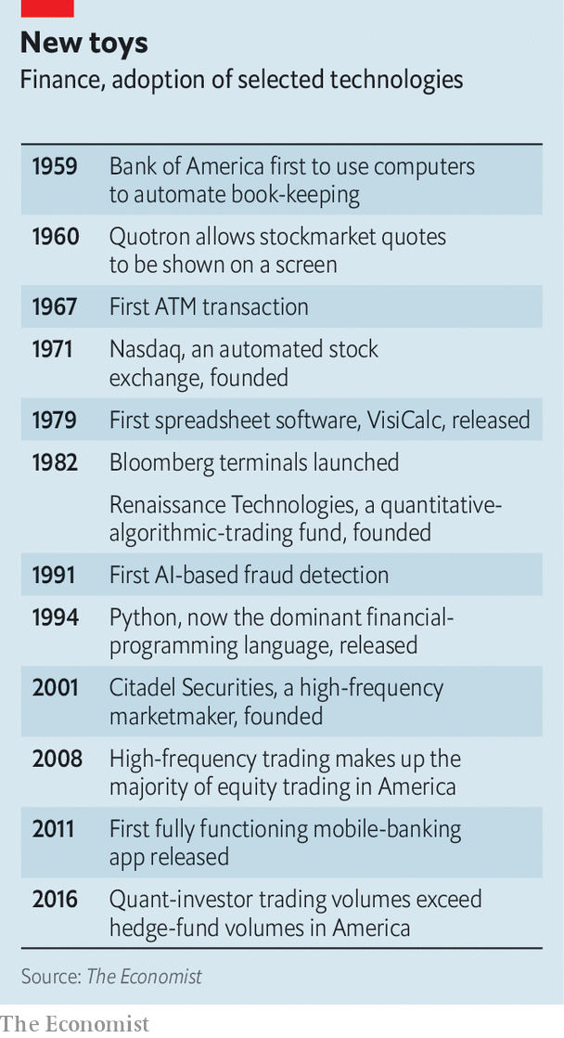

Quantum computers will not beat their classical counterparts at everything. But much of the maths at which they will excel is of interest to bankers. At a conference on December 10th William Zeng, head of quantum research at Goldman Sachs told the audience that quantum computing could have a “revolutionary” impact on the bank, and on finance more broadly.

Many financial calculations boil down to optimisation problems, a known strength of quantum computers, says Marco Pistoia, the head of a research unit at JPMorgan Chase, who spent many years at IBM before that. Quantum quants hope their machines will boost profits by speeding up asset pricing, digging up better-performing portfolios and making machine-learning algorithms more accurate. A study by BBVA, a Spanish bank, concluded in July that quantum computers could boost credit-scoring, spot arbitrage opportunities and accelerate so-called “Monte Carlo” simulations, which are commonly used in finance to try to model the likely behaviour of markets.

Finance is not the only industry looking for a way to profit from even the small, unstable quantum computers that mark the current state of the art; sectors from aerospace to pharmaceuticals are also hunting for a “quantum advantage”. But there are reasons to think finance may be among the first to find it. Mike Biercuk of Q-CTRL, a startup that makes control software for quantum computers, points out that a new financial algorithm can be deployed faster than a new industrial process. The size of financial markets means that even a small advance would be worth a lot of money.

Banks are also buying in expertise. Firms including BBVA, Citigroup, JPMorgan and Standard Chartered have set up research teams and signed deals with computing firms. The Boston Consulting Group reckons that, as of June, banks and insurers in America and Europe had hired more than 115 experts—a big number for what remains, even in academia, a small specialism. “We have more physics and maths PhDs than some big universities,” jokes Alexei Kondratyev, head of data analytics at Standard Chartered.

Startups are exploring possibilities too. Enrique Lizaso of Multiverse Computing reckons his firm’s quantum-enhanced algorithms can spot fraud more effectively, and around a hundred times faster, than existing ones. The firm has also experimented with portfolio optimisation, in which analysts seek well-performing investment strategies. Multiverse re-ran decisions made by real traders at a bank. The job was to choose, over the course of a year, the most profitable mix from a group of 50 assets, subject to restrictions, such as how often trades could be made.

The result was a problem with around 101,300 possible solutions, a number that far outstrips the number of atoms in the visible universe. In reality, the bank’s traders, assisted by models running on classical computers, managed an annual return of 19%. Depending on the amount of volatility investors were prepared to put up with, Multiverse’s algorithm generated returns of 20-80%—though it stops short of claiming a definitive quantum advantage.

Not all potential uses are so glamorous. Monte Carlo simulations are often used in regulatory stress tests. Christopher Savoie of Zapata, a quantum-computing firm based in Boston, recalls one bank executive telling him: “Don’t bring me trading algorithms, bring me a solution to CCAR [an American stress-test regulation]. That stuff eats up half my computing budget.”

All this is promising. But quantum financiers acknowledge that, for now, hardware is a limitation. “We’re not yet able to perform these calculations at a scale where a quantum machine offers a real-world advantage over a classical one,” says Mr Biercuk. One rough way to measure a quantum computer’s capability is its number of “qubits”, the analogue of classical computing’s 1-or-0 bits. For many problems a quantum computer with thousands of stable qubits is provably far faster than any non-quantum machine that could ever be built—it just does not exist yet.

For now, the field must make do with small, unstable devices, which can perform calculations for only tiny fractions of a second before their delicate quantum states break down. John Preskill of the California Institute of Technology has dubbed these “NISQs”—“Noisy, Intermediate-Scale Quantum computers”.

Bankers are working on ways to conduct computations on such machines. Mr Zeng of Goldman pointed out that the computational resources needed to run quantum algorithms have fallen as programmers have tweaked their methods. Mr Pistoia points to papers his team has written exploring ways to scale useful financial calculations into even small machines.

And at some point those programmers will meet hardware-makers coming the other way. In 2019 Google was the first to demonstrate “quantum supremacy”, using a 53-qubit NISQ machine to perform in minutes a calculation that would have taken the world’s fastest supercomputer more than 10,000 years. IBM, which has invested heavily in quantum computing, reckons it can build a 1,000-qubit machine by 2023. Both it and Google have talked of a million qubits by the end of the decade.

When might the financial revolution come? Mr Savoie thinks simple algorithms could be in use within 18 months, with credit-scoring a plausible early application. Mr Kondratyev says three to five years is more realistic. But the crucial point, says one observer, is that no one wants to be late to the party. One common worry is that whoever makes a breakthrough first may choose to reap the rewards in obscurity, rather than broadcast the fact to the world. After all, says Mr Biercuk, “that is how high-frequency trading got started”. ■

This article was downloaded by calibre from <https://www.economist.com/finance-and-economics/2020/12/19/wall-streets-latest-shiny-new-thing-quantum-computing>

|  |  |  |  |
| --- | --- | --- | --- |
|  | 文章 | 章节 | 下一项 |

|  |  |  |  |
| --- | --- | --- | --- |
| 上一项 | 文章 | 章节 | 下一项 |

#### Froth or fundamentals?

# What explains investors’ enthusiasm for risky assets?

There may be more sense to recent market movements than you think

Dec 19th 2020 |

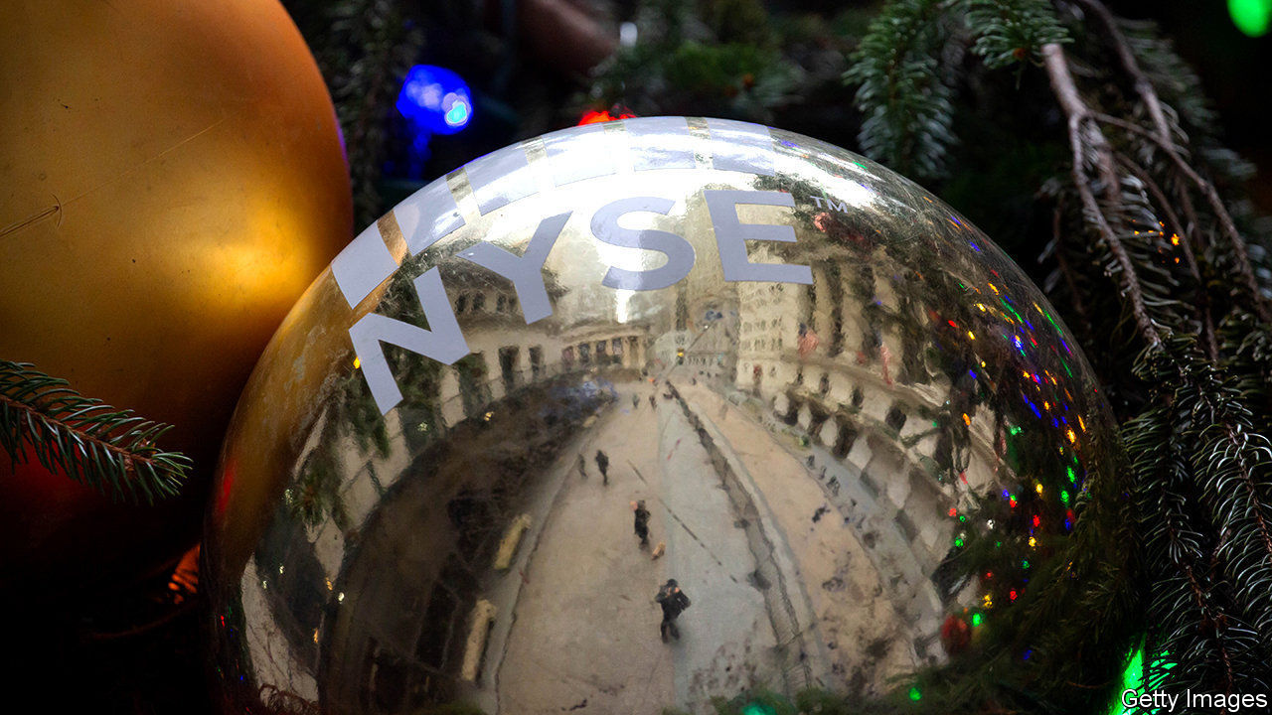

EVEN IN NORMAL times, there is an element of drama to the markets. The oil price may spike or slump in reaction to a geopolitical wobble; bond yields may leap on strong jobs figures; and shareholders may pump up a stock that posted juicy profits. But 2020 has taken the drama to an extreme (see chart 1). The equity sell-off in March was unmatched in its swiftness: stocks lost 30% of their value in a month. The yield on ten-year American Treasuries, the most important asset worldwide, fell by half between January and the middle of March and then by half again in a matter of days, before seizing up and yo-yoing. The contract for imminently delivered barrels of American oil briefly went negative. Over the course of 2020 timber prices have fallen by half, doubled, doubled again, fallen by half once more and then doubled again (overall, they have doubled in 2020).

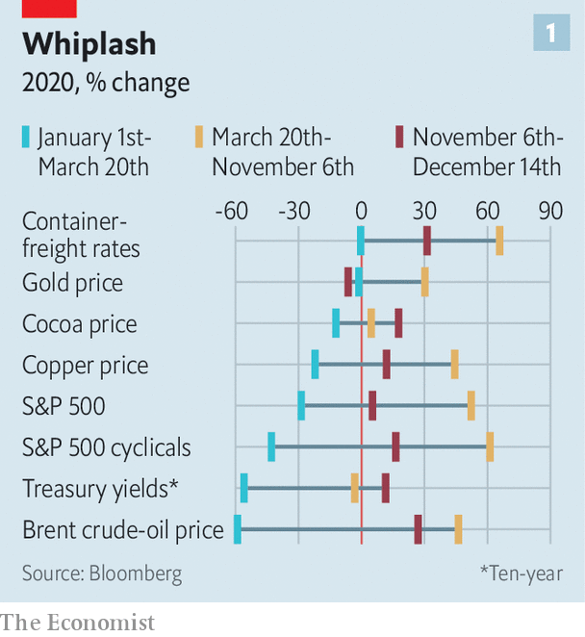

If the plunge in asset prices as countries locked down terrified asset managers, then recovery—led by a fierce bull run in tech stocks over the summer—has made them uneasy. It was only in 2018 that a public company, Apple, first became valued at more than $1trn. In net terms, Apple has gained around $750bn this year. Tesla has increased in value six-fold this year, to a market capitalisation of more than $600bn, roughly the value of the other seven most valuable carmakers combined. Even stocks that were unloved earlier in the year, like banks and energy firms, have rebounded of late, on a spate of good news—of an effective vaccine, and of a clear victory for Joe Biden in America’s presidential elections. When Airbnb, a platform for booking overnight stays, made its public debut on December 10th—after a year in which no-one travelled anywhere—its share price leapt by 115%. On December 5th the value of global stocks crossed $100trn for the first time.

Financial markets reflect investors’ expectations about the future, so it is hardly surprising that they have been chaotic in 2020. But the rebound in risky assets amid fragile economic conditions prompts the question of whether bubbles have formed in certain assets, or whether the ups and downs can be explained by rapidly shifting fundamental factors.

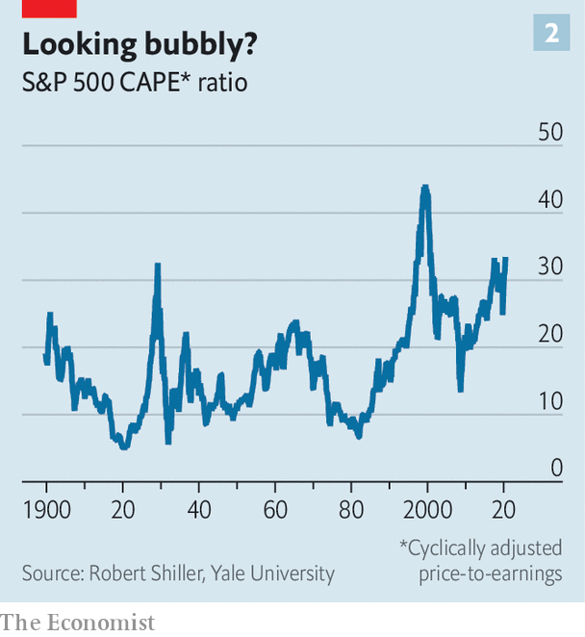

Consider first the evidence for froth. Even as profits slumped, investors in the S&P 500 benchmark index earned 14.3% (excluding dividends) in 2020, about double the typical return over the past 20 years. The gains have pumped up measures of stockmarket valuations. One such gauge is the cyclically adjusted price-to-earnings, or “CAPE”, ratio, devised by Robert Shiller, a Nobel-prizewinning economist. This looks at inflation-adjusted share prices relative to the ten-year average of real earnings per share. When the ratio is high, stocks are dear relative to their earnings; such periods have tended to be followed by low long-term returns over the next decade. In America the ratio in November 2020 was 33, above its level earlier in the year (see chart 2). Only twice before has the ratio exceeded 30 in America—the late 1920s and the early 2000s.

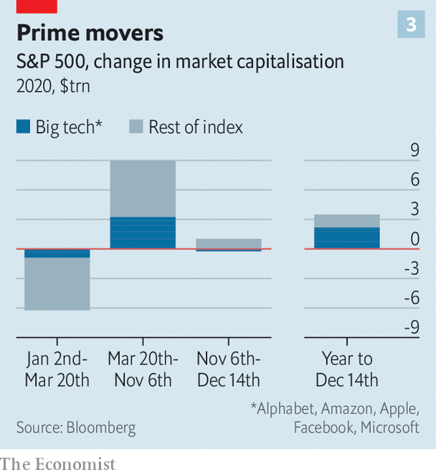

The big tech firms, many of which were expected to benefit from online shopping and home working, have played a disproportionate role in the broader rally. They account for two-thirds of the total returns from holding the S&P 500. At the start of 2020 Alphabet, Amazon, Apple, Facebook and Microsoft were worth around $5trn and made up 17.5% of the value of the index. The five are now worth more than $7trn, and their share has risen to 22% (see chart 3).

Further evidence of froth is the frenzy around initial public offerings of firms such as Airbnb, and the revival in retail trading. Retail investors accounted for 20% of the volume of stock trading, up from 15% in 2019. In the summer small buyers of call options—bets on share prices rising—were responsible for more derivatives trading than large ones.

The circumstantial evidence, then, looks bubbly. But a cross-examination of fundamental factors suggests that these can explain more than a fair chunk of what is going on. Cyclical assets, like stocks in restaurants and retailers, or commodities, like oil and copper, tend to rally as business booms. These fell quickly in value in February and March, followed by slow recoveries as the world reopened. But since November 9th, when news of an effective vaccine broke, they have surged. Container-freight rates have risen to all-time highs. Brent crude oil rose above $50 a barrel for the first time since March on December 10th.

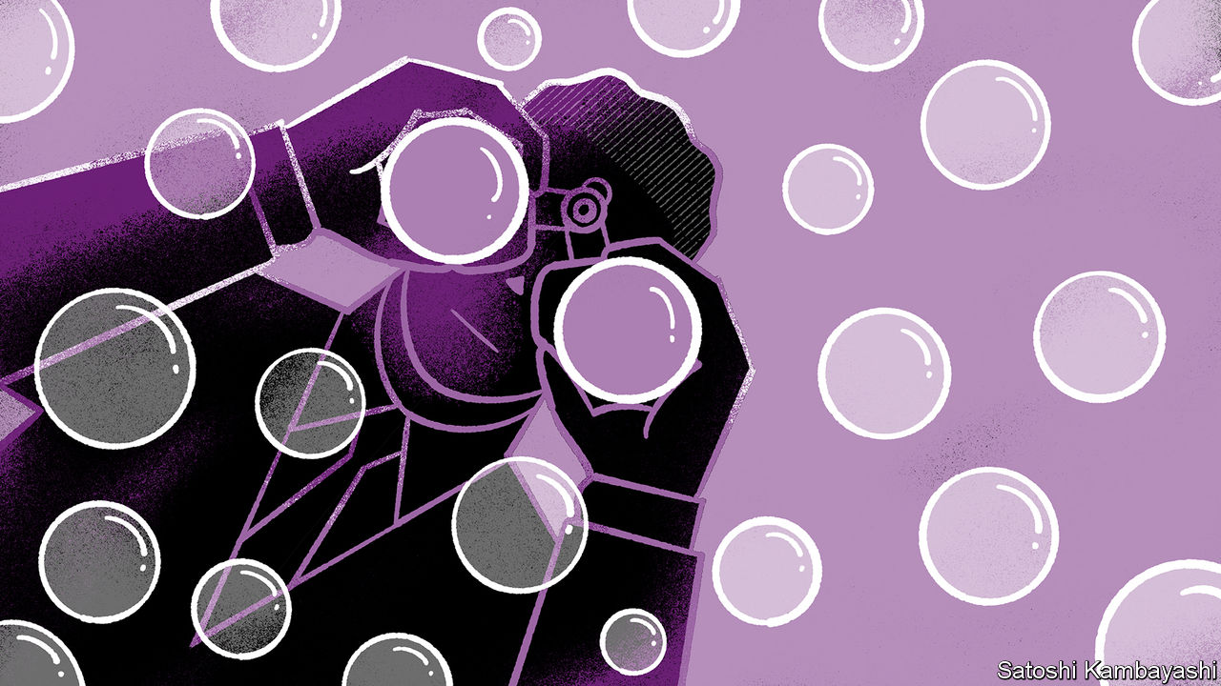

Moreover, the move in interest rates appears to more than explain the behaviour of equity prices. In isolation, the CAPE ratio ignores the impact of discount rates on valuations. The value of a firm, to its shareholders, is the present value of a firm’s future profits—meaning share prices tend to be sensitive to changing expectations of future profits, but also to the discount rate used to calculate what those are worth today. There have been enormous changes in this discount rate for stocks. At the start of 2020 the yield on ten-year Treasuries was 1.8%; by the middle of March it was just 0.6%. Since the vaccine news yields have risen once more, to around 0.9%.

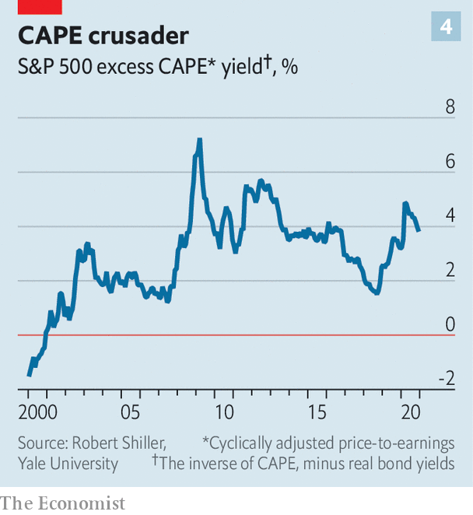

To account for this, on November 30th Mr Shiller published “excess CAPE yield” numbers, which are calculated by inverting the CAPE ratio, to give an indication of the expected yield on equities, and then subtracting the expected real returns on holding bonds (which, thanks to low rates and modest inflation expectations over the next decade, are negative). The excess yield is actually higher than in January (see chart 4). In other words, equities have become more attractive than bonds—at first probably because bond yields fell so quickly, boosting the relative appeal of stocks, but lately thanks to the vaccine heralding the return of growth and profits, which a modest increase in yields has not offset.

The rise in share prices alone, then, is probably not enough to indicate a mania, given the shift in discount rates. This may not dispel investors’ disquiet, in part because they are surrounded by evidence of exuberance. But the case for a bubble, at the very least, is not open and shut. ■

Editor’s note: Some of our covid-19 coverage is free for readers of The Economist Today, our daily [newsletter](https://my.economist.com/user#newsletter). For more stories and our pandemic tracker, see our [hub](https://www.economist.com/news/2020/03/11/the-economists-coverage-of-the-coronavirus)

This article was downloaded by calibre from <https://www.economist.com/finance-and-economics/2020/12/19/what-explains-investors-enthusiasm-for-risky-assets>

|  |  |  |  |
| --- | --- | --- | --- |
| 上一项 | 文章 | 章节 | 下一项 |

|  |  |  |  |
| --- | --- | --- | --- |
| 上一项 | 文章 | 章节 | 下一项 |

#### Panned

# What if a gold standard were still in use?

A new study shows that the economy would be worse off

Dec 19th 2020 |



IN THE AFTERMATH of the first world war, the gold standard inspired nearly religious fervour from central bankers. European officials dutifully re-pegged their war-battered currencies to gold at great cost to their citizens. A hundred years on, it has lost its lustre. Judy Shelton’s past support for it may have derailed her nomination to the Federal Reserve’s board. A recent paper* shows why the gold standard’s tarnished reputation is well deserved.

The authors calculate the impact of a gold standard, had it been in place in 2000-20. This would have required the Fed to set interest rates to maintain a fixed dollar price of gold, rather than to target inflation. The central bank’s policy rate would have become a function of gold supply—the amount of metal mined—and gold demand from investors and households.

Fluctuating gold demand can make monetary policy procyclical. In bad times, people stop spending and increase their demand for gold, so central banks must raise interest rates to make other assets more attractive and stabilise gold’s price. In good times the reverse happens, and central banks have to cut rates. The pace at which gold is mined also introduces some randomness to monetary policy. Whenever gold floods the market, interest rates must fall to keep its price stable. Gold shortages force interest rates up. It is up to fate whether or not the movements in rates are good for the economy.

It requires Herculean assumptions for the gold standard to beat today’s regime, judged by gauges such as the volatility of inflation. The authors show this would be so if the only forces buffeting the economy were fluctuations in productivity growth and in labour supply, and if the supply of gold tracked productivity.

Those assumptions, though, do not survive contact with reality. To adhere to the gold standard the Fed would have had to maintain high interest rates even during the global financial crisis, and beyond, with disastrous effects; in the first quarter of 2020, output would have been 10% lower than otherwise. Gold’s lost shine is no bad thing.

*“Bury the gold standard? A quantitative exploration” by Anthony Diercks, Jonathan Rawls and Eric Sims, NBER Working Paper.

This article was downloaded by calibre from <https://www.economist.com/finance-and-economics/2020/12/19/what-if-a-gold-standard-were-still-in-use>

|  |  |  |  |
| --- | --- | --- | --- |
| 上一项 | 文章 | 章节 | 下一项 |

|  |  |  |  |
| --- | --- | --- | --- |
| 上一项 | 文章 | 章节 | 下一项 |

#### Free exchange

# Is a wave of supply-chain reshoring around the corner?

Experience and evidence suggests they are stickier than you think

Dec 16th 2020 |

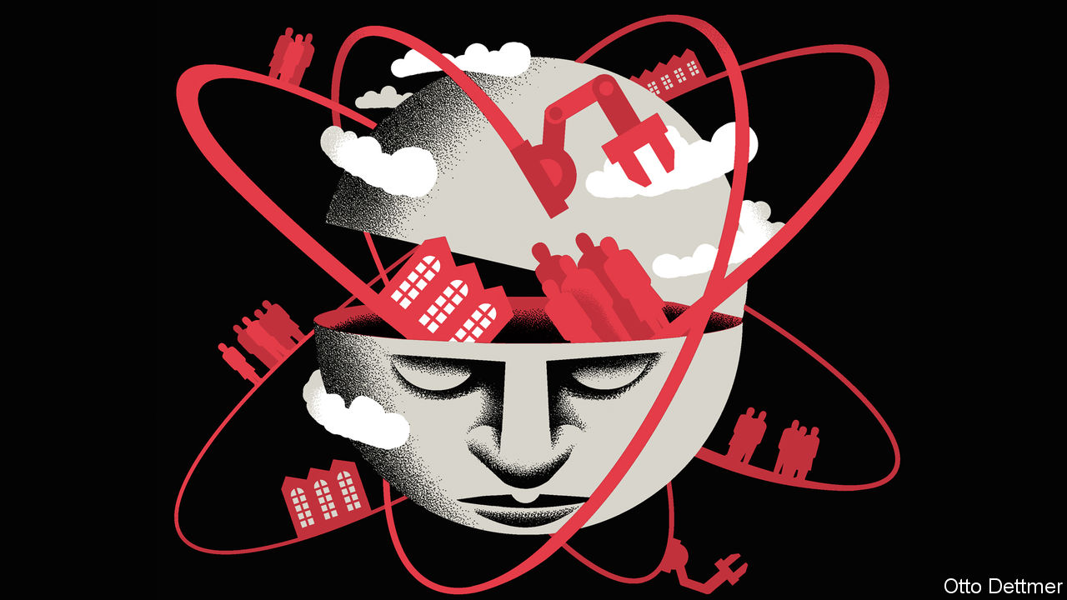

Editor’s note: Some of our covid-19 coverage is free for readers of The Economist Today, our daily [newsletter](https://my.economist.com/user#newsletter). For more stories and our pandemic tracker, see our [hub](https://www.economist.com/news/2020/03/11/the-economists-coverage-of-the-coronavirus)

SUPPLY-CHAIN managers have had a stressful few years. From Sino-American trade wars and Brexit to covid-induced restrictions on medical exports and travel, there has been a lot to deal with. At the worst of the pandemic company bosses inevitably wondered if bringing production closer to consumers might help. In April a survey conducted by EY, an accounting firm, found that as many as 83% of multinational executives were contemplating so-called “reshoring” or “nearshoring”. Recent history shows how sticky supply chains can be, but might this time be different?

Politicians have long angled for companies to shift production to their shores because they want jobs for their constituents. There can be a business case for it too, in order to cut transport costs, say, or reduce inventories. The Reshoring Initiative, which advocates for more manufacturing in America, cites the allure of “Made in USA” branding for older Midwesterners. Some reckon technology might encourage reshoring. In 2017 a report by ING, a bank, predicted that 3D printing could wipe out 40% of trade flows by 2040.

Yet the experience of the past decade suggests that for every company reshoring production, there may be more doing the opposite. A survey of German manufacturers found that 2% brought production home between 2010 and mid-2012. Four times as many shifted operations abroad during that time. A study published in 2016 by the OECD, a club of mostly rich countries, found that the effects of reshoring on national economies were “(still) limited”.

Nor does recent history suggest that new technologies will cannibalise trade. Take 3D printing. A study by Caroline Freund, Alen Mulabdic and Michele Ruta of the World Bank found that its use in the hearing-aid industry increased trade by 58% over nearly a decade, compared with what it might have been expected to be otherwise. As the technology was useful for only part of the manufacturing process and hearing aids are cheap to transport, supply chains did not retreat. Gary Gereffi of Duke University cites the failure of Adidas to print shoes in America and Germany as evidence of the importance of highly orchestrated production networks. He found that a lack of locally available components meant the shoes had to be simplified so much they lost their consumer appeal. The adoption of other technologies can make importing, rather than reshoring, more attractive. Katherine Stapleton of the World Bank and Michael Webb of Stanford University found that Spanish firms using robots were more likely to increase their imports from low-income countries, or open affiliates there. Productivity-enhancing automation led firms to expand output, and so import more parts.

The rise in tariffs in America and elsewhere over the past four years could, in theory, have been a game-changer, encouraging companies to move supply chains nearer consumers. But evidence of a great shift towards “Made in USA” following President Donald Trump’s tariffs on Chinese imports is scant. Although American manufacturing imports from 14 Asian countries fell in 2019, there was no offsetting increase in gross domestic manufacturing production. A study by Ben Charoenwong of the National University of Singapore and Miaozhe Han and Jing Wu of the Chinese University of Hong Kong suggests that, while trade-policy uncertainty was associated with a reduction in the number of foreign suppliers to American companies serving the home market, on average these acquired no more domestic suppliers.

Might the pandemic prompt a shifting of supply chains? So far signs of reshoring are limited. In America import growth is outpacing domestic manufacturing production. Medical companies may be scarred by their experience of the swine-flu outbreak in 2009. At a hearing held by the United States International Trade Commission in September this year, one speaker recalled that companies ramped up production after the swine-flu pandemic, only to be driven to the verge of bankruptcy when demand fell back to normal. Sebastien Miroudot of the OECD finds that the evidence in favour of diversifying across many suppliers is shaky; experience suggests that firms with fewer, longer relationships recover from shocks more quickly. Rather than relocation, he has written, the research seems to argue for ensuring that production can be flexibly moved from place to place in an emergency.

## The call of home

After their initial scare at the start of the pandemic, many companies now seem to have lost their urge to rush back home. A follow-up survey by EY in October found that just 37% of executives were still considering reshoring; a recent survey of firms in America and Europe by Euler Hermes, a trade-credit insurer, found that less than 15% were contemplating reshoring because of covid-19.

Some caution is in order, though. The pandemic is not over, and shifting production can be a slow business. There is some sign of movement in specialist industries: Biju Mohan of GEP, a supply-chain consultancy, reports increased interest from life-sciences firms in moving production from China to America. And industrial policy is back in vogue, and only just gathering steam in Europe and America. Both have plans to subsidise chipmaking, for example, and to make home-grown renewable-energy investments. The economic plan of America’s president-elect, Joe Biden, talks of firms being “dangerously dependent on foreign suppliers”.

The resilience of supply chains so far may come down to a virtuous circle created when globalisation accelerated in the 1990s. When production networks stretch across several countries, trade restrictions can backfire, hurting both the exporter and the importer. That gave governments a big incentive to co-operate, and in turn meant companies were comfortable building or relying on far-flung factories. But, as Brexit, the trade war and a hobbled World Trade Organisation show, that trust is eroding, and companies’ sense of security with it. Companies do not want to hunker down behind borders. But they could yet be forced to do so. ■

This article was downloaded by calibre from <https://www.economist.com/finance-and-economics/2020/12/16/is-a-wave-of-supply-chain-reshoring-around-the-corner>

|  |  |  |  |
| --- | --- | --- | --- |
| 上一项 | 文章 | 章节 | 下一项 |

|  |  |  |
| --- | --- | --- |
| Finance & economics | 章节 | Books & arts |

Science & technology

The highest fidelity: An auricular spectacular

.

Evolution and agriculture: Good catch

.

Data storage: Re-record, not fade away

.

|  |  |  |
| --- | --- | --- |
| Finance & economics | 章节 | Books & arts |

|  |  |  |  |
| --- | --- | --- | --- |
|  | 文章 | 章节 | 下一项 |

#### The highest fidelity

# Sound engineers have better ways to trick listeners’ ears

That will improve those listeners’ experiences

Dec 19th 2020 |

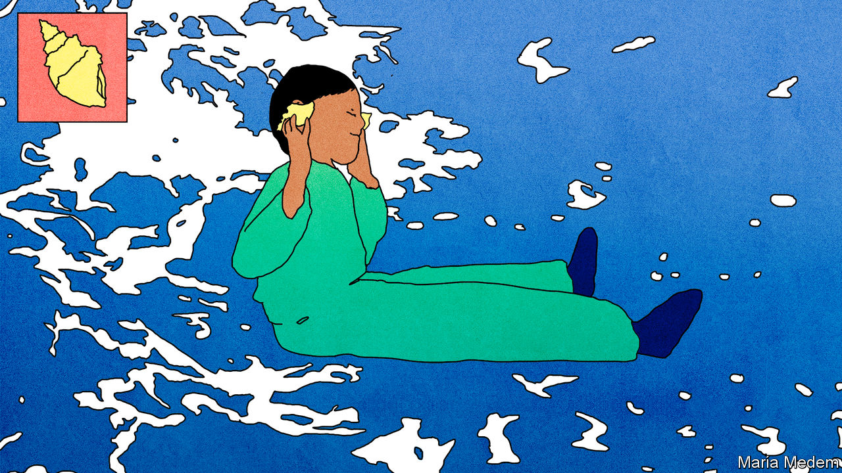

HUMAN BEINGS are good at locating the sources of sounds. Even when blindfolded, most people can point to within ten degrees of the true direction of a sound’s origin. This is a useful knack for evading danger. It is also an extraordinary cerebral feat. Partly, it is a matter of detecting minute differences of volume in each ear. Partly, it comes from tiny disparities in the time it takes a sound to reach two ears that are not equidistant from its source. The heavy lifting of sound-location, however, involves something else entirely.

Audio buffs call it the head-related transfer function. A sound is modulated by the body parts it encounters before it reaches the eardrums. In particular, the various tissues of the head attenuate higher frequencies, weakening the top notes of sound waves that have passed to an eardrum through the skull compared with those from the same source that have arrived directly through the air. The cartilaginous ridges, troughs and protuberances of the outer ear also alter sound before it is transduced into nerve signals. Sounds arriving from different angles are therefore modified in consistent ways that the brain learns to recognise.

For all of their acoustic spatial awareness, however, brains can still be fooled by appropriate technology into believing a sound is coming from somewhere that it is not. That sounds like the basis of a big business. And it is.

## Sounds good

One way to simulate the “immersive” sound of reality through a pair of earbuds is by using a pair of recordings made with microphones embedded in the ear canals of a special dummy head. These heads are made to have the same shape and density as those of their flesh-and-blood counterparts. That means they modulate sound waves passing through them in a realistic manner. Recordings made using them therefore log what would arrive at the ear canals of someone listening to the sound in question for real. When they are played back, what a user hears recapitulates that experience, including the apparent directions from which the sounds are coming.

Dummy-based binaural recordings of this sort have been around for a while. But making them is clunky. It is also expensive. A good dummy head can cost $10,000, and time in a professional recording studio is hardly cheap. These days, though, the process can be emulated inside a computer. And that is leading to a creative explosion.

The trick that the emulator must master is a process called phase modulation. This involves retarding a sound’s high, medium and low frequencies by the slight but varying fractions of a second by which those frequencies would be delayed by different parts of the ears and head in reality. So writing the appropriate software starts by collecting a lot of data on how sound waves interact with a human head, and that means going back to the studio to conduct special binaural recordings, often using people instead of dummies. The resulting signals can then be decomposed into their component frequencies, which yields an understanding of how to modulate a given frequency to make it seem as if it is arriving from a particular location.

Demand for software to mix sound in this way has shot up says Lars Isaksson of Dirac Research, a firm in Uppsala, Sweden. Dirac developed its own version of such software, known as Dirac 3D Audio, by using a year’s worth of recordings it made that encompassed each degree of rotation, both side to side and up and down, around a listener’s head. This panaudicon provided, Mr Isaksson says, notable smoothness in the simulated movement of sound sources. Makers of video games are a big market for such stuff.

Dirac is not alone. Half a dozen other firms, including Dolby Laboratories of America and Sennheiser of Germany, also now make immersive software. To use it, a sound engineer employs a graphic interface that includes a representation of a sphere surrounding an icon representing the listener. The engineer uses a mouse to move sound channels—vocals, percussion and so on, if the product is music—to the points in the sphere from which their outputs are intended to originate. Software of this sort provides a way to take any recording and “project it in 3D”, says Véronique Larcher, co-director of Sennheiser’s division for immersive audio.

Sennheiser’s product is called AMBEO. Dolby’s is called Atmos. This has generated the soundtracks of more than 20 video games and 2,500 films and television shows, as well as many pieces of music. Immersive sound may even come to videoconferencing. Dirac is promoting software that makes the voices of participants seem to emerge from the spots on the screen where their images appear. The software uses a laptop’s camera to track listeners’ heads. To those who look, say, left, it will sound as though their interlocutors are off to the right. Dirac is in talks with videoconferencing firms including BlueJeans, Lifesize and Zoom.

Facebook, a social-media company, is also designing “spatialised audio” for video calls that use its Oculus virtual-reality headsets. Ravish Mehra, head of audio research at Facebook Reality Labs, is coy about how long it will take his team to perfect the aural illusion that this is intended to create. But he says software the firm has in development can modify the frequencies and volumes of sounds so that they match the virtual surroundings chosen for a call, as well as the speaker’s perceived position. The acoustics of a beach, he notes, are unlike those of a room.

## Tin pan alley

Such stuff is for the professionals. But amateurs can play too. For the man or woman in the street who wants to jazz up a record collection, many simpler programs now permit people to give a more immersive feeling to their existing recordings by running them through software that modulates the sounds of those recordings to achieve that end.

Programs of this sort cannot handle different parts of a recording differently in the way that studio-based systems manage, but they do create an illusion of sonic space around the listener. Isak Olsson of Stockholm, who has put together two such packages, 8D Audio and Audioalter, describes them as seeming to increase the size of the room. This helps to overcome a phenomenon known as the “in-the-head experience”. And, as Michael Kelly, head of engineering at Xperi, an immersive-software firm based in California, observes, sounds that appear to come from outside the head are more comfortable.

At the other end of the technological scale from such do-it-yourself kits, a number of firms, Dirac, Dolby, Facebook, Sony and Xperi among them, are working on a bespoke approach to sonic immersion. They are tailoring it, in other words, to an individual listener’s anatomy.

One method, that being used by Sony, is to ask potential customers to upload photographs of their ears. Another, which may be adopted by Xperi, is to repurpose data from the face-recognition systems that now unlock many people’s smartphones. If this way of thinking works, it will bring with it the ultimate in high fidelity. This is a recognition that, in the real world, even if what they are hearing is the same set of sound waves, every listener’s experience is different—and that this needs to be replicated in the world of recorded sound, too. With that realisation, acknowledgment of the head-related transfer function’s importance has reached its logical conclusion. And the term “headbanging” may take on a new and positive meaning.■

This article was downloaded by calibre from <https://www.economist.com/science-and-technology/2020/12/19/sound-engineers-have-better-ways-to-trick-listeners-ears>

|  |  |  |  |
| --- | --- | --- | --- |
|  | 文章 | 章节 | 下一项 |

|  |  |  |  |
| --- | --- | --- | --- |
| 上一项 | 文章 | 章节 | 下一项 |

#### Agriculture and evolution

# Wheat absorbs phosphorus from desert dust

After 12 millennia, a common crop still springs surprises

Dec 19th 2020 |



WHEAT WAS among the first plants to be domesticated and is now the most widespread crop in the world. It thus sounds unlikely there would be much left to learn about what makes it thrive. Yet, some 12,000 years after relations between people and wheat began, a wheat plant has been caught doing something unexpected. It helped itself to a dose of much-needed phosphorus when its leaves received a coating of desert dust.

The plant (or, rather, plants) in question were in the care of Avner Gross of the Ben Gurion University of the Negev, in Israel. As Dr Gross told this year’s meeting of the American Geophysical Union, which took place online during the first half of December, his study was prompted by hikes he had taken near Neve Shalom, his home village in the Judean Hills. On these, he often noticed plant leaves completely covered in dust that had been carried there by sand storms from the Sahara desert.

It occurred to him that this dust might not be the light-blocking nuisance it appeared at first sight. It could, on the contrary, be beneficial because of the growth-enhancing elements such as phosphorus which it contained. Until then, botanists had assumed that phosphorus in dust landing on a plant was of little value, because it is locked up in an insoluble mineral called apatite. This makes it unavailable for absorption. Dr Gross, however, reasoned that plants which had evolved near deserts, the source of almost all naturally occurring dust in the atmosphere, might well have evolved a way to exploit it.

He and two colleagues, Sudeep Tiwari, also at Ben Gurion, and Ran Erel of the Gilat Research Centre, therefore started experimenting with a pair of species, wheat and chickpeas (the world’s 17th most planted crop), that both came originally from the Middle East. As a control, they also raised some maize, a plant from the Americas that evolved in far less dusty surroundings.

First, having established them as seedlings, they starved their charges of phosphorus until signs of deficiency such as yellow leaves appeared. Then they scattered desert dust on the leaves of half of the specimens of each species, while taking steps to stop any of it reaching the soil. After this, though the dust-dosed maize continued to suffer from phosphorus deficiency, the wheat and chickpea plants perked up and grew to more than double the size of their undusted lab-mates. What is more, these species were clearly ready for the dust’s arrival. As soon as a lack of phosphorus announced itself, two things happened. Their leaves became hairier, and therefore better at capturing dust. And those leaves also started secreting acid fluids that could dissolve any incoming apatite, assisting phosphorus’s absorption.

That plants can take up phosphorus through their leaves is not, of itself, news to farmers—for this was established in the 1950s. But until now the practical consequence of such knowledge has been that crops are sprayed with liquid fertiliser derived, in turn, from apatite-containing rocks which have been treated with acid. Dusting leaves could, Dr Gross suggests, be an alternative and more efficient way of providing desert-derived crop species with the phosphorus they need. And maybe not just those. His next plan is to look at avocado and cocoa trees, which evolved in tropical regions of the Americas that regularly get a helpful transatlantic dose of Saharan dust carried westward by the trade winds. It will be interesting to see if they are up to the same tricks as wheat and chickpeas.■

This article was downloaded by calibre from <https://www.economist.com/science-and-technology/2020/12/19/wheat-absorbs-phosphorus-from-desert-dust>

|  |  |  |  |
| --- | --- | --- | --- |
| 上一项 | 文章 | 章节 | 下一项 |

|  |  |  |  |
| --- | --- | --- | --- |
| 上一项 | 文章 | 章节 | 下一项 |

#### Data storage

# Magnetic tape has a surprisingly promising future

Re-record, not fade away

Dec 15th 2020 |



THE WHIRR of spooling magnetic tape is more likely to evoke feelings of nostalgia than technological awe. Yet tape remains important for data storage, with millions of kilometres of the stuff coiled up in the world’s data centres. Indirectly, says Mark Lantz of IBM, most computer users thus rely on tape every day.

Though tape may seem archaic, it is still getting better. In 2015 Dr Lantz’s team unveiled a version capable of squirrelling away 123 gigabytes per square inch (19Gb per square centimetre, but tapemakers still use Imperial units). In 2017 they reached 201Gb/in2. And on December 15th they revealed a design that has a density of 317Gb/in2. That rate of growth is unmatched by any of tape’s competitors.

Tape’s heyday as a data-storage medium for computers was in the 1950s. Hard disks, introduced in 1956, were quickly seen as superior because they required no time-consuming spooling. Decades of selective investment mean they now also have a better density of information storage than tape. The best can manage more than 1,000Gb/in2. As a result they are in high demand—2018 saw the sale of more than 800bn gigabytes-worth, which is eight times the figure for tape. But disks have drawbacks. They are costlier than tape, have shorter lifespans and their spinning platters generate far more unwanted heat.

This leads to tape being the medium of choice for the so-called “cold” storage of data that need to be looked at only infrequently. And disks’ advantages elsewhere may be slipping. In the 1990s hard-disk storage densities doubled every year. Over the past decade that rate of growth has dropped to 7.6%, as manufacturers run out of headroom. Smaller magnetic particles need more energy to keep them in line, and the magnets which provide this are approaching the theoretical limits of their strength. The storage density of magnetic tape, by contrast, has been increasing steadily, by 34% a year for nearly three decades. As a consequence, tape may catch up with hard disks within five years.

To maintain this blistering rate of growth, Dr Lantz’s team concentrated on three matters. First, they reduced the size of the magnetic grains that form a tape’s recording surface, by substituting strontium ferrite for the current industry standard of barium ferrite. Second, they shrank the size of the read heads by a factor of 30, permitting data to be packed onto narrower tracks. Third, they developed systems able to track and correct the position of the tape with nanometre accuracy as it flowed under the smaller heads, stopping it going off-track and distorting the signal. Though it may take a decade for these technological improvements to make their way into products, this sort of progress bolsters confidence in tape’s long-term utility.

Other innovations may be coming, too. Ohkoshi Shin-ichi of the University of Tokyo, for example, advocates using particles of epsilon iron oxide. This material is particularly magnetically stable, meaning its grain-size can be reduced (and thus storage density increased) without any risk of the field flipping randomly and thus changing what is encoded.

## Taped up

Demand for more storage will certainly be there. Estimates suggest that four times more data will be generated in 2025 than in 2019. In the part of the data-storage market where tape currently reigns supreme, it is likely to remain so for a while.

The biggest threat to tape comes from the flash-drive technology used in SD cards and USB sticks. Flash relies on a flow of electrons through transistors, rather than on magnetised particles read by mechanical components, so it is capable of better data densities even than hard disks. Lack of moving parts also makes such solid-state devices faster at writing and retrieving information. Flash drives are, however, more costly than magnetic storage and do not last as long. This makes them ten times more expensive per byte per year of storage than hard disks, and nearly 50 times more expensive than tape. They are therefore too dear to use for anything but the most important jewels in the data vault. Until that changes, the reel is likely to continue.■

This article was downloaded by calibre from <https://www.economist.com/science-and-technology/2020/12/15/magnetic-tape-has-a-surprisingly-promising-future>

|  |  |  |  |
| --- | --- | --- | --- |
| 上一项 | 文章 | 章节 | 下一项 |

|  |  |  |
| --- | --- | --- |
| Science & ... | 章节 | Economic & ... |

Books & arts

Poetry on the Tube: Tunnels of love

.

Winter weather: The white stuff

.

|  |  |  |
| --- | --- | --- |
| Science & ... | 章节 | Economic & ... |

|  |  |  |  |
| --- | --- | --- | --- |
|  | 文章 | 章节 | 下一项 |

#### Poetry on the Tube

# The mysterious poets of the London Underground drop their masks

Previously known as N1 and E1, the duo have fans around the world

Dec 19th 2020 |

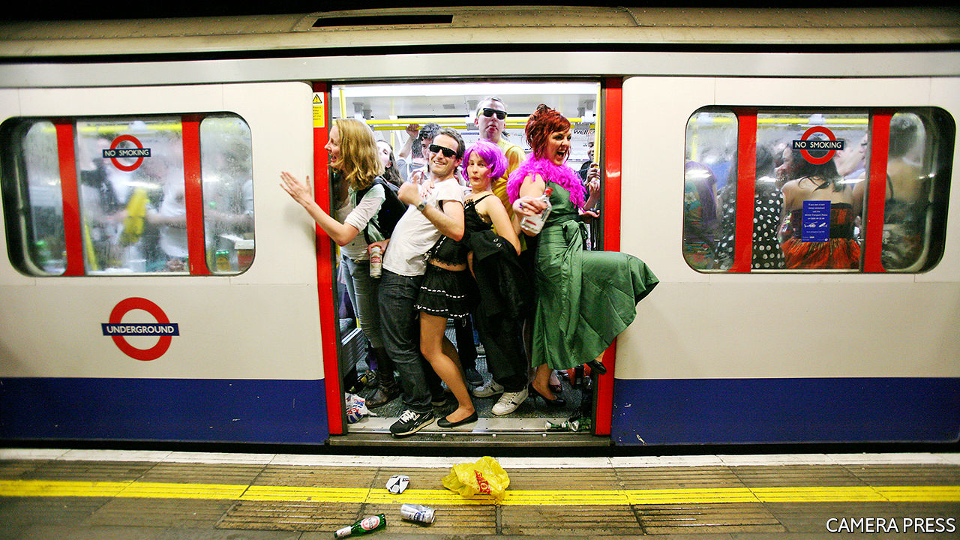

All on the Board. Yellow Kite; 288 pages; £14.99

IT WAS MARCH 2017 and fans were streaming out of a concert by Craig David at the O2 Arena in London and into North Greenwich Tube station. As they jovially belted out their favourite tunes, an ode to the pop star, crammed with song titles and catchy rhymes, appeared on a whiteboard in the ticket hall. A crowd soon surrounded the board, giggling and taking selfies.

Hundreds of rhymes have since been posted mysteriously around London’s Underground network, each signed “@allontheboard”. The poems—written, it transpires, by two Tube workers—range from life lessons to dad jokes. A ditty tackling men’s mental-health problems is dedicated to “sad lads, broken blokes, unhappy chappies”. A “Fruit & Veg Guide to Life” urges: “Don’t be bananas, give peas a chance, we can turnip around.”

In their day jobs, the two subterranean poets usher people through turnstiles and control crowds. But even before turning to verse, they confide in an interview, they sought ways to add a flicker of fun to their shifts, for instance challenging one another to drop pop-song titles into responses to customers’ inquiries. A request for directions could be met with a hand cupped behind an ear and “Hit me baby one more time?” After the night of the concert, they realised that they could lift commuters’ spirits with their poems. They began wheeling spare whiteboards into quiet tunnels to write. To maintain their anonymity they donned masks, long before those became mandatory on public transport because of covid-19.

And to cultivate mystique, they adopted the noms de plume N1 and E1, a play on London’s system of postcodes and shorthand for “No one” and “Everyone”. Referring to the feted street artist, N1 explains that they “quite liked the idea of being like the Banksys of the Underground”.

First they needed permission to display their poems on spare boards where passengers could see them. The city’s transport authority previously had tight rules for the use of its whiteboards: only service messages, no underlining, just a handful of regulation coloured pens. But managers were persuaded to make an exception, and before long station bosses began asking the men to brighten up ticket halls with a poem. Supportive colleagues juggle shifts to make sure they are on duty together. They are best-known for their tributes to celebrities, especially those appearing at the O2, which they pack with song and film titles, puns and quotes.

## Looking on the bright side

Less than four years after their debut, they have more than 500,000 followers on Instagram. Fans include a young woman in Turkey who reads the poems online to practise her English, an Iranian girl seeking positivity as she battles suicidal thoughts, Brits abroad who crave a taste of home, and assorted stars. A poem studded with quotes from Michelle Obama was spotted by her staff during a book tour in London; the former First Lady posted a picture of the board on Instagram. Performing in the city, Katy Perry, a singer, put on a baseball cap and dark glasses and rode the Tube to snap a photo with a board dedicated to her. “You know you’ve made it once you’re on one of those boards,” N1 says.

In November the pair finally discarded their masks (metaphorically, at least) and revealed their true identities when they published an anthology of their writing, also called “All on the Board”. N1 is a former train driver named Ian Redpath; E1 is his pal, Jeremy Chopra. One reason they are so good at cheering up commuters, they reveal, is that they have sometimes needed cheering up themselves. Their sympathy for health problems such as tinnitus and colitis derives from personal experience.

In a harrowing recollection, for instance, Mr Redpath tells of the day a woman threw herself in front of his train, leaving him with post-traumatic stress disorder that ended his career as a driver. “When she jumped, our eyes connected, and she smiled just before the train hit her,” he remembers. “I was scared of the dark for ages. I was scared of seeing her face in my dreams.” Sharp-elbowed Londoners tend to spare little thought for the harried staff on the Tube; this poignant anthology humanises them.

The pandemic is an eerie time for both the rhymesters and their normally teeming workplace. At the moment there may be more mice in Tube stations than there are passengers; ridership sank to just 4% of normal levels in April and May, during London’s first full lockdown, and it remains low. But All on the Board think their mission to boost morale is as important as ever. The duo have continued to put up poems throughout the year, writing sonnets to thank doctors, congratulate people celebrating lonely birthdays and reminisce about the forbidden joys of hugging. “Life is a journey,” one board reflects, “and at the moment/the train we are all on is in a tunnel,/But, one day we will see the light.”

Some of these pandemic-themed offerings feature in the book, rhyming “alive” with “survive” and “friends” with “ends”. But the best parts of the anthology involve the simplest British humour, which will raise a smile whether readers are hunkering down at home or negotiating a desolate commute. Take one poem called “The Beauty of Tea”:

Put the kettle on and make a cuppa,  
It’s the perfect lifter upper;  
 Do you risk it with your biscuits  
 And dunk them far too long?  
 Do you prefer your tea with sugar?  
 Do you like it weak or strong?  
 A nice brew can make things better  
 And can also quench your thirst,  
 Are you one of those  
 Who put the milk in first?

This article was downloaded by calibre from <https://www.economist.com/books-and-arts/2020/12/19/the-mysterious-poets-of-the-london-underground-drop-their-masks>

|  |  |  |  |
| --- | --- | --- | --- |
|  | 文章 | 章节 | 下一项 |

|  |  |  |  |
| --- | --- | --- | --- |
| 上一项 | 文章 | 章节 | 下一项 |

#### The white stuff

# The peculiar allure of snow

Anthony Wood considers both its science and its enticements

Dec 19th 2020 |

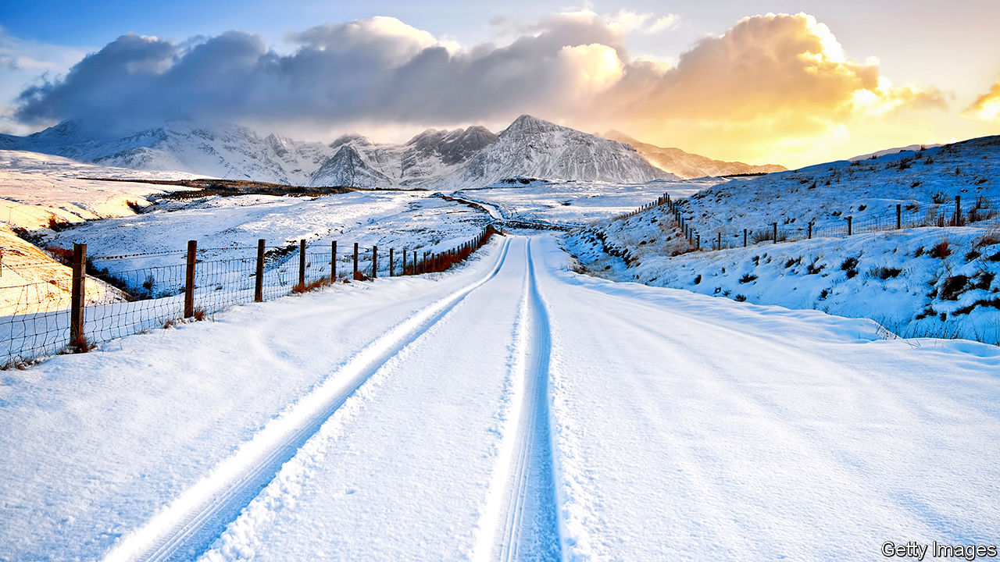

Snow. By Anthony Wood. Prometheus Books; 272 pages; $24.95 and £19.99

ANTHONY WOOD remembers sitting in the classroom one snowy morning as his teacher eyed the “saucer-size flakes” swirling outside the window. “Please boys and girls”, she implored, “pray that it stops snowing.” How little she grasped the mind of children, Mr Wood observes: “We were praying, alright—praying that it would snow until June.”

Everyone knows children love snow. Mr Wood’s new book is meant for adults who remain infatuated. It is less a systematic history than a meander through assorted snow-related subjects—beginning with the snowflake itself, which the author describes poetically as “the DNA of God”.

These miniature ice crystals were once neglected by scientists, who saw little practical benefit in studying them. Their disdain, however, was not shared by Wilson Bentley, a farm boy in Vermont who was given a microscope on his 15th birthday in 1880; later he acquired a bellows-camera, which he adapted to take the first-ever photomicrographs of snowflakes, being careful not to breathe on his evanescent subjects before tripping the shutter.

Inspired by Bentley’s ethereal images, in 1936 Nakaya Ukichiro, a Japanese nuclear physicist, became the first person to manufacture snow in the lab. His research on how the crystals form showed that snowflakes develop on the fly, during their sometimes hours-long journey to the ground. The higher the humidity that they encounter on the way, the more intricate their architecture becomes.

Monster snowstorms interest Mr Wood, too, such as the great white hurricane of 1888, during which hundreds of people in the north-eastern United States died of hypothermia. Paralysing winter storms were disasters for cities like New York and Philadelphia, which initiated their own local “arms race against nature”, experimenting with crude ploughs to clear streets and with substances from cinders to grape extract and salt to de-ice them. Snow also spurred the development of subway systems that burrowed beyond the reach of winter weather.

The atmospheric forces that created such blizzards remained unknown until Ooishi Wasaburo, another Japanese scientist, discovered chaotic eddies in the upper atmosphere, now known as the jet stream, in the 1920s. When the frigid jet stream bumps hard against humid air generated by the Gulf Stream in the Atlantic, meteorological mayhem results. Given the complexity of the atmosphere—and the spotty nature of the available data on it—snow forecasting will always remain an inexact science, Mr Wood contends.

His scattershot chapters touch on the impact of erratic snowfall on the water crisis in California and on winter fun everywhere. He offers some frustratingly disjointed speculation about how climate change will alter future snowfalls. The short answer is that there will probably be more snow in places where humidity increases, and less where temperatures become too high to sustain it.

And he reflects, if briefly, on snow’s delights and peculiar allure. Why do people either love it or hate it? Many long for it, Mr Wood proposes, because of the splendid isolation that it enforces. As with the pandemic, a white-out can be overwhelming. It can also direct attention inward, and help people return to themselves. ■

This article was downloaded by calibre from <https://www.economist.com/books-and-arts/2020/12/19/the-peculiar-allure-of-snow>

|  |  |  |  |
| --- | --- | --- | --- |
| 上一项 | 文章 | 章节 | 下一项 |

|  |  |  |
| --- | --- | --- |
| Books & arts | 章节 | Graphic detail |

Economic & financial indicators

Economic data, commodities and markets

.

|  |  |  |
| --- | --- | --- |
| Books & arts | 章节 | Graphic detail |

|  |  |  |  |
| --- | --- | --- | --- |
|  | 文章 | 章节 | 下一项 |

# Economic data, commodities and markets

Dec 19th 2020 |

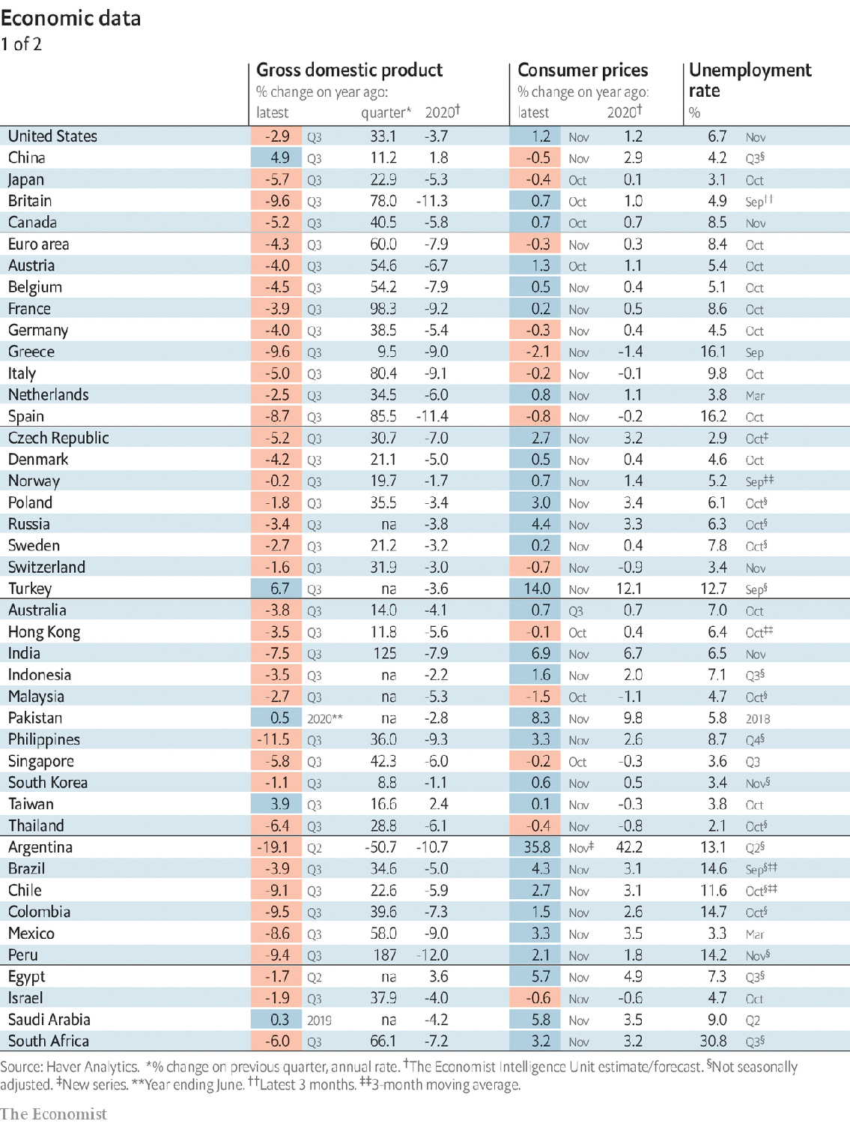

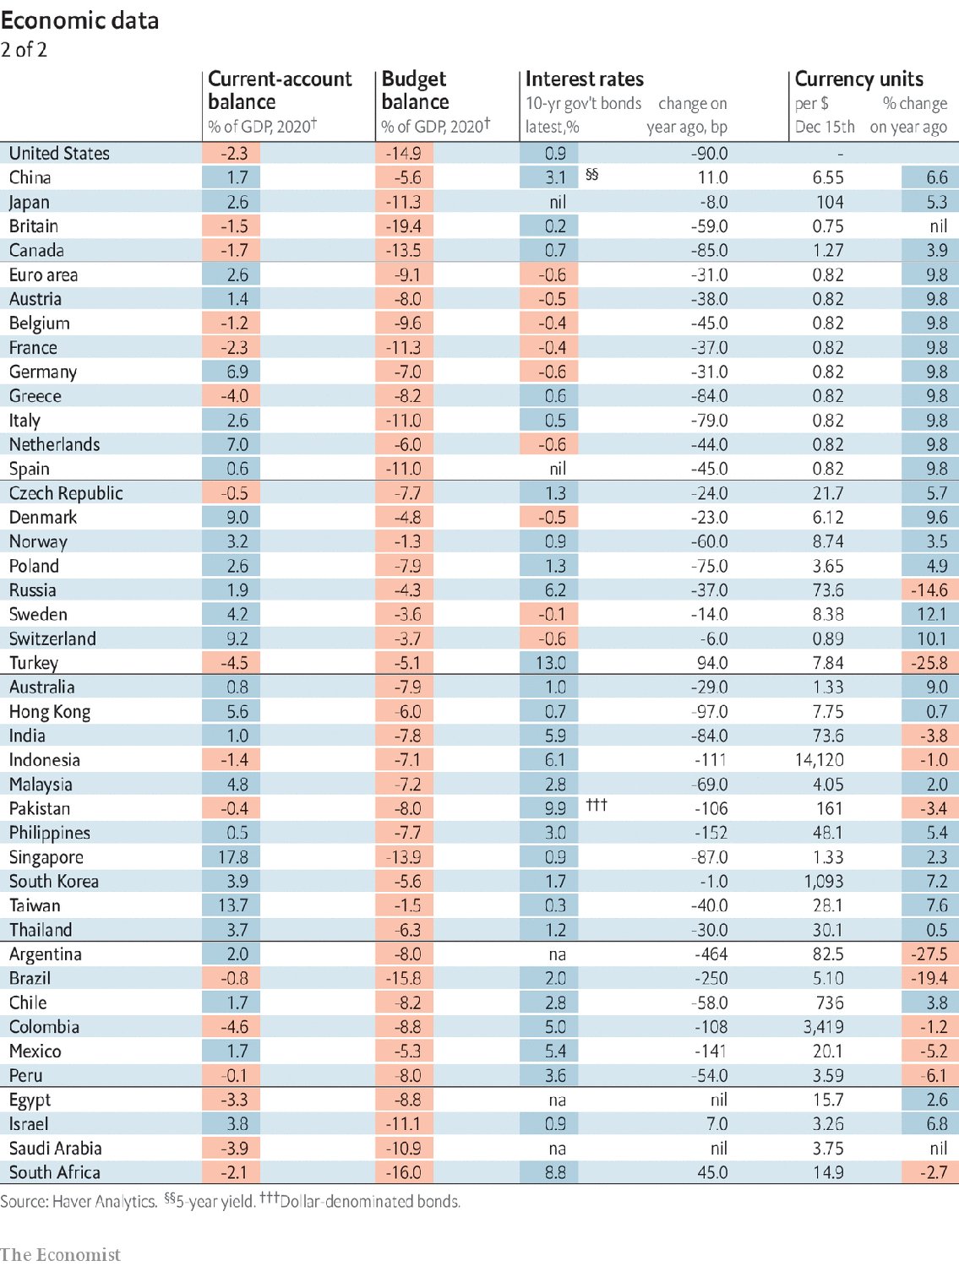

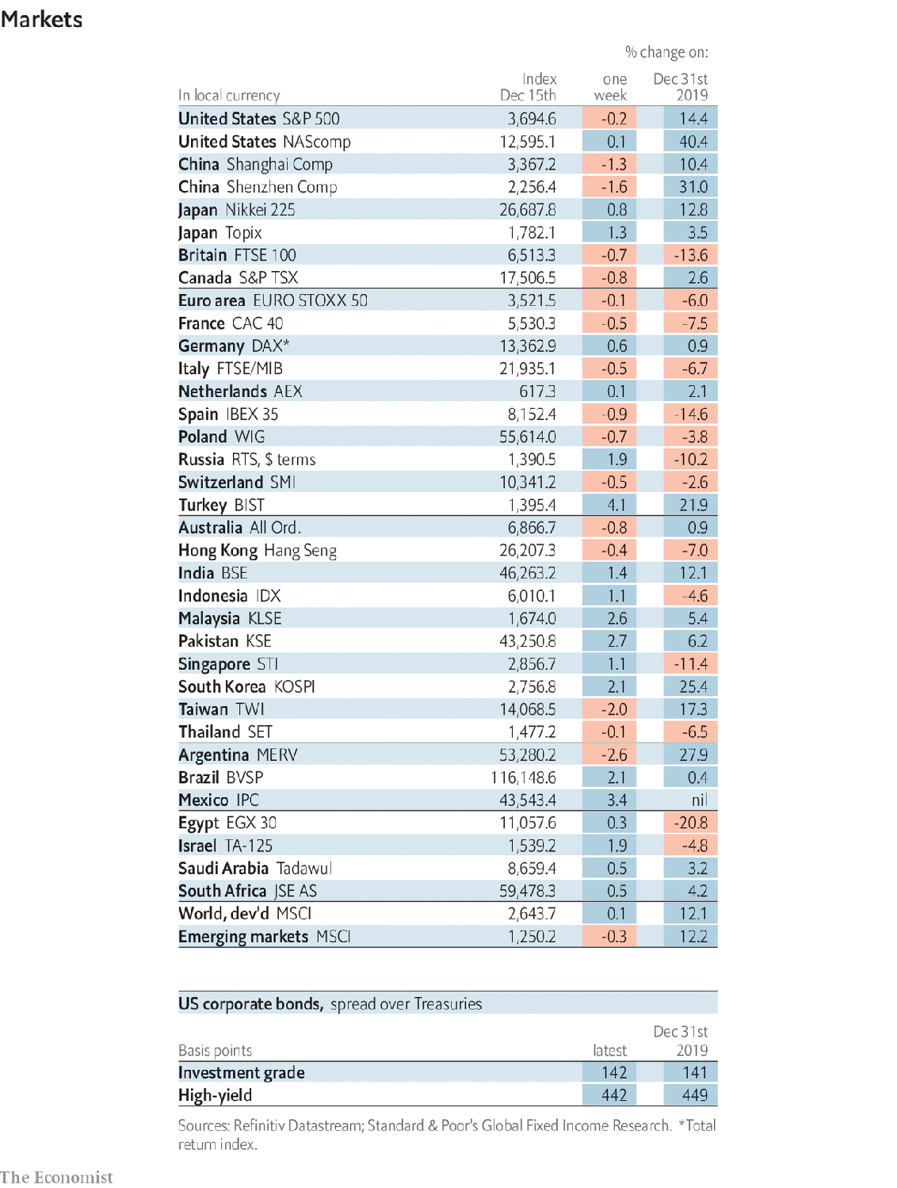

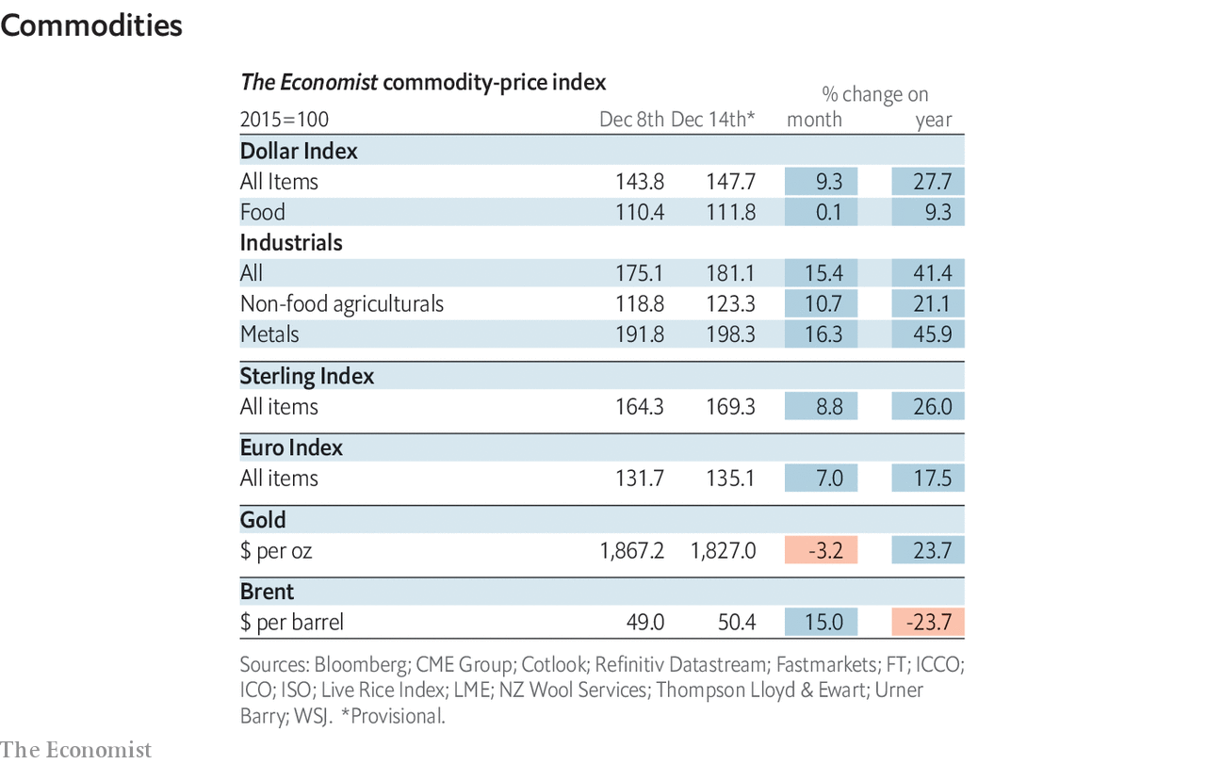

This article was downloaded by calibre from <https://www.economist.com/economic-and-financial-indicators/2020/12/19/economic-data-commodities-and-markets>

|  |  |  |  |
| --- | --- | --- | --- |
|  | 文章 | 章节 | 下一项 |

|  |  |  |
| --- | --- | --- |
| Economic & ... | 章节 | Obituary |

Graphic detail

The media and covid-19: The biggest story ever?

.

We’re hiring full-time and trainee data journalists

.

|  |  |  |
| --- | --- | --- |
| Economic & ... | 章节 | Obituary |

|  |  |  |  |
| --- | --- | --- | --- |
|  | 文章 | 章节 | 下一项 |

#### The biggest story ever?

# Only the world wars have rivalled covid-19 for news coverage

In late March, 80% of our articles mentioned “covid” or “coronavirus”

Dec 19th 2020 |

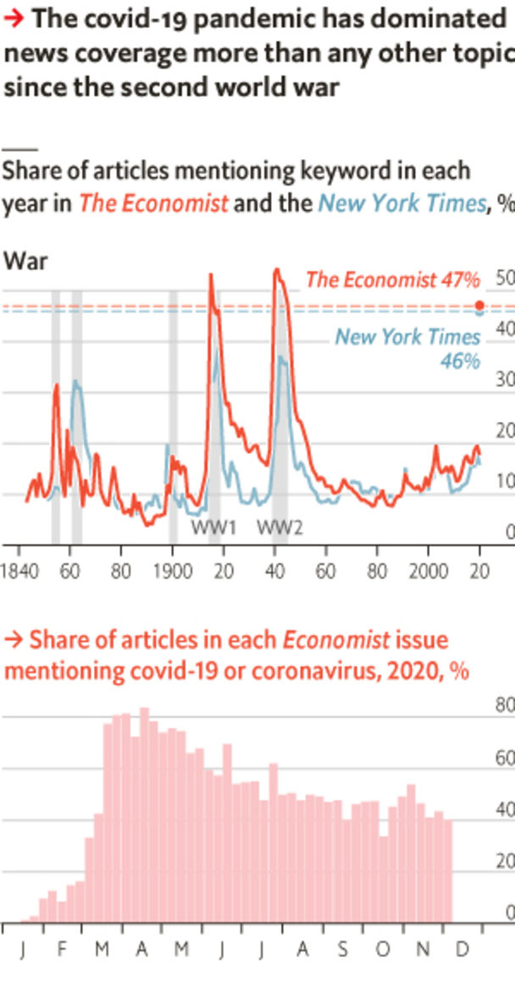

GIVEN HOW much the world has changed in 2020, it is hard to fathom that the year was just one leap-day longer than 2019. On January 16th The Economist published its first article about a novel coronavirus in Wuhan, China, which at that point had been confirmed only as the cause of 42 infections and one death. Two weeks later, covid-19 made its debut on our cover. It returned there on February 27th, and held the slot for ten consecutive issues. The topic has claimed seven more covers since then.

Is the pandemic the biggest news story ever? The two world wars and the Spanish flu of 1918 caused far more deaths, as have various famines and genocides. However, covid-19 has altered people’s daily routines in almost every country, in a way that deadlier events did not. Moreover, fatality counts cannot quantify developments that have changed people’s lives for the better.

As an alternative measure, we combed through every article we have published since our founding in 1843, and counted how often we mentioned certain keywords in each year. To diversify this analysis, the New York Times has also granted us access to its archives, which stretch back to 1851. In both publications, just under half of articles this year (including January and February, when the disease was mostly limited to China) have included “covid-19” or “coronavirus”. In late March, four-fifths of our own stories used one of those words.

Only two events in modern history have come close to these fractions: the world wars. The share of Economist stories referring to “war” reached 53% in 1915 and 54% in 1941. For the New York Times, it peaked at 39% in 1918 and 37% in 1942. This gap may be explained by America’s distance from the battlefronts, which reduced the effect of the fighting on daily life. If newspapers around the world hewed closer to 35% than 55% in their reporting of the wars, then covid-19 has probably set a new record.

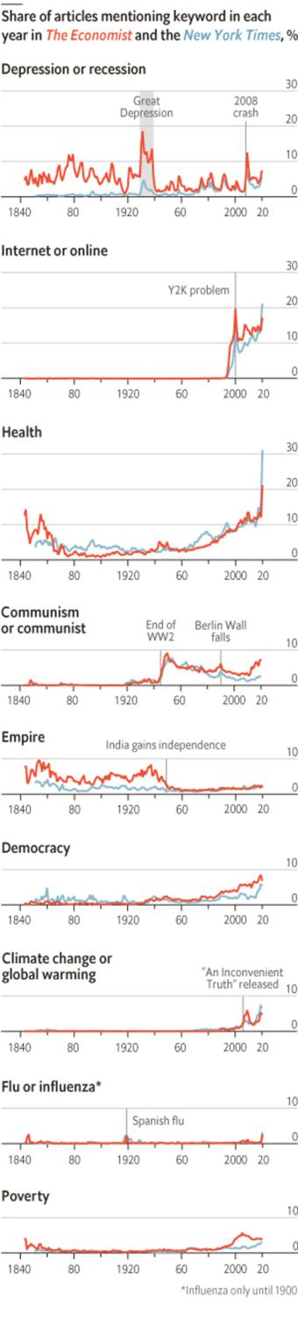

Media coverage is a flawed gauge of importance. Many critics worry that journalists focus too much on bad news, which often arrives via unexpected catastrophes, and too little on improvements, which tend to accumulate more gradually. Nonetheless, The Economist’s archive bears traces of life getting better—or at least, we have taken stock of slow-moving changes in welfare more frequently as time has gone on. Even before 2020, mentions of “health” were rising. “Democracy”, though under threat in many countries, grew in popularity in the late 1980s. Articles about “poverty” became more common after 2000, when the UN listed its eradication as its first goal for the new millennium.

The 21st century also brought a surge in stories referring to the “internet” or being “online”. Before 2020, the biggest change in most people’s daily lives in recent decades was probably the advent of the world wide web and smartphones. If the pandemic makes working from home realistic for many employees, it might have a similarly long-lasting effect. That would be a welcome silver lining to a long, gloomy year. ■

Sources: Gale; New York Times; The Economist

This article was downloaded by calibre from <https://www.economist.com/graphic-detail/2020/12/19/only-the-world-wars-have-rivalled-covid-19-for-news-coverage>

|  |  |  |  |
| --- | --- | --- | --- |
|  | 文章 | 章节 | 下一项 |

|  |  |  |  |
| --- | --- | --- | --- |
| 上一项 | 文章 | 章节 | 下一项 |

# We’re hiring full-time and trainee data journalists

Come and join The Economist’s quantitative-journalism department

Dec 19th 2020 |



We’re hiring: The Economist is looking to add both a full-time data journalist and a promising young trainee to our data team. Please visit [economist.com/datajobs](https://www.economist.com/datajobs) for details.

This article was downloaded by calibre from <https://www.economist.com/graphic-detail/2020/12/19/were-hiring-full-time-and-trainee-data-journalists>

|  |  |  |  |
| --- | --- | --- | --- |
| 上一项 | 文章 | 章节 | 下一项 |

|  |  |  |
| --- | --- | --- |
| Graphic detail | 章节 |  |

Obituary

John le Carré: The watchful scribbler

.

|  |  |  |
| --- | --- | --- |
| Graphic detail | 章节 |  |

|  |  |  |  |
| --- | --- | --- | --- |
|  | 文章 | 章节 | 下一项 |

#### The watchful scribbler

# John le Carré died on December 12th

The master of the spy novel and creator of George Smiley was 89

Dec 14th 2020 |

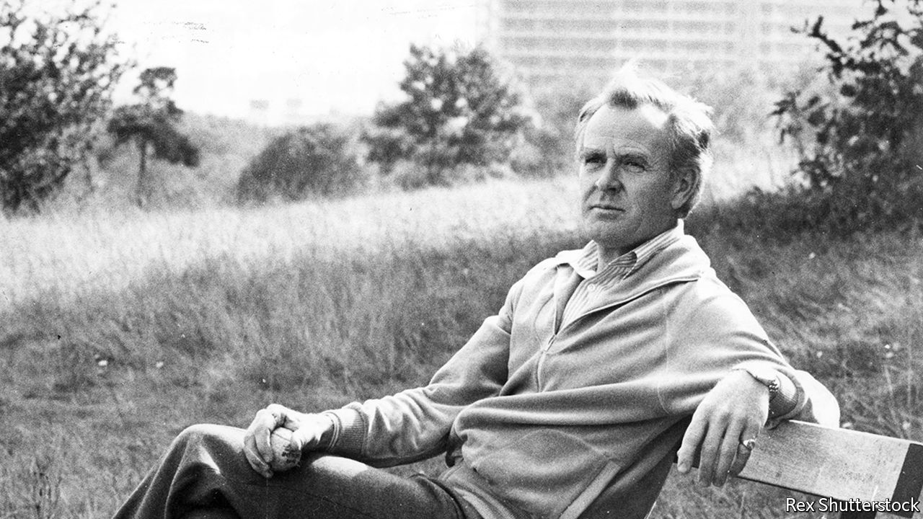

THE HOUSE in Gainsborough Gardens was tall and elegant in the red-brick Hampstead manner, with a background of old trees. In front of the houses stretched a dank lawn strewn with leaves. He walked across it quickly to the locked gate on the Well Walk side, which preserved the hidden feel of the place. He might have been going to lunch at the Wells, where the rhubarb crumble was reliably good. But too many people knew John le Carré there, spotted his upright stance and far-sighted gaze, the fine greying head, and might start conversations. Today he had a different assignation. He turned not left but right, towards the Heath.

A weather-boarded barn stood by East Heath Road, with a bench on which it was said that Keats had sat and wept. On the other side of the road, a gravel track curved down through an avenue of trees. A few dog-walkers wandered on it. It was here, in “Smiley’s People”, the third part of his George Smiley trilogy, that General Vladimir had been shot in the face by Moscow agents. And there, just off the path, lodged in a crevice where a tree forked, Smiley had found the cigarette packet that held the proof he needed.

On the avenue his own pace slowed. Instinctively he began to practise tradecraft, or writing craft. He became observant, guarded, watchful, keeping to the edge of the path where the undergrowth slightly obscured him. Writers and spies shared the same “corrosive eye”, as Graham Greene put it: that wish to penetrate the surface to the centre and truth of things.

In fact he had not been in “the circus” for long; just a few years, running low-grade agents into eastern Europe and then working out of the British embassy in Bonn, before Kim Philby, a celebrated double agent, exposed him. He was a writer who, very briefly, had been a spy. Yet he felt he had been recruited to the secret world from childhood, as Conrad was to the sea. He had acquired the comforting habit of cover-stories to try to account for a father who was in jail one moment and at Ascot the next: an epic conman from whom his mother bolted when he was five. He had joined the secret service for all kinds of romantic reasons, to do some good for society, and to discover how the world was really run; but also because he felt corporate attachment offered him a family’s protection. To some extent it did. But he soon found with Alec Leamas, the pretend defector whom Smiley in “The Spy Who Came in from the Cold” sent into East Germany and ultimately to his death, that spies were not priests or saints, but “a squalid procession of vain fools…sadists and drunkards, people who play cowboys and Indians to brighten their rotten lives”. In the cold war Western agents, aping Soviet ones, walked on the thinnest moral ice. It often broke.

At the end of the avenue lay a games field, with a goalpost askew and a few boys playing. Their bicycles were sprawled by the path. Across the field stood a small green tin pavilion, like a bus shelter. There Smiley had found, at head-height, the shiny MI6 drawing pin whose message was Proceed to the rendezvous, no danger sighted, together with Vladimir’s chalked reply. Here, too, Smiley’s shadow walked. A plump figure, balding, bespectacled and breathtakingly ordinary; keenly observant, wise, cunning, yet also shy, embarrassed by life, convinced that his clothes were wrong. He had emerged in 1961, in “Call for the Dead”, a fully fledged combination of several people from the le Carré past; he took his bow in 2017, giving lectures in “A Legacy of Spies”. And he had exposed his creator, through the books and films and especially the TV series of “Tinker Tailor Soldier Spy”, to the blaze of literary fame.

It was not wanted. “John le Carré” was a mask for a man, as much as a necessity for an author in the intelligence service. As a writer, like a spy, he needed to go incognito, sit at a back table, slip through doors, avoid the crowd. If he wanted he could unleash in a warm, military tone a fund of good stories, such as his near-seduction at 16, in front of her husband, by a countess at dinner in Panama, which drew him to the country later to set a novel of a crooked tailor. Storytelling was what he did. Now he was pumped for information which his vestigial loyalty to the service forbade him to speak of, as well as for solutions to mysteries that he knew nothing about. (“Who killed Robert Maxwell?” Rupert Murdoch asked him, suddenly, when they lunched together.) And the public presumed he was at a loss when the cold war ended, with his great preoccupying subject gone.

On the contrary, its end delighted him. And history was far from over. The players changed, the game went on. He had focused on the cold war from the 1960s because it was the overriding drama of the age. Others quickly succeeded it: the arms trade (“The Night Manager”), the war on terror (“Absolute Friends”), Big Pharma’s misdeeds in Africa (“The Constant Gardener”). Trump’s America and Johnson’s Britain, with their spoon-fed media and nationalistic duping of the public, appalled him equally. Each deserved excoriation in a book in which the characters acted out a global argument, just as the closed society of spies had been, for him, a theatre of the world.

So there could be no end to writing, and that, on this gradually clearing morning, was his purpose on the Heath. Notebooks weighed down his pockets; no laptop for him, but the unmechanised thrill of shaping the words with his pen. He had other scribbling places, particularly his seaside house at St Buryan in Cornwall, where no one knew who he was. North London was more difficult, as joggers panted past and trains rattled distantly on the Overground. He was making for a particular bench that stood separate from its companions, tucked under a spreading tree.

There he worked away. And it seemed to him from time to time, when he looked up, that a figure observed him. Balding, plump, quite unlike him physically, but with the same tendency to want to hide, and the same occasional sharp pain from seeing too much. Even at a distance he could spot him, from the way he thoughtfully cleaned his glasses with the fat end of his tie. A large part of himself, too, had gone to make up Smiley. He was now walking towards him, his lenses gleaming like mirrors. ■

This article was downloaded by calibre from <https://www.economist.com/obituary/2020/12/14/john-le-carre-died-on-december-12th>

|  |  |  |  |
| --- | --- | --- | --- |
|  | 文章 | 章节 | 下一项 |